**Ahmednagar Jilha Maratha Vidya Prasarak Samaj’s**

**New Arts, Commerce And Science College, Parner**



**Department of BSc.Computer Science**

**Project Report On**

**“Courier Management System ”**

Submitted in partial fulfilment of the requirement of the degree

Under the guidance of

Proff.Patade Madam

**Submitted By**

**Mr Kiran Ananda Dingare**

**Mr.Aniket Dadabhau Takale**

To

Savitribai Phule Pune University, Pune 2022-2023)

Certificate

Acknowledgement

The list of people to whom I am grateful for their assistance and support in the completion of an academic project is long, and I hope that I don't leave anyone out. If I missed anyone, please know that your contributions are appreciated.

As I am presenting this project on “**Courier Management System**” for New Arts, Commerce and Science College, Parner I am aware of the humanity and gratitude towards all individuals who have so kindly offered us their time, skill, knowledge, guidance and facilities.

I take this opportunity to express my deepest gratitude to our project guide Prof.patade madam for her valuable guidance, encouragement and assistance throughout the project. I would like to thank Prof.S.P.Gaikwad Sir(HOD), BSC Computer Science for his suggestions and co-operation.

INDEX

|  |
| --- |
| **Introduction 5**  Problem statement 6  Objective and goals 6  **System Analysis 7**  Existing System 7  limitations of existing systems 7  **Proposed System 8**  **Requirement analysis 9**  Functional requirements 9  **System Design 10**  Design constraints 10  Cost 10  Time 10  Scope 10  **System Model and Diagram 11**  UML Diagram 12  Sequence Diagram 13  DFD Diagram 14  Use Case Diagram 15  Data Models 16  **Implementation details 17**  Software specifications 17  Hardware specifications 17  **Outputs and Reports Testing 18**  **Conclusion 23**  **The Future Scope 24**  **References 25** |

# Introduction

This Courier Management System Project will have different modules. The login section will have login facility for the admin and for the user who will operate this system. While taking orders from its customers, it will take all the details of its customers who is placing the orders and all the details for the recipient such as its address, name, mobile number. During billing process system will generate a tracking id for their products. Through this tracking id, customers or its recipient will able to track their products from any location using internet. It will provide status of the product after placing orders within 1 minute

This Courier Management System Project will have different modules. The login section will have login facility for the admin and for the user who will operate this system. While taking orders from its customers, it will take all the details of its customers who is placing the orders and all the details for the recipient such as its address, name, mobile number. During billing process system will generate a tracking id for their products. Through this tracking id, customers or its recipient will able to track their products from any location using internet. It will provide status of the product after placing orders within 1 minute.

.

## Problem statement

People when transfer their products using any courier service wants to know whether their product has been shifted to their right place or not, if not then by what time it will be shifted and where it is now. Taking all this information manually is very difficult and time taking process. To handle all these activities include various processes and paper work from the management side also

## Objective and goals

* To gain maximum business region, customer demands good service. So to make more profit and
* gain maximum business region, their administration must also have a system to tackle all these
* problems on time. Its administration can take immediate ordes and provide a receipt which will
* include all the details of the products along with appropriate price to their customers. Thus
* saving time and eliminating line making process.

# System Analysis

## Existing System

This system will have different modules. The login section will have login facility for the admin and for the user who will operate this system. While taking orders from its customers, it will take all the details of its customers who is placing the orders and all the details for the recipient such as its address, name, mobile number. During billing process system will generate a tracking id for their products. Through this tracking id, customers or its recipient will able to track their products from any location using internet. It will provide status of the product after placing orders within 1 minute. This system will provide information recipient with following details where the current consignment is, till when it will reached its final destination, if any delay then reason of the delay, the route of current consignment, date of placing consignment, final date to reach its destination

## limitations of existing systems

It Hard to manage your record goals and skills in old system in case you want to update the whole could is to be updated and you have to check always for database for new queries or registration design to creative takes more time

# Proposed System

This system will have different modules. The login section will have login facility for the admin and for the user who will operate this system. While taking orders from its customers, it will take all the details of its customers who is placing the orders and all the details for the recipient such as its address, name, mobile number. During billing process system will generate a tracking id for their products. Through this tracking id, customers or its recipient will able to track their products from any location using internet. It will provide status of the product after placing orders within 1 minute. This system will provide information recipient with following details where the current consignment is, till when it will reached its final destination, if any delay then reason of the delay, the route of current consignment, date of placing consignment, final date to reach its destination

# Requirement analysis

## Functional requirements

* Computer system of the courier service provides fast access.
* databases in the computer system of courier services,
* Using this computerized system, bill issued procedure becomes fast.
* In computer system the person has to fill the various forms & number of copies of the
* forms can be easily generated at a time.
* In computer system, it is not necessary to create the Manifest but we can directly print it,
* which saves our time.
* It contain better storage capacity.
* Accuracy in work.
* Easy & fast retrieval of information.
* Well designed reports.
* Access of any information individually.

# System Design

## Design constraints

## Cost

The total budget of the project can vary from 2000 to 3000 INR. The budget covers the expenses for buying web fonts, domain name and hosting, and also to special plug-ins which can be used in the development process to save time.

The required photography or graphics for layout design can be found on different free to use online sources

## 

## Time

Creating the schedule of the project will help to define the needed total amount of time for each step and will keep the workflow on track by following stated deadlines.

## Scope

The portfolio website should consist of our main parts such as personal information, including short CV and professional skills, portfolio showcase, and contact information including feedback form.

# System Model and Diagram

System modelling is the process of developing abstract models of a system, with each model presenting a different view or perspective of that system. It is about representing a system using some kind of graphical notation, which is now almost always based on notations in the Unified Modeling Language (UML). Models help the analyst to understand the functionality of the system; they are used to communicate with customers

## 

## 

## UML Diagram

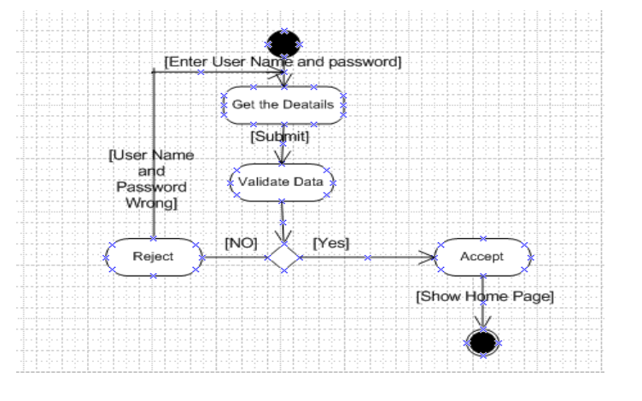

Activity Diagram For Login

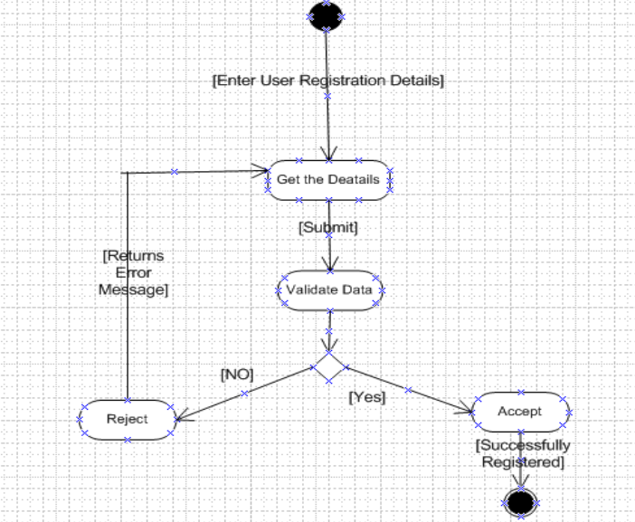

Activity Diagram For Registration

## Sequence Diagram

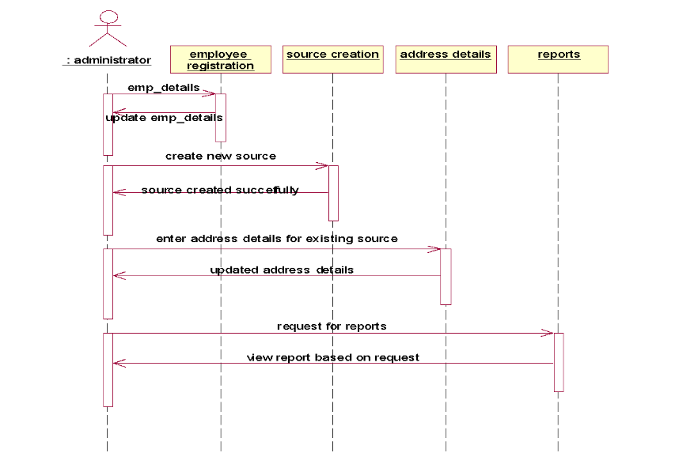

Sequence Diagram For Admin

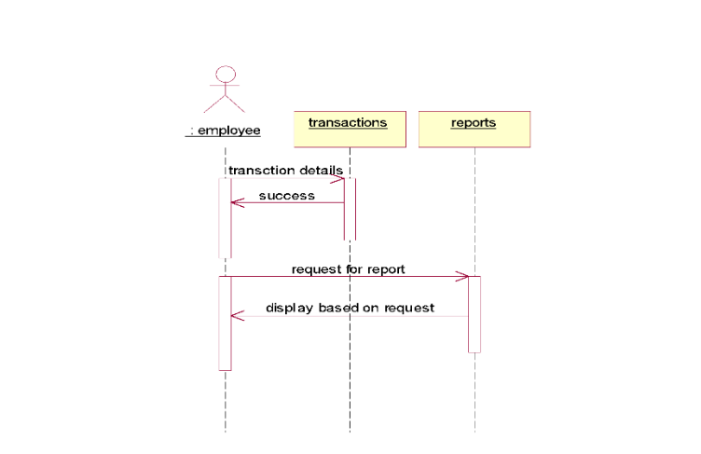

Sequence Diagram For Employee

## DFD Diagram

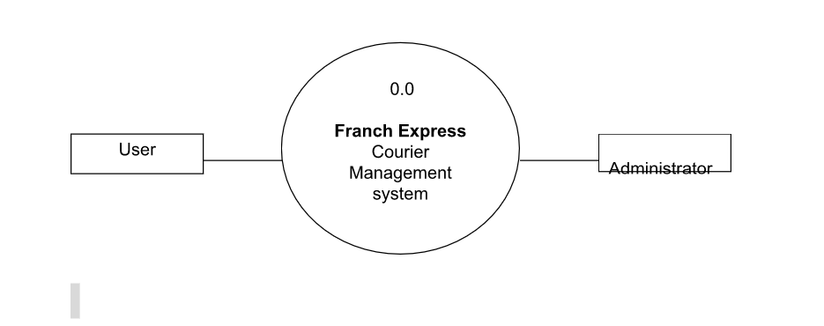

Zero Level DFD

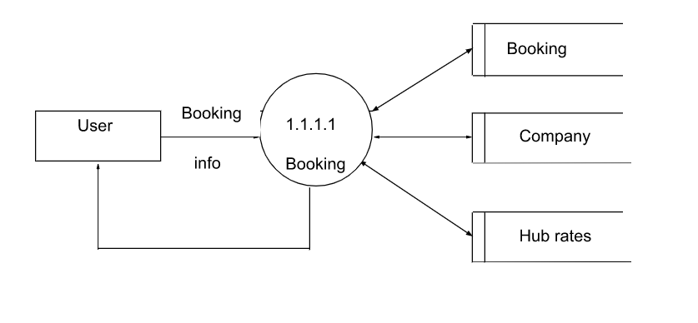

First Level DFD



Second Level DFD

## Use Case Diagram

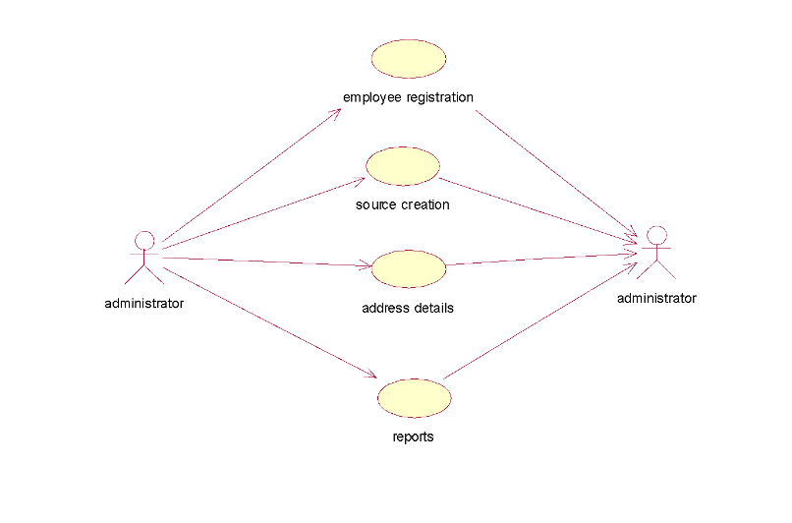

Use Case Diagram Admin

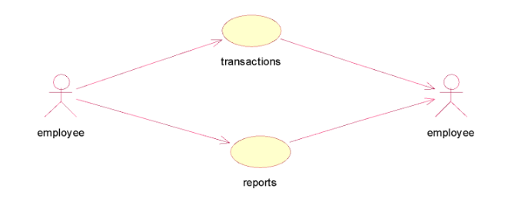

Use Case Diagram Empolyee

# 

## Data Models

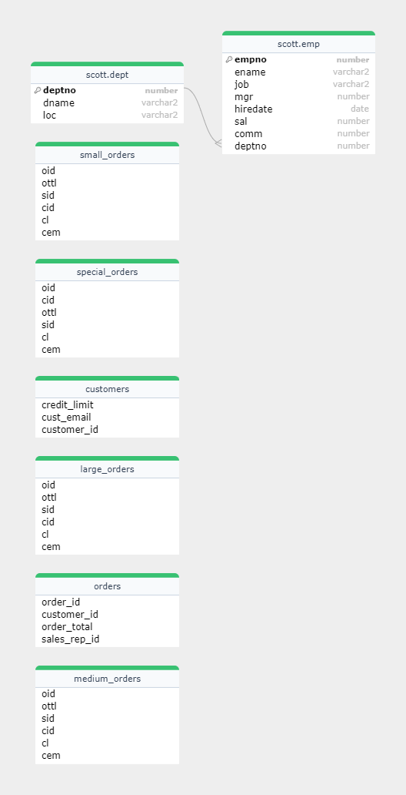

ER Diagram

# Implementation details

## Software specifications

# 

# 

# 

## Hardware specifications

# Outputs and Reports Testing

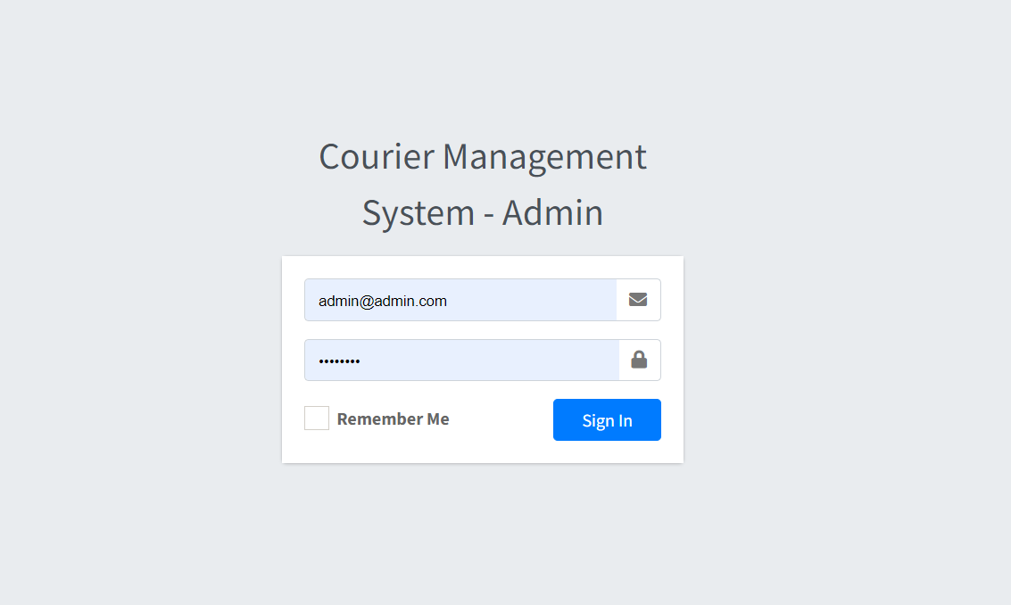

Login

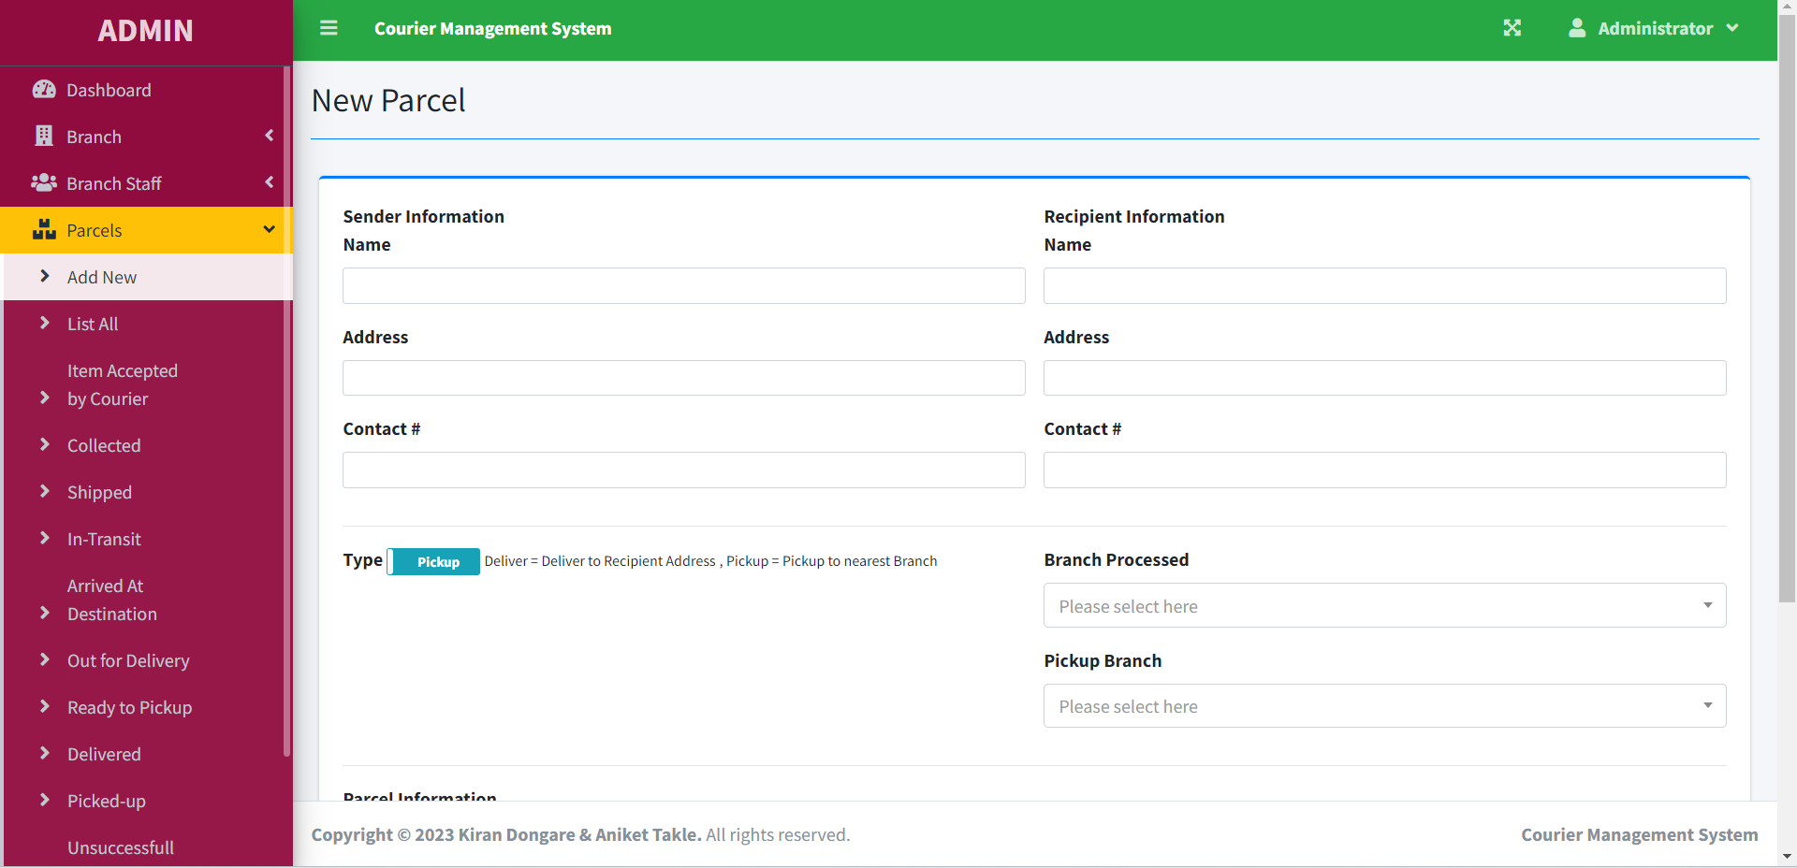

New Parcel

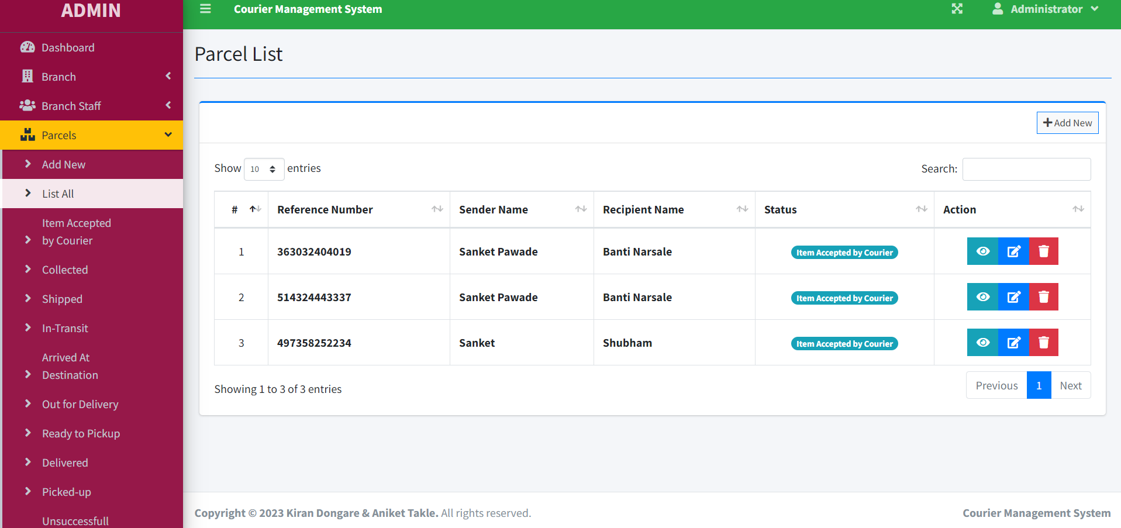

Parcel List

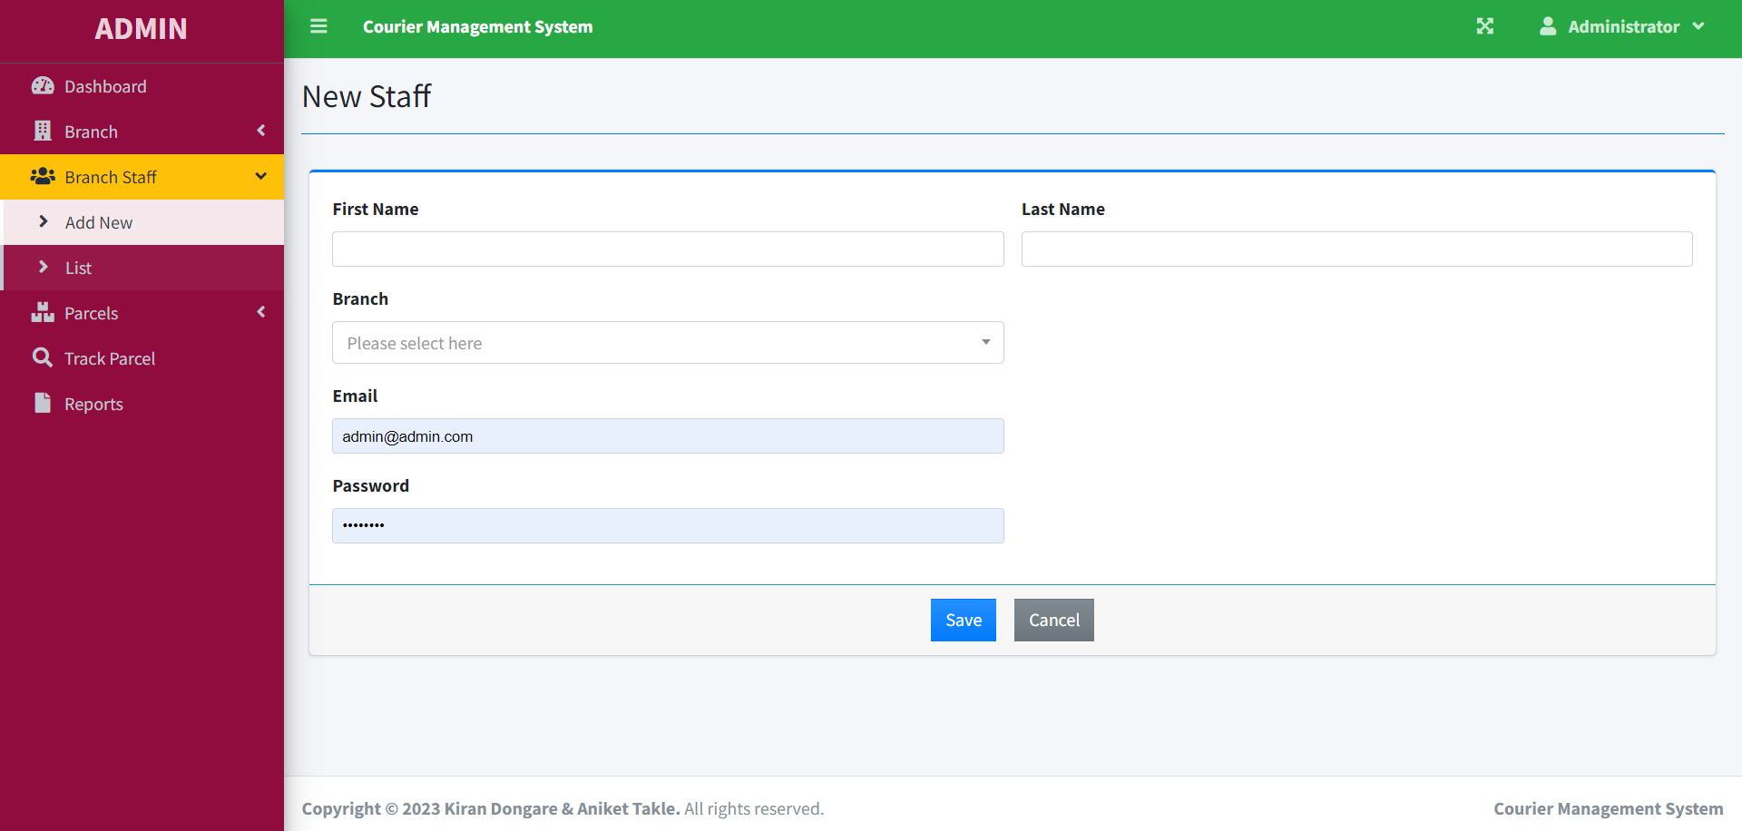

Add Staff

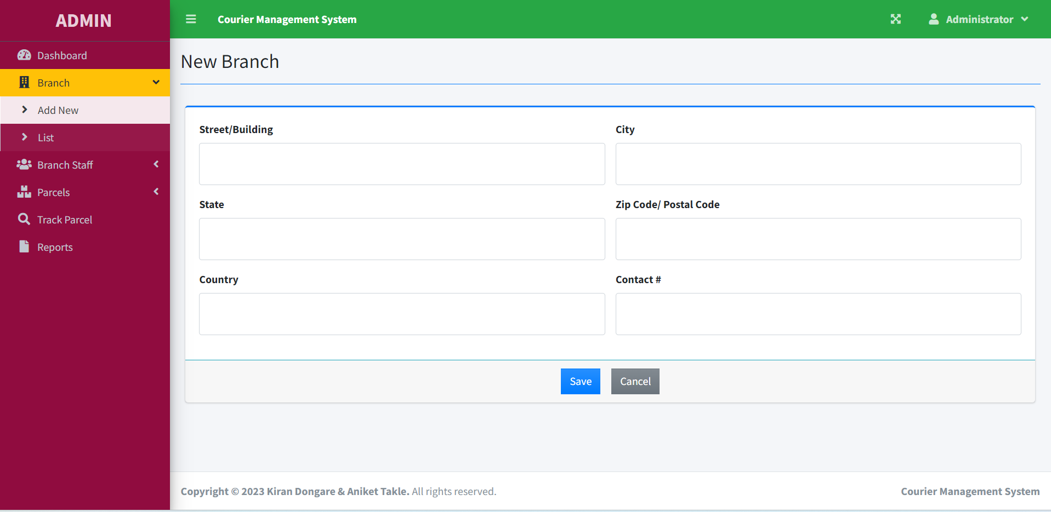

Branch Add

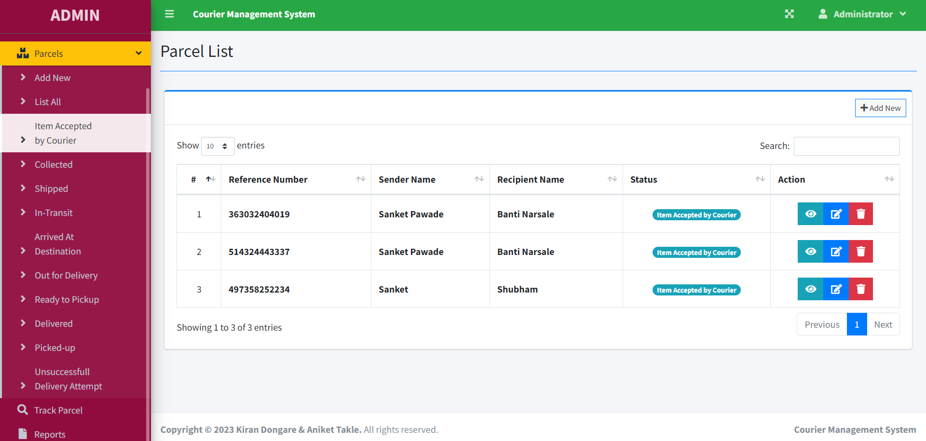

Item Accpted By Courier

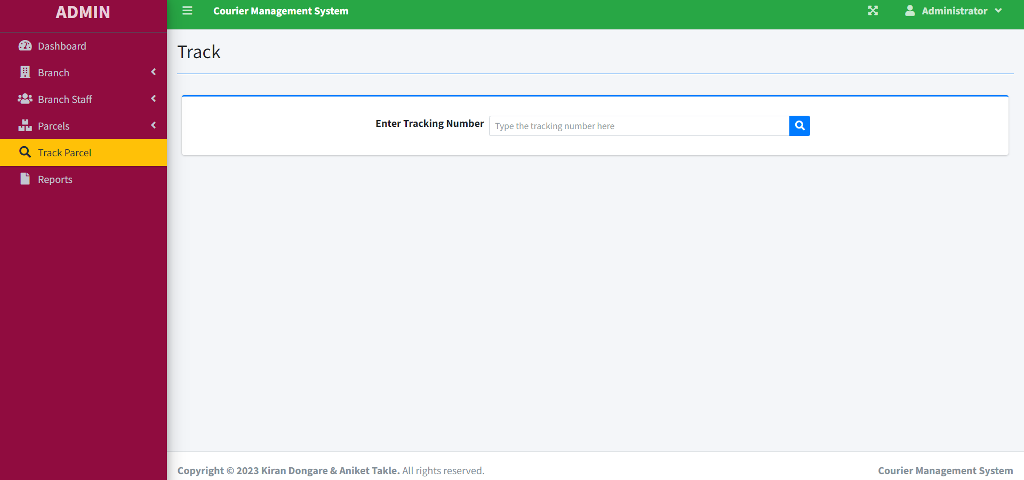Track Parcel

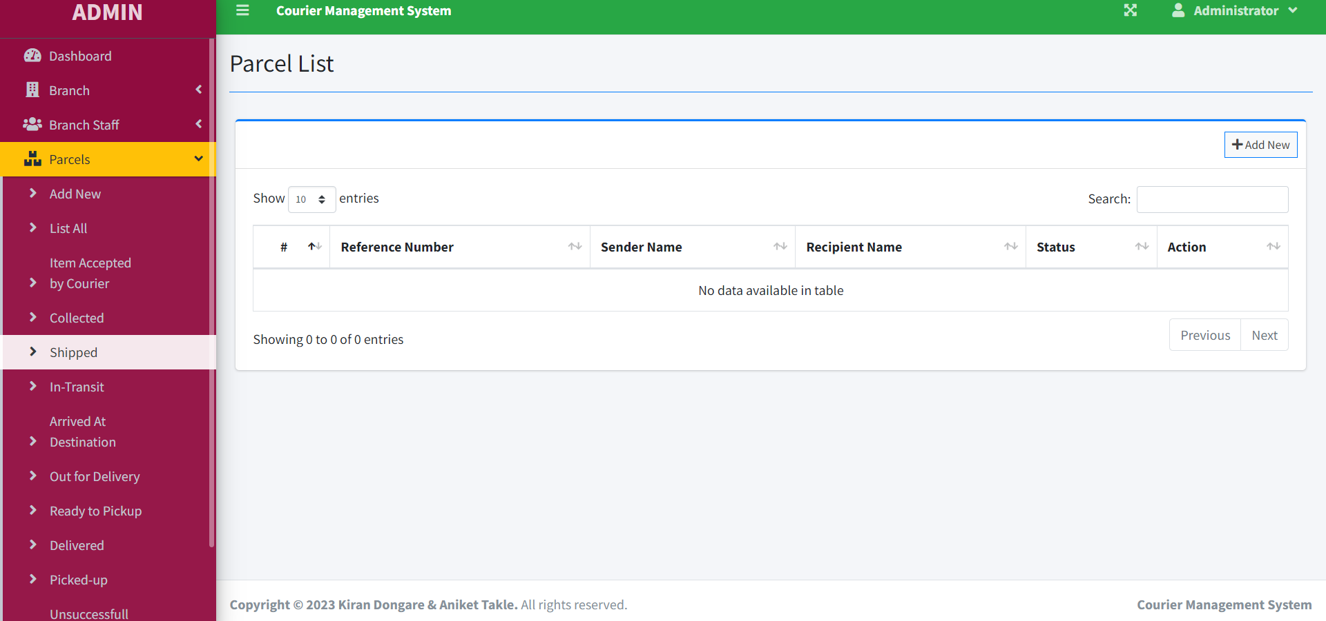

Shipped

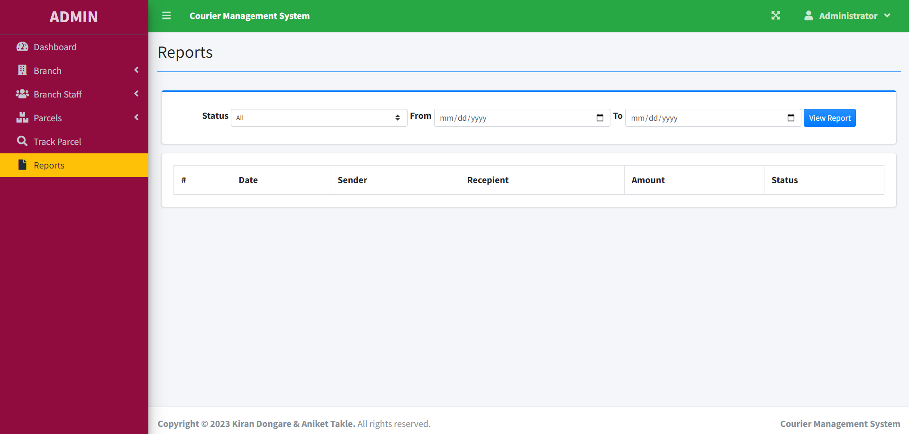

Reports

# Conclusion

Overall, the personalised design solution had been developed according to all client’s requirements including all needed content, and the client was satisfied with the result of this project. The process workflow was clearly described and documented. It will be presented in a printed brochure format at the thesis presentation day. The reported process included research work, content development, visual design concept, personal visual identity integration, and technical specifications including applying grid system and wireframe development.

# The Future Scope

The future development stage was overviewed providing a short explanation of main coding languages and other terms, including examples. During the project, the designer has got new critical, theoretical and practical knowledge which can be used in the future projects. Since he also had a role as a client in the portfolio design process he achieved better understanding of a project and a design management, improved his design skills and decision making ability. Summarising the results of the project he created list of hints for the young designers who are planning to create a portfolio

# References