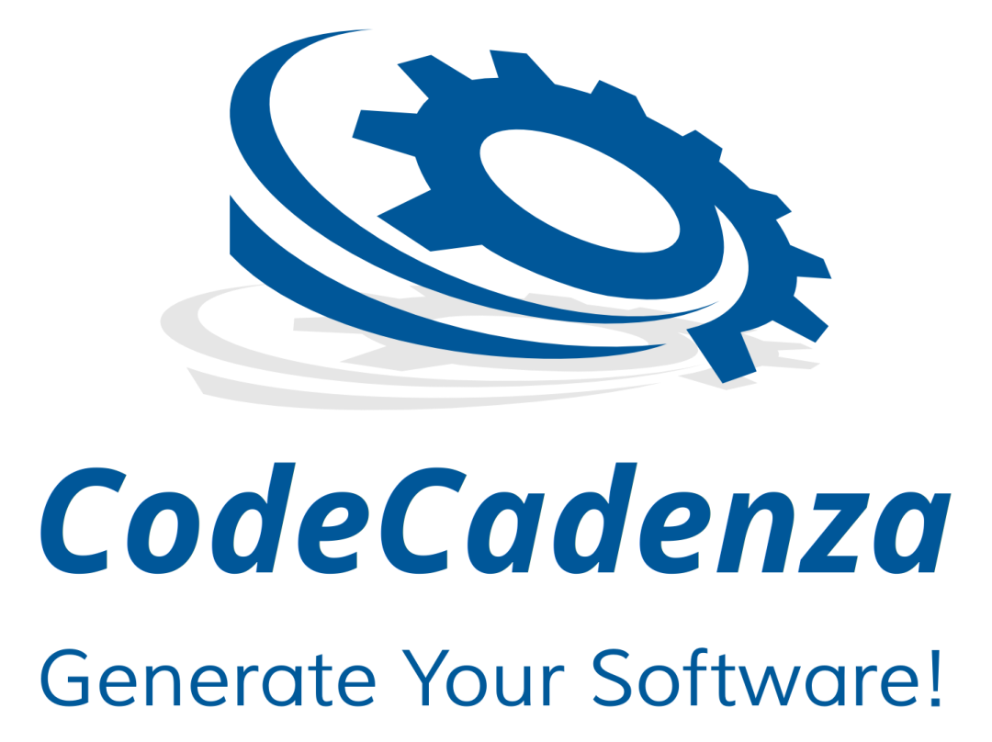

CodeCadenza Tutorial
(version 2.0.0)

List of contents

1 Introduction 7
2 Preface 8
3 Installation 9
4 List of provided plug-ins 11
5 General architecture – patterns and idioms 13
6 Creating a new project 16
7 The CodeCadenza project navigator 33
7.1 Maintenance of general project data 35
7.2 Data source settings 37
7.3 The persistence unit 38
8 Model the domain 40
8.1 Create a domain object 41
8.2 Adding attributes to domain objects 43
8.3 Create an enumeration 54
8.4 Domain object associations 57
8.4.1 The many-to-one association 57
8.4.2 The many-to-many association 60
8.4.3 The one-to-one association 63
8.4.4 The one-to-many association 66
8.5 References to domain objects in other sub-packages 69
8.6 Inheritance 72
8.6.1 Single table per class 72
8.6.2 Table per concrete class hierarchy 75
8.6.3 Table per sub-class 75
8.6.4 Non-entity base class 75
8.7 Property sheets 76
8.7.1 Property sheets for domain objects 76
8.7.2 Property sheets for domain attributes 80
8.7.3 Property sheets for domain associations 82
8.8 Tagging 84
8.8.1 Documents 85
8.8.2 Authentication and authorization 86
8.8.3 Mandating 89
8.8.4 Logging 92
8.8.5 Saved queries 93
8.9 Reverse Engineering 94
8.9.1 Default namespace selection 96
8.9.2 Database import 96
8.9.3 Domain model validation 97
8.9.4 Display the results in the Reverse Engineering editor 97
8.9.5 Adapting the initial domain model 98
8.9.6 Filtering and mapping 104
8.9.7 Saving the domain model 105
8.10 The JPA query editor 107
9 The database 109
9.1 Database properties 109
9.2 Synchronization with the target database 112
9.3 The database query editor 114
10 Creating and maintaining repositories 116
11 The client 118
11.1 Form groups 118
11.2 Single record forms 119
11.2.1 The Visual Editor 122
11.2.2 Form panels 122
11.2.3 Simple form fields 123
11.2.4 Fields for many-to-one associations 127
11.2.5 Data selection fields 130
11.2.6 Handling of one-to-one associations 131
11.2.7 Grid panels 132
11.2.8 Additional fields 133
11.2.9 Initial one-to-many associations 134
11.2.10 Fields containing binary data 135
11.2.11 Fields for element collections 136
11.3 List forms 138
11.3.1 SIMPLE_VIEW 138
11.3.2 LOV (list of values) 144
11.3.3 SEARCHABLE_VIEW 145
11.3.4 Grid panels 150
11.4 Tree views 152
11.5 Default forms 159
11.6 Standard form actions in the project navigator 161
12 Boundary beans and data transfer objects 162
12.1 Creating new boundary beans 162
12.2 Creating and maintaining data transfer objects 165
13 Data exchange 167
13.1 Basics 167
13.2 Applied technologies and libraries 169
13.3 Architecture 170
13.4 Case example 171
13.5 Creating a new data exchange method 172
13.6 Mapping persistent domain model to external data structures 179
13.6.1 Mapping domain attributes 179
13.6.2 Mapping many-to-one associations 183
13.6.3 Mapping many-to-many associations 185
13.6.4 Mapping one-to-many associations 187
13.6.5 Mapping one-to-one associations 190
13.7 Edit mapping element and attribute data 193
13.7.1 Edit data of an attribute that is mapped to a data exchange attribute 193
13.7.2 Edit data of an attribute that is mapped to a data exchange element 196
13.7.3 Edit container-element data 197
13.8 Create unmapped attributes and elements 200
13.9 Query statements 202
13.10 Adding filter parameters 203
13.11 Joined data exchange methods 205
13.12 Client integration 207
14 Integration beans 209
14.1 Basics 209
14.2 REST 211
14.3 SOAP 213
14.4 RMI 216
14.5 KAFKA 218
14.6 JMS 223
15 Integration tests 227
15.1 Core concepts 227
15.2 Creating a first integration test 229
15.3 Tracked attributes 236
15.4 Fields for entering and validating test data 240
15.4.1 Fields with a simple type 240
15.4.2 Fields that are mapped to a many-to-one association 240
15.4.3 Fields that are mapped to a many-to-many and one-to-many associations 241
15.4.4 Fields that are mapped to an element collection 243
15.5 Nested invocations 244
15.6 Pre-processing and post-processing statements 246
15.7 Testing search- and count-operations 248
15.8 Testing file operations 251
15.9 Configuration properties 253
15.10 Starting the test 254
16 GUI testing 255
16.1 Creating a first GUI test 255
16.2 The anatomy of a generated GUI test 259
16.3 Page objects 260
16.4 Test data 261
16.5 Global configuration properties 263
16.6 GUI test actions 265
16.6.1 Enter form data 265
16.6.2 Validate form data 268
16.6.3 Execute form actions 268
16.6.4 Search input 270
16.6.5 Row count validation 271
16.6.6 Uploading and downloading files 272
16.6.7 Login and logout 272
16.7 Additional features 273
16.7.1 Page title test 273
16.7.2 Moving test actions 273
16.7.3 Test action results 274
16.7.4 Delaying test actions 275
16.7.5 Test action comments 275
16.7.6 Delete a test action 276
16.8 Test data proposals 276
16.9 Running a test 276
16.10 GUI test suites 277
17 Communication between client and server 279
18 Launching the application 282
19 Maintenance of generated source code 286
20 Trademarks 287

Introduction
Since Java EE 5, it became very easy to develop multi-tier Java enterprise applications. However, there is still much effort required in order to create the full application-stack from scratch. The basic design methodology CodeCadenza follows is the model driven architecture (MDA). That means that we extract a static domain model from the software requirements analysis and create that model graphically by using CodeCadenza's domain editor. As we can see in subsequent chapters this model represents the base for further artifacts we may design and create.

Preface
Since 2005, I have been working now on CodeCadenza. Many hours in my spare time were necessary to design and to create the result that is now accessible, adaptable and usable by the community. I am aware of the fact that many people will complain about features, architectures in use, documentation and generated sources. But for some people – and I hope for a lot of people – it will help to create Java enterprise applications faster, easier and with higher quality.

Installation
CodeCadenza provides an update-site to easily integrate it into Eclipse. Open your IDE and select “Install new software” in the “Help” menu of Eclipse. A dialog opens where we have to select the repository to install CodeCadenza from. Click on the “Add” button to create a new repository.
The “Add repository” dialog contains two fields that we have to fill out. Enter “CodeCadenza” into field “Name”.

The update-site URL

https://github.com/codecadenza/codecadenza/raw/main/update

must be entered into the second field “Location”.

Now, we just have to select “CodeCadenza”. After clicking on button “Next”, Eclipse will search for plug-in-dependencies. Depending on your specific installation, it might take some time to find and to install them.

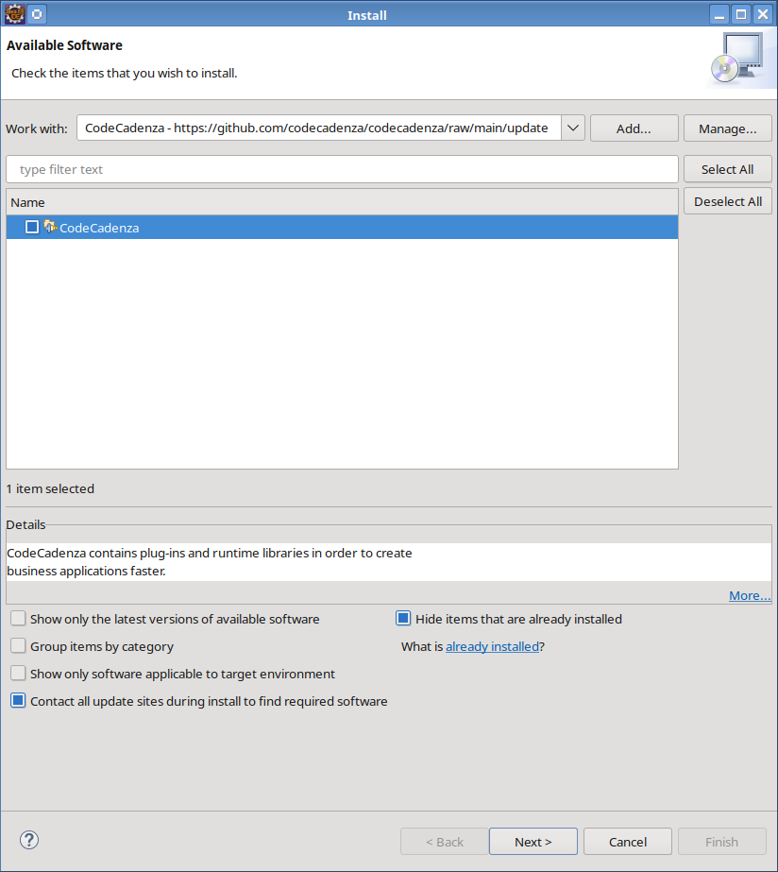Dialog to install CodeCadenza
CodeCadenza is available on the Eclipse Marketplace which provides an easy way to install plug-ins into the Eclipse ecosystem.
Note that the current version of CodeCadenza was developed and tested with Eclipse 2025-12 and Java 25 SDK.

List of provided plug-ins
CodeCadenza currently consists of nine plug-ins that are necessary to integrate this software into the Eclipse ecosystem:

- net.codecadenza.eclipse.model

This plug-in provides the meta-model of CodeCadenza. It contains Ecore-files and the Ecore-diagram-files in order to change or to extend the meta-model. It is highly advisable that changes concerning the model structure are done within the corresponding diagram.

- net.codecadenza.eclipse.resource

Common images and static libraries for server and client side are located in this plug-in.

- net.codecadenza.eclipse.service

This plug-in provides high level service methods for different kinds of internal meta-model classes.

- net.codecadenza.eclipse.shared

The plug-in contains a set of generic widgets that are used internally.

- net.codecadenza.eclipse.tools

In order to query the target database by using SQL and to check JPA query statements instantly, this plug-in has been created. Thus, further external tools are not necessary for these purposes. Furthermore, there are tools for synchronization of the database model with the target database, services that encapsulate JDT calls and utility classes for protecting manual source code changes from being lost when rebuilding generated classes.

- net.codecadenza.eclipse.ui

This plug-in contains classes for the CodeCadenza project navigator, common dialogs and a wizard to create a new CodeCadenza project.

- net.codecadenza.eclipse.testing

This plug-in contains some SWTBot unit tests to check the basic functionality of CodeCadenza.

- net.codecadenza.eclipse.domain-diagram

This plug-in provides the domain diagram editor that is based on GMF.

- net.codecadenza.eclipse.generator

The plug-in is responsible for providing source code generation services.

- net.codecadenza.eclipse.buildtest

In the past, it was hard to test new features, bug-fixes and improvements. This plug-in helps to ease that problem by providing automatic build tests upon internal, predefined projects.
The build process can be initiated by running the “Perform CodeCadenza build test” action in the Package Explorer view of Eclipse.

General architecture – patterns and idioms
Although the plug-in provides creation of very flexible and complex domain models and full-featured applications, the general architecture is determined and cannot be affected by the application designer in terms of special settings or properties within the plug-ins.

- Domain Object
A domain object in problem solving and software engineering can be thought of as a conceptual model of a system which describes the various entities involved in that system and their relationships.
In CodeCadenza all domain objects are mapped to an abstract or non-abstract JPA entity, a mapped-superclass or an enumeration. An application designer is able to create domain objects, associates them via different kinds of relationships and adds attributes to domain objects. The terms entity bean, entity and domain object will be used synonymously within this manual.

- Repository
A repository provides a way to manage the data access logic in a central location. The plug-in generates one repository for every abstract and non-abstract domain object. The application designer cannot directly influence the methods being created by the plug-in. Beside of the methods that are common for all repositories (e.g. persist, delete, search...), CodeCadenza creates additional finder-, getter- and check-methods for every unique key constraint of the specific domain object. These additional methods will be created for every unique key constraint that consists of two columns at most!
There is currently no support for more than two columns as generated method names would be simply too long! Typically, repositories won't be accessed directly by the client!

- DTO
The data transfer object pattern has been already introduced from the very first of J2EE and represents just a simple data container that provides state but no behaviour. A DTO is used to collect all data that is necessary for a remote operation. In the days of Jakarta EE many developers and application designers came to the conclusion that DTOs are evil and should not be used any longer as JPA entities are now – in contrast to J2EE entity beans – plain old Java objects (POJO) that can be easily sent across the network.
Furthermore, data transfer objects are hard to create and to maintain (just think of a DTO that contains dozens of attributes).
But why is the plug-in's architecture based on such an evil design pattern? First of all, a DTO provides a special client-side view on data that normally is represented by one or more domain objects. Hence, the internal domain object structure is completely hidden for the client (information hiding). In CodeCadenza the DTO attributes depend on the definition of the client (we will come back later to that point). This means that the DTO only contains data that is really necessary for a special client operation or form. Just think of a combobox where a user has to select a customer identified by his name and id. The customer domain object consists of thirty attributes and ten associations to other domain objects. The corresponding customer DTO for the list contains maybe just two attributes (the id and the name). Guess what is faster to load, all customers including all fields and non-lazy associations or the DTO with those attributes you really need? Another important aspect is the fact that the application designer doesn't have to create and maintain them manually. As described earlier, the data transfer objects are model artifacts that will be defined implicitly when client forms will be designed.

- Boundary beans
A boundary provides an interface between client and business logic, performs DTO conversion and invokes application service methods (e.g. repository methods). If the application is deployed on a server, the boundary is a stateless session bean that offers a remote interface.

- Facade
If a client can work directly with domain objects, it isn’t necessary creating boundary beans, repositories and most of the DTOs. In these scenarios, all business and persistence logic can be put together in one service facade class. From a meta-model perspective, a facade is just a boundary bean. A facade contains all boundary methods and most, but not all, repository methods of a specific domain object. Only the internal generator treats the meta-model differently and combines data from boundary beans and repositories in a single class! An advantage of this approach is that the meta-model can be reused easily for different architectures.

- Data exchange bean
A data exchange bean provides an interface in order to operate on data using a predefined format (CSV, Excel, JSON and Excel). The data itself is more or less tightly bound to the internal domain model. Depending on the selected data exchange format the bean can be configured to use either a String or a file for either reading or writing data.

- Integration bean
An integration bean exposes its methods via REST, SOAP, RMI, KAFKA or JMS. Every method of an integration bean refers to a corresponding boundary bean method.

Creating a new project
After we have successfully installed all required CodeCadenza plug-ins, we are now able to start developing a small sample application.
First of all, we go to the main menu of Eclipse, choose “File” and select the item “Other...” in the “New” sub-menu. A wizard appears to select the resource or project we want to create. Search for folder “CodeCadenza” and select item “CodeCadenza project”.

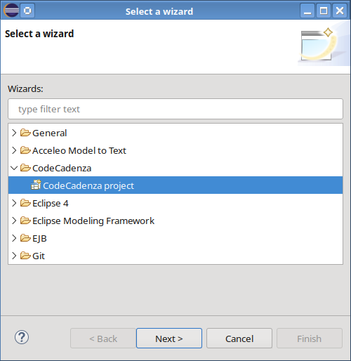Wizard for creating a new project
Now, a new wizard page will be opened to enter general project settings. The field “Project name” expects a string that is used as a default name prefix for all Apache Maven artifacts and Eclipse projects that need to be created for a new CodeCadenza project. The second field “Project code” is mainly used for the root context of a generated web application.
The field “Boundary mode” determines if a project should use boundary beans or facades. Note that this setting will be ignored if subsequent settings regarding either client or server platform don't match (see below). Also, note that this decision must be taken before a project is generated. Afterwards, it cannot be changed!
The plug-in supports protecting manual changes in generated Java source files from being lost when rebuilding the respective files. This feature can be turned off with the checkbox “Protect manual changes” (see chapter 19).
CodeCadenza always creates appropriate projects including all necessary basic packages at which the package structure is expected to be fixed. Manual changing of these structures is likely to cause severe model and build errors. Therefore, it is very advisable not to touch them. Of course, there is no problem to add additional packages manually! Although these structures are fixed, the names of the packages can be changed in the following fields (e.g. “Domain Package”).
The “Sub-packages” field on this page needs a deeper explanation. Here the developer can add sub-packages to his project. When creating the Eclipse project, the plug-in also creates new model source files (*.xmi) for every sub-package and adds these packages to all basic packages.

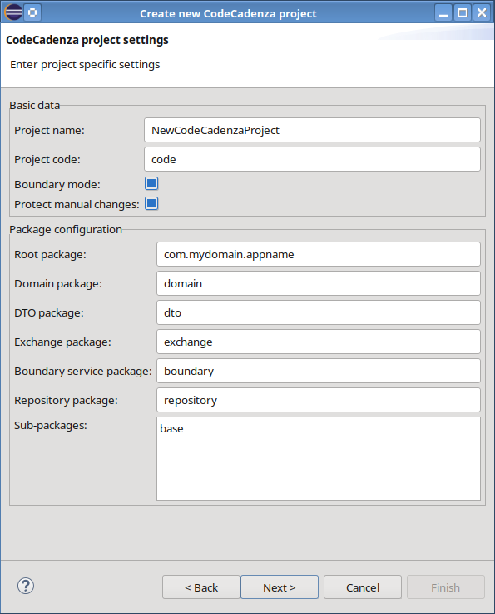General project settings

The next wizard page is used to enter database-related data. Currently, the plug-in supports

- MySQL (tested with version 8.0.31),
- Oracle (tested with version 10g),
- H2 (tested with version 2.4.240),
- PostgreSQL (tested with version 16)
- Microsoft® SQL Server® (tested with version 2008 Express)

After selecting the vendor, the developer should provide a valid connection URL, the user name and the password for the target database he wants to work with. The field “Data source name” refers to the data source defined within the target application server and will be inserted into the persistence.xml file.
Moreover, a developer can enter either a default catalog or a schema name. Please consult the documentation of the selected database if it supports either catalogs or schemas.
Since some vendors restrict the redistribution of their JDBC drivers, it is necessary to download them and add them to the "JDBC drivers" list field. You can omit this step but the plug-in won't be able afterwards to provide some features like synchronizing or querying the target database without having an appropriate driver in place. The JDBC driver library file(s) can also be selected after creating a new project (see below).
Note that the database vendor cannot be changed after a new project has been created! Nevertheless, it is possible to change the database vendor manually in the respective resource file. If we do so, it is likely that we will get wrong column types in DDL commands of domain objects that have been created before we changed the database vendor!

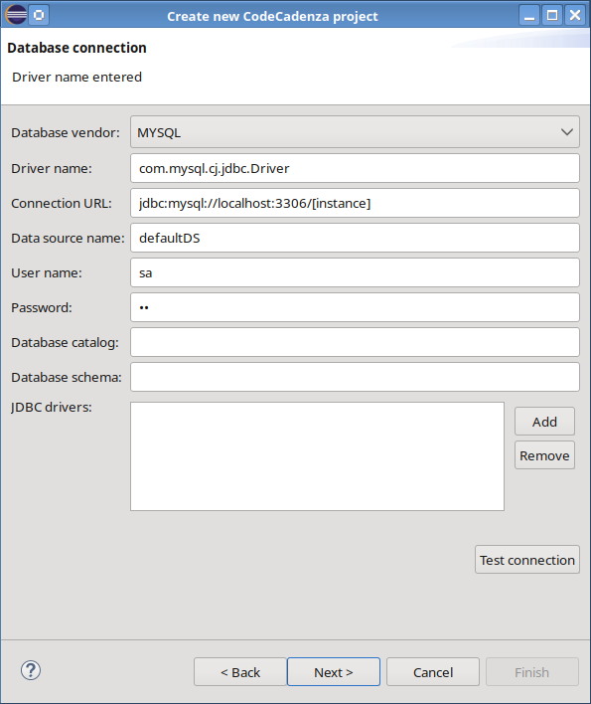Database settings
In the next wizard page, the developer can enter global application data. In the first group, he selects the client technology that should be used. Currently, a developer may select:

- NONE (no client should be generated)
- Eclipse RCP 4 (Eclipse Rich Client Platform)
- RAP e4 (Eclipse Remote Application Platform)
- Swing
- JavaFX
- JSF using the Primefaces library
- Vaadin or
- Angular

If we choose RAP, we will have to install a proper RAP target runtime! CodeCadenza has been tested with RAP e4 target runtime version 4.5. For more information about how to install the RAP runtime please follow this link!
The option “NONE” makes sense if either a Jakarta EE or a Spring Boot application should be created that doesn't require a generated graphical user interface.
Furthermore, the developer can enter the name of the application and the name of the client package.

Before creating an Angular project it is mandatory to install Node.js on the development system! Otherwise, the GUI project cannot be created properly! Note, that Node.js is also necessary for running Vaadin applications!

In the second group server-related settings can be made. Currently, the developer is able to select JBOSS (tested with WildFly 39), GLASSFISH (tested with Payara 7.2026.1) or TOMCAT as the target platform.
Moreover, we may select NONE to build projects that just run locally in an unmanaged environment without using an application server. This option is only available for RCP, Swing and JavaFX clients. In this case, applications will use EclipseLink (version 4.0.9) as persistence provider. This option especially makes senses for applications that

- don't need remote access via the internet.
- don't require sophisticated interfaces to other applications.
- don't need advanced technologies (e.g. Topics, Queues, JNDI)

For Vaadin applications we can select either a supported Jakarta EE server (see above) or Tomcat. A full overview about all supported and tested configurations illustrates the following picture:

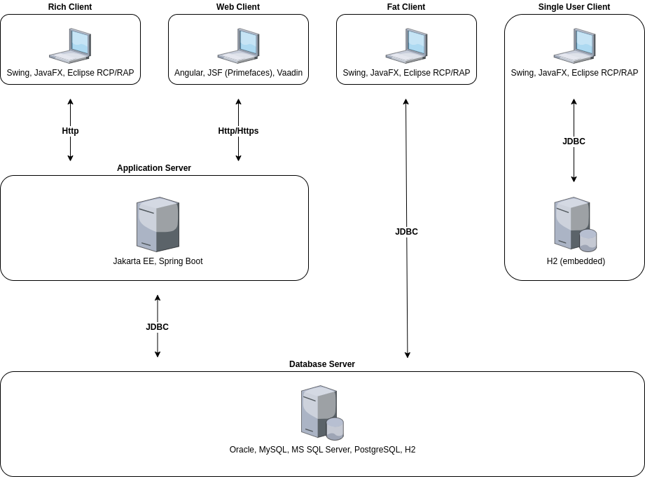Supported configurations
In the next field “Deploy directory”, the user can insert the path of the server where a Jakarta EE application should be deployed to.
The plug-in supports two different JPA implementations: Hibernate® and EclipseLink. It turned out that both implementations behave slightly differently in some situations and thus, the respective generators create different output due to selected implementation.
CodeCadenza supports JPA 3.2. In combobox “Validation type” we can select the domain object validation library being used. The user can choose if he prefers using the internal or the standard implementation (JSR 303), which is tightly integrated into JPA 3.2.
Note that most fields of this page are interdependent. The plug-in prohibits illegal selections that either make no sense or are not supported by CodeCadenza at all.

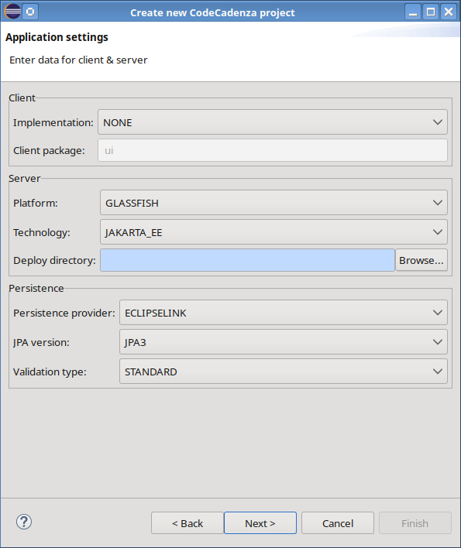Further settings regarding client, server and persistence
The next page contains fields for maintaining integration-related project settings. In the panel “XML binding” a developer can enter a specific XML namespace name as well as an XML namespace prefix. While the XML namespace name field requires an input the field for the namespace prefix can be left blank! In subsequent chapters, we will see that it could be necessary to supply data transfer objects with JAXB annotations. The combobox “Mapping strategy” can be used to control if these annotations should be either suppressed, created on demand or added by default. On the other hand, it is not possible to control this behaviour for a single data transfer object!
While most generation details are implemented in respective generators the developer is able to define a global mapping type in combobox “Mapping type”. The possible values are ATTRIBUTE and ELEMENT. If ATTRIBUTE is selected, the generator will add (if applicable) a respective annotation that maps a field to an XML attribute. When selecting ELEMENT, all fields of a data transfer object are mapped to XML elements.
The panel “Module definition” contains different fields for adding integration modules based on different technologies. Basically, an integration module contains beans that expose boundary methods via REST, SOAP, RMI, KAFKA or JMS. The possibility of defining one or more integration modules depends on settings made in the previous wizard page. If the final application should run in an unmanaged environment (see field “Platform”), an integration module cannot be defined! In case of Jakarta EE, an integration module can be defined for either REST, SOAP, RMI or JMS. If the target platform technology is Spring Boot the supported technologies are REST, SOAP, KAFKA and JMS!
Usually, an Angular application uses REST in order to communicate with the back-end. Thus, CodeCadenza will force the creation of a REST module in this case!

When selecting an integration module checkbox (e.g. “Add SOAP module”), the corresponding detail fields in the respective panel (e.g. “SOAP”) will be enabled. For every selected integration module it is possible to overwrite the default package name (e.g. “integration.soap”).

By default, the checkbox “Add security handler” is selected. In most cases, it seems to be reasonable to keep this setting as the generator will later generate a respective handler file. This handler is responsible for extracting user credentials from a request and authenticates the user by using the application's login mechanism. If this file isn't in place it is very likely that all boundary method invocations will fail at runtime if the application is secured.
Furthermore, the developer may select if a client artifact should be generated when building the project. A client artifact represents a project within the Eclipse workspace that in turn contains classes that can be used to interact with the respective services from another Java application.
If the generated integration client should be used in a managed environment (e.g. Jakarta EE or Spring Boot) it makes sense to let CodeCadenza create producer classes as they facilitate the injection of the service interface into another managed bean.

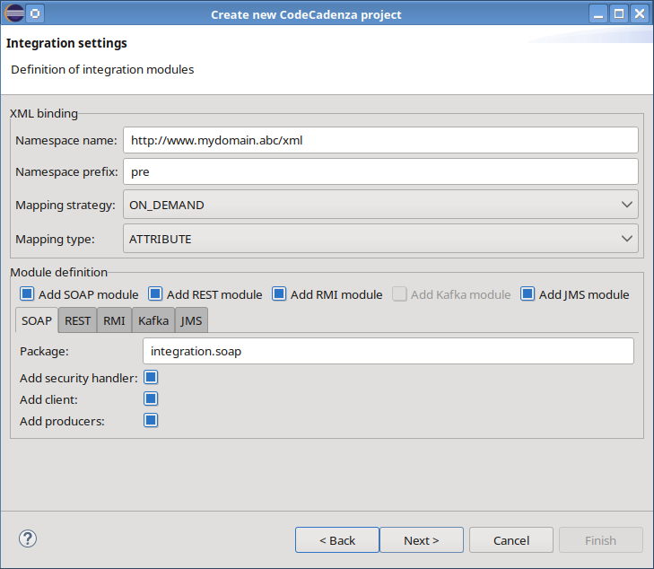Wizard page for integration settings

For Angular, JSF and Vaadin projects the plug-in supports modelling of GUI tests. The global configuration of that functionality is provided by the next page.

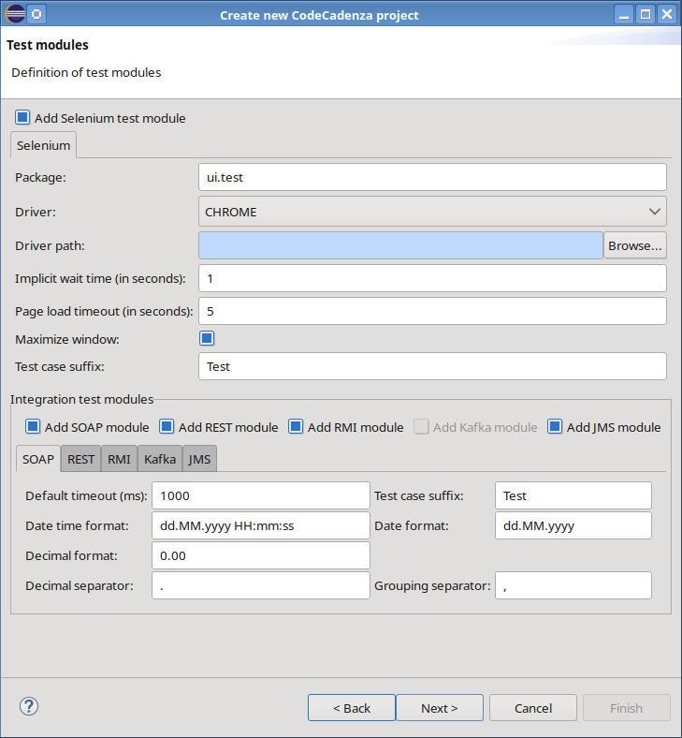Wizard page for test modules
If checkbox “Add Selenium test module” won't be selected a GUI test module will not be added to the project. Note that a GUI testing module cannot be added after the project has been generated. The field “Package” is used to enter the root package name for all generated GUI tests. As CodeCadenza's GUI testing strongly depends on Selenium it is important to select the browser in which the tests should be executed. The combobox provides a list of all currently supported browsers. By pressing button “Browse” the path to the respective Selenium driver can be selected. The three following fields “Implicit wait time”, “Page load timeout” and “Maximize window” represent basic configuration properties for the Selenium WebDriver. As soon as CodeCadenza creates the GUI testing artifact it also stores a file that contains global configuration properties. The values entered in the three aforementioned fields are added to this file (see chapter 16.5). The value entered in field “Test case suffix” controls the default name of a new GUI test.
For each selected integration module, a dedicated test module can be added to the project. In this section, the default timeout and the test case suffix are specified. Additional fields define the formatting of decimal and date values, that determine how the corresponding fields are stored in the test-data files (see chapter 15 for more details). Since the generated test cases depend on the client artifact, the option must be enabled for the respective integration module on the previous page.

The build configuration page provides a combobox containing supported build tools and a table with detailed information about the proposed artifacts.

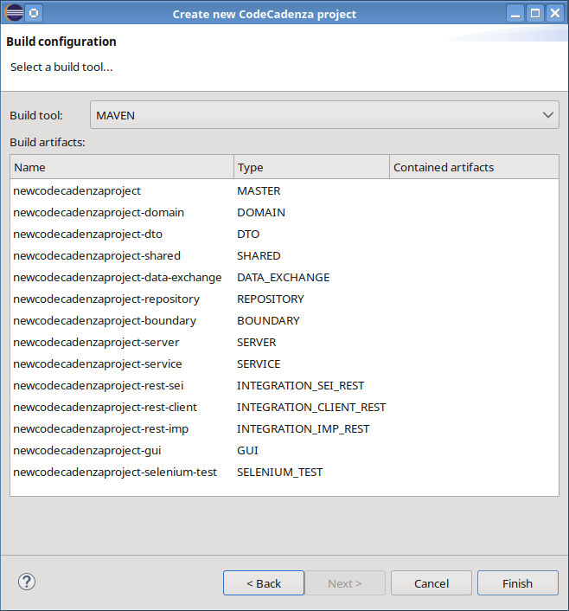Build configuration page
CodeCadenza uses Apache Maven for building the generated applications and providing all required third-party libraries.

Due to internal restrictions, CodeCadenza currently does not use Apache Maven for Eclipse RCP and Eclipse RAP projects. If the project contains other artifacts the Eclipse application directly depends on, they are able to provide a respective library that is copied to the library folder of the Eclipse project as soon as the build process has finished. Thus, it is necessary to rebuild that artifacts on a regular basis in order to provide all classes that are required by the GUI of an Eclipse application.
Depending on inputs made in previous wizard pages the plug-in creates an initial build configuration and displays it in a table.
Every row in this table represents an artifact that is later used for creating a project in the Eclipse workspace. The first column contains the name that can be easily changed by clicking on the respective table cell. Initially, the plug-in creates a name that is a combination of the project code (see chapter 6) and a suffix that depends on the given artifact type. If the name is changed manually, the plug-in will perform validation checks (e.g. the names must be unique and the current workspace must not contain a project with the same name). The next column contains the name of the artifact type.
Currently, CodeCadenza supports following artifact types:

- MASTER: The master artifact of an Apache Maven multi-module project.

- DOMAIN: Artifact that includes domain classes, the meta-model files and JPA configuration files (e.g. persistence.xml).

- SHARED: The generator places all enumerations into this artifact. It also provides a suitable place to add classes that are needed for all other modules.

- DTO: Contains all data transfer objects.

- REPOSITORY: Contains the repositories. It is only available if boundary mode is selected.

- BOUNDARY: Includes boundary beans. It is only available if boundary mode is selected.

- CLIENT_INTERFACE: Contains boundary interfaces. It is only available if boundary mode is selected.

- FACADE: Includes facade beans. It is only available if facade mode is selected.

- DATA_EXCHANGE: Contains classes for data exchange operations (incl. mapping files).

- SERVICE: Includes classes for application services like logging and saved queries.

- GUI: Contains GUI classes and respective configuration files.

- SERVER: Artifacts of this type are responsible for creating server deployment files (*.war). This artifact type is only used in case of rich-client applications!

- SOAP_SEI: Contains the service endpoint interfaces for all SOAP integration services. This artifact is only available if the respective build module is selected (see above).

- REST_SEI: Contains the service endpoint interfaces for all REST integration services. This artifact won't be created if the corresponding REST_CLIENT artifact should be omitted for this integration module!

- RMI_SEI: Contains the service endpoint interfaces for all RMI integration services.

- KAFKA_SEI: Contains the service endpoint interfaces, the Avro IDL files and the generated Avro classes for all Kafka services.

- JMS_SEI: Contains the service endpoint interfaces that are implemented by JMS clients.

- SOAP_IMP: Includes all SOAP service implementation classes and the respective security handler.

- REST_IMP: Includes all REST service implementation classes and the respective security handler.

- RMI_IMP: Includes all RMI service implementation classes.

- KAFKA_IMP: Contains all Kafka message consumer classes.

- JMS_IMP: Contains all JMS message consumer classes.

- SOAP_CLIENT: This artifact can be used by Java applications that want to consume the respective SOAP services.

- REST_CLIENT: This artifact can be used by Java applications that want to consume the respective REST services. Internally, the artifact is based on RESTEasy to interact with the provided REST resources.

- RMI_CLIENT: This artifact can be used by Java applications that want to consume the respective RMI services.

- KAFKA_CLIENT: This artifact contains classes for sending messages to Kafka topics. This provides a way for interacting with the generated Kafka message consumer classes in the KAFKA_IMP artifact.

- JMS_CLIENT: This artifact contains classes for sending messages to JMS destinations.

- SELENIUM_TEST: Contains all test cases, test suites and necessary configuration files for GUI tests.

- INTEGRATION_TEST_SOAP: Contains all SOAP integration tests.

- INTEGRATION_TEST_REST: Contains all REST integration tests.

- INTEGRATION_TEST_RMI: Contains all RMI integration tests.

- INTEGRATION_TEST_KAFKA: Contains all Kafka integration tests.

- INTEGRATION_TEST_JMS: Contains all JMS integration tests.

The following picture depicts the distribution of integration artifacts within different architecture levels:

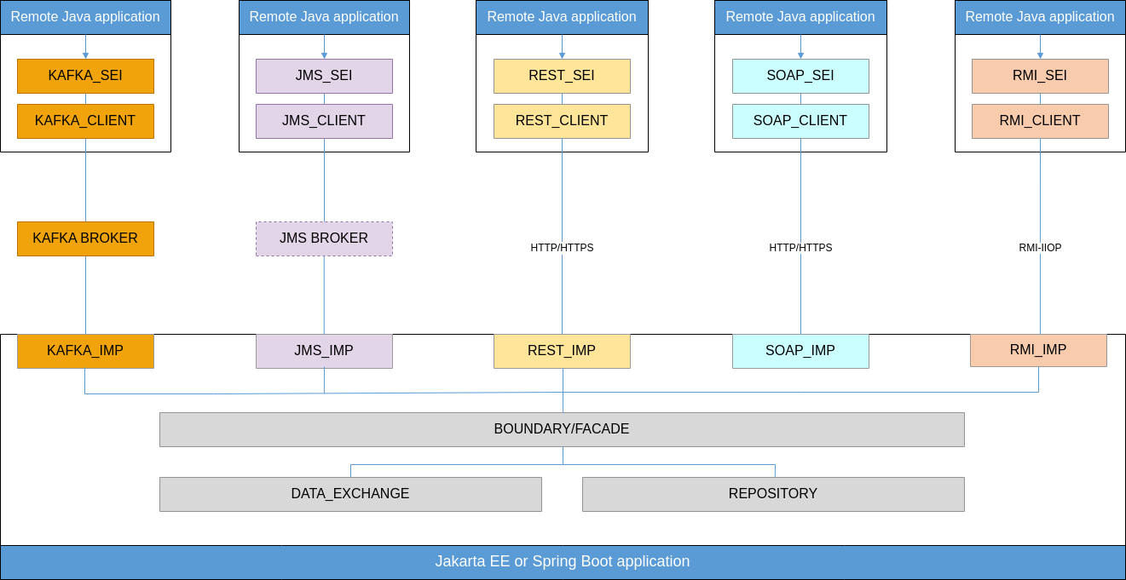Integration artifacts
Basically, the *_SEI and *_CLIENT artifacts just provide a convenient way for other Java applications consuming the integration services of our application. In the case of REST, SOAP and KAFKA, it is, of course, possible to invoke our service methods in non-Java applications without being forced to make use of the *_SEI and *_CLIENT artifacts!
Please note, that integration artifacts are not contained in the default build configuration if the application settings made in previous wizard pages prevent the creation of a given integration technology!
If an artifact is included in another artifact, it will be displayed in column Contained artifacts.
Please note that the initial build configuration regarding contained artifacts cannot be changed manually!
By clicking on button “Finish” the wizard closes and builds the project within the current workspace. After this operation has been finished, a new project should appear in the Package Explorer of Eclipse without compilation errors. It has to be mentioned here that errors and warnings highly depend on compiler preferences of Eclipse!

The CodeCadenza project navigator
In this chapter, we should take a look at a very important component of CodeCadenza that we will refer to continually in subsequent chapters. The plug-in comes with a project tree view that provides important features for different kinds of objects (domain objects, boundary beans, repositories etc.). Throughout this tutorial, the terms project navigator and project tree view are used synonymously!
First, we have to open the view via the “Show view” dialog of Eclipse.

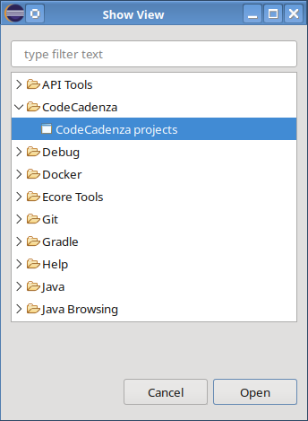Eclipse "Show View" dialog
Once the view has been opened, it will scan all open projects in the current workspace and adds every CodeCadenza project as top-level tree item to the view.

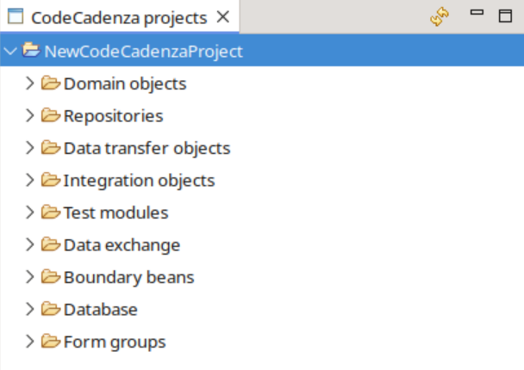CodeCadenza project navigator
By performing the view's toolbar refresh action, the plug-in searches for new CodeCadenza projects, loads the current meta-model into memory and completely rebuilds the tree view.
It's very important to note at this point that the project navigator as well the graphical domain diagram editor (see chapter 8) are completely separated clients that work in parallel against the meta-model resource files. That means that changes being made by a diagram domain editor are not automatically reflected in the project tree view and vice versa. But this easily could lead to model inconsistencies. In order to avoid such critical situations, all tree view actions that might lead to updates of the underlying model resource files are prohibited as long as even one graphical domain editor is open!
Whenever a domain editor save action is performed by the developer, the navigator view will be refreshed automatically!

Maintenance of general project data
We may change project data like name, code and package names at any time after a project has been created successfully. CodeCadenza comes with a respective dialog that can be opened by selecting menu item “Edit” of the corresponding project item in the tree view.

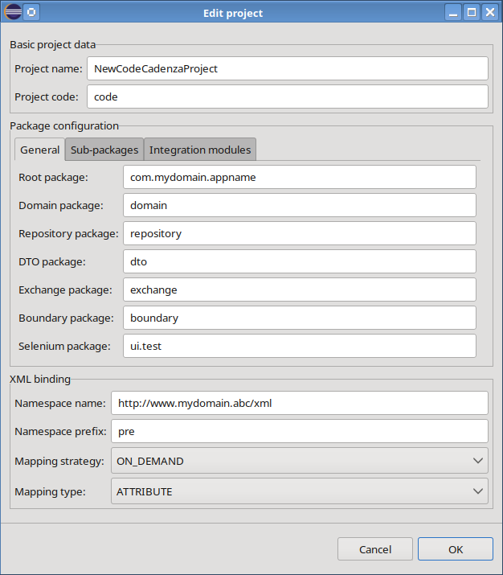Dialog for maintaining project data
Package rename operations are not atomic! If the user cancels the refactoring, the project package structure and its representation in the meta-model will be different, causing subsequent plug-in build operations to fail!

We also use the dialog to create new sub-packages and diagram editors respectively. It is also possible to change XML binding-related data.

Data source settings
Sometimes it might be necessary to test the application on a different target database. The plug-in provides a dialog to change settings like database connection URL, user name, password and name of the data source. It can be opened by selecting the menu item “Edit data source” of the project's top-level item in the tree view navigator.

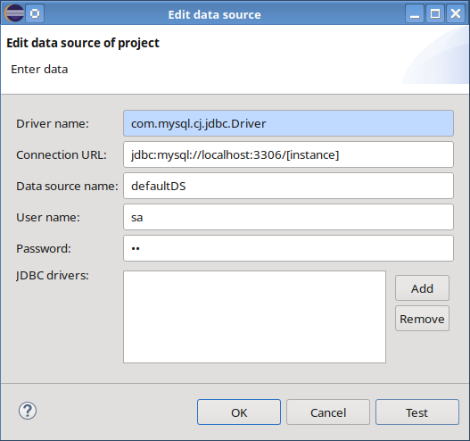Dialog to change data source settings
By pressing Test, we can check if the plug-in is able to connect to the selected database. In this dialog, we are also able to either add new or remove existing JDBC driver libraries.

The persistence unit
In JPA an EntityManager maps a fixed set of classes to a particular database. This set of classes is called a persistence unit. A persistence unit is defined in a persistence.xml file. This file is a required deployment descriptor (see JPA specification) and is located in the META-INF directory of our project (e.g. CRMProject).
CodeCadenza always builds a persistence.xml file when a new project is created. The file contains the name of the persistence unit, the JNDI name of the data source the application should use and a list of generic, vendor-dependent properties.

<persistence xmlns="https://jakarta.ee/xml/ns/persistence"
xmlns:xsi="http://www.w3.org/2001/XMLSchema-instance"
xsi:schemaLocation="https://jakarta.ee/xml/ns/persistence
https://jakarta.ee/xml/ns/persistence/persistence_3_2.xsd" version="3.2">
<persistence-unit name="_default">
<jta-data-source>java:app/jdbc/testDS</jta-data-source>
<properties>
<property name="eclipselink.id-validation" value="NULL"/>
<property name="eclipselink.cache.shared.default" value="false"/>
</properties>
</persistence-unit>
</persistence>

The persistence unit name “_default” must not be changed as some parts of the framework rely on it!
A developer is able to change the persistence.xml file manually. Alternatively, the plug-in provides a dialog to maintain persistence unit properties.

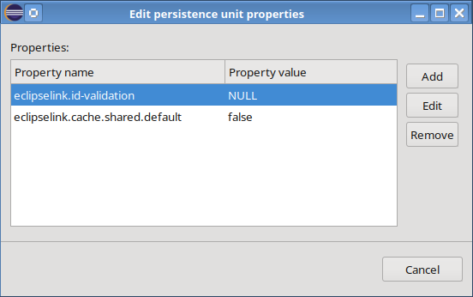Dialog to maintain persistence unit properties
Note that it is the developer's responsibility to provide valid properties and property values! The plug-in will automatically rebuild this file if a developer changes the data source name or the persistence unit properties in the corresponding dialogs.

Model the domain
After the project has been created, we are now able to start modelling our domain. While building the project the plug-in has automatically created a model file (e.g. package-base.xmi) and a diagram file (e.g. package-base.ccd) for every sub-package (e.g. base) in the project folder model. These files represent the persistent containers of our domain model.
Every CodeCadenza project contains another model file (project.xmi) which is responsible for saving further model artifacts (e.g. general project data, package structure, DTOs, repositories and so on).
At this point, it has to be mentioned that it is always possible to change the content of the files manually by opening them via a text editor or the built-in reflective Ecore model editor. Sometimes it might be necessary to do so but care has to be taken as wrong input may damage the integrity of the internal structures. In the end, it might happen that the model is corrupt and cannot be used any longer. Hence, it is always advisable using a source code management system (e.g. Git or Subversion) or creating backups regularly.
In case of a damaged diagram file (*.ccd), it will be hard to recover it manually by using a text editor. A far better approach is to delete the file and to create it again afterwards by selecting the corresponding model file and opening the respective pop-up menu. As soon as we select item “Initialize domain diagram file”, a wizard will be opened to select the name and the location where the file should be saved to. We can use the defaults and click on “Finish”. Now, the wizard will be closed automatically and a diagram containing all existing domain model parts will be opened in the editor area of Eclipse.

Although CodeCadenza maps domain objects to JPA entities, the model editor is not a JPA editor! Therefore, one cannot expect that either the graphical editor or other plug-in components fully support all features of the JPA standard (e.g. composite primary keys)!

Create a domain object
We can create a new domain object just by dragging the “Domain object” item in the palette of the diagram editor of CodeCadenza and drop it on the editor area. As soon as the drop operation is finished, a dialog appears to enter general data concerning the new domain object.
First of all, the dialog expects the name of the new domain object. After we have entered a valid name and the input field loses the focus, further fields (labels, comment and table name) will be initialized with appropriate default values.
The plug-in supports abstract and non-abstract entity domain objects and mapped superclasses. The developer may change the default type (non-abstract) by selecting one of the provided checkbox fields (“Abstract class” or “Mapped-superclass”). The combobox field “Tag”, as well as details concerning inheritance, will be discussed afterwards.

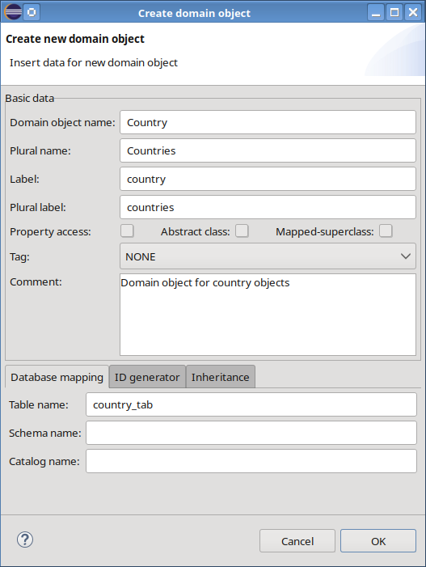Dialog to create a new domain object
A further very important aspect when working with JPA is the id generation type which tells the persistence provider how to generate the primary key for this entity at runtime. The developer selects an id generation type and may enter (depending on the selected type) further data like initial value and block size using the respective controls of tab-page “ID generator”. The number of available items and the default value of the “ID generator type” combobox depends on the selected database vendor! For example, current versions of MySQLTM doesn't support sequence objects. Thus, the respective item isn't available in this list.

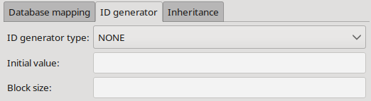Tab-page "ID generator"
Our first domain object should be a Country with id generation type NONE. If we click on the "OK" button, the dialog will be closed and the domain object appears in the graphical editor.

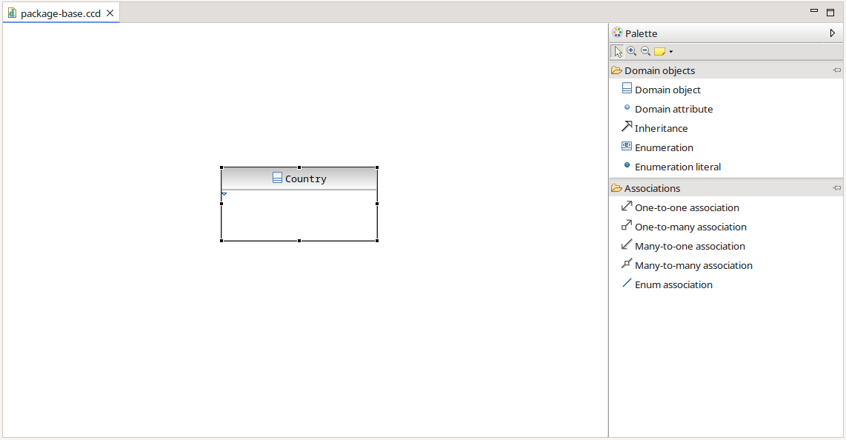Graphical editor with domain object Country

Adding attributes to domain objects
Now, we are ready to add attributes to our newly created domain object Country by dragging a “Domain attribute” item from the editor's palette. The domain attribute must be dropped on the respective domain object. Other places (e.g. editor area) are prohibited by the graphical editor. When the drop operation is finished, a dialog will be opened to enter detail data.
In the first field, a valid attribute name is expected. After we have provided a name, the dialog automatically fills label fields with appropriate values.
In the next field, a developer can insert the data type. The checkbox “Primary key” controls if this attribute should represent the primary key. Note that a JPA entity always expects at least one primary key attribute. It is also important to note that CodeCadenza doesn't support compound primary keys or primary key classes! As long as a domain object doesn't provide a primary key attribute the domain object cannot be created as Java class in the workspace nor it can be the target of an association and it cannot be used as part of other modelling actions. For example, it is not possible to create a new form for this particular domain object!
In CodeCadenza a primary key attribute must be of type String, Long, long, int, Integer or java.util.UUID. Other types are currently not supported!
Let's create a primary key domain attribute for our Country class with name code and type String as shown in the next picture:

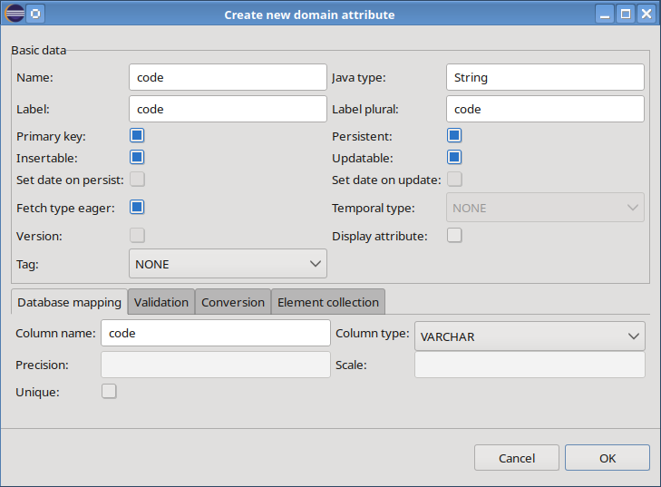Dialog to create new domain attribute code
After pressing the "OK" button, the plug-in automatically generates a Java class in the package base:

@Entity
@Table(name = "country_tab")
@NamedQueries
({
@NamedQuery(name = Country.NQ_DELETE_ALL,
query = "delete from Country a"),
@NamedQuery(name = Country.NQ_DELETE,
query = "delete from Country a where a.code = :code"),
@NamedQuery(name = Country.NQ_GET_ALL,
query = "select a from Country a"),
@NamedQuery(name = Country.NQ_FIND,
query = "select a from Country a where a.code = :code"),
@NamedQuery(name = Country.NQ_CHECK,
query = "select count(a) from Country a where a.code = :code"),
@NamedQuery(name = Country.NQ_COUNT,
query = "select count(a) from Country a"),
})
public class Country {
@Generated
public static final String NQ_DELETE_ALL = "Country.deleteAll";
@Generated
public static final String NQ_GET_ALL = "Country.getAll";
@Generated
public static final String NQ_FIND = "Country.find";
@Generated
public static final String NQ_COUNT = "Country.count";
@Generated
public static final String NQ_CHECK = "Country.check";
@Generated
public static final String NQ_DELETE = "Country.delete";

@Id
@Column(name = "code")
@Generated
private String code;

/**
*Default constructor
*/
@Generated
public Country() {
}

/**
*Constructor using fields
*@param code
*/
@Generated
public Country(String code) {
this.code = code;
}

/**
* @return the code
*/
@NotNull(message = "Field \"code\" must not be null!")
@MaxLength(value = 5, message = "...")
@Generated
public String getCode() {
return this.code;
}

/**
* @param code the code to set.
*/
@Generated
public void setCode(String code) {
this.code = code;
}

/* (non-Javadoc)
* @see java.lang.Object#equals(java.lang.Object)
*/
@Generated
@Override
public boolean equals(Object obj) {
if(this == obj)
return true;

if(obj == null)
return false;

if(getClass() != obj.getClass())
return false;

final var bean = (Country) obj;

if(getCode() == null) {
if(bean.getCode() != null)
return false;
}
else if(!getCode().equals(bean.getCode()))
return false;

return true;
}

/* (non-Javadoc)
* @see java.lang.Object#hashCode()
*/
@Generated
@Override
public int hashCode() {
return getCode().hashCode();
}

/**
* Validate the object before performing an update or persist operation
*/
@PreUpdate
@PrePersist
@Generated
protected void validate() {
final var validator = new BeanValidator(this);
validator.validate();
}
}

Beside of features like proper annotations, a default constructor, a constructor with a primary key attribute, the attributes and their respective getters and setters, there are further artifacts that the generator adds to the class. First of all, a bunch of named queries and suitable name constants are generated.
In many situations (e.g. within the collections framework of Java), it is very important to provide well-implemented hashCode() and equals() methods. Both will be created by the plug-in by using the primary key attribute.
In order to check values of domain attributes, an annotation based entity validation methodology has been added to the CodeCadenza framework. Different validation annotations are provided by the framework to check null-ability, length and even content of a String via regular expressions. The annotations have to be placed on the respective getter methods. The validation itself will be performed by the generated validate() method which is called every time before any persist or update operation is invoked upon this domain object.
Alternatively, the respective annotations of the Jakarta Bean Validation framework (JSR 303) are used if the project was created with this option (see chapter 6)!

Since version 2.0, JPA supports the creation of type-safe queries in combination with a canonical meta-model for entities. CodeCadenza automatically creates a canonical meta-model for all persistent domain objects. The generator recreates this file (e.g. Country_.java) as soon as the developer changes the meta-model of a domain object (e.g. Country) by adding or removing an attribute or an association.

@StaticMetamodel(Country.class)
public class Country {
@Generated
public static volatile SingularAttribute<Country, String> code;

@Generated
public static volatile SingularAttribute<Country, String> name;

}

In some situations, an attribute should not be part of a persistent operation as it represents a combination or calculated result of one or more persistent fields to be transferred to the client (e.g. total amount of a customer order). In order to mark such a “transient” attribute, the checkbox “Persistent” must be unchecked.

The next two checkboxes “Insertable” and “Updatable” define if an attribute is part of an insert or update operation. If an attribute is marked to be not updatable, it cannot be changed by JPA update or merge operations.

Per default, the checkbox fields “Set date on persist” and “Set date on update” are disabled. As soon as a developer selects a type java.util.Date or java.util.GregorianCalendar, both fields will be enabled automatically. In many projects, it is very likely that some date fields should be set by the system without client interaction. Just think of a creation date or the last update time-stamp of a persistent object. If at least one of both checkboxes is selected, the plug-in will generate an entity callback listener that fills the attribute with an appropriate value when the domain object is either persisted or updated. The creationDate attribute is a good example for a field that is insertable but not updatable.

public class CountryCallbackListener {
/**
* Method to be executed before persisting a country object
* @param object the country object
*/
@PrePersist
@Generated
public void doPrePersist(Country object) {
object.setCreationDate(new GregorianCalendar().getTime());
}

/**
* Method to be executed before merging a country object
* @param object the country object
*/
@PreUpdate
@Generated
public void doPreUpdate(Country object) {
}
}

Especially for attributes of type java.util.Date or java.util.GregorianCalendar JPA defines a further attribute setting in order to select if the date value represents a date, a time or a time-stamp. If the user selects an aforementioned type, the combobox “Temporal type” will be enabled.

When the entity manager attaches an entity bean to the persistence context, all attributes are initialized with their respective values loaded from the database. In JPA this is called eager loading. There might be situations (e.g. handling blob-fields) where one or more attributes should be loaded on demand only. This is also known as lazy-loading which can be enabled by deselecting the checkbox “Fetch type eager”. Keep in mind that the JPA specification (Version 1.0 and 2.0) states that a persistence provider is not forced to pay attention to this setting as those fields might be loaded eagerly even if they are annotated with @Basic (fetch=FetchType.LAZY).

The optimistic locking capability of JPA offers a great opportunity to protect entity beans against concurrent modifications. The term optimistic locking means that we are optimistic that concurrent modifications on an entity don't happen very often. The opposite of this pattern is called pessimistic locking where an entity bean has a high concurrent write contention.
To enable optimistic locking in JPA an entity bean needs an attribute that is annotated with @Version. This can be achieved by adding a new attribute of type int, Integer, long or Long and selecting field “Version”.

In many cases, a domain object represents a target of a domain association (see chapter 8.4). When generating the client and other artifacts, CodeCadenza is not aware what attribute should be used as a visual representation of the referenced domain object. If no further information is provided, CodeCadenza will always take the primary key attribute for that purpose. This default behaviour can be overwritten by selecting the field “Display attribute”. If we choose this option, the respective field will be used in order to represent an instance of a domain object to the end user.
As an example, think of a simple client form for a given domain object that references another domain object. To keep the things simple, we assume that the referenced domain object can be selected by a combobox. If no display attribute for the referenced domain object is selected, the items might be filled with auto-generated numbers of the referenced domain object's primary key field. But with a display attribute in place the items of the combobox will provide a much more meaningful interpretation of the objects that are added to that form field.
If the checkbox “Display attribute” is selected, the checkbox “Unique” is selected automatically. In most cases, it makes sense that this attribute is also unique. But the developer is also able to create non-unique display attributes! Display attributes must be always of type String! It is not possible to define more than one display attribute in an inheritance hierarchy!

The field “Tag” will be discussed in later chapters.

One of our fields may represent an image or the text of a large document. The @Lob annotation is used to map these large object types. The corresponding checkbox “Lob” must be selected to create such an attribute that must be of type byte[] or Byte[]. Although it is not guaranteed by the persistence provider to initialize such fields on demand only, it is probably best to mark the fetch type as lazy, since you usually won't access these large objects very often when interacting with the entity bean.

The next fields in tab-page “Database mapping” are used to enter database-related information. After entering the attribute name, the “Column name” field will be filled with an appropriate default value (e.g. attribute name creationDate will be converted to creation_date).
By entering or selecting the attribute type the combobox “Column type” will be filled with supported database column types of the selected database vendor.
Some database column types may require a length attribute that can be entered into the “Length” field.
Precision is the number of digits in a number. The scale is the number of digits to the right of the decimal point in a number. A developer can use the fields “Sale” and “Precision” to specify these values.
A domain attribute may be selected to be unique by utilizing field “Unique”.

As the name implies, the tab-page “Validation” is used to enter validation settings on field level.

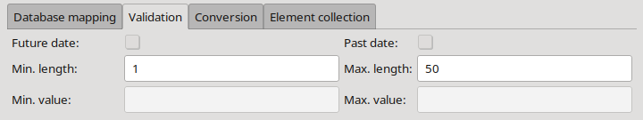Tab-page "Validation"
The “Future date” and “Past date” fields are prohibited for all types except for java.util.Date and java.util.GregorianCalendar. If enabled, the field validation processor checks if the respective value is in past or future (depending on the selection made) and raises an exception if the validation fails.
In order to specify the minimum and maximum length of an attribute, the fields “Min. length” and “Max. length” can be used.
The developer defines the maximum and minimum value of an attribute in the “Min. value” and “Max. value” fields. For example, the age attribute of a human being domain object can be easily supplied with a constraint that the minimum value is 0 and the maximum value is 130. The following code snippet demonstrates the result of our definition:

@MinIntegerValue(value=0,message="Field \"age\" (rest omitted)")
@MaxIntegerValue(value=130,message="Field \"age\" (rest omitted)")
@Generated
public int getAge() {
return this.age;
}

Another powerful kind of validation represents the adoption of regular expressions that can be maintained in field “Regular expression”.
“Nullable” is the last field in that dialog and defines if an attribute may be null! This setting is not supported for primitive types (e.g. int)!

For fields of type String it is often desirable to remove leading or trailing whitespace characters before saving them in the database. This behaviour can be controlled using the corresponding field in tab-page “Conversion”. Furthermore, it is possible that a String will be automatically converted to upper-case or lower-case. For all other mapping types these fields are always disabled! If one of the checkboxes is selected the generator will add respective conversion code in boundary, facade, integration and data exchange methods.

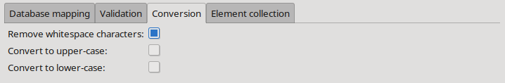Tab-page "Conversion"
Usually, exactly one value is stored in an attribute. If necessary to store multiple values in a list, the attribute can be configured accordingly in the "Element collection" tab. To do this, select either the value LIST or SET in the "Collection type" field. Subsequently, it can be selected whether the corresponding values should be stored in a separate table (choice TABLE) or in a string (choice CONVERTER). When selecting TABLE, there is also the option to override the suggested table name in the "Collection table name" field.

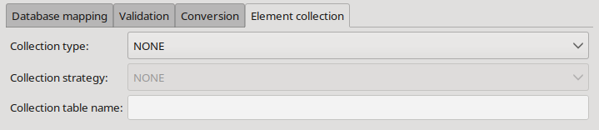Tab-page "Element collection"
The following code snippet shows the declaration of an element collection that uses type SET in combination with the TABLE strategy:

@ElementCollection
@CollectionTable(name = "nicknames_tab",
joinColumns = @JoinColumn(name = "id"))
@Column(name = "nickname")
@Generated
private Set<String> nicknames = new HashSet<>();

Alternatively, the values could also be stored in a database column with a type that can be mapped to a String. In this case, CodeCadenza offers a converter for all supported data types that convert the value list into a String and vice versa:

@Column(name = "nicknames", nullable = true)
@Convert(converter = StringListToStringConverter.class)
@Generated
private List<String> nicknames = new ArrayList<>();

The question arises as to which strategy to choose. In general, the CONVERTER strategy makes sense when the number of elements is manageable, the maximum length constraint of the corresponding column is unlikely to be exceeded, and filtering on this field is definitely not necessary.

Limitations:

- Element collections cannot be used for filtering data (e.g. in a generated view or grid panel).
- The types boolean or byte[] cannot be used for an element collection.
- Element collections that use the CONVERTER strategy are not supported for EclipseLink as it uses custom annotations for the conversion of a string to a list.
- The types char and java.util.GregorianCalendar are not supported when using EclipseLink. Internally, the persistence provider stores the list items with a different type which can lead to ClassCastExceptions.

Create an enumeration
Since version 5, Java supports the enum type. These types usually consist of a fixed set of constants. Common examples include compass directions, days of the week or states of a product.
We want to add an enum to our domain model by dragging an “Enumeration” element from the palette onto the editor area. After we have dropped the enum, a dialog appears where we have to enter the type name and a comment.

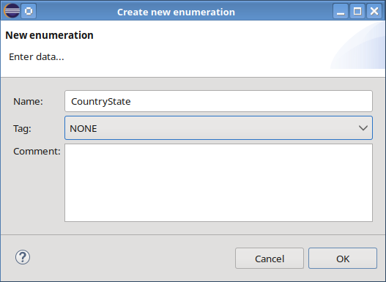Dialog for creating a new enumeration
The enumeration is now ready for adding some literals to it. Again we go to the editor's palette and drag some “Enumeration literal” elements that we afterwards drop on the newly created enum. In a dialog we are requested to enter a valid literal name (e.g. NO_RESTRICTION, EXPORT_RESTRICTION, IMPORT_RESTRICTION).

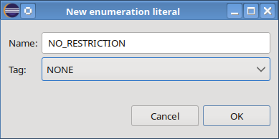Dialog for creating a new literal
The generated source code is very simple:

public enum CountryState {
NO_RESTRICTION, EXPORT_RESTRICTION, IMPORT_RESTRICTION;
}

In order to add new attribute countryState that makes use of this type, we have to draw an “Enum association” from the domain object Country to CountryState. As soon as we finish this operation, we are requested to enter the name of the new attribute. Note that associations of this kind are supported only from a domain object to an enum. The reverse direction wouldn't make sense and is not possible. The term association refers to the connection line between the domain object and the enumeration. However, the type Country just gets a new attribute:

@Enumerated(EnumType.STRING)
@Basic(optional = false, fetch = FetchType.LAZY)
@Column(name = "country_state", nullable = false, updatable = true, insertable = true)
@Generated
private CountryState countryState;

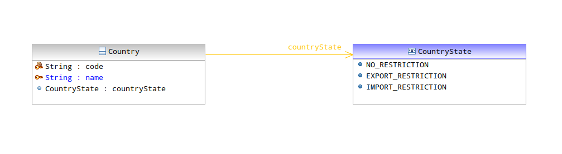Enumeration in the graphical editor

Domain object associations
In order to create complex models, we need to be able to create relationships between our domain model classes. At the moment the plug-in supports four different kinds of associations that all have a respective counterpart in JPA:

The many-to-one association
Many-to-one relationships are necessary when many entity beans reference a single entity bean, but the referenced entity bean is unaware of the relationship. In our domain model, for example, we want to deal with an Address that maintains a relationship with the Country domain object, but the Country entity does not keep track of the addresses for which it is used. This kind of association is called a unidirectional association.
A many-to-one association must be created by selecting a “Many-to-one association” element from the editor's palette. After that, we just can draw a connection line from the domain object that represents the owner of the association (Address) to the target domain object (Country). A dialog to enter further information appears:

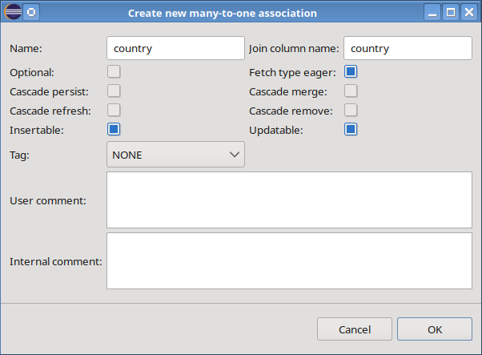Dialog to create a new many-to-one association
Beside of attribute and column name, the user is able to select if this association is optional. If we select that this association is optional, it will be possible to have Address objects without referencing a Country.
As we have discussed earlier, JPA supports loading data on demand. In order to enable lazy-loading for this association, we would have to deselect the “Fetch type eager” checkbox.
At first glance, it seems advisable to enable lazy-loading for every many-to-one association. Keep in mind that this could lead to severe consequences concerning heap-space and performance as the JPA provider might create special proxy objects for every entity bean instance additionally to load the referenced entity bean on the reverse side on demand.
The next four checkbox fields are used to control persistent cascade options. Please take a look at the JPA specification for details of cascading operations.
“Insertable” and “Updatable” define if an association is able to be part of persist and update operations. An association that is marked to be insertable but not updatable can be set when the entity bean, the association belongs to, is persisted. In subsequent update or merge operations, the association value cannot be changed any longer.
The field “User comment” is used to create a tooltip text when generating respective client forms (see chapter 11). The field “Internal comment” is used for documentation purpose only.

In the domain diagram, these associations have an arrow at the target. The cardinality (here 1) is also displayed. In the case of an optional association the cardinality would be 0..1!

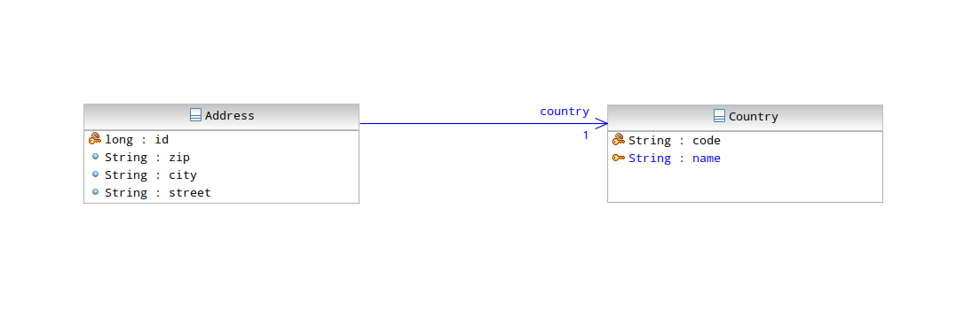Domain diagram with a many-to-one association
CodeCadenza adds following source code to our Address class:

@ManyToOne(fetch = FetchType.EAGER, optional = false)
@JoinColumn(name="country",referencedColumnName="code",nullable=false)
@Generated
private Country country;

/**
* @return the country
*/
@NotNull(message = "Field \"country\" must not be null!")
@Generated
public Country getCountry() {
return this.country;
}

/**
* @param country the country to set.
*/
@Generated
public void setCountry(Country country) {
this.country = country;
}

The many-to-many association
Many-to-many relationships occur when many beans maintain a collection-based relationship property with another bean, and each bean referenced in the collection maintains a collection-based relationship property back to the aggregation beans.
As an example, let's suppose that our model needs a Customer domain object which should provide a collection of Country objects that belong to a particular Customer.
A many-to-many association must be created by selecting a “Many-to-many association” element from the editor's palette. After that, we just can draw a connection line from the domain object that represents the owner of the association (Customer) to the target domain object (Country). A dialog to enter further settings appears:

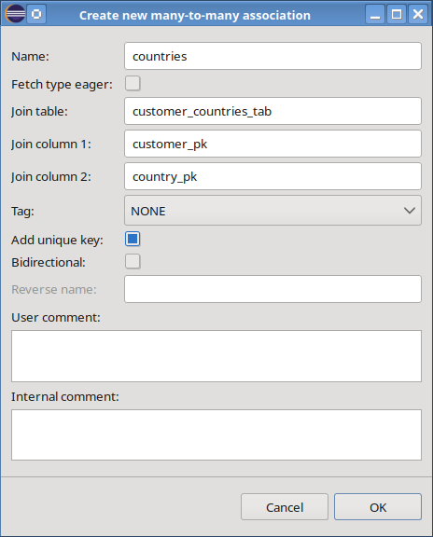Dialog for creating a many-to-many association
We have to insert a name for the collection-based attribute and a fetch type can be selected. In contrast to the many-to-one association, it is possible to mark this kind of association as bidirectional. If we do so, the reverse name must be specified and a collection-based attribute to the Country class will be added also. But the owner of the association will be still Customer.
From a database perspective, a many-to-many association is mapped to a join table (in our case customer_countries_tab) that contains two columns (customer_pk and country_pk) that in turn hold the respective primary key values of the owner and the target table. This join table has no primary key but we can add a unique key composed of both columns by selecting “Add unique key”. This can be helpful if our application shouldn't allow saving the same (Customer/Country) combination more than once.
The plug-in adds following source code to the Customer class:

@ManyToMany(fetch = FetchType.LAZY)
@JoinTable(name = "customer_countries_tab",
joinColumns = {@JoinColumn(name = "customer_pk") },
inverseJoinColumns = { @JoinColumn(name = "country_pk")})
@Generated
private Collection<Country> countries = new ArrayList<Country>();

/**
* @return the countries
*/
@Generated
public Collection<Country> getCountries() {
return this.countries;
}

/**
* @param countries the countries
*/
@Generated
public void setCountries(Collection<Country> countries) {
this.countries = countries;
}

The following picture illustrates a unidirectional many-to-many association in the graphical domain editor. The cardinality of a many-to-many association drawn in the graphical domain editor is always 0..*!

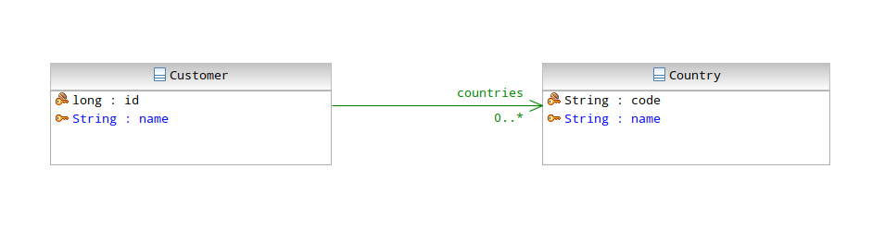Many-to-many association in the graphical editor

The one-to-one association
An example of a one-to-one relationship is one between a Person domain object and an Address domain object. In this example, each Person has exactly one Address, and each Address belongs to exactly one Person.

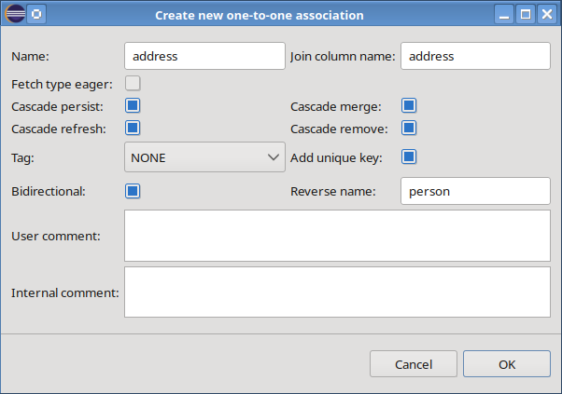Dialog for creating a new one-to-one association
In the dialog we can enter the name of the attribute and the name of the database column. Furthermore, the fetch type can be specified.
The checkbox fields for all cascade operations are selected by default as it is very advisable that CascadeType.ALL is used always within the CodeCadenza framework when dealing with one-to-one associations.
By default, a one-to-one association is bidirectional and the “Reverse name” field is filled with an appropriate default value.
The plug-in adds following source code to the Person class:

@OneToOne(fetch=FetchType.LAZY,optional=false,cascade={CascadeType.ALL})
@JoinColumn(name="address",referencedColumnName="id",nullable=false)
@Generated
private Address address;

/**
* @return the address
*/
@NotNull(message = "Field \"address\" must not be null!")
@Generated
public Address getAddress() {
return this.address;
}

/**
* @param address the address to set.
*/
@Generated
public void setAddress(Address address) {
this.address = address;
}

As we have defined that this association should be bidirectional the Address class has been changed also:

@OneToOne(mappedBy = "address")
@Generated
private Person person;

/**
* @return the person
*/
@Generated
public Person getPerson() {
return this.person;
}

/**
* @param person the person to set.
*/
@Generated
public void setPerson(Person person) {
this.person = person;
}

The domain diagram may look like this:

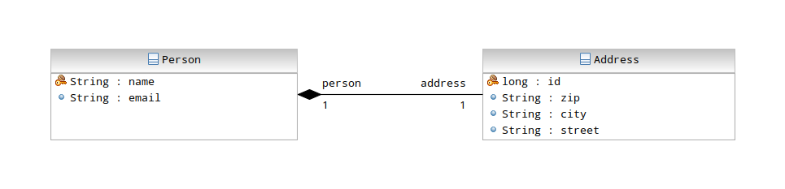Domain diagram with a one-to-one association
In the given example the association is bidirectional. Thus, the arrow at the association end will be omitted and both ends contain a label with the corresponding property name. The cardinality of a non-optional one-to-one association is 1! The association represents a composition and thus, a black diamond is shown on the owning side. This means that an Address usually cannot exist without a Person. If the association was optional, the diamond would have a white background colour. In UML, this kind of association is called an aggregation.

The one-to-many association
There is another way of domain objects maintaining relationships with multiplicity. For example, a Person may have relationships with many Phones, each of which represents a phone number. In contrast to many-to-many relationships, where one Phone could be shared among different Person domain objects, in this configuration, the Phone belongs to one and only one Person.
A one-to-many association must be created by selecting a “One-to-many association” element from the editor's palette. After that, we just can draw a connection line from the domain object that represents the owner of the association (Person) to the target domain object (Phone). A dialog to enter further information appears:

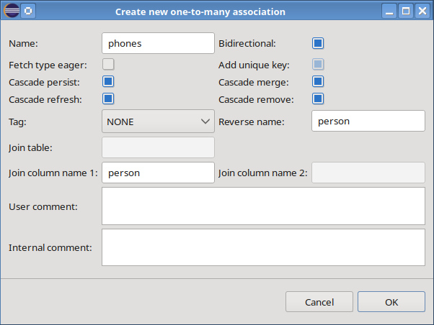Dialog for creating a new one-to-many association
We have to insert a name for the collection-based attribute and the fetch type can be chosen. The cascade operations may be set in the following fields. By default, the one-to-many association is bidirectional. By deselecting the checkbox “Bidirectional”, a unidirectional one-to-many association can be created. In this case, a join table is necessary to map this association in the database. The fields “Join table”, “Join column name 1” and “Join column name 2” are filled with appropriate default values and are used when creating this table in the database. In addition, the field “Add unique key” controls whether a unique key on the second join column should be added so that the database prevents the same target object from being referenced more than once!

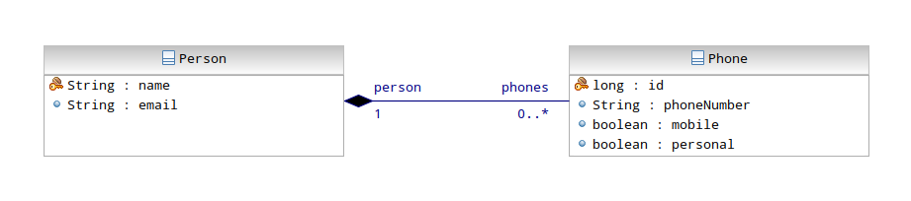Domain diagram with a one-to-many association
The cardinality of the target side is always 0..*! The cardinality of the owning side is either 1 or 0..1 if, for example, a Phone object can exist without referencing a Person. The association is usually displayed as a composition. It is displayed as an aggregation if the association is either unidirectional or if the reverse side is optional.

The generated source code in the Person class looks like this:

@OneToMany
(
targetEntity = Phone.class, mappedBy = "person",
fetch = FetchType.LAZY, cascade = { CascadeType.ALL }
)
@Generated
private Collection<Phone> phones = new ArrayList<Phone>();

/**
* @return the phones
*/
@Generated
public Collection<Phone> getPhones() {
return this.phones;
}

/**
* @param phones the phones
*/
@Generated
public void setPhones(Collection<Phone> phones) {
this.phones = phones;
}

Because of the bidirectional nature of this association further source code has been added to the Phone class:

@ManyToOne(fetch=FetchType.LAZY,optional=false)
@JoinColumn(name="person",referencedColumnName="name",nullable=false)
@Generated
private Person person;

/**
* @return the person
*/
@NotNull(message = "Field \"person\" must not be null!")
@Generated
public Person getPerson() {
return this.person;
}

/**
* @param person the person to set.
*/
@Generated
public void setPerson(Person person) {
this.person = person;
}

References to domain objects in other sub-packages
So far, all our domain objects and enumerations were placed on the same diagram editor. From a structural perspective, all those objects were put into the same sub-package (in our case base). In a real-world scenario, there might be many different sub-packages in order to group domain objects belonging together. It is also very likely that some domain objects must be referenced in other packages. This chapter describes how this case is handled in CodeCadenza.
Let's assume that we have to model a Customer domain object in the initially created sub-package cust. The Customer entity should provide a reference to a Country that resides in the base package. If it doesn't exist yet, we first have to create the domain diagram editor by selecting the respective model file (package-cust.xmi) and perform the “Initialize domain diagram file” action.

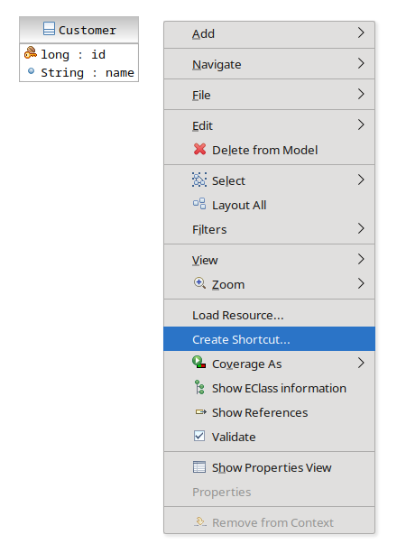Context-menu to create a shortcut

As soon as the Customer entity including a primary key attribute has been created, we may add a reference or shortcut to Country from the sub-package base. This can be achieved by opening the diagram's context-menu. If we select “Create Shortcut”, a dialog will appear to select the domain object or enumeration that should be referenced in this editor.

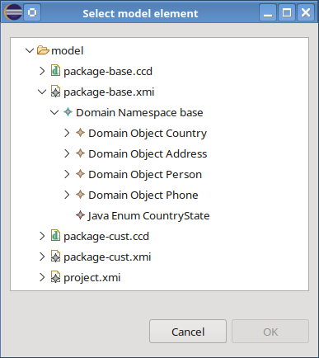Dialog to select a domain object to be referenced
If we press the "OK" button, the shortcut will be created and displayed in the graphical editor. Referenced domain objects are supplied with a small arrow-icon on the lower left corner in order to indicate that this object doesn't belong to this package originally.

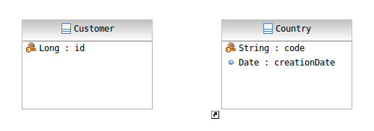Diagram editor with a referenced domain object

Inheritance
In this chapter, we want to discuss the inheritance features the plug-in provides. Although inheritance is one of the key concepts of object-oriented design, care has to be taken as there is no equivalent concept in the relational database world. Hence, if we rely too strongly on that design principle we might face performance problems afterwards. It is also important to note that inheritance must be specified always when a new domain object is created. A domain object cannot be selected to be the root of a hierarchy afterwards!
Currently, the plug-in supports three different inheritance types:

Single table per class
In the single table per class hierarchy mapping strategy one database table contains columns for all fields of all classes of a given domain object hierarchy.
We want to modify our existing model in order to demonstrate creating a simple hierarchy based on an AbstractPerson that should provide basic attributes for all further sub-classes. As mentioned earlier, CodeCadenza doesn't support this kind of re-factoring out-of-the-box. The first step is to delete all references to and from the existing Person entity. After that, we create the new domain object AbstractPerson as described earlier. As the name already makes clear, our base class should be abstract. To do so, we have to select field “Abstract class” in the new domain object dialog. Moreover, the value SINGLE_TABLE must be selected in the “Inheritance” combobox.
As mentioned earlier, relational databases don't natively support inheritance (impedance mismatch). In JPA this problem is solved by introducing a so-called discriminator column that should be added to every table that represents the root of a hierarchy. Later on, the persistence provider will save a discriminator value, which depends on the real type of the entity to be persisted, into this column. Therefore, we now have to insert additional information concerning the discriminator column. Beside of the column name, we must select the type (INTEGER, STRING or CHARACTER) and an appropriate discriminator value. Note that in any case, the dialog expects a discriminator value, even for abstract classes!

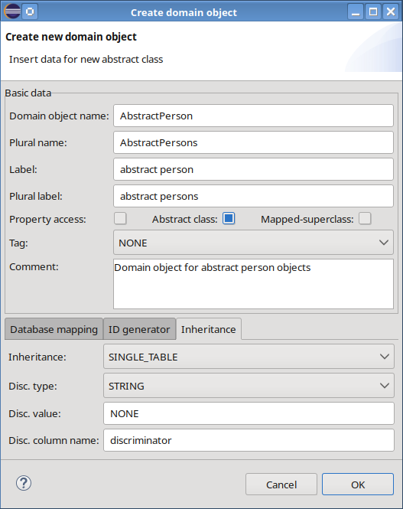Dialog to create a new abstract root domain object
Afterwards, attributes and associations can be added to our newly created base class. The plug-in generates following source code (bold lines are responsible for inheritance):

@Entity
@Table(name = "person_tab")
@Inheritance(strategy = InheritanceType.SINGLE_TABLE)
@DiscriminatorColumn(name = "discriminator", discriminatorType = DiscriminatorType.STRING)
@DiscriminatorValue("NONE")
public class AbstractPerson

We now create some sub-classes that inherit from AbstractPerson. For example, let's define an Employee that derives from AbstractPerson. We simply create the Employee by dragging a “Domain object” from the editor's palette. As Employee doesn't represent the root of the hierarchy we may omit inheritance information like discriminator type, value and column name. In order to derive Employee from AbstractPerson, we have to select an “Inheritance” element from the palette and draw a connection line from Employee to AbstractPerson. An input dialog will request a discriminator value (e.g. “EMP”) for the Employee sub-class.

@Entity
@DiscriminatorValue("EMP")
public class Employee extends AbstractPerson

Next picture illustrates a sample model including a complex hierarchy:

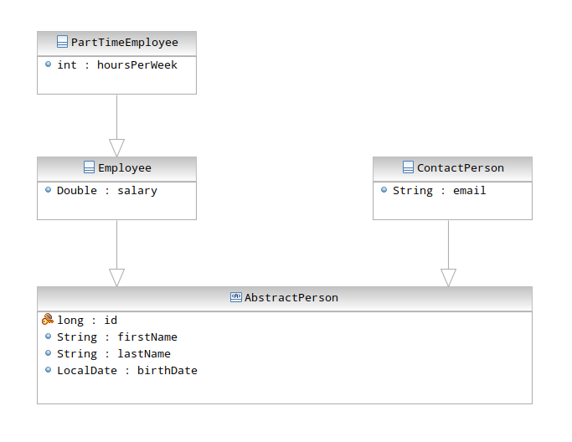Complex inheritance hierarchy

Table per concrete class hierarchy
In the table per concrete class strategy, a database table is defined for each concrete class in the hierarchy. Each table has columns representing its properties and all properties of any superclass. The JPA specification (Version 1.0 and 2.0) states that this inheritance strategy is not mandatory to be implemented by a persistence provider. Thus, the plug-in doesn't support it at all.

Table per sub-class
In the table per sub-class strategy, each sub-class possesses its own table, but this table contains only the properties that are defined on that particular class. In other words, it is similar to the table per class strategy, except that the schema is normalized. This is also called the JOINED strategy and is fully supported by CodeCadenza. The only difference while creating a root class in contrast to the single table strategy is that the type JOINED in field “Inheritance” in the new domain object dialog must be selected.

Non-entity base class
Sometimes it is necessary to inherit from a non-entity superclass also known as mapped-superclass that can be created like any other domain object by utilizing the plug-in's new domain object dialog. Only the field “Mapped-superclass” must be selected to mark a domain object as a mapped-superclass. Note that CodeCadenza currently doesn't support those classes to be source or target for any kind of association! Because of this limitation, it might be interesting for base classes (e. g. BaseEntity see next picture) that just contain technical or system-specific properties (primary key attribute, creation date, last update, version) that are commonly used by a great number of domain objects within a project.

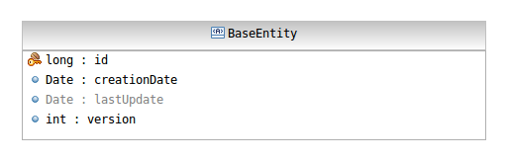Mapped-superclass in the diagram editor

Property sheets
In order to get detailed information about domain objects, attributes and associations, the graphical editor provides property sheets. Every time a user selects an object in the editor area the property view of Eclipse refreshes its state and displays corresponding data.

Property sheets for domain objects
In case of domain objects, the respective property sheet contains three sections:
The “Standard properties” section contains label and comment fields that may be changed after a domain object has been created.

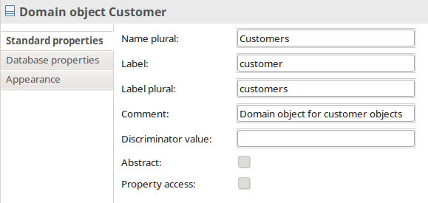Standard properties of a domain object
The next section “Database properties” displays columns, indexes, primary key and foreign keys that belong to the selected domain object's database table.

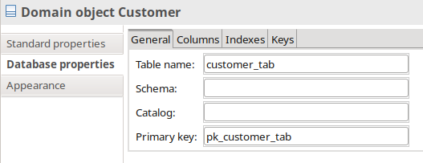Tab-page containing general table information
The tab-page “Columns” shows all table columns:

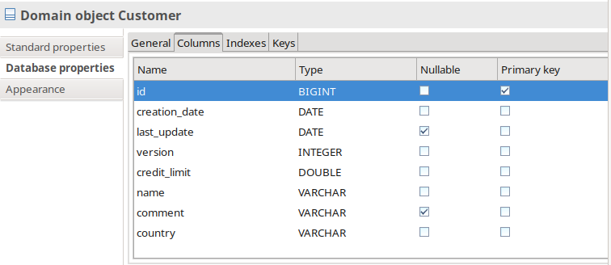Tab-page for table columns
By performing a double-click on a selected row or pressing menu item “Edit” a dialog is opened that allows a developer to change database column data:

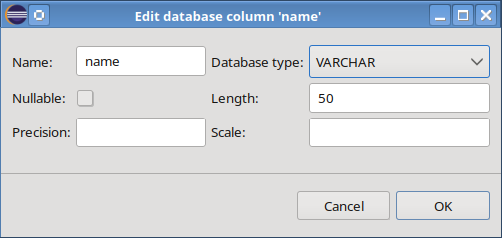Dialog to change column data
The next tab-page contains all indexes:

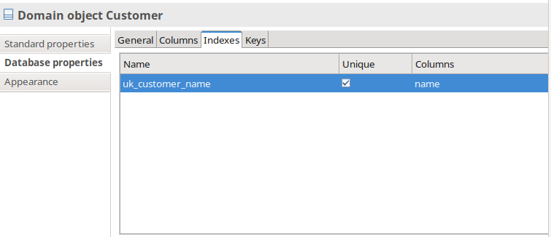Tab-page containing indexes
This section is especially useful in order to create unique keys and indexes manually. For example, our Customer object should contain a unique key that is composed of the name. We simply have to select menu item “Add unique key” that opens a dialog which expects a name for the unique key and the columns to be added to it.

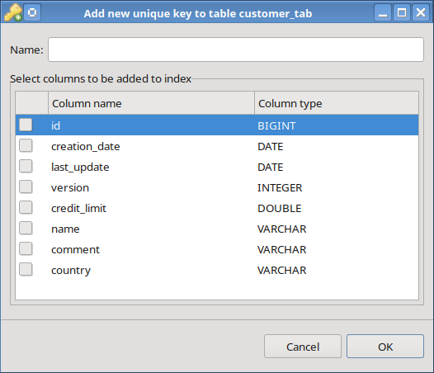Dialog for creating a new unique key
After saving the changes, it is always advisable to synchronize the repositories in order to let CodeCadenza automatically create additional finder- and check-methods!

The tab-page “Keys” contains all foreign keys of the selected database table:

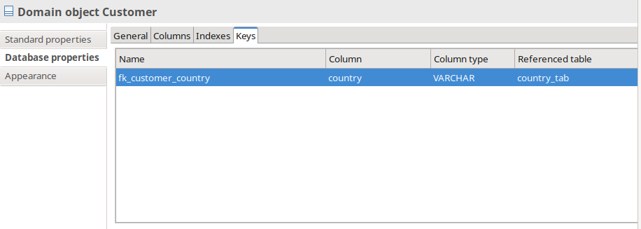Tab-page with foreign keys
The grid component provides a menu with items for either deleting or renaming an existing foreign key.
All elements of section “Appearance” are disabled for all kinds of objects in the graphical editor of CodeCadenza!

Property sheets for domain attributes
The property sheet for domain attributes also contains four sections. Apart from name and type nearly all properties of a domain object attribute may be changed in the “Standard properties” section.

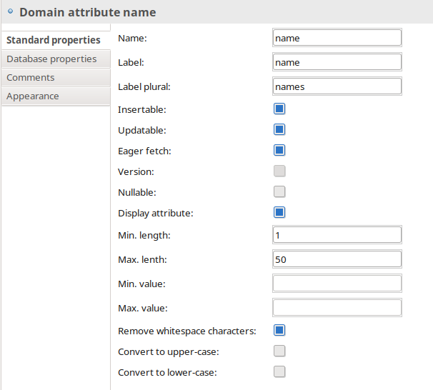Standard properties of a domain attribute

The section “Database properties” displays all column details of the selected domain attribute and doesn't contain editable fields.

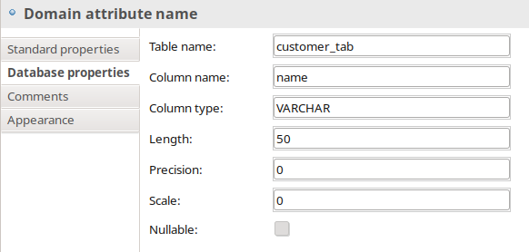Database-related information of a selected attribute
In the “Comments” section it is possible to enter internal and user comments. Whereas internal comments are only used for documentation purpose the user comments come into play when generating client forms (see chapter 11). If the user comment field for an attribute contains a text, it will be used later on to add a tooltip text to a form field that is mapped to the corresponding attribute.

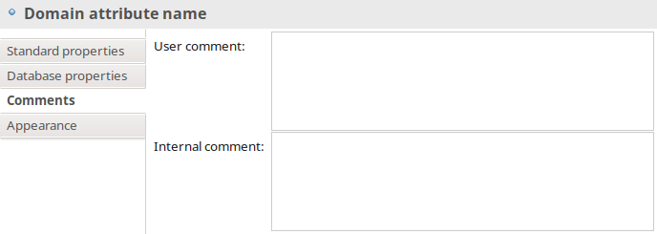Domain attribute comments

Property sheets for domain associations
The property sheet for domain associations provides four sections also. The “Database properties” and “Standard properties” sections are slightly different depending on the association's type. Database-related fields are always read-only.

For example, we may change the selected association's cascade-types and the fetch type. Furthermore, a user is able to change the optional, insertable and updatable flags.

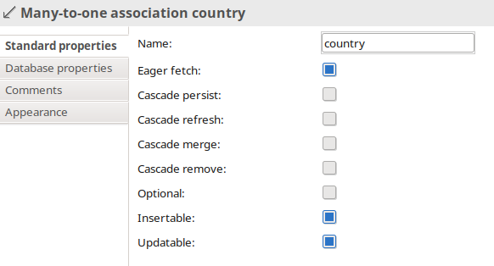Standard properties of a many-to-one association
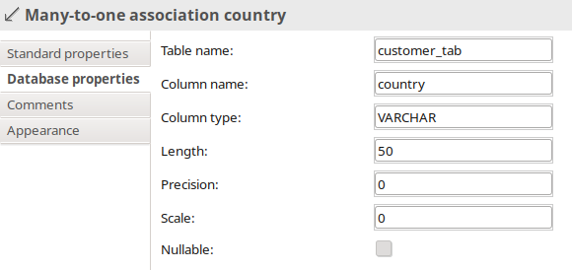Database properties of a many-to-one association
In the “Comments” section it is possible to enter an internal and a user comment. As with domain attributes the user comment is used to generate tooltip texts for respective form fields.

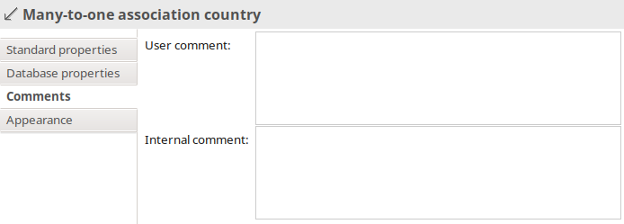Comments for a many-to-one association

Tagging
When modelling a domain for a specific project, we basically define the technical structure of our application. Beside of that, it would make sense to enhance the domain model with system-related information. Just think of the problem that we are already able to model a User entity, but how should the framework be aware of that in order to integrate this entity seamlessly into the authorization and authentication services?
In CodeCadenza the problem is solved by a technique that is called Tagging. In other words, the framework provides a facility to add further information to entities, attributes and associations in order to build a bridge between the domain model and system-related services.
Although the plug-in supports Tagging for authorization, authentication, mandating, logging and documents at the moment, it is very likely that there will be more in future versions of CodeCadenza.
The entry point for Tagging is always the domain object or enumeration. Note that a domain object must be tagged always when it is created. The respective dialog provides a field “Tag”. Performing this operation afterwards is not possible! It has to be mentioned also that Tagging is not supported for abstract classes or mapped superclasses. Moreover, most tags (e.g. USER or ROLE) may be used only once within a project! As soon as we have created a tagged domain object (e.g. User), we may add tagged and untagged attributes and associations just like we would do it with regular entities.

Documents
In a first example, our application should be able to handle physical files. With CodeCadenza it is really easy to integrate handling of files seamlessly. We create a domain object Attachment that is tagged with DOCUMENT.
There are three mandatory attributes that must be created and tagged properly in order to get full support for respective functionality:

Tag | Description | Valid types
DOCUMENT_NAME | Contains the document name. | String
DOCUMENT_SIZE | The physical size of the document. | int, Integer, long, Long
DOCUMENT_REF | Represents the fully qualified path name of the document. When uploading a file, the application moves the file to a predefined repository folder. The path of the file in the repository folder will be stored in this field. | String
DOCUMENT_DATA | Contains the document in a binary form. If a domain object contains an attribute that is tagged with DOCUMENT_DATA, it won't be possible to create an attribute with tag DOCUMENT_REF and vice versa! | byte[], Byte[]

At first glance, after creating the domain object Attachment including all attributes and associations we cannot see great benefits of Tagging. But when defining respective client forms (see chapter 11) CodeCadenza will provide additional form actions that enable a user to upload and download physical files.

Authentication and authorization
The concept of Tagging domain objects is vital in order to easily gain authentication and authorization features for our application.
In real-world projects that have been developed with CodeCadenza, it turned out that security-related parts should be implemented as soon as possible.
The next picture shows the easiest possible domain model that is necessary to utilize security features of the framework.

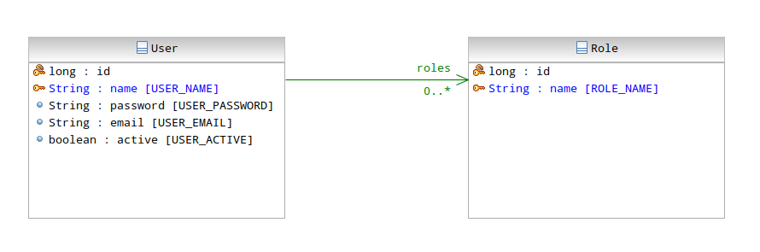Sample domain model for authentication and authorization
The domain object that represents the User must provide at least a unique display attribute for the name, a password, an email address and a flag that determines if the User is active or not. We also need a Role entity with at least a unique display attribute for the name of a role. We must create a tagged (USER_ROLE) many-to-one or many-to-many association that defines the roles that are granted to a user account. Note that all names of tagged domain objects, attributes and associations are arbitrary.

Next, we have to define a special data transfer object that is responsible for exchanging security-related data between application layers. Go to CodeCadenza's project tree view, select the respective project item, open the context-menu and select “Create log-on DTO”. CodeCadenza will perform some checks to validate if the creation of this DTO is possible.
The most important constraints are:

  - Another log-on DTO must not exist.
  - A domain object for security services (see above) must be tagged properly.

Apart from the log-on DTO the plug-in also adds a logOn() method to the boundary of the User entity in order to provide an easy authentication service for the client. As soon as this operation is finished, all client forms will be supplied with security-related source code artifacts when the forms are created or rebuilt. For example, actions will be added to the toolbar of a dialog depending on the roles granted to a user:

IToolBarManager toolbarManager = getViewSite().getActionBars().getToolBarManager();

if(SecurityManager.isCallerInRoles(UserBoundaryService.ROLE_ADMIN))
toolbarManager.add(actionDelete);

if(SecurityManager.isCallerInRoles(UserBoundaryService.ROLE_ADMIN,
UserBoundaryService.ROLE_OPERATOR))
toolbarManager.add(actionCreate);

if(SecurityManager.isCallerInRoles(UserBoundaryService.ROLE_ADMINISTRATOR))
toolbarManager.add(actionUpdate);

By default, the plug-in creates two default roles (ADMINISTRATOR and READONLY) when creating a new project. In most scenarios, these roles are not sufficient enough to cover all different authorization strategies that might be necessary. Thus, it must be possible to add further roles. In order to maintain project specific roles, we have to go to the project tree view, select the respective project item, open the context-menu and select item “Roles”. A dialog appears to create, edit and remove roles.

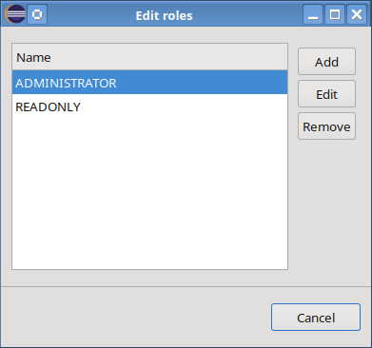Dialog to maintain roles
A role consists of a name and two flags “Administrator” and “Readonly”. If we create a new role and set the flag “Administrator”, this role will be added automatically afterwards when new forms and form actions are created. Therefore, by default, this role will enable all functions of an application to any user this role is granted to. On the other hand, if we create a role and set the flag “Readonly” it will be added automatically afterwards to all forms and form actions that do not change or delete data.

CodeCadenza doesn't rely on this simple authentication and authorization client-side strategy solely. In addition of that, the framework utilizes security features of the application server.
At this point, we don't want to dive too deeply into JAAS (Java Authentication and Authorization Service) which is a standardized security specification all Java application server vendors must implement. Please consult the specification of your vendor how to setup a security domain for your application.

Mandating
In many enterprise applications, there is a demand of storing data for different organizational units, customers or locations (hereinafter referred to as clients) in a shared database. Usually, this is accomplished by defining a table that contains the different clients as table rows. All relevant business objects that are intended to be mandated will be supplied with a foreign key to that table. This allows accurate records being returned for subsequent queries that actually belong to a client.

As with other additional functions (authentication, authorization etc.), CodeCadenza provides a solution to realize such tasks easily.
First, we must tag an appropriate domain object with CLIENT. The two attribute tags CLIENT_ACTIVE and CLIENT_NAME are not used currently but might come into play in future versions.
An essential prerequisite for the use of mandating in CodeCadenza is the definition of the domain objects for user management (see above). The domain object that represents the user (tag USER) must be also supplied with a non-optional many-to-one association to the client domain object. This association must be tagged with CLIENT_REFERENCE.
In other words, every user account must be assigned to a client. An assignment to more than one client is not supported.

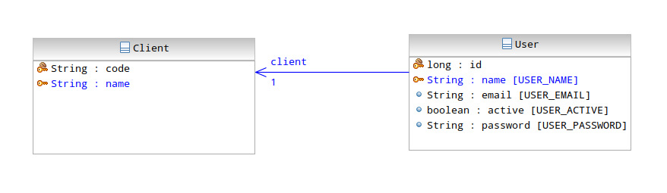Required domain model to use mandating
Now, we can start creating further domain objects. Once we create a many-to-one association, which is tagged with CLIENT_REFERENCE, the domain object is considered to be mandated. However, not all domain objects are equipped with such an association. Typically, there are some objects that are shared by all clients. CodeCadenza also includes a mechanism that can automatically determine a membership to a client. For example, it is sufficient that only the Customer has a reference to the client. The CreditInfo class is then automatically associated to the client of the respective customer. A prerequisite is that an object (in this case CreditInfo) has a direct or indirect (wired via other domain object associations between both objects) and non-optional many-to-one or one-to-one association to a mandated object.

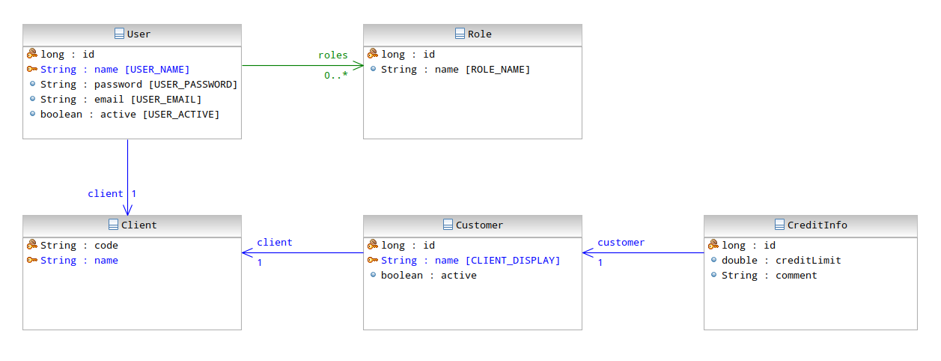Example of an indirectly mandated domain object CreditInfo
Another very important tag concerning mandating represents CLIENT_DISPLAY. In many cases, an application contains mandated master data. This basically prevents the use of a unique display attribute. Otherwise, a client would possibly interfere creating or maintaining data of other clients (e.g. due to duplicate customer names). To circumvent this, the developer can define an attribute of type String and sets the tag CLIENT_DISPLAY. This automatically generates a unique key that consists of the foreign key column to the table that holds the clients and the column of this attribute. For the later use of client dialog fields, the content of this attribute will be taken automatically to be displayed in comboboxes, list of values, proposal text fields and selection lists. If the reference to a client exists only indirectly, it cannot enforce database keys to be generated! The content of that attribute is still used for display purposes in the aforementioned fields, but there is no direct way in order to perform unique checks upon inserted data. This would have to be ensured by manually added queries!

When creating new mandated objects, the additional form field type SELECTION_BY_CLIENT emerges. Those fields will be set automatically by the appropriate log-on DTO attribute in subsequent storage operations.
Hence, this type is very similar to SELECTION_BY_SECURITY_DTO (see page 127).

Also, when using other field types (e.g. proposal text fields, comboboxes etc.) there is an impact when using mandated domain objects. The boundary or facade methods that fetch list data are provided with an additional parameter. This parameter is set automatically also in the user interface and represents the id (primary key field) of the client. In the boundary/facade method itself, this parameter is used to restrict the result set so that the user only receives objects that are assigned to the client he belongs to.

When defining search or list views, the developer may choose whether or not the result set should be restricted automatically. This behaviour is driven by selection list “Data fetch type”. Depending on the selected domain object, the list may contain three different entries. If we select DEFAULT, there is no restriction at all and a user is able to search for all objects that are stored in the database. When selecting USER or CLIENT, an additional parameter is added to the signature of the respective boundary/facade methods and the number of returned objects is limited accordingly.

Logging
If the application runs on a server, we can also create a domain object that contains log entries that are created when accessing boundary/facade methods. CodeCadenza requires creating an enumeration that contains the logging levels. The corresponding domain object for logging needs following tagged attributes:

Tag | Description | Valid types
LOGGING_DURATION | The duration time in milliseconds of the method invocation. | int, Integer, long, Long
LOGGING_STACK_TRACE | The content of the stack trace if the invocation threw an exception. The respective attribute should be nullable! | String
LOGGING_MESSAGE | The message that the logging service has generated for a respective invocation. | String
LOGGING_CLASS_NAME | Contains the class name the method belongs to. | String
LOGGING_METHOD_NAME | The name of the method that has been invoked. | String
LOGGING_DATE | The creation date of the log entry. | Date, GregorianCalendar
LOGGING_HOST_NAME | The name of the physical server where the log entry has been created. This is especially useful if the application is deployed in an application server cluster! | String
LOGGING_LEVEL | Contains the log level. | Tagged enumeration
LOGGING_USER | An optional association to the domain object that is tagged with USER!

The following picture illustrates a sample domain model:

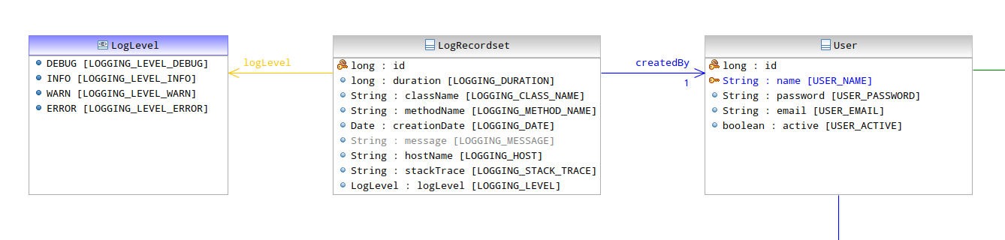Domain model for logging
In addition of that, we must create an implementation of the logging service by executing the project's navigator “Rebuild logging” action.

Saved queries
For users it is very convenient that queries can be saved and restored. In order to provide such functionality for JSF clients, CodeCadenza also uses Tagging. The respective domain object only needs following attributes and associations to be tagged:

Tag | Description | Valid types
SAVEDQUERY_TITLE | The title of the query that is normally provided by the user. | String
SAVEDQUERY_VIEW_NAME | The name of the view form the query is based on (see below) | String
SAVEQUERY_DATA_OBJ | Represents a binary container that holds all information about a query (e.g. filter criteria, sorting...) | byte[], Byte[]
SAVEDQUERY_OWNER | An association to the domain object that is tagged with USER!

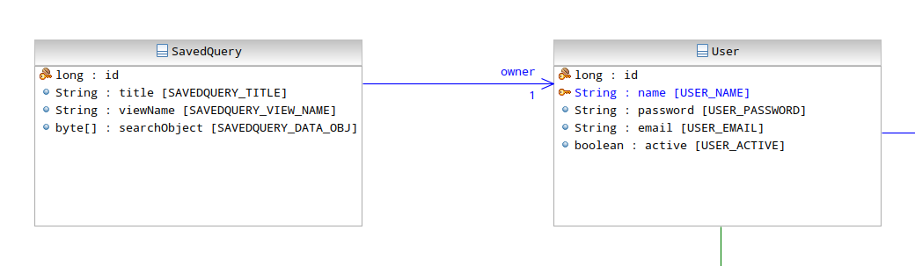Domain model with class UserQuery
The source code of the saved query service must be created by executing the project's navigator “Rebuild saved query service” action.

Reverse Engineering
Beside of creating domain objects via the diagram editor, it is also possible to use an alternative way that is based on the fact that domain objects are tightly bound to database tables. That means that domain objects can be inferred by analysing the tables of a given database. This process is called Reverse Engineering. In order to describe the basic concepts, we start with a small ER model that depicts the tables and their relationships of an existing sample database.

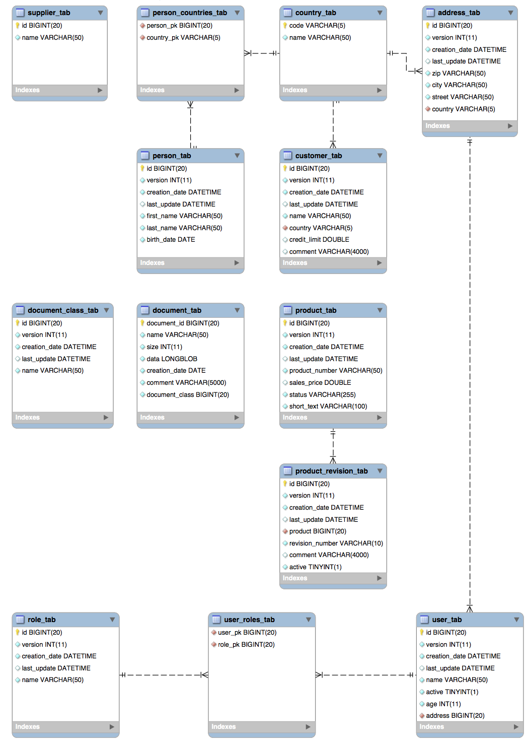Entity relationship diagram of a sample database
Before starting Reverse Engineering it must be checked if the project's data source is configured appropriately (see chapter 7.2)! In the following chapters, we will describe all steps of the process.

Default namespace selection
The context-menu of a dedicated domain namespace in the CodeCadenza project navigator contains an item “Reverse engineering” that opens the Reverse Engineering editor.

Database import
As soon as the editor is visible to the user the editor connects to the target database, reads the database meta-model and infers domain objects, attributes and associations.
In most of the cases, one domain object is created per table. But there are some exceptions to that rule. If a database table doesn't have a primary key, a domain object cannot be inferred! If the primary key consists of more than one column, a domain object cannot be inferred also as CodeCadenza doesn't support compound primary keys. If a database table contains two attributes that both hold a foreign key, the import process assumes that the table represents an association table of a many-to-many association. Every column is converted to a domain attribute. The database column type must be defined within the CodeCadenza project (see page 109). This is necessary as the import process must infer the respective Java type for the domain attribute. If the Java type cannot be determined, the attribute won't be added to the domain object. If the column belongs to a foreign key, a many-to-one association is created instead.
Note that the import process neither finds inheritance hierarchies nor it is possible to define them afterwards!
In case of data that cannot be processed (e.g. illegal or missing primary key, unknown database column type...), a log message is being generated that will be displayed to the user as soon as the operation has finished.
It is even supported that we start a Reverse Engineering process for a project that already contains existing domain objects. In this case, the import process is aware of the existing domain objects and adds new attributes and domain associations to them when necessary. Domain objects that don't exist yet are created as well!

Domain model validation
Every time a domain model has been either created or changed CodeCadenza validates the domain model and generates respective log messages either if new domain objects, associations or attributes have been created or the validation has failed.

Display the results in the Reverse Engineering editor
As soon as the validation process has finished the results of the Reverse Engineering operation are displayed in three different areas.
The “Log statements” area contains a list of all messages that have been generated by the Reverse Engineering process. A log statement has a status (INFO, WARNING, ERROR), a source (IMPORT, VALIDATION) and provides a human-readable message text. It must be noted that the log statement source plays an important role. As long as the log contains at least one WARNING or ERROR statement that has been created by the validation process the domain model cannot be saved. Otherwise, it is very likely that the domain model is inconsistent which must be strictly avoided as subsequent operations (e.g. source code generation) are likely to fail. On the other hand, a WARNING or ERROR import log message doesn't stop the user from saving the domain model.
On the left side of the editor, the “Domain model” tree view contains all domain objects that have been created by the Reverse Engineering process. All new domain objects are added to the namespace that has been selected initially before opening the editor. The “Database model” area displays the imported database meta-model.

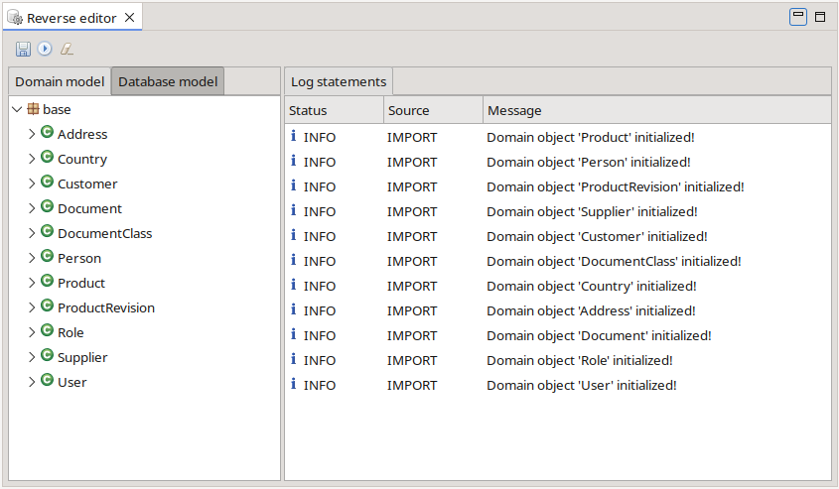Reverse Engineering editor

Adapting the initial domain model
The initial domain model represents a good starting point but in most situations it is likely that we have to change various details in order to get a model that fits our needs.
The namespace the domain object belongs to can be simply changed by dragging the respective tree item to the target namespace. When performing a double-click on the domain object in the tree view, a dialog is opened where further details (e.g. name, label and ID generator type) can be changed.

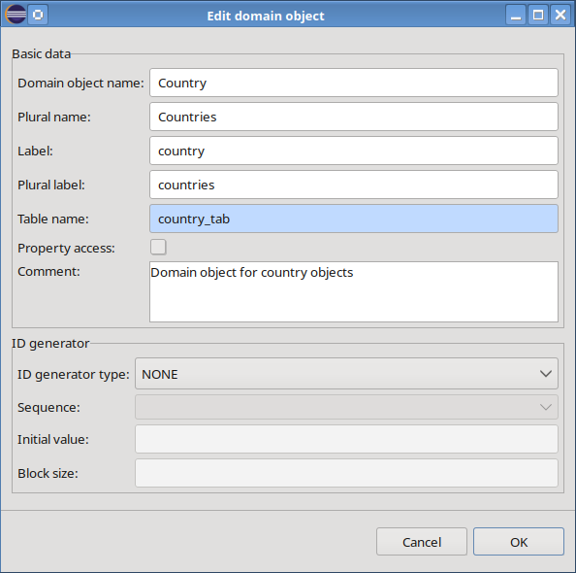Dialog to edit domain object data

The domain object's tree view item also provides a context-menu that in turn contains an item to delete a domain object. But care has to be taken as deleting a domain object will be cascaded through all domain associations that reference the selected domain object!
A domain attribute can be changed by either performing a double-click on the respective tree item or by selecting the attribute's “Edit” context-menu item.

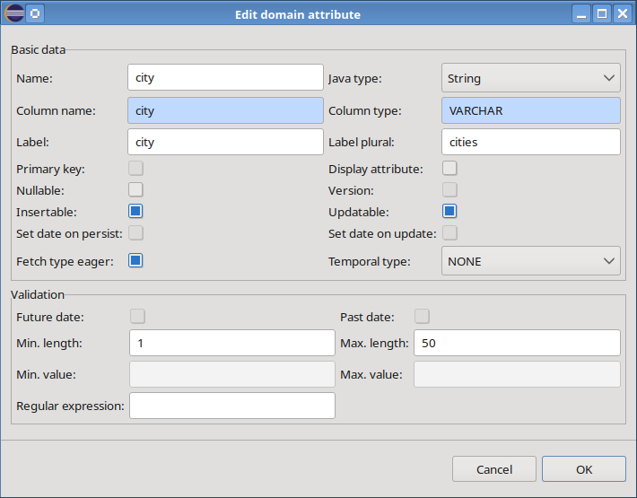Dialog to edit a domain attribute
The context-menu also offers an item to delete a domain attribute. Note that deleting a primary key attribute is not supported!
If foreign keys are either missing or not supported, it is even possible to convert an attribute to a many-to-one association. This functionality is provided by the respective context-menu item “Convert to many-to-one association”. In this case, we must select the target domain object in a separate dialog.

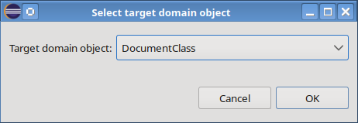Dialog for selecting a target domain object
We can edit and delete all kinds of domain associations. If the owning side of a bidirectional association is deleted, the reverse side is deleted also.

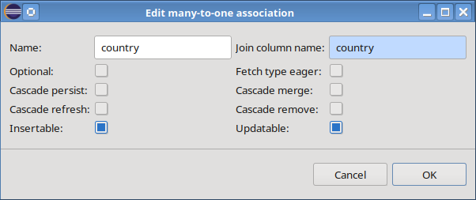Dialog to edit a many-to-one association
As the import process always creates many-to-one associations it is possible to either add a one-to-many association or convert it to a one-to-one association. When converting a many-to-one to a one-to-one association, CodeCadenza will always add a reverse association. We may even convert a many-to-one association to a domain attribute.
The context-menu item “Exchange owner” is only applicable for many-to-many associations!

When importing the database meta-model, it is not possible to infer enumerations. But we may create them afterwards by selecting the item “Add enum” of the namespace context-menu. If we do so, a dialog to create a new enumeration is opened.
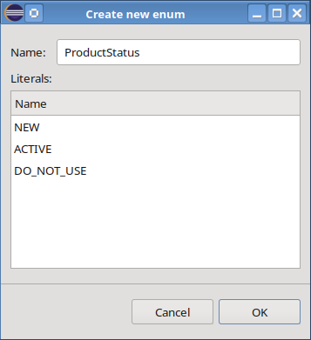Dialog for creating a new enumeration
Beside of the name, an arbitrary number of literals can be added to the new enumeration. The enumeration can now be used as type when opening the dialog to edit a domain attribute as depicted in the following picture:

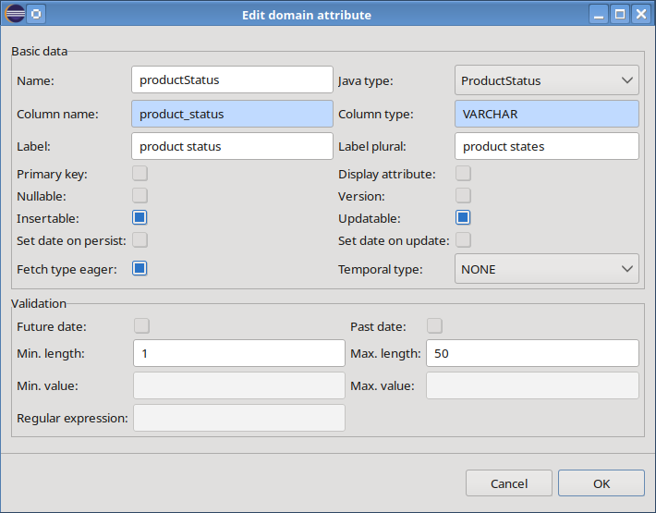Mapping of a domain attribute type to a Java enum
All enumerations, domain objects, attributes and associations that have already existed before starting the Reverse Engineering process are read-only! Thus, they neither can be changed nor deleted in the editor!

Filtering and mapping
In contrast to the sample ER model that only contains a small number of tables and relationships, it is likely that a production database possesses a large number of tables. It is feasible to perform the Reverse Engineering in an iterative way by reducing the number of imported tables via the configuration dialog. By pressing the “Edit configuration” item on the right side of the toolbar this dialog is opened.

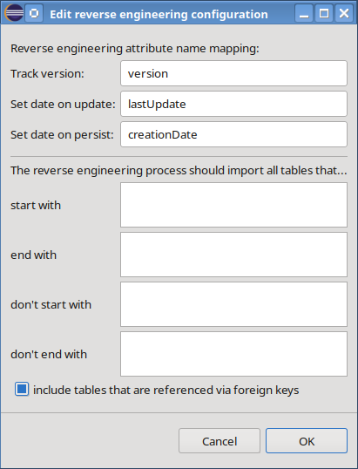Reverse Engineering configuration dialog
The first section contains input fields for special domain attribute mappings. If the import process creates an attribute with the given name it will set internal version and date flags automatically, provided that the attribute has a suitable type.
The next four fields allow us to filter the tables that should be processed in a comprehensive way. We may enter an arbitrary number of search strings into every single field. In case of inverted filter criteria (e.g. don't start with), an AND logic is applied. When performing the search operation, all filter strings are handled in a case-insensitive manner. We don't have to enter the full name of a table as the table names are compared by checking if the particular filter string is a prefix of the table name.
Furthermore, it is possible to define if tables that are referenced via foreign keys should be imported also.
As soon as we apply the changes we must confirm that the import process should start again because all manual changes get lost when starting a new import process!

Saving the domain model
If the domain model is ready and no validation errors or warnings exist, the domain model can be saved via the “Save” button in the editor's toolbar. As soon as the save operation has been finished successfully the editor will be closed and all domain objects will be saved locally in the corresponding domain model files. The new domain objects should be present in the diagram files that refer to the namespaces the objects have been added to.

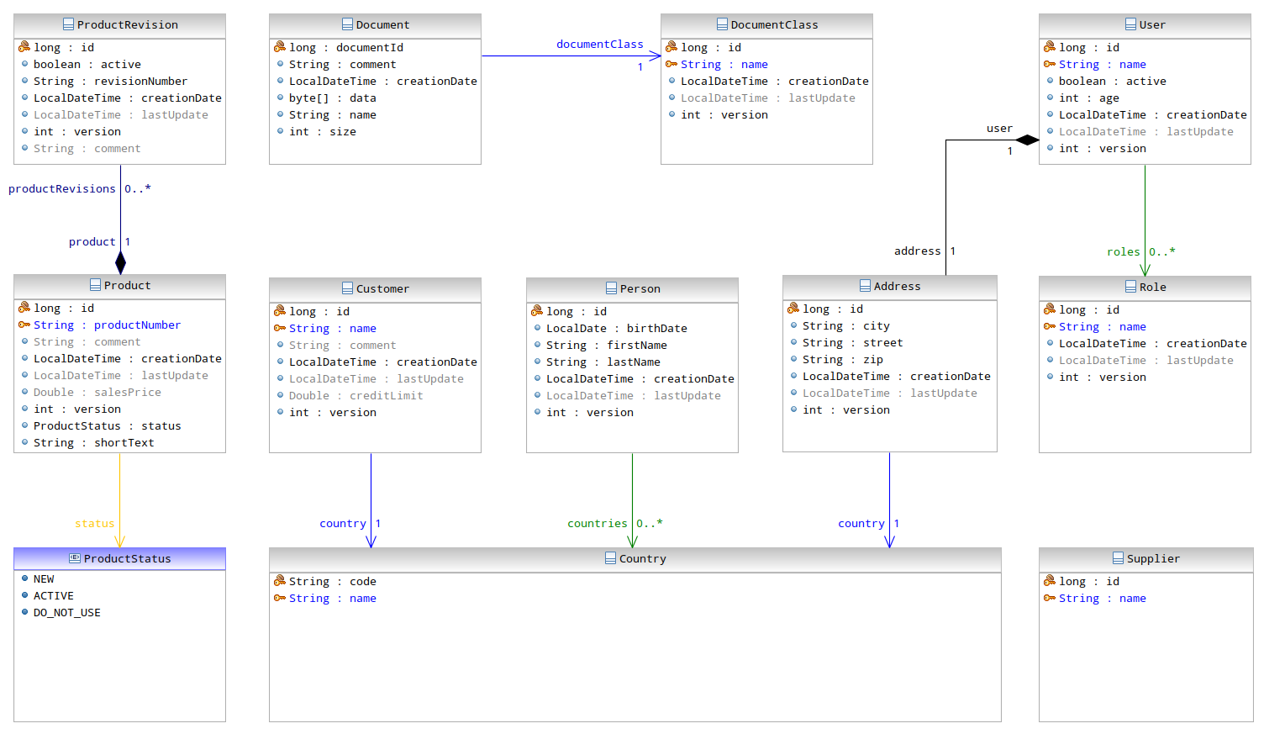Sample domain model created by Reverse Engineering in a diagram editor

The JPA query editor
The development of complex JPA queries represents a reoccurring task for many developers. Sometimes the application must be restarted many times until a JPA query works as expected. In contrast to this try-and-error approach, it is also possible to create such a query at design-time using CodeCadenza's JPA query editor. The starting point for creating a new query is usually a domain object item in the project navigator. By selecting the context-menu item “Query” a new editor page is opened in the editor area of Eclipse. Basically, the editor consists of a toolbar, a query input field and a result list panel. Beside of the standard buttons that are used for executing and saving a query the toolbar also contains a checkbox that allows the developer to select if the number of returned objects should be limited. If so, a maximum number of returned objects can be entered in a text field. The query input field provides syntax colouring and a content proposal assistant that is activated when entering a dot character. This field contains a default select statement when creating a new query. When opening a saved JPA query - which can be usually found in the “jpa” folder of the workspace project that contains the domain objects - the file content is displayed in the query input field.
Before executing a query following preconditions must be met:

- the data source settings must be correct (see chapter 7.2),
- an appropriate JDBC driver must be selected
- and all necessary database tables the domain object references must be in sync!

As soon as the “Execute” button in the toolbar is pressed an internal JPA engine is started and the query is performed. If no error has occurred, the result will be displayed in the result panel.

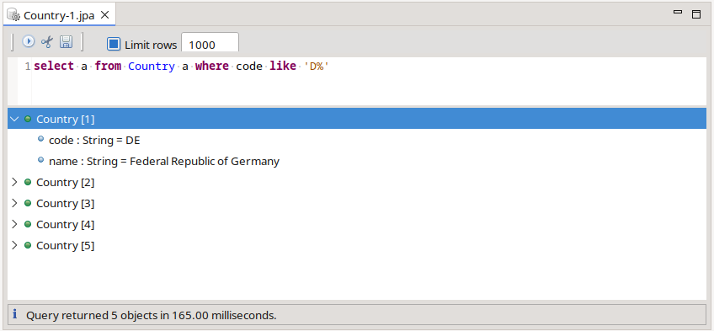JPA query editor
Basically, the JPA query editor supports two different operation modes. When executing a query that returns an arbitrary number of objects, the result panel displays all persistent objects found in a hierarchical tree structure where all attributes and associations are added as child items to a respective object. In case of an association, the corresponding tree item can be expanded in order to see the objects that are referenced by this association.
Furthermore, it is possible to create a tabular result if the query select clause contains an arbitrary number of domain attributes separated by a comma.

The database
The following chapter describes basic settings and tools necessary for working with the project's relational database.

Database properties
When creating a new project, a developer must select the database vendor (see page 16). This selection has a deep impact on many different subsequent modelling and generation steps. Internally, a database meta-data object with proper default values will be saved when creating the new project. In many situations, it is very likely that these settings are appropriate when building a new project from scratch. But especially if we try to adopt a CodeCadenza project to an existing database schema it is very likely that general database properties must be adapted! We can change these properties by selecting menu item “Properties” of the context-menu of the “Database meta data” item in the project navigator. If we do so, the following dialog will be opened:

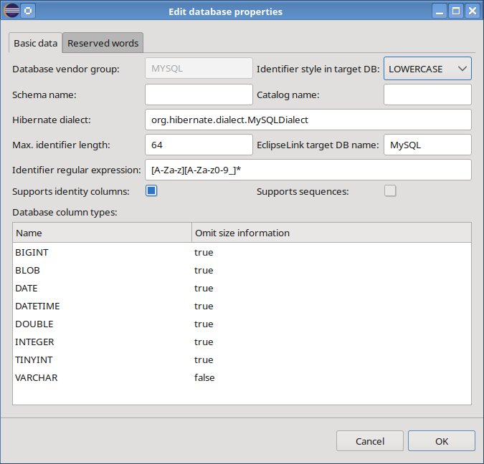Database properties
One of the most important fields is “Identifier style in target DB”. When modelling a new domain, the respective database identifiers for table and column names will be initialized with proper default values. They are stored as entered in respective text fields. The identifier style controls how a given identifier will be converted in generated DDL statements and JPA mapping annotations. Three different options are possible:

- LOWERCASE: All identifiers will be converted to lowercase
- UPPERCASE: All identifiers will be converted to uppercase
- CASE_SENSITIVE: The identifiers will be used without performing conversions.

Note that changing the field's value doesn't change the identifiers saved in the meta-model. Rather, the presentation in respective source code fragments and DDL scripts will be changed accordingly! It is always advisable to change this setting only directly after creating a new project. Of course, it is possible to change it afterwards but this might end up in recreating the full database!

The dialog provides further fields for entering a default schema and a default catalog name, the Hibernate® dialect, the EclipseLink target database name and some fields that control performing validation checks upon given database identifiers. On the one hand, the user is able to change the maximum length of a database identifier (e.g. table name). The field “Identifier regular expression” is used to enter a regular expression that checks the validity of an entered database identifier. The tab-page “Reserved words” contains a text field with all reserved words (separated by blanks) of a given database. If a developer creates a new object (e.g. domain attribute) that is mapped to the database, he will get an error if the given identifier (e.g. column name) is contained in this list!
Furthermore, we can manually overwrite the default values regarding support of identity columns and sequences.

The next section contains a list of all available database types. For all supported databases CodeCadenza provides a good starting point for mapping domain attributes to database columns. Sometimes it is necessary to either create new or change existing column types. This is possible by selecting a respective context-menu item of the list. When opening the dialog to edit an existing database type, it is possible to adapt the Java type mapping. Furthermore, the selection of checkbox “Omit size information” can be changed. Sometimes the developer provides a maximum field length when creating a new persistent domain attribute (see page 43). Normally, this value is used in respective DDL scripts in order to control the column's length constraint. But depending on the selected database vendor and database type, sometimes such a value is not expected in the DDL command and produces an error when executing the DDL statement. In this case, we can select “Omit size information” in order to avoid the length constraint from being added to corresponding scripts.

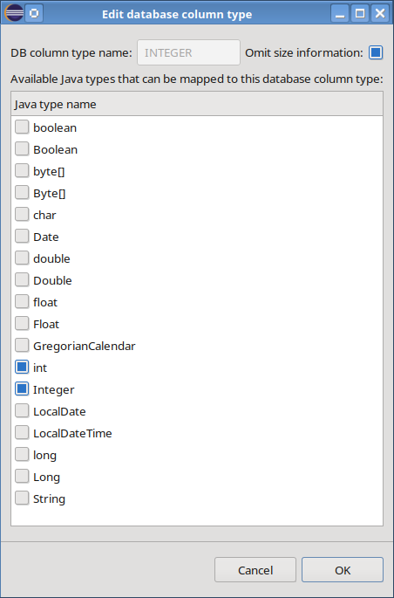Dialog to change an existing database type

Synchronization with the target database
Many JPA providers (e.g. Hibernate®, EclipseLink) support the generation of database elements when initializing the persistence unit. In some situations, when developing and maintaining real-world applications, the results of these DDL (Data Definition Language) exports are unsatisfactory due to uncommon naming conventions of indexes, missing of unsupported elements (e.g. complex unique keys) and data that might get lost (mostly due to wrong script parameters).
The plug-in provides an easy and reliable way to generate the database structure at all times a developer wants to synchronize the persistent domain model with the underlying target database. In order to initialize a synchronization job, we have to go to the project navigator, select the respective item “Database meta data”, open the context-menu and select “Synchronize”. The plug-in opens a new “Database sync editor”, creates a connection to the selected target database and searches for differences between database meta-model and target database.

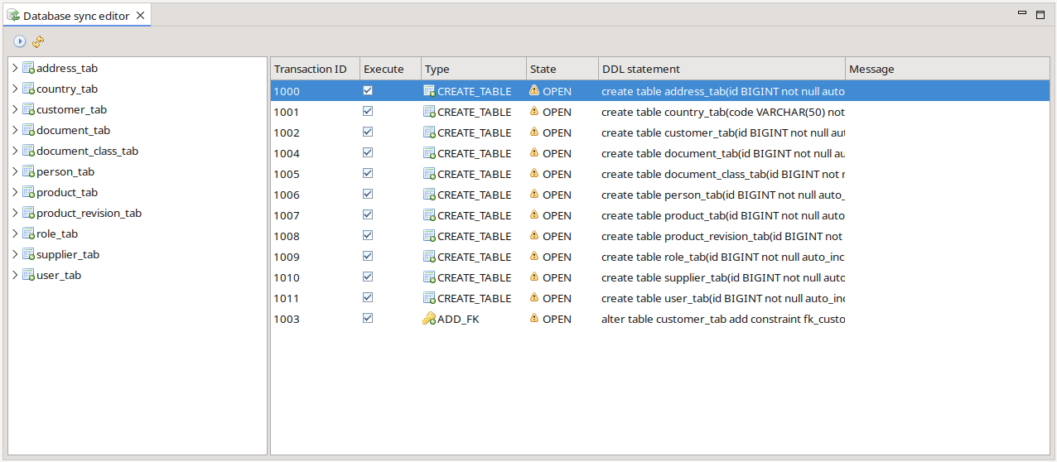Database sync editor
On the right editor side, all suggested DDL script statements are displayed. Every row consists of an internally used transaction ID, a flag that determines if the statement should be executed or not, a type that easily identifies what the statement does, a state, the statement itself and a response message.
Sometimes it might be necessary to change the generated statement. This can be achieved by performing a double-click on the corresponding row that opens a dialog to manually rewrite the script statement.
If we press the “Execute” button in the editor's toolbar, the plug-in starts to send every single DDL statement to our target database. Note that CodeCadenza only executes statements that are marked properly (checkbox “Execute” must be selected). If the database was not able to perform an operation successfully, a detailed error message will be added to the field “Message” and the state will be set to “Error” in the respective row. It must be mentioned here that CodeCadenza doesn't create DDL statements to remove tables that are not (or no longer) part of the domain model! Those tables shall be deleted manually.

The database query editor
Sometimes it is necessary to either check or to change the plain content in the database. For this purpose, CodeCadenza provides a powerful editor that is directly integrated into Eclipse.
For creating a new query it is necessary to go to the “Database meta data” item in the project navigator. When expanding this item, all tables that are mapped to domain objects of the project's domain model are displayed. By selecting the context-menu item “Query” of such a table item a new editor page is opened in the editor area of Eclipse. The editor contains a toolbar, a query input field, a result list panel and a grid panel that displays feedback messages. Beside of the standard buttons that are used for executing and saving a query, the toolbar also contains a checkbox that allows the developer to select if the number of returned objects should be limited. If so, a maximum number of returned objects can be entered in a text field. The “Auto commit” checkbox controls if update, insert or delete operations should by committed automatically. The query input field contains a default select statement when creating a new query. When opening a saved query - which can be usually found in the “sql” folder of the workspace project that contains the domain objects - the file content is displayed in the query input field. In addition to syntax colouring, the query input field also offers a content proposal assistant that is triggered by entering a dot character.
Before executing statements following preconditions must be met:

- the data source settings must be correct (see chapter 7.2),
- an appropriate JDBC driver must be selected
- and all necessary database tables must exist in the target database!

As soon as the “Execute” button in the toolbar is pressed the statements(s) entered are sent to the database. If no error has occurred, all recordsets will be displayed in the result panel. When executing update or insert statements that don't return data, the result panel will be empty!

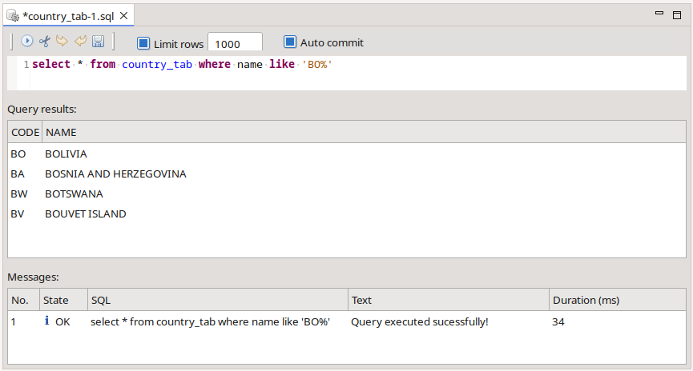The database query editor
In any case, the plug-in creates a message for every single statement and displays it in the corresponding grid panel. Multiple statements (e.g. a couple of insert statements) must be delimited by using a semicolon.

Creating and maintaining repositories
To some extent, the plug-in's architecture is based on services that provide basic persistent operations that are also known as repositories (see page 13). After we have modelled our domain, the plug-in is now able to leverage this information in order to easily infer knowledge about how to build these services. Hence, the developer doesn't have to create repositories manually. Rather, he simply creates all necessary objects by performing the “Synchronize” operation in the context-menu of item “Repositories” in CodeCadenza's project tree view.
By default, all methods of a repository use the same transaction attribute Required. That means that a method uses the transactional context of the caller. If no transactional context exists, a new transaction will be started by the container. For more information concerning transaction management take a look at the EJB specification (version 3.0 or above).
Furthermore, the permission mode PermitAll is set initially for every repository method. This mode specifies that all security roles are permitted to execute this method.
The permission mode, as well as the transaction attribute, may be changed by the developer for every single repository method if the project uses the facade mode.
We just have to search for the method in CodeCadenza's project tree view and select “Edit” in the context-menu. A dialog appears to change both default values:

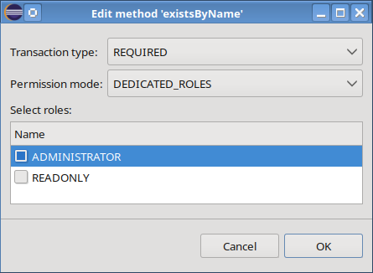Dialog to change repository method data
If permission mode DEDICATED_ROLES is selected, we may change the authorization strategy in a way allowing to invoke this method by clients that have specific roles granted. For example, the copy() method should be invoked always within a new transactional context. Moreover, only users with role “ADMINISTRATOR” should be allowed to invoke it.
CodeCadenza creates following source code:

@RolesAllowed({ "ADMINISTRATOR" })
@TransactionAttribute(TransactionAttributeType.REQUIRES_NEW)
public Country copy(Country sourceObject, Country targetObject)
// Rest omitted!

Note that authentication-related settings won't work until respective application server services (JAAS) are not properly configured. If the application runs in an unmanaged environment, the selected transaction type and permission mode won't be added to the generated method and therefore have no effect!

The client
This chapter describes the features of CodeCadenza to build a fully working client application. The practice has shown that developing the client shouldn't be started until the domain model has been created and reviewed.
Note that all screenshots of the sample application made at runtime highly depend on the selected operating system and the client technology that is used for a particular project. Furthermore, it must be mentioned that each client technology may implement the given model differently!

Form groups
The more domain objects we create in our project the more forms will be necessary to view, create, update and search in our client application. The plug-in provides a simple mechanism to classify forms in a hierarchical structure we call form groups. Thus, it will be easier for the user to find a form afterwards.
Form groups are created and maintained solely in the “Form groups” folder of the CodeCadenza project tree view. When creating a new project, one form group Master data will be added by default.
As form groups provide a hierarchical structure we may create as many sub-groups as we want. All form groups that are put directly under the “Form groups” folder represent the top-level elements of our hierarchy.
For example, we want to add a sub-group Country to the existing top-level group Master data. The context-menu of Master data offers an item “Add form group”. If we select this item, a dialog will appear to enter form group data:

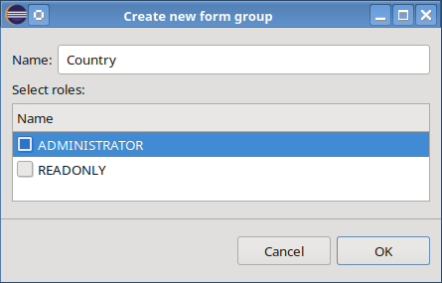Dialog for creating a new form group
The dialog expects a name for this new object. Moreover, we may select roles that afterwards should be granted automatically to forms and sub-groups that are added to this group. When pressing the “OK” button, the tree view instantly adds the new form group to the selected parent group:

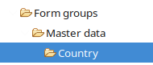New form group
The name and the selected roles may be changed afterwards but there is currently no support relocating a form group within the hierarchy!

Single record forms
This chapter covers how to create and maintain single record forms. As the name already illustrates, these kinds of forms always handle one object at a time. If we might want to create, update or view a domain object, we will create a single record form.
Currently, CodeCadenza supports four different form types:

CREATE | A form to create a new object.
UPDATE | A form to edit data of an existing object.
READONLY | A form that provides a read-only view on object data.
ADD | A form to add an object to a parent. The parent's primary key attribute will be provided e.g. by setting an appropriate constructor parameter of the form. Forms of this type will be used in conjunction with one-to-many associations solely.

Per definition, every form belongs to a form group. Hence, we first have to select a form group in the project tree view and open its context-menu. In order to create a new single record form, we have to choose item “Create update form”. When performing this action, an empty dialog appears. Now, the dialog expects the selection of an existing domain object by entering one or more letters into the auto-complete field “Domain object”. When a user presses a key, only the domain objects starting with the selected letter are shown. By entering more characters, the developer can filter down the list to better matches. As soon as we select Country, the form will be initialized with appropriate default values for name, title, initial width and height, name of corresponding DTO and boundary/facade method name.
Checkbox “Add title area” controls if the form should be supplied with a title area. In addition of that, we are able to define if the form should be modal and/or resizable. If field “Open update after create” is selected, the plug-in will add source code in order to open a respective dialog to update a newly created object after this dialog has been closed. This field is enabled for forms of type CREATE and ADD only!
The field “Return type void” controls if the corresponding boundary method should return void or the form's data transfer object. If the project is based on facades and this checkbox is selected, the method will return the persistent domain object. The field “Form DTO” will be visible only if the project is configured to use the boundary mode.
By selecting the checkbox “Create shared DTO” the same data transfer object is used for all single record forms of the same domain object which reduces the number of generated data transfer objects significantly! Otherwise, CodeCadenza creates a new DTO for every single record form!

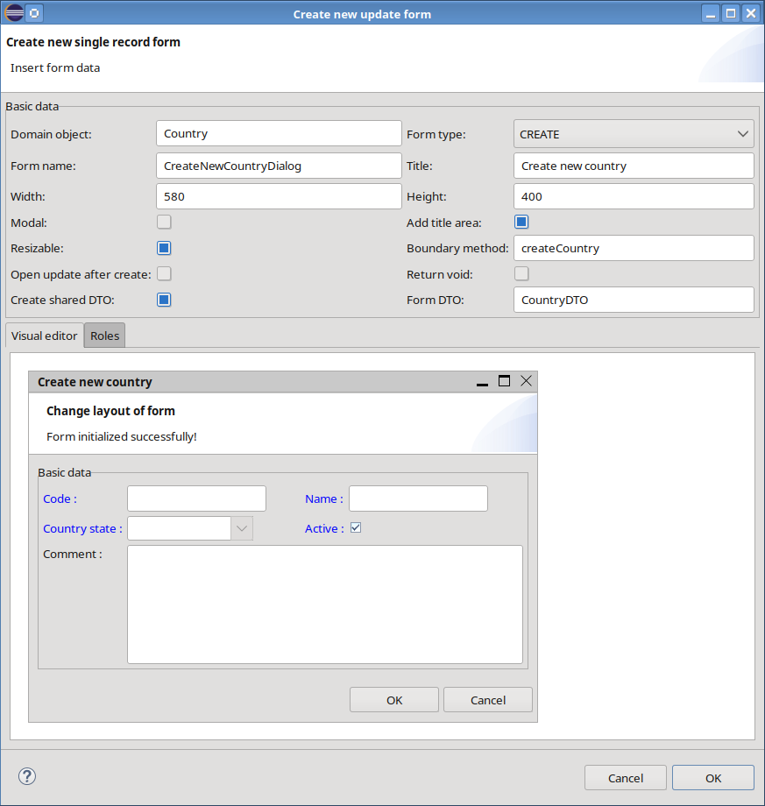Creating a new single record form for Country objects
The rest of the dialog contains a tab-folder with two tab-pages “Visual Editor” and “Roles”. The list in page “Roles” contains the roles that may use this form and is initialized with the roles selected in the corresponding form group. Of course, a developer is able to change the default selection according to his needs.

The Visual Editor
After selecting a domain object the plug-in creates a default model of the form including all panels and fields. By using this model, the Visual Editor is able to build up a graphical representation of the form. Thus, a developer instantly gets feedback about how the form may look like at runtime. The Visual Editor is independent of the client technology the project is based on. That means that the real form is likely to look differently in a browser e.g. in case of a JSF application.
The Visual Editor also provides powerful features to change the underlying model which will be discussed in subsequent chapters.

Form panels
A form contains at least one form panel that in turn holds an arbitrary number of form fields. Our first form possesses just one panel “Basic data”. We can change panel data by performing the respective context-menu action “Edit panel”.

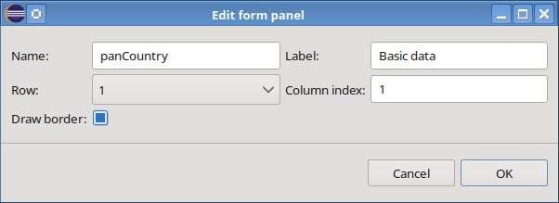Dialog to edit a form panel
Beside of amending the panel's name and label, the user is able to change the relative position by selecting a different row and/or column. In this example that uses just one panel, it makes no sense to change the position. Rather, these settings are coming into play if we have more than one panel on a form. In this situation, a form is divided into a top (Row 1) and a bottom (Row 2) area. Both areas span over the full width of the form. The height of the first row depends on the highest panel that in turn depends on the height of all vertically arranged elements. The rest of the form's height is left over for the second row.
In the case that a row contains more than one panel, we have to define a distinct column index for every panel. While generating the form's source code a tab-folder will be created for multiple panels in a row whereas every panel represents one tab-page.
Especially for domain objects with a great number of attributes and associations, it might be necessary to place the fields on more than one panel. Although the plug-in initially places all simple fields on one default panel, we may create as many additional form panels as necessary and move the fields by drag-and-drop on the newly created panels. Every panel in the Visual Editor contains a context-menu item in order to add a new panel to a form.
It is also possible to delete a panel via the context-menu item “Delete panel”. Note that a panel cannot be deleted as long as it contains form fields!

Simple form fields
Per definition, every form field belongs to a form panel. Depending on the domain object and the form type, the plug-in inspects all attributes and associations of the domain object and creates respective form panels and form fields.
For different types of domain object attributes CodeCadenza supports different form field types:

Java type | Form field type
Boolean, boolean | checkbox
String | single- or multi-line text field, label, external Web or Mail-link
Double, double | text field, label
Float, float | text field, label
BigDecimal | text field, label
Long, long | text field, label
Integer, int | text field, label
char | text field, label
GregorianCalendar, Date | date-time field, label
enum | combobox
Byte[], byte[] | toolbar action

After initialization, a developer is able to change the field's name, label and width in the corresponding field edit dialog by performing a double-click on the corresponding field in the Visual Editor:

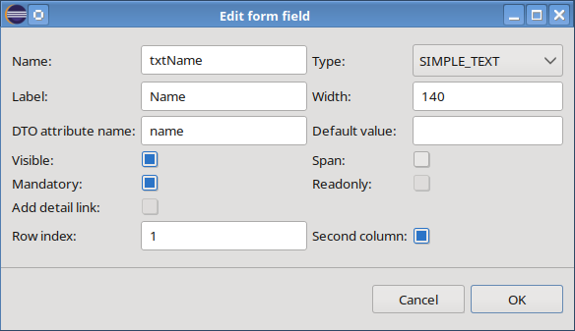Dialog to edit a form field
Furthermore, it is possible to enter a default value. Note that for every date or boolean field a default value cannot be entered in textual form. Rather, only a checkbox is available. In case of a date type, a selection of this checkbox means that the field will be initialized with the current date. The default value fields are enabled for forms of type ADD and CREATE only.
In some cases, it might be useful hiding a form field. This can be achieved by deselecting checkbox “Visible”. An invisible form field leads to a completely different behaviour in contrast to simply deleting it. Internally, every form field will be mapped to an attribute of the form's data transfer object. If we delete a form field, the DTO attribute will be removed too! An invisible form field will not be added to the form's source code but the DTO attribute remains. By default, CodeCadenza hides a form field (in case of forms of type ADD and CREATE) that is mapped to a surrogate id attribute, that is filled automatically by the persistence provider. This is especially useful when the data transfer object must be returned after performing a persist-operation and we need to know the id of the newly created object in order to perform further actions upon it.
A form field can be also made invisible in the Visual Editor by performing the “Hide” action of the field's context-menu.
As the Visual Editor should render the form model as precisely as possible the invisible fields are not displayed in the respective panel. But the dynamic context-menu of the form panel is aware of all invisible fields that belong to the panel and provides an “Edit field” action for every hidden field. When performing this action, the respective edit form field dialog is opened.
The layout of a panel that contains simple form fields follows a simple grid-layout scheme at which a panel may contain one or two columns and a random number of rows. By default, a panel only contains just one column, but we can move fields into a second column by selecting checkbox “Second column”. The row index “1” represents the topmost position of a panel. By editing the field “Row index” we may change the vertical position of a form field. Increasing the index moves the field down.
If checkbox “Span” is selected, the field will ignore the specified width and will span over both columns of a row. Note that this selection has no impact on forms of JSF clients as this feature is basically not supported by this technology.
The following picture illustrates the grid-layout scheme:

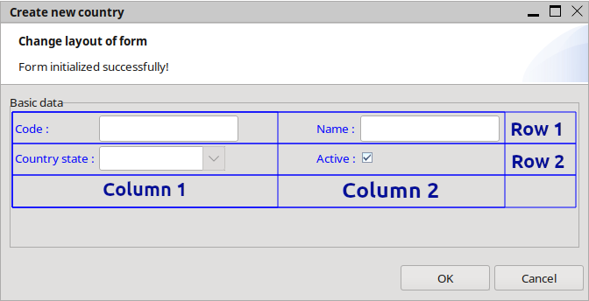Grid-layout of a panel with simple form fields
The layout of the form fields can be also changed easily by using drag and drop in the Visual Editor. If the position of two fields should be exchanged, we can simply drag the field label and drop it on the label of the desired field. The Visual Editor refreshes the layout and both fields will be placed on their new positions. It is also possible to drag a visible field to an empty placeholder in the panel's grid-layout. These placeholders appear as yellow marked areas as soon as a form field is dragged over.
When performing the “Add row” context-menu action, the Visual Editor creates additional placeholder areas at the bottom of the panel to which existing fields can be dragged to. As soon as the Visual Editor is refreshed the new row disappears if no field has been moved to it!
By analysing the domain model data CodeCadenza is able to infer if a user is obliged to enter data for a given field. This information is depicted in field “Mandatory”. We are able to overwrite this setting but care has to be taken as the plug-in doesn't validate if a manually changed entry might cause problems at runtime!
The field “Readonly” controls if a form field can be changed by the user at runtime. The default value can only be changed for fields that belong to forms of type UPDATE!
If the field represents a combobox, a LOV or a proposal text field (see chapter 11.2.4), it is possible to change the value of field “Add detail link”. If the field is selected, the generator will add a link to the field's label. When following the link at runtime, it will open a corresponding read-only form of the referenced object.

As soon as every field and other form-related data fit our needs, we may create our first form by pressing the "OK" button. Beside of the form, further meta-data objects and source code for boundary/facade method and corresponding form DTO are generated by CodeCadenza. The form DTO will be omitted if the project is based on facades!
The following picture shows the new form for creating Country objects at runtime:

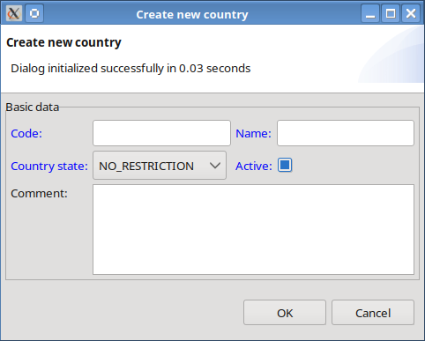Dialog for creating new Country objects
It must be mentioned at this point that this tutorial cannot discuss the generated code. Only this very simple example results in some hundred lines of code in different classes for GUI and business logic!

Fields for many-to-one associations
In the last chapter, we have already learned that the plug-in inspects the selected domain object when the dialog for creating a new single record form is initialized. It also has been shown how CodeCadenza handles attributes. This chapter describes the transformation of many-to-one associations in a single record form. For example, we need an Address entity with some attributes and a many-to-one association to the Country object.

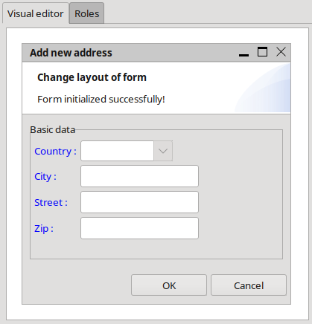Form field that is mapped to a many-to-one association
Currently, six different ways exist how to handle many-to-one associations:

1.) COMBOBOX
By default, a many-to-one association is mapped to a combobox which references a separate list DTO (e.g. CountryListDTO). The DTO contains at least the primary key attribute of the referenced domain object (in this case Country). If the referenced entity contains a display attribute, a second attribute will be added to the DTO. As the name implies, a display attribute is used as visual representation of the referenced object in the combobox field. This kind of component should be used only if the number of referenced objects is not too high as the client always tries to fetch all objects at once when a form is initialized at runtime. For security reasons, the number of returned objects is limited by the respective boundary/facade method.

2.) LOV
A list of values is a special kind of a list view that will be discussed in detail in a later chapter. It represents a good alternative to comboboxes as the user must search for a suitable reference object manually by using the list of values dialog. Therefore, automatic bulk fetch operations are not performed by the client (cf. combobox)!

3.) SELECTION_BY_SECURITY_DTO
In some situations, an entity references a domain object that represents the application user. For example, we want to know what user has created the Country. Thus, we add a new many-to-one association from Country to User. In the client this reference should be set automatically without user interaction. If we have proper security-related settings (via Tagging) in place, we will be able to select this field type, which has no visual representation.

4.) SELECTION_BY_PARENT_FORM
This type isn't visible also and will come into play if we work with bidirectional one-to-many associations in the client. For example, we have a CustomerOrder and an OrderLineItem domain object and a CustomerOrder consists of a random number of OrderLineItem objects. In our application we need a form to add new OrderLineItem objects to a given CustomerOrder. If we choose this type, the association (e.g. customerOrder) will be set implicitly when initializing the form (e.g. AddOrderLineItem).

5.) PROPOSAL_TEXT
The most convenient way of maintaining a many-to-one association in the client is a proposal text field. As soon as a user enters a minimum number of characters (normally 2), only referenced objects starting with the selected letters are shown. By entering more characters, the user can filter down the list to better matches.

6.) FORM_LINK
In case of non-updatable associations, this component is suggested by default. The value cannot be changed but a respective label is displayed on the form. By clicking on the label, a read-only detail form will be opened at runtime. If no respective form exists, the action won't be performed!

Data selection fields
In CodeCadenza many-to-many and unidirectional one-to-many associations are handled on the client-side by a dual data selection list component. By default, the plug-in suggests a separate form panel for every component of this type. If we come back to our example of a Region that contains a many-to-many association to Country, we will get following proposal:

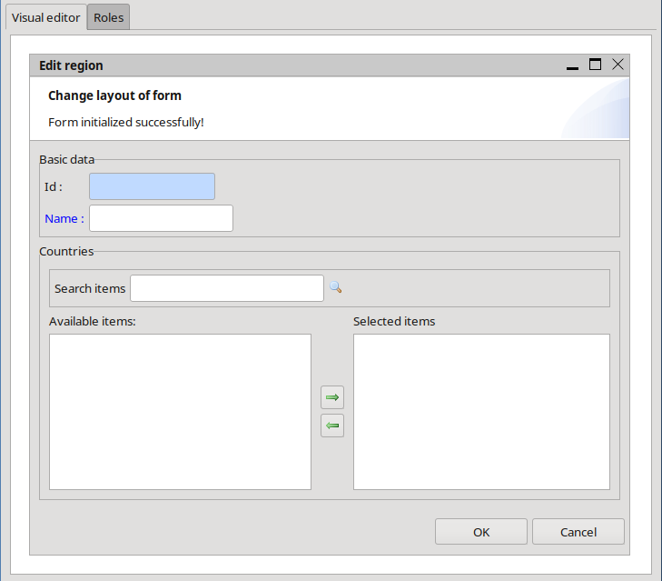Form with a dual data selection list
Just like in the chapter above where we have covered many-to-one associations this component uses a simple data transfer object containing the primary key and an optional display attribute. But in contrast to a many-to-one association, where the form DTO contains a reference to the list DTO, the form's DTO will now hold a collection of corresponding list DTOs.
By default, this component provides a lookup field (SEARCHABLE_LIST) in order to search for items to be displayed in the list on the left side. A user can copy items from the left source list to the right one by either performing a double-click action or pressing the respective selection button. The target list on the right side contains the elements that are saved afterwards in the many-to-many association.
If we expect only a small number of selectable items, we can change the component type to LIST. Thereby a filter input text field will be omitted and the source list will be initialized with all objects available!

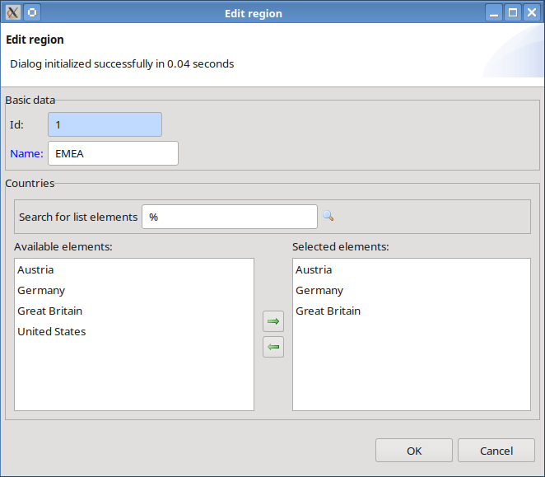Dialog with a dual data selection list at runtime

Handling of one-to-one associations
If the plug-in finds a one-to-one association while inspecting the selected domain object's structure, it automatically creates an additional form panel and adds all attributes and many-to-one associations of the referenced domain object to it.
In a previous chapter we have designed a Person that has a bidirectional one-to-one association to an Address. For example, we now want to create a form to create a new Person. CodeCadenza adds all attributes and many-to-one associations of the association's target domain object to a separate panel (in this case Address). The suggested structure illustrates next picture:

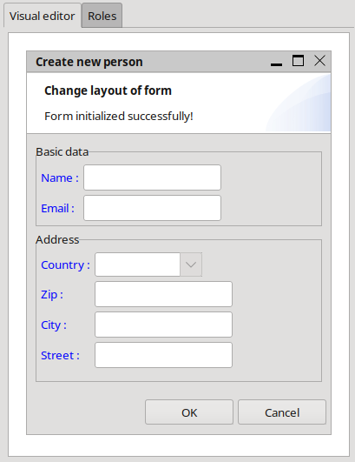Form with an additional panel for a one-to-one association
Note that it is possible that the one-to-one association's target domain object also contains further one-to-one, many-to-many and one-to-many associations. But these configurations are currently not supported when modelling a client form.

Grid panels
The last kind of association that hasn't been covered yet is the one-to-many association. For every one-to-many association CodeCadenza will add a grid panel, provided that it has been already defined!
In chapter 11.3.4 we will take a look at how to create grid panels in detail.

Additional fields
When initializing a new form, the plug-in doesn't add form fields for all attributes of every referenced domain object. But in case of forms of type READONLY and UPDATE a developer is able to add additional fields that are mapped to attributes of referenced domain objects, provided that the reference represents a many-to-one or one-to-one association.
We now want to create a form to update Person data. Every form panel context-menu in the Visual Editor contains an item “Add field”. When selecting this item, a dialog is opened that contains all attributes and associations we are allowed to add. In this example, there is the name attribute of entity Country that makes sense to be used. The new field can be created by just performing a double-click on corresponding tree view item.
No matter what form type (READONLY or UPDATE) we have selected before, the field is initialized to be read-only! Of course, it is possible to change this setting, but changes to the field's value at runtime won't be adopted in subsequent update operations.

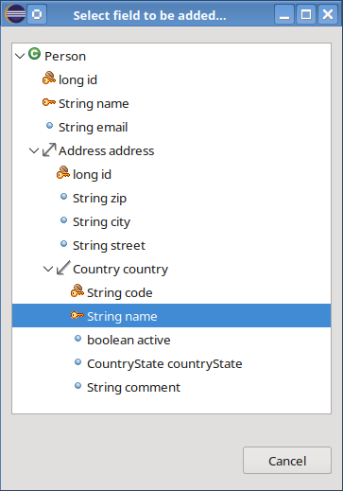Dialog for selecting additional fields

Initial one-to-many associations
In the examples above we have defined a Person that always had exactly one Address. We redesign the model in order to attach a random number of Address objects to a Person. That means that we have to replace the existing one-to-one association by a new one-to-many association.
Afterwards, we would like to have a form to create a new Person. If we select a form of type CREATE or ADD, the “Add field” action provides a dialog that contains all distinct one-to-many associations of the selected domain object. When selecting the addresses item, a new form panel will be created and initialized with all fields of the referenced Address object. Hence, it is possible to add one Address to a new Person. In other words, a Person will always have at least one Address when creating the Person via the respective dialog.

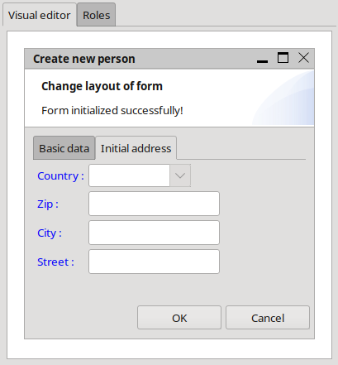Dialog with an initial one-to-many association
Although it is possible to create an initial one-to-many association in an Angular application it must be noted that the respective object cannot be sent to the back-end. The reason for this is that all data transfer objects are transferred by using the content parameter of the corresponding REST method. As a REST method can only have one content parameter the application will only send the data transfer object of the main form! In this case a developer must adapt the generated code accordingly in order to avoid an unexpected runtime behaviour!

Fields containing binary data
In many projects, documents, photos, videos and other kinds of binary data are part of the domain model. CodeCadenza provides some basic features for handling binary data in all layers of the application.
For example, a Person should also contain an attribute that represents a picture. In this case, we have to add a new LOB-attribute of type Byte[] or byte[] to that entity. Attributes of this type are not directly mapped to form fields. Rather, the plug-in adds a toolbar containing actions concerning file handling. Forms of type CREATE just get a browse action to select a file to be attached to the respective object. CodeCadenza adds actions to upload and download files for forms of type UPDATE. The upload action will be omitted if the field isn't updatable.

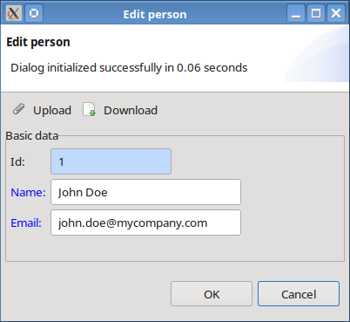Dialog with toolbar

Fields for element collections
A field for an element collection contains a list with the available elements. If the field is not read-only, an additional area is provided where new elements can be added. The editable field typically includes features such as input validation and error handling to ensure that new elements are added correctly and consistently. The list also provides a context-menu for deleting either the currently selected element or all elements.

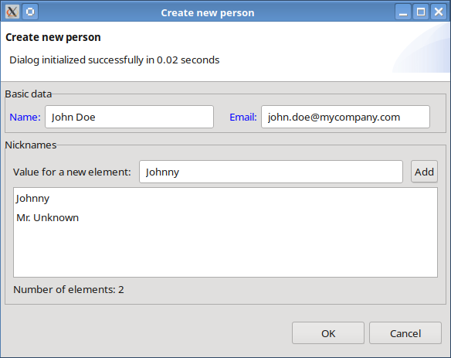Dialog with an element collection editor

List forms
The previous chapters have explained how to define forms to create, update and view single domain objects. This chapter shows how we can create forms to either search or display a random number of entities in one dialog.
Note that the terms “view form” and “list form” are used synonymously throughout this manual!
The plug-in supports three different types of list forms:

SIMPLE_VIEW
A form of this type provides a tabular view based on a specific domain object. Every attribute is mapped to a separate column. Per definition, the form tries to fetch all items of a given domain object. But for security reasons the query automatically limits the number of returned objects! It is not possible to enter filter criteria at all.
Like single record forms, a view form always belongs to a form group. In order to create a new form of this type, we have to choose item “Create view form”. When performing this action, an empty dialog appears. Now, the dialog expects the selection of an existing domain object by entering one or more letters into the auto-complete field “Domain object”. When a user presses a key, only the domain objects starting with the selected letter are shown. As soon as we select e.g. the Customer domain object, the form will be initialized with appropriate default values for name, title, name of corresponding DTO and method names for searching and counting objects.
Finally, the form type SIMPLE_VIEW has to be selected in the “Form type” combobox.
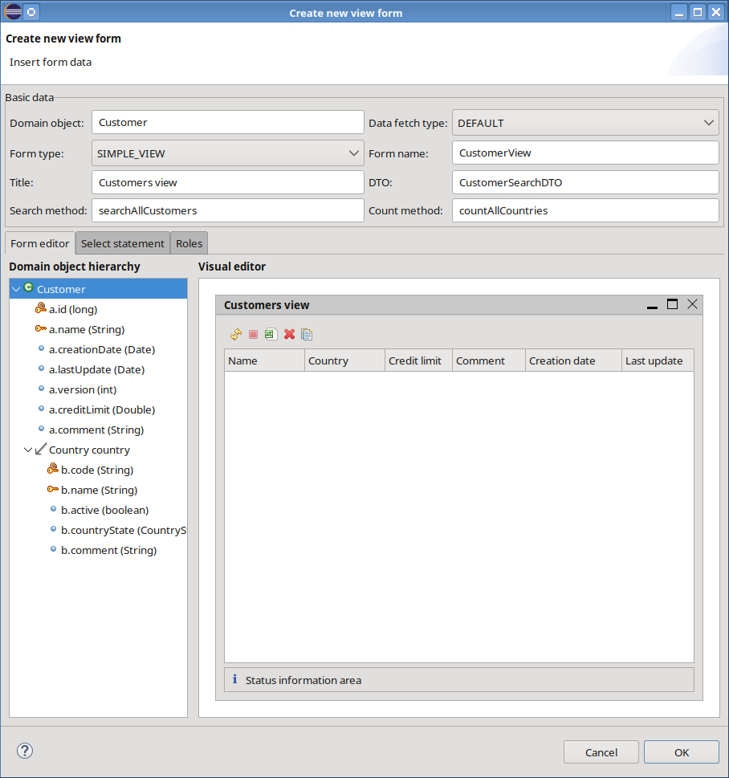Dialog for creating a view form
The bottom area of the dialog contains a tab-folder with three tab-pages “Form editor”, “Select statement“ and “Roles”. The list in group “Roles” contains the roles that may use this form and is initialized with the roles selected in the corresponding form group.
Group “Form editor” is used to maintain table column fields. Whenever a user changes the selected domain object or the form type, the dialog refreshes its state.
The “Domain object hierarchy” tree view contains the complete structure including all supported attributes and associations of the selected domain object. The “Visual editor” located on the right side of this panel contains a preview of all table column fields and default actions this form should provide. A list view always contains only one panel that in turn holds a table. Every column of this table is mapped to a single DTO attribute.
Additional table column fields can be added to the default table by dragging an attribute from the “Domain object hierarchy” tree to the table of the Visual Editor on the right side. The default order of the columns can be simply changed by dragging a table column header to the desired position.
We can also edit table column data by performing a click on the respective table column header field.

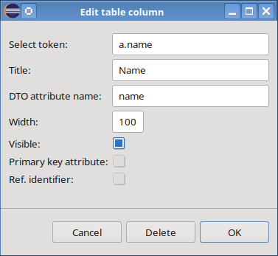Dialog for maintaining table column field data
Beside of the field's name and title, we are able to change the name of the DTO attribute and the default column width. Moreover, the dialog provides a checkbox in order to define the column's visibility. If a table column field is selected to be hidden, it won't be visible but the form's DTO will contain the corresponding attribute value.
By pressing the “Delete” button an existing table column field can be deleted!

The Visual Editor also contains a toolbar with standard actions as well as actions that have been generated when initializing the form. The number of generated actions depends on the single record forms of the selected domain object that have been created already. Furthermore, the plug-in adds an action to delete an object. For every binary data field of this entity, a download action is provided. Beside of these actions, every list form contains (depending on the client technology) standard actions to export data into Excel format, refresh the view by reloading data from the database or application server and an action to stop a running fetch operation. Moreover, the form provides an action to create a deep copy of a selected object. While standard actions are only displayed for conformity reasons the generated actions may be adapted by the user by pressing the corresponding toolbar item.

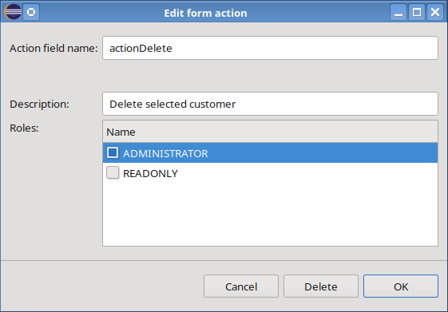Dialog for maintaining form action data
This dialog can also be used to delete the currently selected action!

The tab-page “Select statement” contains a text field that displays the generated JPA select statement which will be refreshed any time we add or remove a table column field. In text field “Additional statement” we may enter additional static filter criteria.

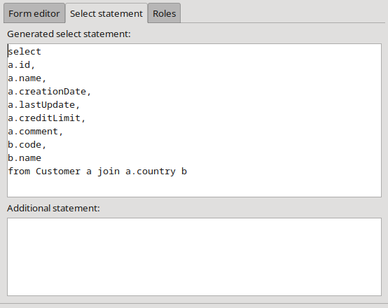Tab-page "Select statement"
The next picture illustrates the new form at runtime:

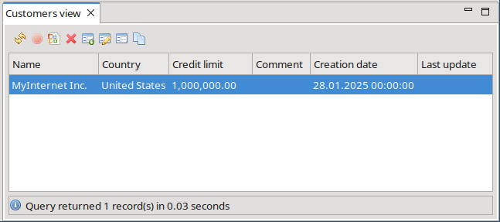The generated SIMPLE_VIEW at runtime
Every time when we add a new list view to our application CodeCadenza automatically adds a reference to that form to the navigator view of the application. Thus, the navigator view provides an entry point for the user to find existing views he is allowed to open. The view's hierarchy follows the form group structure we have already defined. In other words, every form group represents a folder in the navigator and depending on the view's form group, the view is added to the respective folder.

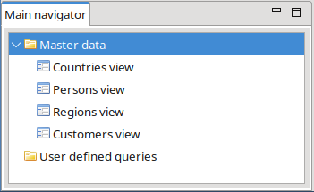The navigator view at runtime

LOV (list of values)
List forms of type LOV provide a simple way of searching objects via the primary key or the display attribute of a domain object. Four major differences between a LOV and a SIMPLE_VIEW exist:

1.) A LOV isn't displayed in the navigator view.
2.) A LOV doesn't provide form actions.
3.) A LOV is always used in combination with a LOV field of a single record or list form.
4.) A LOV contains exactly one filter input field to search objects.

The following picture shows how a typical LOV for the Person object may look like:

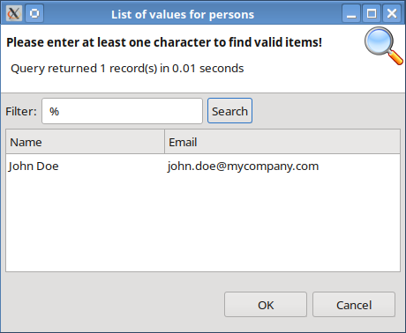LOV dialog at runtime
The selected object is returned to the corresponding LOV field by pressing the "OK" button or performing a double-click on the respective grid row.

SEARCHABLE_VIEW
A SEACHABLE_VIEW is very similar to a SIMPLE_VIEW. As the name implies, a user is able to enter filter and sorting criteria. The definition of a SEACHABLE_VIEW follows the same rules as mentioned above. Only the dialog to edit table column fields contains two additional fields. The developer may select a suitable LOV in the “List of values” combobox that contains all lists of values we have already created. If the checkbox “Searchable” is not selected, it will be visible at runtime as a column in the result grid, but a user won't be able to enter filter criteria for the given field.

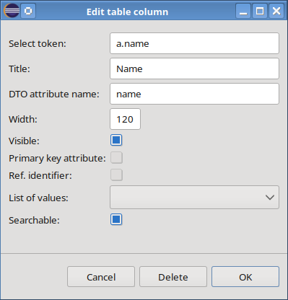Dialog for maintaining table column field data
At runtime, a SEARCHABLE_VIEW looks quite similar to a SIMPLE_VIEW:

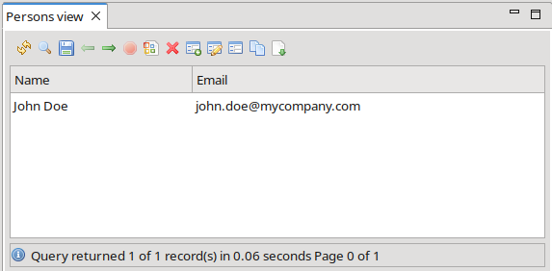The generated SEARCHABLE_VIEW at runtime
Forms of this type always provide four additional actions in contrast to a SIMPLE_VIEW:

- Search action (magnifier icon)

If a user performs this action, a search dialog is opened to enter filter and sorting criteria. The dialog contains a tab-folder with two tab-pages. The first tab-page “Filter settings” is used to insert filter criteria for all table column fields that have been defined as searchable. Every table column field that is related to a LOV contains an icon on the right side of each row. By clicking on this icon the user is able to open the appropriate list of values dialog.
The “Count” button performs a count operation based on entered filter settings and opens a message-box with the result. If a user presses the “Clear” button, the dialog will perform a reset operation on all entered filter and sort settings. By clicking on the “Search” button the dialog checks the input and calls the appropriate search method. Afterwards, the dialog is closed and all objects that match the filter settings are displayed in the view form.

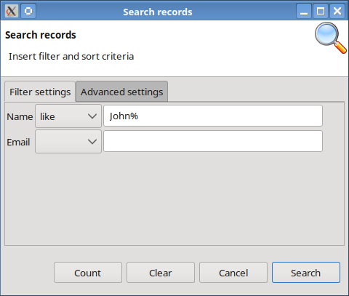Dialog for entering filter criteria
The second tab-page “Advanced settings” contains fields to select if the filter criteria are case-sensitive and if an exact filter match is expected. Furthermore, a user may select to automatically count all objects that this query would return. This setting is obligatory for paging through result sets. The value of combobox “Max. fetch size” determines how many objects are returned in one fetch operation at most!
A user may hide columns from the result grid by removing items from the “Selected fields” list. Those items automatically appear in the “Available fields” list and may be selected again to be visible afterwards. Moreover, a user is able to change the column order of visible fields in the “Selected fields” list by performing respective context-menu actions (“Move up” and “Move down”).

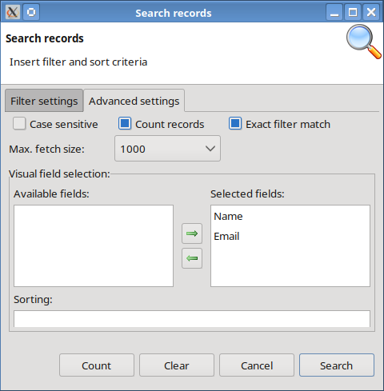Tab-page with further search settings
In order to enable sorting, a user can drag a visible table column field and drop it into the “Sorting” list. The default sort order (ascending) may be changed by performing the “Invert sort order” context-menu action.

- Save query action (disc icon)

Some kinds of queries have to be performed on a regular basis and can be saved locally by performing this action.

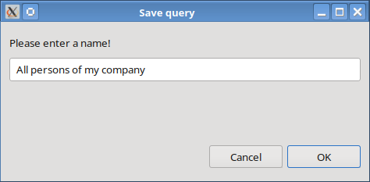Dialog for saving a query
When executed, the user just has to insert a unique name for the query that should be saved. As soon as the operation is finished successfully, a new item in the navigator view's “User defined queries” folder will appear.

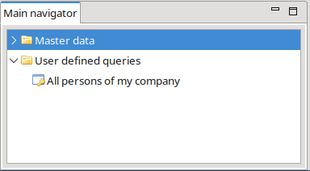The saved query in the navigator view
- Next and previous page actions (arrow icons)

In some situations, queries might return a great number of objects. To avoid long response times and problems with the client's heap space the framework supports result set paging. That means that a query returns always just a limited number (a page) of objects in one single step. The “Next page” and “Previous page” actions can be used in order to navigate through all pages of the result set. Note that the “Count records” checkbox in the search input dialog must be selected to enable this functionality! The page size is limited by the selected value of the “Max. fetch size” combobox in the same dialog.

Grid panels
A grid panel is a tabular view on attributes of a domain object that is referenced by a one-to-many or many-to-many association from another entity. As the next picture illustrates, the definition of a grid panel component is quite similar to list views. The most important difference is that we have to select a one-to-many or many-to-many association that we want to use. After this selection is made, the dialog will be pre-initialized. Table column fields, select statement and actions can be maintained just like we did with list forms.

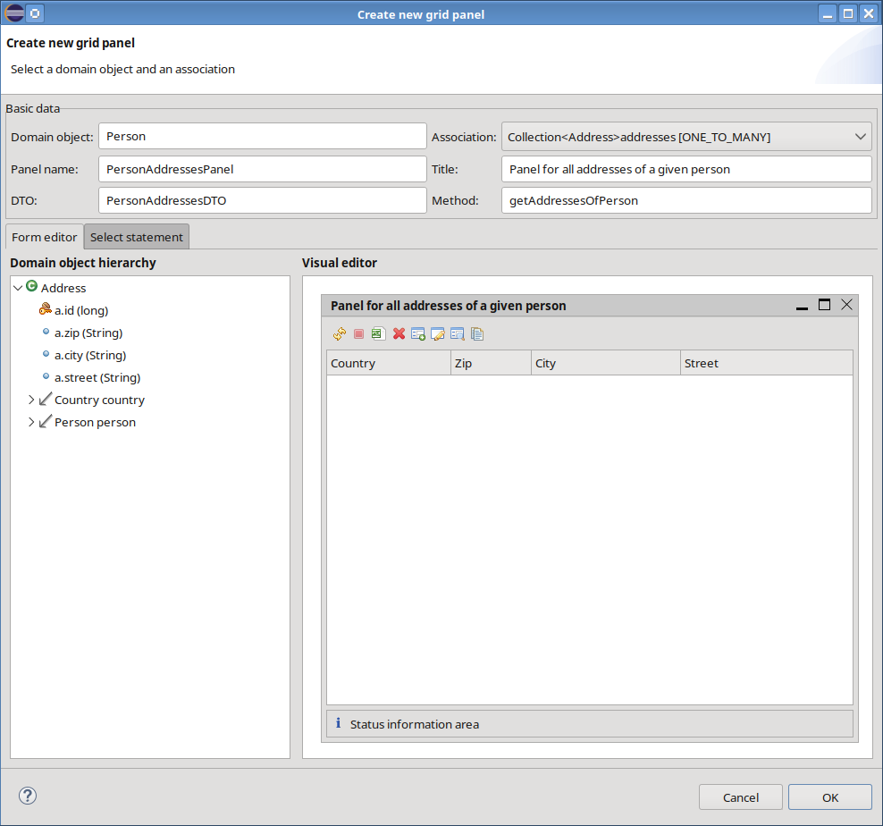Dialog for creating a new grid panel

The dialog to update Person data and to maintain the Address objects illustrates the following picture:

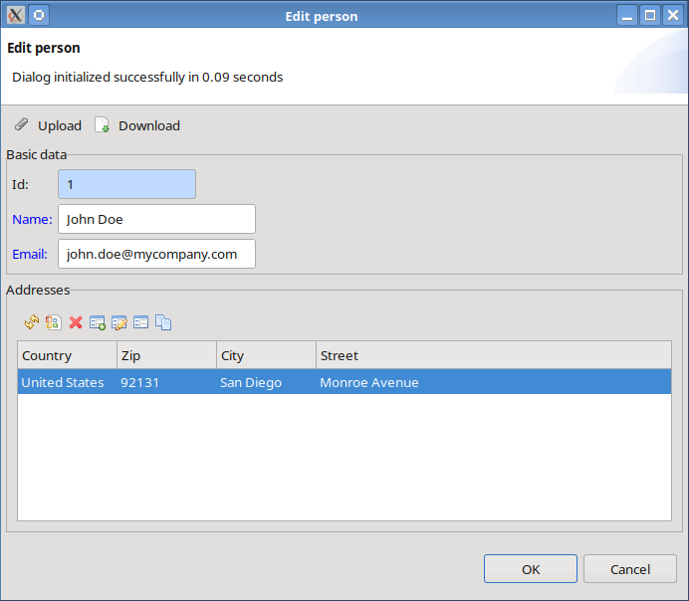Dialog with a grid panel at runtime

Tree views
This chapter covers the details on how to create tree views in CodeCadenza. Tree views are excellently suitable to display and to maintain hierarchical structures. In the first example, we want to discuss the basics how to build a very simple tree view by using the Person domain object that contains a random number of Address objects.
We have already learned that every form belongs to a form group. Thus, we first have to select a form group in the project tree view and open its context-menu. In order to create a new tree view form, we have to choose item “Create tree view”.
In the corresponding dialog, we first have to select the root domain object. Afterwards, the plug-in initializes the dialog with default values for the view's name and title. Moreover, a tree view that contains the selected domain object's hierarchy including all attributes and associations on the left side, as well as the tree view's definition hierarchy, are built up.

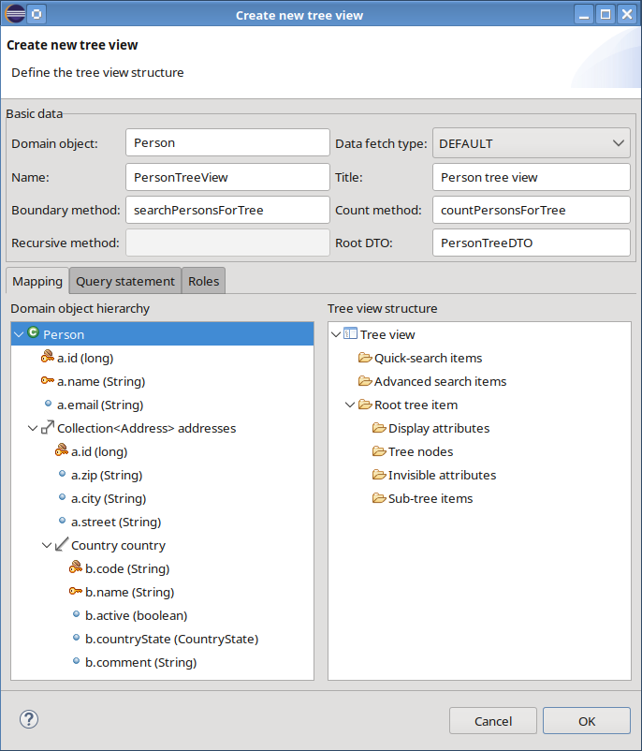Dialog for creating a new tree view
The tree view's definition hierarchy contains various folders that a developer has to fill with desired attributes or associations for the tree view on the left side:

- Quick search items

We might want to easily filter the objects to be displayed in the tree view. In order to achieve that, we just drag the name attribute of Person and drop it in this folder. Note that CodeCadenza supports attributes of type String for this feature only. Every quick search item is mapped to a search input field on top of the result tree view.

- Advanced search items
In order to enter more complex filter criteria, it is possible to add all kinds of attributes (not just attributes of type String) to this folder. At runtime, all advanced search items will appear in a search input dialog that we have already covered in the chapter about SEARCHABLE_VIEW forms. It is even possible to define tree views without any quick search items and advanced search items. In this case, the tree view always fetches all objects initially!

- Root tree item

The root tree item represents the first item hierarchy level grouping folders that belong together. Direct mapping of attributes or associations to this folder is disallowed! For example, every Person object corresponds to a root tree item.

- Display attributes

For every hierarchy level in a tree view at least one display attribute must be defined in order to specify the tree item's label at runtime. Note that the term display attribute in this context has nothing to do with the “display attribute” property of a domain attribute! Nevertheless, the name attribute is a good candidate for the tree item's label.

- Tree nodes

Every hierarchy level may contain a random number of sub-nodes, whereby every tree node is mapped to a domain attribute. Although it is not mandatory to have at least one tree node, we select the email attribute for demonstration purpose.

- Invisible attributes

While building the tree view structure we implicitly define at least one DTO that holds all attributes to exchange data between different application layers. Per definition, every DTO needs an attribute that represents the primary key of the corresponding domain object. So far, the implicitly attached tree DTO doesn't contain the primary key attribute. In particular, when working with surrogate keys, most of the time they shouldn't be visible at all. For such cases, an attribute can be dropped to the “Invisible attributes folder”.

- Sub-tree items

The sub-tree items folder represents a container for all items in the next hierarchy level. In order to create a sub-tree item, we simply have to drag a one-to-many or many-to-many association from the domain object tree view and drop it into that folder. In our first example it is possible to create just one sub-tree item by using the addresses association. As soon as the drop operation has been finished, a respective sub-tree item is displayed in the hierarchy tree view. Every sub-tree item, in turn, contains folders for tree nodes, display attributes, invisible attributes and sub-tree items. Hence, it is possible building trees with an unlimited number of levels! Note that the sub-tree items container may contain a random number of sub-tree items.
The next pictures illustrate the Person tree view at design time and runtime:

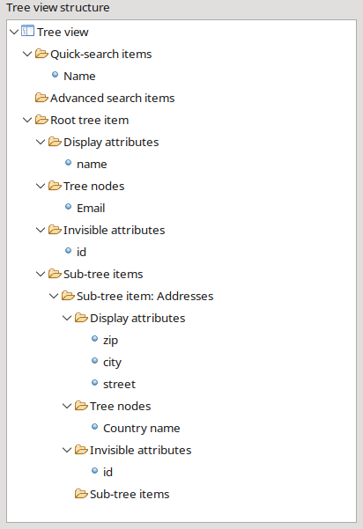Person tree view at design time
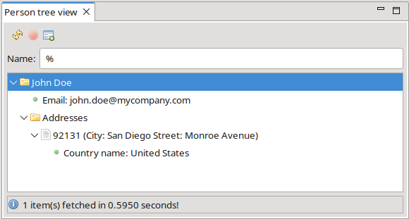Person tree view at runtime
In a second example, we want to discover some more advanced features of CodeCadenza regarding tree views.
The application should provide a ProductHierarchy that contains a one-to-many association to itself. This structure is always an excellent starting point in order to build multi-level tree views. The reverse side of the association (in this case parentHierarchy) should be marked as nullable as we need one root item at least that hasn't a parent. As the name already implies, a ProductHierarchy contains a random number of products that in turn provide product revisions.

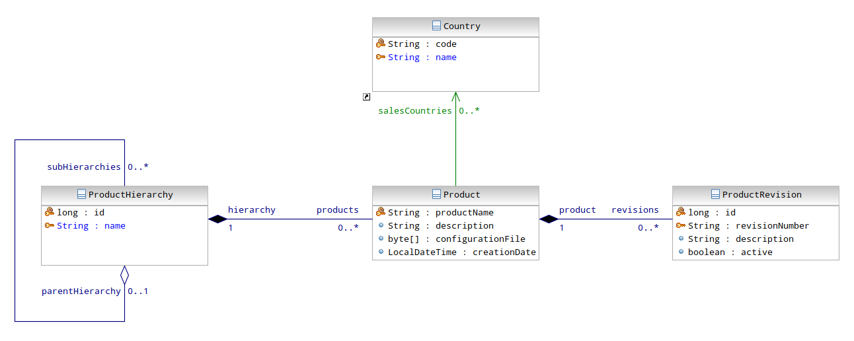Product hierarchy domain model
When opening the dialog to create a new tree view, we can select the ProductHierarchy entity as root object of the tree. Now, we are able to add products as a sub-item container of the root item. A level below we might want to add revisions and salesCountries.
In case of multi-level tree views that contain any number of sub-levels (e.g. product hierarchies), we might want to define quick and advanced search items. This is possible, but keep in mind that these fields always cover the first level of the hierarchy only!

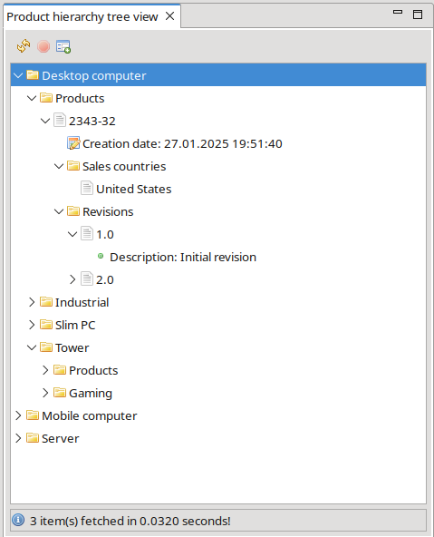Multi-level tree at runtime
In the case of one-to-many and many-to-many associations, the generated tree views even support drag-and-drop of sub-item elements. In our example, it is possible to change the level of a hierarchy element and the hierarchy a product belongs to. Note that the reverse side of a corresponding one-to-many association must be updatable in order to activate this feature when creating the tree view's source code!

Default forms
We have seen that CodeCadenza provides powerful tools for creating versatile forms. In a view minutes, the developer is able to produce thousands of lines of source code. However, it appears to be hard work to create all forms for a great number of domain objects. Moreover, when creating a project for either test or demonstration purpose, the forms should be available quickly.
CodeCadenza supports creating all forms of a selected domain object with nearly no further user interaction required. Every form group in the project navigator has a context-menu item “Create default forms” that in turn opens a dialog that initially requires the selection of an existing domain object. As soon as a domain object is selected by the user, CodeCadenza analysis the domain object and searches for existing forms. The following form fields will be initialized according to the results of the aforementioned analysis. A disabled field indicates that CodeCadenza has found an existing form of the given type for the selected domain object. Thus, a default form of this type cannot be created in this context.
If no form for a selected domain object exists, the fields will be initialized with default values. The comboxes for “Create form type” and “View form type” contain empty items that will force CodeCadenza to skip the generation of the respective form.
The possible values for field “Create form type” are ADD and CREATE. The user is able to select either SIMPLE_VIEW or SEARCHABLE_VIEW in the combobox “View form type”.
By default, the checkbox “Create list of values” is not selected. Nevertheless, the build process will create a LOV if the user overwrites the default value.
If no respective UPDATE or READONLY form exists, the fields “Create update form” and “Create read-only form” are enabled and selected and will force the creation of the forms when starting the build process.
If the selected domain object contains either many-to-many or one-to-many associations, the field “Create grid panels” is enabled and selected. The build process will create a grid panel for every single many-to-many and one-to-many association if the checkbox is selected.
The checkbox “Share DTOs” controls if a shared DTO should be used for all single record forms. This control is only available if the project is configured in boundary mode.
As tree views don't provide a default initialization they are not supported when generating default forms.
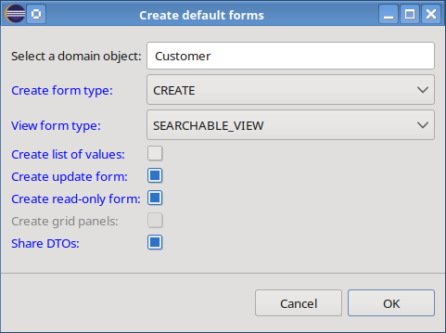Dialog for creating default forms
By pressing the "OK" button all selected forms are being generated and the dialog is closed. Afterwards, the selected form group in the project navigator is refreshed and contains the newly created forms.

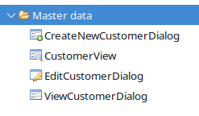New forms in the project navigator

Standard form actions in the project navigator
The tree view item in the project navigator of either a form or grid panel possesses different context-menu items.

Open | Opens the corresponding Java source file in an editor.
Edit | Opens a dialog to edit an existing form or grid panel.
Preview | Opens a preview dialog that provides similar functionality as the Visual Editor. This operation is not supported for tree views!
Rename | Opens a dialog for entering a new name.
Rebuild | Rebuilds the corresponding source file.
Synchronize actions | Searches for new actions that can be added to a list form or grid panel.
Delete | Deletes the form or grid panel in a secure manner. The delete operation fails if other forms or grid panels reference the selected element.

Boundary beans and data transfer objects
In the previous chapter, we have learned that boundary beans and data transfer objects (DTO) are created automatically when defining new dialogs and view forms. While this represents the standard way it is also possible to maintain these objects manually.

Creating new boundary beans
If a new boundary should be created, the item “Boundary beans” in the project tree view provides a context-menu with the item “New”. As soon as this item is selected a small dialog is opened that only requires the selection of an existing domain object that the new boundary bean should be based on.

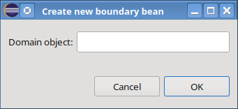Dialog for creating a new boundary bean
By pressing the "OK" button CodeCadenza creates a new boundary bean, provided that another boundary doesn't already exist that refers to the same domain object that has been selected in the dialog.
If the creation of the new object has been finished successfully, a new dialog is opened that allows us to add existing repository methods to the newly created boundary bean.

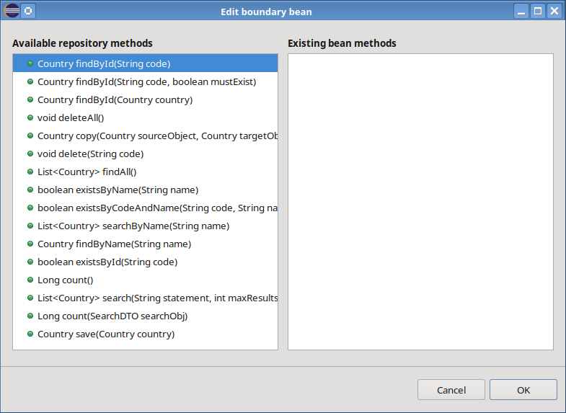Dialog for adding new methods to a boundary bean
The dialog consists of two list components. While the list component on the left side contains all available repository methods, the component on the right side shows all existing boundary methods. A new boundary method is added by simply dragging a repository method to the list component on the right side.
It might be the case that CodeCadenza needs further information if a repository method is selected. If so, a dialog is opened that lets the user fill in the necessary data.

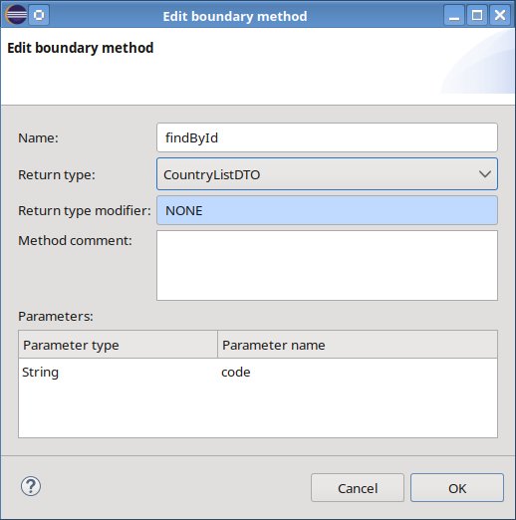Dialog for maintaining boundary method data
In some situations, the dialog is missing either necessary return or parameter types as a proper data transfer object is missing. If so, the creation of the boundary method cannot be finished successfully. To circumvent this, it is necessary to create a suitable data transfer object manually and adding the desired method afterwards.

After a new boundary method has been created it is not possible to change method-related data! If necessary (e.g. an existing method should return a different DTO), the method must be deleted in the project navigator. Afterwards, a new boundary method with the correct settings can be created again.

Creating and maintaining data transfer objects
It sometimes could be necessary to create a data transfer object manually. The starting point for this operation is again the project navigator. When selecting the menu item “New” of the tree view item “Data transfer objects” a dialog is opened that allows us to create a new DTO. Initially, an existing domain object must be selected by using field “Domain object”. After a domain object is selected, the name of the new object is proposed in field “Bean name”. Furthermore, the domain object hierarchy tree view shows all domain attributes and associations that may be used in order to create new DTO attributes. When creating a new data transfer object, the selection in field “Standard Conversion” controls if the field structure should be flat or hierarchical.

If we choose to create a DTO that shouldn't use standard conversion, all many-to-many associations will be removed form the domain object hierarchy tree view.
Within the initialization process of the dialog, the plug-in also creates default DTO attributes that are displayed in the tree view on the right-hand side of the dialog. If a new DTO should be created, it is possible to delete a random number of attributes by using the respective context-menu item. Only the DTO attribute that is mapped to the id attribute of the selected domain object must not be deleted! The same dialog is also used to edit an existing data transfer object. In this case, either new DTO attributes may be added or existing ones can be deleted. CodeCadenza will prohibit deleting an existing attribute if it is referenced by other objects (e.g. form fields)!

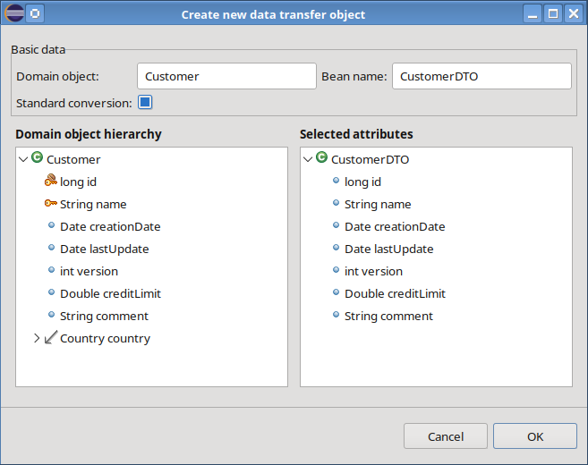Dialog for creating a new data transfer object
The context-menu of a DTO attribute also offers an item that allows us to rename the selected attribute.

In case of standard conversion, a DTO might have attributes that in turn have a DTO type. To achieve that, a domain association must be used for adding a new attribute. In contrast to attributes that have a simple type, it is necessary to select the type of the new attribute in a small dialog.

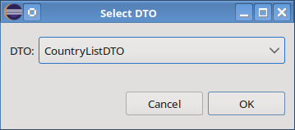DTO selection dialog

Data exchange
In most enterprise applications it is necessary to import and export data from/to external applications (e.g. ERP or CRM systems) in a predefined manner. CodeCadenza is able to support an application developer to define and to generate respective services with versatile options and features.

Basics
Before going into details, the most important terms should be described in order to ease understanding how CodeCadenza works.

- Data exchange service
A data exchange service contains methods that are responsible for data import and export. If an application is deployed on a Jakarta EE server, a data exchange service will represent a stateless session bean.

- Data exchange operation
In case of a data import, the data exchange operation parses external data, writes data into mapping objects, creates respective domain objects and copies the field values of a mapping object to domain object attributes. Finally, it persists or updates the persistent domain objects.
If an operation is responsible for exporting data, it will perform a query to determine the domain object(s) to be exported. Afterwards, it will create proper mapping objects that in turn will be initialized with respective values of the domain objects returned by the query. The mapping objects will be used to write data to the external data structure.
The generator will treat any data exchange operation as one method (e.g. importCustomer()) that will be added to a respective exchange service bean (e.g. CustomerExchangeService) that in turn refers to a specific domain object (e.g. Customer).
From a meta-model perspective, an exchange method contains a complex mapping tree that defines how an external data structure is mapped to one or more mapping objects. Depending on the selected content type and complexity, the generator creates further methods for a given data exchange operation.

- External data structure
An external data structure represents a String or a physical file that contains data to be either exported or imported.

- Mapping object
Data is not directly read or written from external data structures into the application's domain objects. Rather, a mapping object is used to carry data for import or export. The generator will treat a mapping object as a simple POJO!
It would be seductive to define an architecture without such POJOs. Rather, some might think of using persistent domain objects directly as mapping targets. From a memory management perspective, this has some advantages compared to separate mapping objects. But using mapping objects brings more flexibility and a higher degree of abstraction. The generator places the mapping objects into respective packages of the DTO artifact. This facilitates their reuse in other artifacts (e.g. see chapter 14).

- Mapping attribute
A mapping object contains any number of mapping attributes. Normally, the mapping attribute represents atomic information provided by an external data structure (e.g. column in an Excel sheet or an element in an XML file). In most cases, a mapping attribute references a persistent domain attribute.

Applied technologies and libraries
Parsing and generation of content can be very sophisticated tasks that cannot be fulfilled by CodeCadenza. Rather, the plug-in relies on external (standard) libraries. In the current version, CodeCadenza supports four different content types:

- XML
XML is still used frequently especially when different systems are exchanging data directly without user interaction. CodeCadenza uses JAXB 4.0 for XML data binding.

- EXCEL97 and EXCEL2007
The Excel format is very convenient for end users. For this format, the Apache POI library is applied for parsing and writing content. CodeCadenza supports the previous (*.xls) as well as the current document format (*.xlsx).

- CSV
Especially in case of communication with legacy applications this format is used. CodeCadenza delegates parsing and writing of CSV content to the Apache Commons CSV library.

- JSON
JSON (JavaScript Object Notation) is a lightweight, readable format for structuring data. Internally, CodeCadenza uses JSON-B for binding objects to JSON documents.

Architecture
From a system architecture perspective, a data exchange service is part of the integration layer. Hence, it cannot be used directly by remote services or applications. Rather, boundaries/facades and JMS queues/topics are responsible for building a bridge to remote systems. In many cases, a data exchange service will share files directly with a file server.

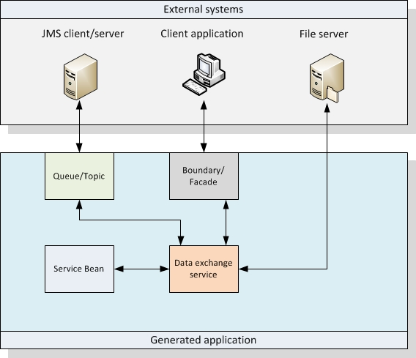Data exchange system schema

Case example
To demonstrate the most important features we introduce a sample domain model that should be used throughout the next chapters.
A customer contains some basic attributes and belongs to a customer group. Different sales persons are responsible for attending a customer. It should be possible to add any number of direct contacts to it. Further information regarding a customer (e.g. address details) is provided by class CustomerInfo.

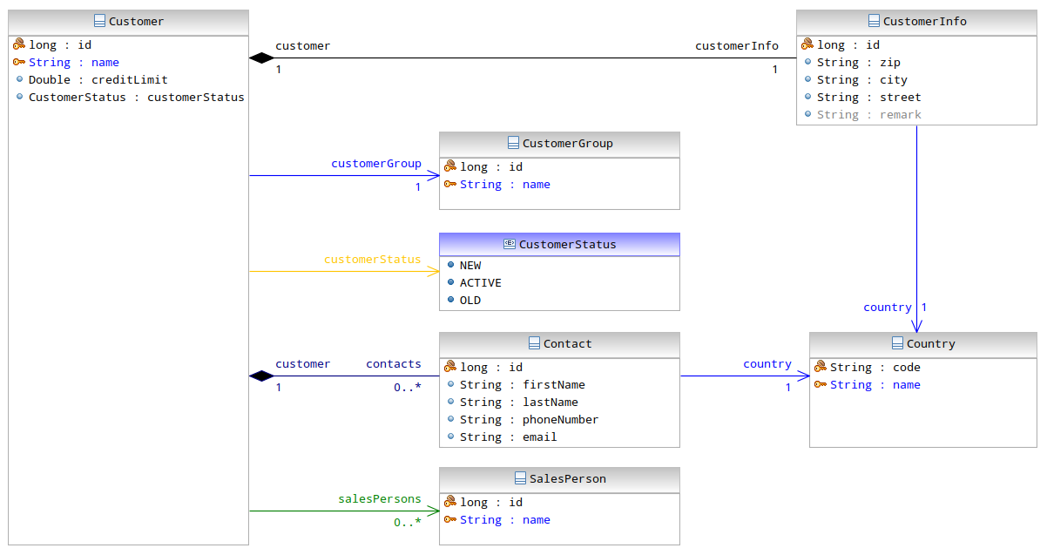Sample domain model

Creating a new data exchange method
Every project in the project tree navigator contains a folder „Data exchange“. This folder contains a pop-up menu with one item „New data exchange method“. If we click on that item, a dialog will be opened to create a new data exchange method from scratch.

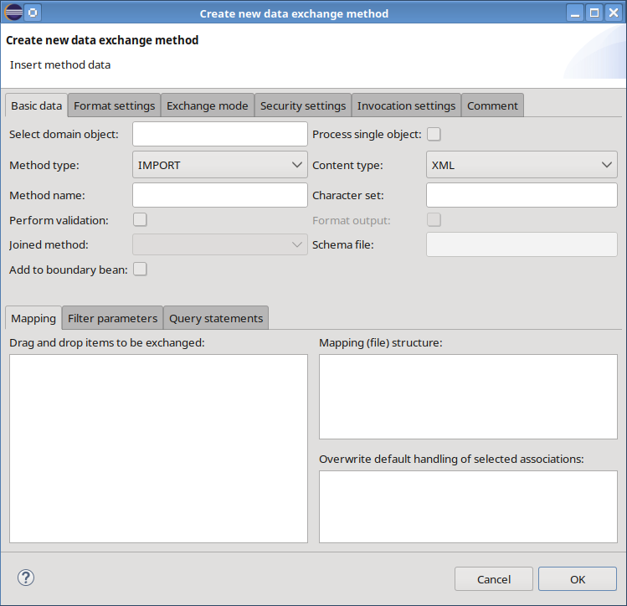Dialog for creating a new data exchange method
First, we must select an existing, non-abstract domain object that should be used in field „Select domain object“. After a domain object is selected, the dialog will be pre-initialized. The checkbox field „Process single object“ controls if exactly one or any number of objects should be processed within one method invocation.
The combobox „Method type“ is responsible for selecting if we want to import or export data. Another important field is „Content type“. As mentioned above, CodeCadenza supports five different content types: XML, EXCEL97, EXCEL2007, CSV and JSON. Once defined, the content type for a given method cannot be changed afterwards! We will come back to special features and limitations regarding the content type in subsequent chapters. The next field „Method name“ will be initialized when selecting a domain object with a reasonable default value. An application designer may change the default name but the name must apply to general Java method naming rules.
In some situations, the character set must be defined when exchanging data between two systems. The default character set is UTF-8 but it can be changed in field „Character set“. Note that the specific target platform must support a specific charset. Otherwise, it is likely that content cannot be processed at runtime!
The checkbox „Perform validation“ controls if the method should process data validation when parsing or writing data. Field „Format output“ controls if output should be created in a human readable format when performing either XML or JSON data export operations.
The combobox „Joined method“ will be discussed later. If the content type XML is selected, it is possible to define the name of a corresponding XML schema file in field “Schema file”. By selecting the checkbox “Add to boundary” the plug-in automatically creates a suitable boundary method that in turn invokes the data exchange method. This field is not being displayed if the data exchange method is already used by a boundary method!
For data exchange operations using content type CSV it is possible to define various format settings in tab-page „Format settings“.

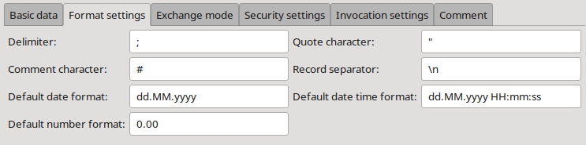Tab-page for format settings with default values
The next tab-page „Exchange mode“ controls how content is physically exchanged between the application and an external system. For most content types there are two modes available.
For import operations using exchange mode STRING a parameter that contains the data to be imported will be added to the method's signature.

e.g. void importCustomers(String content)

In case of export operations, the method returns a String if the exchange mode STRING was selected.

e.g. String exportCustomers()

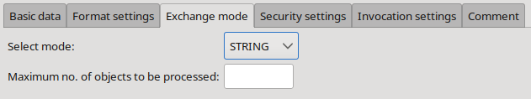STRING exchange mode for data export
The second supported exchange mode is FILE. Note that the number of fields presented to the user depends on selected content and method type!

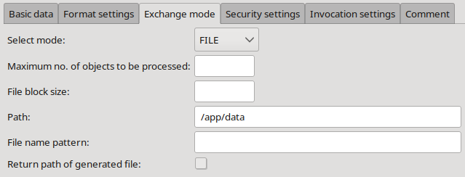FILE exchange mode for data export
If the method should be used for data import, the field “Path” contains the fully qualified path name of the file to be imported. It is also possible to specify a source folder. In this case, the import method would pick up all files in this folder.
The field „File name pattern“ contains either the import file name or a specific pattern.

Sometimes it makes sense to handle every single file in a separate transaction. If field „Start new transaction per file“ is set, the generator will adapt transaction handling accordingly! If the target file to be imported should be controlled by the caller of the method, we can set field „Add parameter for path“. In this case, CodeCadenza adds another parameter (of type String) to the method that contains the path of the file to be imported.
If a method should export data, we can limit the number of objects to be processed in field „Maximum no. of objects to be processed“. Note that this field has no effect if we want to export one object only (see field „Process single object“)!

It might be the case that an application contains a big amount of objects that should be exported. Instead of creating one big file that the target system isn't able to parse, it is possible to split files after a given number of objects have been processed. This can be defined in field „File block size“. After reaching the respective threshold, the export method creates a new file and writes the next data block to it. In this case, it is necessary to have a deeper look at the field „File name pattern“.
CodeCadenza is able to process static file names but like in the scenario above the generator must be also aware of dynamic file names.

The general syntax is: {PatterName([value,][format])}

Currently, the generator supports three different dynamic file name patterns:

- date
If the file name should contain a date value, the pattern date should be used.
e.g. Customer_{date(now, dd-MM-yy)}.xml
The pattern expects „now“ as the value which represents the current system date. The format string must follow the rules of class SimpleDateFormat!

- batchindex
If the export operation creates multiple files (see field „File block size“), this pattern helps to create unique file names.
e.g. Customer_{batchindex(000)}.xml
The pattern doesn't need a value and the format string must follow the rules of class DecimalFormat! This pattern is not supported for data import methods.

- attr
This pattern is only supported for data export operations that handle a single object!
e.g. Customer_{attr(code)}.xml
The format string can be omitted if the attribute is of type String!

CodeCadenza supports concatenating more than one pattern within one statement.

e.g. Cust_{date(now, dd-MM-yy)}_{batchindex(000)}.xml

Note that nesting of patterns is not allowed!

For export operations, it is possible to select checkbox „Return path of generated file“. If selected, CodeCadenza will add a String return type to the method's signature. At runtime, the method returns the fully qualified path name of the generated export file.

When selecting XML, the exchange mode combobox contains another item: DIRECT. If this item is selected, CodeCadenza will use corresponding mapping objects for parameter or return types. In case of an import method, a typical signature looks like:

void importCustomers(CustomerRootDTO obj)

An export method may have following signature:

CustomerRootDTO exportCustomers()

Internally, the method doesn't have to perform parsing or unmarshalling as a suitable object structure is already available. But what is this mode for? We will see in chapter 14 that boundary methods can be easily exposed via a supported integration technology (e.g. REST). But in contrast to a standard boundary method, a data exchange method provides much more powerful modelling features (as we will see in the next chapters). Of course, the usage of a data exchange method within an integration method is not limited to the DIRECT mode, but it provides a cleaner API compared to a data exchange method that is based on a different mode.

In tab-page „Security settings“ it is possible to enter the permission mode. If permission mode DEDICATED_ROLES is selected, it is possible to define specific role authorizations.

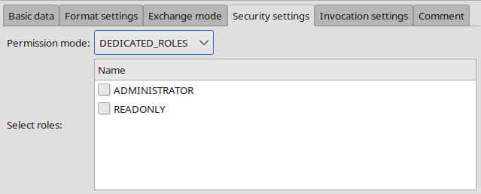Tab-page with security settings
If the application should be deployed on a Jakarta EE server or as a Spring Boot application, it is possible to define even more details of how the respective method should be invoked. These settings are available in tab-page „Invocation settings“. The first field contains the selected mode. When creating a new method, the field contains the value DEFAULT initially! This mode has no special impact. Rather, it is used only to distinguish the standard setting from others. Following modes are supported:

- ASYNCHRONOUS
If selected, the generator will add the annotation @Asynchronous to the method. At runtime, the method will be invoked asynchronously in a separate transaction context. By entering a value in field „Invocation delay (in ms)“ it is possible to delay the execution.

- SCHEDULED
In many cases, it is necessary that a method is not called by a client directly. Rather, an export or import operation should be processed on a regular basis. In this mode, the generator adds the annotation @Schedule. For all annotation elements the form provides corresponding input fields. Note that the application developer is responsible for entering correct values!

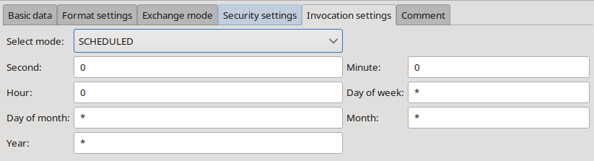Tab-page “Invocation settings” in mode SCHEDULED with default values
Last but not least, the dialog provides a tab-page that allows us to change the default comment.

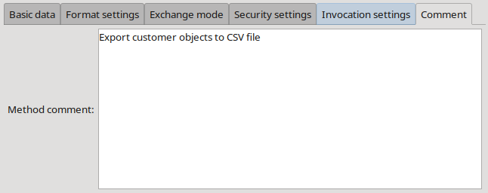Tab-page "Comment"

Mapping persistent domain model to external data structures
So far, we have just defined global settings regarding a method that should be responsible to either export or import data. More or less only the method's signature has been specified yet. But the generator must be also aware of how attributes and associations of our domain model should be mapped to the external data structure.

Mapping domain attributes
After selecting a valid domain object, a tree view on the left side of tab-page „Mapping“ will be filled with all attributes and associations. CodeCadenza doesn't support attributes of type Byte[] and byte[] for data exchange operations. Hence, they won't be added to this component!
The initial content of the tree view for the external data structure on the right side of this tab-page depends on the selected domain object, the content type and the setting in field „Process single object“. In any case, the mapping tree view contains a container-element that refers to the domain object selected already. If content is provided in XML format, the root element is the XML root element. In case of EXCEL97 or EXCEL2007, it represents a data sheet. If CSV is selected as content type, it is just a container for all columns.
Every mapping element contains at least a sub-folder “Attributes” that acts as a container for all mapping attributes of a given element. As with the elements, the mapping attributes have different meaning depending on the selected content type. A mapping attribute represents an XML attribute if the content type is XML. If we add a mapping attribute to an Excel sheet, it's just like adding a new column to that sheet. If CSV is selected, an attribute will represent one dedicated column. In case of JSON an attribute is mapped to a name-value pair.
It is not possible to create mapping objects (attributes or elements) that are mapped to multiple domain object attributes or associations!

If a method handles multiple objects that must be either imported or exported in XML format, an element (e.g. customers) without attributes will be added automatically. This element represents the XML root element that always contains one sub-element (e.g. customer) that in turn carries further sub-elements and attributes.

In most cases, it is irrelevant how many attributes are mapped to a mapping element (e.g. customer) that acts as a container for further mapping elements or attributes. Normally, it is necessary that a corresponding primary key or display attribute will be mapped to a container-element! Otherwise, it can be hard or even impossible for the generator to create proper output! If the external data structure cannot provide either the primary key or the display attribute, it is also possible to create a valid mapping. But this will be discussed in one of the following chapters.
To some extent, the external data structure must match the domain object model. That means that a persistent attribute cannot be placed at any location in the mapping tree view. A persistent attribute can be added to a container-element if the attribute belongs directly to the attribute list of the container-element's domain object. It is also possible that a domain attribute will be mapped if it is connected through any number of cascaded many-to-one or one-to-one associations to the container-element's domain object! CodeCadenza prevents creating illegal or unsupported mappings!
Note, that there are special rules that apply for domain attributes that are mapped to an element collection. On the one hand, they are not supported for CSV and EXCEL! When using JSON, the attribute must be mapped to a data exchange attribute. In contrast, with XML it must be mapped to a data exchange element.

In a first step, we just map some persistent domain attributes to an XML data structure by dragging attributes from the domain object tree view and add them to the “Attributes” folder of the container-element customer.

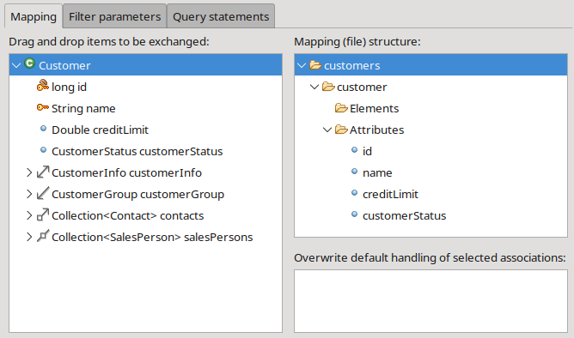Basic attribute mapping for customer objects (XML)
Example XML data structure:

<?xml version="1.0" encoding="UTF-8" standalone="yes"?>
<customers>
<customer id="123" name="ABCD Inc." creditLimit="0.0" customerStatus="NEW"/>
</customers>

Note that it is also supported to map domain attributes to XML elements! In this case, we just would have dragged the domain attributes to sub-folder “Elements” of container-element customer!

If another content type is selected, the mapping file structure will look different:

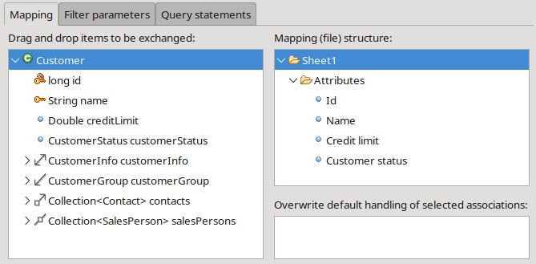Basic attribute mapping for customer objects (EXCEL)
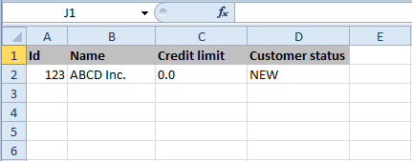Excel sheet that fits the required mapping structure
Depending on specified format settings (see above), a corresponding CSV data structure could be like this:

"Id";"Name";"Credit limit";"Customer status"
"123";"ABCD Inc.";"0.00";"NEW"

Mapping many-to-one associations
In the previous chapter, we have covered how to map domain attributes to external data structures. Now, we dive into the mapping of different kinds of domain associations and start with the many-to-one association.
In case of export operations, we can just map attributes that belong to the association's target object as we did before with attributes of the selected domain object (see above). For import operations there are some differences that must be explained in detail!
The most important question in this context is how an association can be controlled by an external data structure? In CodeCadenza the reference control has been realized by mapping the primary or display attribute of the association's target domain object. In our example, the Customer domain object has a many-to-one reference to the domain object CustomerGroup. As we want to set this association during insert or update operations while importing data we must drag the id or name attribute from the domain object tree view and add it to the “Attributes” folder in the mapping tree view.
The developer may even select both. But what happens if he does? If the respective generator finds such a configuration later on, it will take the id attribute prior to the name attribute. This is an internal standard behaviour and cannot be changed by adapting the meta-model configuration! The reason for this is simply a matter of performance. Especially when importing many objects, a query using the display attribute as filter criterion must be performed for every single object in order to set the association properly! When using the primary key attribute, the generator will use the entity manager's getReference() method which should be much faster than performing a query!
It is also possible that attributes neither represent a primary nor a display attribute. But these attributes will not be used to determine the respective association.
Associations can be optional also. As a result, the external data structure provides e.g. empty fields at runtime. In this case, a respective association is set to null. But sometimes the primary key attribute is of type long or int. Per definition, the value 0 will set the corresponding association field to null!
In some scenarios, it is not possible that an external system either provides the primary key or the display attribute of our domain model in order to determine the respective association when importing data. To handle these cases CodeCadenza provides another way of reference control. The dialog to create new data exchange methods contains another tree view component in the „Mapping“ tab-page that can be used to overwrite default association control. In almost the same manner as attributes can be mapped to an external data structure a mapping attribute from the mapping tree view or an association from the domain object tree view can be dropped to this component. After this operation has been finished, a new item will be added. The root node contains information about the association being used and contains two sub-folders.
The sub-folder “Attributes for reference determination” contains all attributes that should be used to control the association.

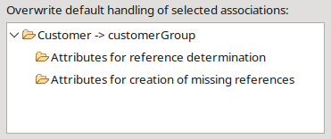Reference control
If an association is configured to be driven by these attributes, the generator won't use a mapped primary key or display attribute for reference determination. Note that the generator requires one mapping attribute to be defined at least in order to generate expected output!

It is even possible to create referenced objects that currently don't exist in the project's target database we are importing data to. In order to instruct the generator to handle that case, we can drag mapping attributes to folder “Attributes for creation of missing references”.

As an example, it should be assumed that the customer data import interface provides an attribute that is mapped to domain attribute name of domain object CustomerGroup. Moreover, it could be the case that the interface provides attribute values that don't exist in the database yet and the import process should create missing reference objects of type CustomerGroup. The mapping attribute customerGroupName must be added to both folders:

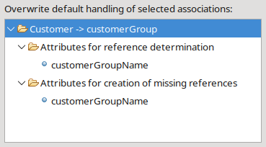Configuration for creating non-existing reference objects
The generator will add a new method (e.g. findCustomerGroup()) for all associations that should be handled in that way. First, the method will perform a query in order to search for an object that fits expected filter criteria (e.g. customerGroupName).
If the query finds an object, it will be returned directly to the data import method. In the case of getting non-unique results, an exception will be thrown! If no object has been found, it will create a new CustomerGroup object, sets all available attributes that have been specified in folder “Attributes for creation of missing references”, persists the new object and finally returns it to the caller.

Mapping many-to-many associations
The interface should be expanded by adding the many-to-many association salesPersons. In case of XML, this can be achieved by dragging the respective association item from the domain object tree and dropping it to sub-folder “Elements” of the customer container-element. The plug-in generates a new container-element salesPerson including sub-folders “Elements” and “Attributes” in the mapping tree view.
For reference determination we have to map the primary key or display attribute of the association's target domain object to an attribute or element of the external data structure (cf. Mapping of many-to-one associations).

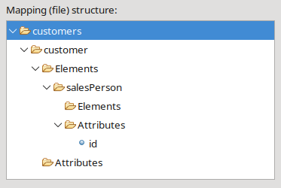Mapping of a many-to-many association (XML)
Example XML data structure:

<?xml version="1.0" encoding="UTF-8" standalone="yes"?>
<customers>
<customer id="123" name="ABCD Inc." customerStatus="NEW" creditLimit="0.0">
<salesPerson id=”332”/>
<salesPerson id=”564”/>
</customer>
</customers>

If the method should either import or export data in Excel format, the association must be dropped to the root element Sheet1!

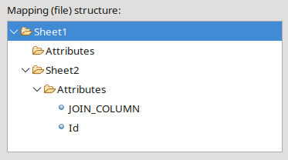Mapping of a many-to-many association (EXCEL)
CodeCadenza creates a second container-element Sheet2. We also drag the id attribute of domain object SalesPerson to the “Attributes” folder of Sheet2.

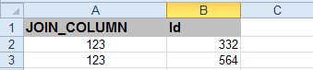Excel sheet for a many-to-many association
Note that the plug-in automatically adds another mapping attribute JOIN_COLUMN. If the data exchange operation should handle more than one “master” object (e.g. Customers), this column is necessary to link “detail” objects in further sheets (e.g. Sheet2) to rows of the master sheet (e.g. Sheet1). It is possible to delete that special mapping attribute but the generator won't be able to generate code that is responsible for joining master and detail objects afterwards. The JOIN_COLUMN is also used for mapping of one-to-many associations (see the following chapter).

The mapping of many-to-many and one-to-many associations is not supported for content type CSV!

Mapping one-to-many associations
This chapter describes how to map one-to-many associations for data exchange operations. Once again we use the Customer domain object as the root object in our mapping hierarchy. In the example domain model, the Customer class has a one-to-many association contacts to domain object Contact. This association must be dragged to the “Elements” folder. As soon as the association will be dropped to that folder, CodeCadenza creates a new container-element contact including the sub-folders “Elements” and “Attributes”.

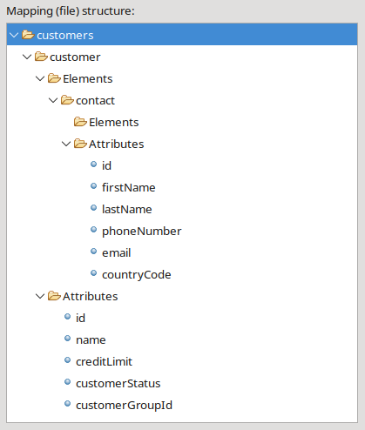Mapping of a one-to-many association (XML)
In contrast to many-to-many associations where only references between two objects had to be maintained, we now have Customer and Contact objects that must be handled in a proper way! Therefore, it is normally not enough just to map the primary key or display attribute of the association's target domain object. Particularly for data import operations where Contact objects have to be either created or updated it makes sense that an appropriate number of attributes is mapped. CodeCadenza doesn't provide a check if mandatory mapping attributes are missing for insert operations!

Example XML data structure:

<?xml version="1.0" encoding="UTF-8" standalone="yes"?>
<customers>
<customer id="123" name="ABCD Inc." customerStatus="NEW" creditLimit="0.0">
<contact id=”642” firstName=”Jane” lastName=”Doe” phoneNumber=”112”.../>
<contact id=”142” firstName=”John” lastName=”Doe” phoneNumber=”110”.../>
</customer>
</customers>

Note that the plug-in doesn't support recursive one-to-many associations!

It is also possible to handle one-to-many association mappings for Excel documents. The mapping tree view is slightly different:

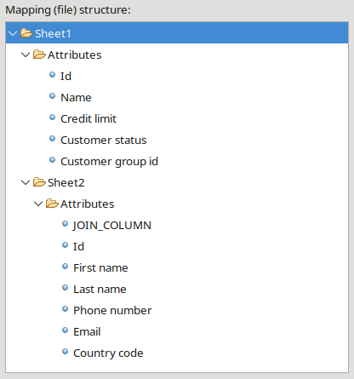Mapping of a one-to-many association (EXCEL)
A corresponding Excel file might look like the following:

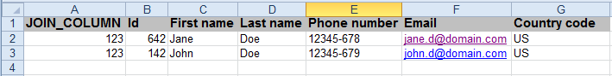Excel sheet for a one-to-many association

Mapping one-to-one associations
The last association type to be discussed is the one-to-one association. In our example, domain object Customer contains a one-to-one association to CustomerInfo. In order to successfully create new Customer objects when performing data import operations, it is necessary to generate a CustomerInfo also. CodeCadenza provides three options how to handle one-to-one associations:

As described above, it is allowed to map all attributes that are directly or indirectly wired through many-to-one or one-to-one associations to a container-element's domain object. For this reason, we can just map all attributes of CustomerInfo to the customer element:

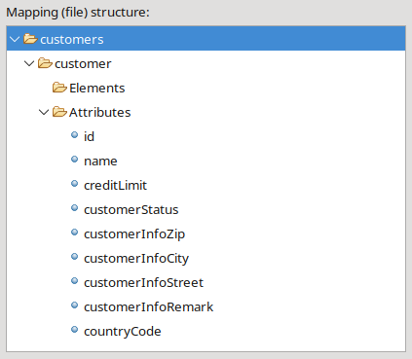Mapping of a one-to-one association (XML)
The id attribute of domain object CustomerInfo can be omitted in that case as its value is created by the persistence provider.

As an alternative, the association can be also used to create a new container-element by simply dragging the association from the domain object Customer to the “Elements” folder of the container-element customer.

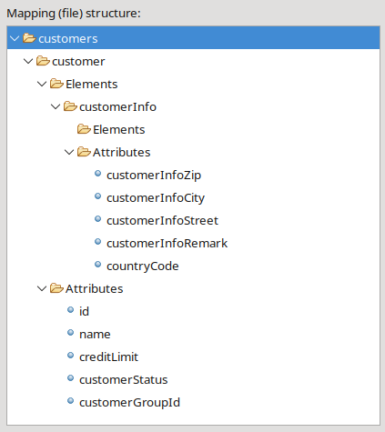Mapping of a one-to-one association to a new container-element (XML)

Furthermore, we even could mix aforementioned mapping strategies! But care has to be taken as the generator is not optimized for that and thus, runtime errors might come up due to association cascade settings that prevent the referenced object (e.g. CustomerInfo) from being persisted! Note that mapping of associations to container-elements is generally not supported for CSV!

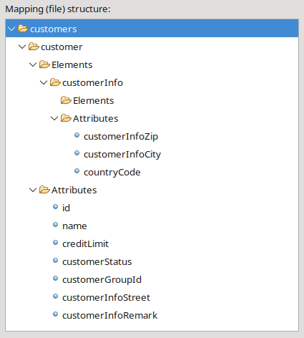Mapping of a one-to-one association to two different container-elements (XML)

Edit mapping element and attribute data
When mapping persistent domain attributes and associations, CodeCadenza automatically initializes different meta-data regarding created mapping attributes and elements (e.g. name, data type...) in the background. In many cases, it is very likely that the developer accepts these values as they satisfy his or the project's needs.
But if these values have to be changed afterwards CodeCadenza provides a broad range of different features to change or even to enhance the mapping meta-model.

Edit data of an attribute that is mapped to a data exchange attribute
A mapping attribute's meta-model field values can be changed in a separate dialog by performing a double-click on the respective mapping tree view item or by pressing the pop-up menu item “Edit attribute”.

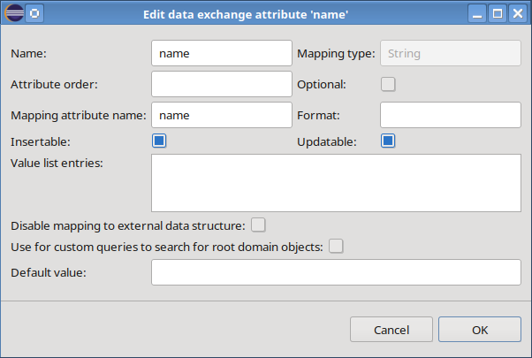Dialog to edit an exchange mapping attribute
The field “Name” contains the name of the mapping attribute. The mapping attribute's type name is shown in field “Mapping type” and cannot be changed! The field “Attribute order” is empty by default. A value can be entered but the plug-in won't use the field value in the current version!
An external data structure may contain optional attribute or column values. The checkbox “Optional” can be used to overwrite the default setting. Normally, an attribute or a column that belongs to the external data structure is mapped to a mapping attribute that in turn belongs to a mapping POJO. The field “Mapping attribute name” can be used to change it.
Especially for CSV content, the field “Format” is used in conjunction with numeric and date attributes. This is necessary because of the fact that all cell values that must be read come as String. The generator must be aware of how to convert these values into appropriate target types (e.g. java.util.Date)!
In case of data import operations, it is possible to control if an attribute should be used for insert and/or update operations. The fields “Insertable” and “Updateable” allow the user to overwrite the default values.
Sometimes the business logic requires limiting the number of possible entries in a field. Those business rules can be even expanded to external data structures! For example, a String field should contain only the values “UNDEFINED” and “ACTIVE”. These values can be added to list component “Value list entries”. For the supported content types the effect of doing so is different!
For XML the values would be added to the respective XML schema. In case of EXCEL97 or EXCEL2007, the generated export file would be supplied with a list constraint for all cells of a particular column. For CSV and JSON these entries have no effect!
In some cases, the external data structure is not able to provide mandatory data for a given attribute. As a result, import operations would fail due to the fact that an object cannot be created with missing mandatory fields. To solve that problem an attribute can be provided with a default value in field “Default value” and field “Disable mapping to external data structure” can be selected!
For data exchange methods that collaborate with EXCEL97 or EXCEL2007 files the dialog looks slightly different as it contains some additional fields:

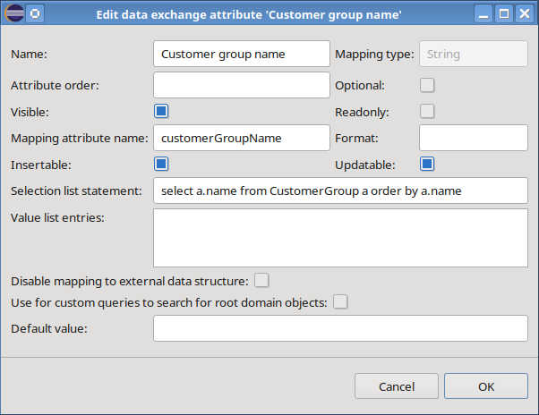Dialog to edit an exchange mapping attribute (EXCEL)
The field “Visible” controls if a column is visible within a respective sheet. This can be helpful when exporting e.g. surrogate keys that should be available in the sheet but not visible to an end user. The value of field “Readonly” has currently no effect.
CodeCadenza also provides a powerful feature that allows adding selection lists to generated Excel files for a given attribute. We just have to enter a valid JPA single-attribute query statement (see above) into the field “Selection list statement”. Note that it lies in the developer's responsibility to enter a formal correct statement!

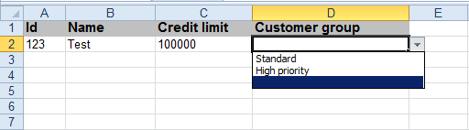Excel file containing a selection list
If an attribute contains a selection list statement and entries in field “Value list entries”, the plug-in will automatically use the list statement prior to the value list entries when generating the method's source code!
It was already mentioned that we normally need either the primary key or the display attribute in order to determine the respective domain object at runtime. But sometimes an external data structure cannot provide this data. In this case, we can select one or more attributes that should be used for searching a root domain object by selecting field “Use for customer queries to search for root domain objects”. If selected, the generator will add an additional method to the generated exchange service bean that will be responsible for searching the root domain object while performing a data import operation.

Edit data of an attribute that is mapped to a data exchange element
If content type XML is used, a domain attribute can be also mapped to a data exchange element. If a developer wants to change respective data, he can open a dialog that in turn is very similar to the dialog for editing an exchange attribute. Hence, only important differences to the dialog above should be explained here.

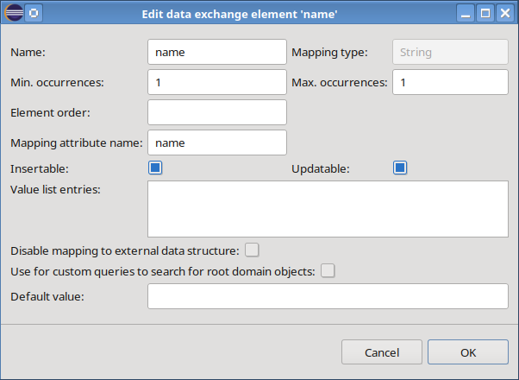Dialog to edit an exchange mapping element
The fields “Min. occurrences” and “Max. occurrences” control how often an element may appear within a parent container-element. For domain attributes the value for “Max. occurrences” is always 1 and cannot be changed. The possible values in field “Min. occurrences” are 0 or 1. The field “Element order” is intended for future use!

Edit container-element data
Every data exchange method contains at least one container-element (e.g. Sheet1) that in turn is mapped to an exchange mapping object (e.g. CustomerExchangeDTO). It is also likely that initial settings regarding those elements must be changed.

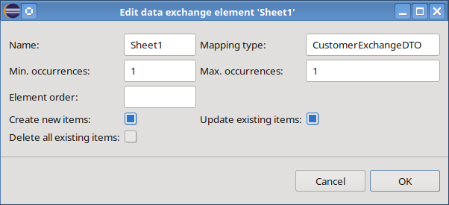Dialog to edit a container-element (EXCEL)
The field “Name” contains the element's name. In field “Mapping type” we can change the default name of the corresponding mapping object class. The fields “Min. occurrences” and “Max. occurrences” define how often the respective element can be added to its parent element. For root container-elements both fields always have value 1! Values in field “Element order” currently have no effect! In case of data import operations, the dialog contains three additional fields that manage general generator characteristics. If field “Create new items” is selected, the generator will add source code in order to create non-existing objects. It is also possible to control if fields of existing objects should be updated during the import process. If “Update existing items” isn't selected, the import won't touch existing objects at all! Note that it is even possible to deselect both fields. In this case, the import neither creates new nor it updates existing objects. Care has to be taken if field “Delete all existing items” will be selected! In this case, the import would delete all objects (e.g. customers) before creating new objects provided by the import interface.
If content type XML is selected, the dialog will contain an additional field “Schema type name” that allows the developer to change the initial name of the XML schema type.

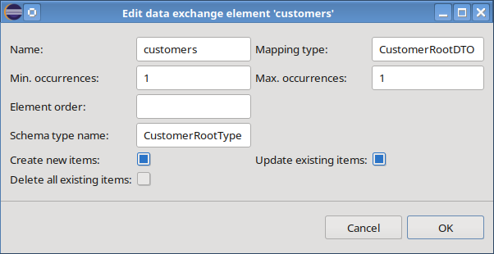Dialog to edit a root container-element (XML)
If we want to perform an XML data exchange operation with Customer objects including the one-to-many association contacts, the corresponding container-element's dialog will contain another field “Wrapper element name”. As soon as we enter a field value (e.g. contacts), the contact elements will be embedded into the parent element contacts!

Example XML data structure:

<?xml version="1.0" encoding="UTF-8" standalone="yes"?>
<customers>
<customer id="123" name="ABCD Inc." customerStatus="NEW" creditLimit="0.0">
<contacts>
<contact id=”642” firstName=”Jane” lastName=”Doe” phoneNumber=”112”.../>
<contact id=”142” firstName=”John” lastName=”Doe” phoneNumber=”110”.../>
</contacts>
</customer>
</customers>

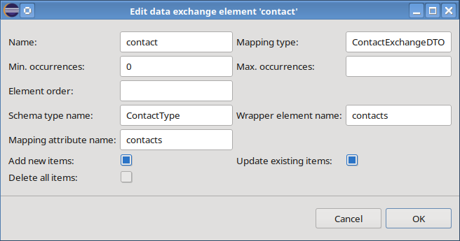Dialog to edit a container-element that is mapped to a one-to-many association (XML)

Create unmapped attributes and elements
Until now, all examples have been built assuming that all mappings between internal objects and external data structures match exactly! In real-world scenarios, it is likely that both data structures are more or less different. To some extent, CodeCadenza even supports handling such cases.

In a first example, the external data structure should provide an XML attribute, a CSV or an Excel column or a JSON name-value pair with name type and the import process should be able to import that into the mapping attribute customerType. An unmapped attribute can be added by clicking on pop-up menu item “Add attribute” of sub-folder “Attributes". The following dialog will be opened:

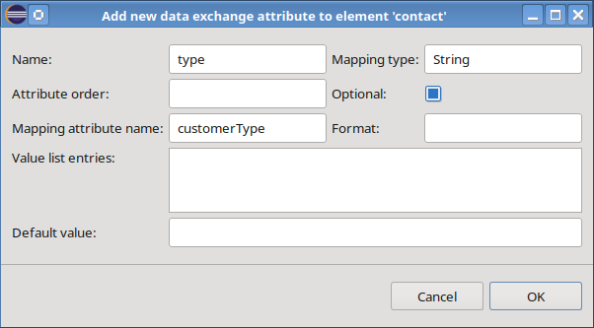Create a new unmapped attribute
When performing the import operation, the respective method is now able to read data from the attribute type and would write the value into mapping attribute customerType. Note that the field's value cannot be written to the target database as no persistent attribute exists that is able to carry it! It is now up to the developer deciding how to continue working with that unmapped attribute.
If no value has been entered in field “Mapping attribute name”, an attribute won't be added to the respective mapping object (e.g. CustomerExchangeDTO)!
If the application should export customer objects to an external system, it is also possible that we define unmapped attributes. Particularly in these cases it might be helpful to enter a default value (e.g. N/A) for mandatory attributes of the external data structure!
For the content type XML CodeCadenza provides the functionality to create unmapped elements. The pop-up menu of sub-folder “Elements” contains two items. If we select menu item “Add unmapped element”, the following dialog will be opened:

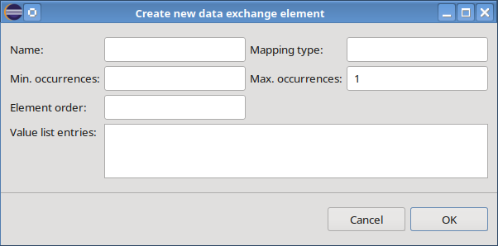Dialog to create an unmapped element
The dialog requires entering values into fields “Name” and “Mapping type”. By pressing “OK”, we extend the XML schema with an element that belongs to a respective parent element. A mapping attribute to be filled by the parser won't be added!
If such a mapping attribute is required, the menu item “Add mapped element” has to be selected! In this context the word mapped refers to the corresponding mapping attribute!

Query statements
By default, a data export operation takes all available objects (e.g. Customer) and writes them to the external data structure. CodeCadenza allows overwriting the default query statement in tab-page “Query statements”.

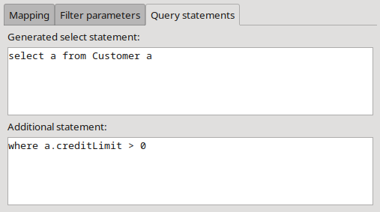Tab-page for query statements
The field “Generated select statement” contains the query statement created and maintained by CodeCadenza. It shouldn't be changed manually! As an example, the method should only export customers with a credit limit greater than 0. The appropriate JPA query fragment can be entered in field “Additional statement”.

Adding filter parameters
Sometimes the number of objects to be exported cannot be determined solely by a static query statement. Rather, the caller of the data export method should be able to provide filter criteria dynamically. CodeCadenza allows defining filter parameters in tab-page “Filter parameters”.

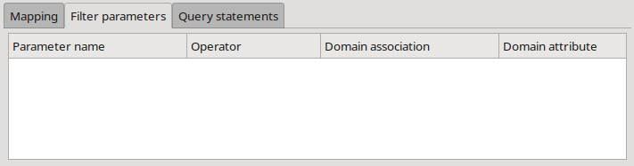Tab-page for creating and maintaining filter parameters
The grid component provides a context-menu with different items to create, update and delete filter parameters. By clicking on item “Create new parameter” a dialog is opened:

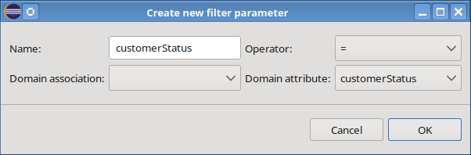Dialog for creating a new filter parameter
When creating a new parameter, the dialog expects a valid name in field “Name”. Furthermore, an operator must be selected. The combobox “Domain association” contains all many-to-one and one-to-one associations of the selected root domain object (e.g. Customer). As soon as we change the selection, all domain attributes of the selected association's target domain object will be added to combobox “Domain attribute”! If no association has been selected, the combobox will contain all attributes of the root domain object. Note that every filter parameter requires an attribute to be selected! When pressing "OK", the parameter will be added to the method:

String performCustomerXMLExport(CustomerStatus customerStatus)

The generated JPA query statement (see above) will be adapted also:

select a from Customer a where a.customerStatus = :customerStatus

It is possible to add any number of filter method parameters. The generated query fragments will be concatenated using an AND operator!
As soon as a data exchange method is used by a boundary method it is not possible to either add new or delete existing filter parameters.

Joined data exchange methods
A data exchange method will be created always for a specific domain object and content type. Moreover, a developer has to decide if the method performs an import or an export operation. The practice has shown that it could be the case that an application has to import and export data via the same data structure. From what we have learned so far, we would be forced to create two data exchange methods with the same (redundant) mapping structure to handle that case.
CodeCadenza offers an easy solution handling such use cases by introducing the concept of joining two methods. The starting point of doing this is always the import method as only an export method can be joined to an existing import method. After creating the import method, the developer must create the joined export method. Note that some general method settings must be equal in order to create a join:

- selected root domain object (e.g. Customer)
- content type (e.g. XML)
- setting in field “Process single object”

Whenever the developer changes these settings, the dialog searches for suitable import methods and adds them to combobox “Joined method”.

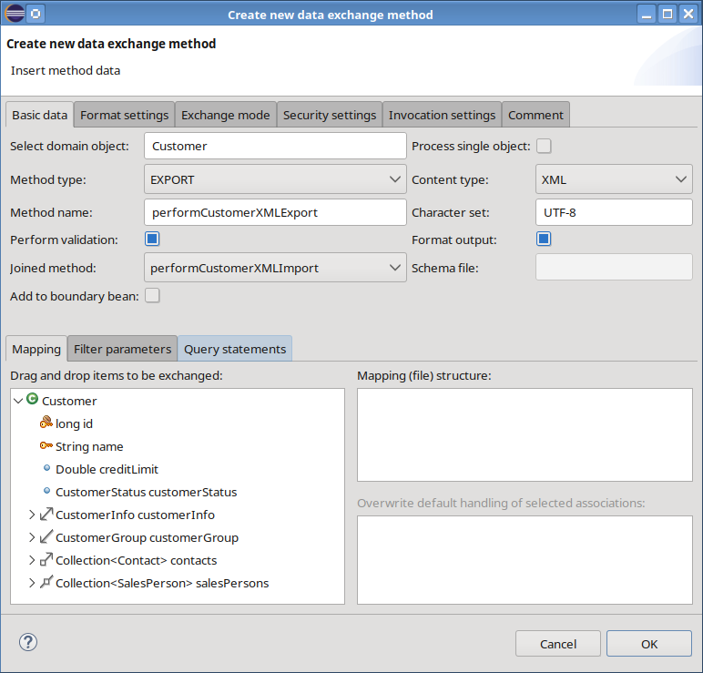Creating a joined data exchange method
As soon as we select a method in combobox “Joined method”, the tree view components in tab-page “Mapping” will be reset and disabled as mapping definition is entirely driven by the import method.

Client integration
From an architectural point of view, a data exchange service belongs to the integration layer of an application. Especially if the application runs in a managed environment (Jakarta EE or Spring Boot) these services are basically not accessible by a remote client. On the other hand, some business processes require either uploading import files or downloading export files. Furthermore, when developing an application, it proves to be very beneficial testing generated data exchange methods via the generated client. For these use cases, CodeCadenza provides an easy way to generate respective source code.
For example, the customer Excel import should be available in the generated client. As a prerequisite, a view form of type SIMPLE_VIEW or SEARCHABLE_VIEW for the corresponding root domain object (e.g. Customer) must exist. As the data exchange operation must be bound to a client by a respective form action we have to open the dialog to edit an existing view form (e.g. CustomerView). The Visual Editor possesses a context-menu item “Create new action”. If we click on that item, a dialog will be opened:

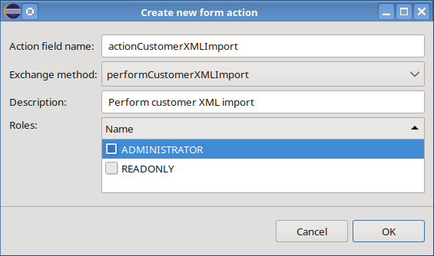Dialog for creating a new form action
As soon as an exchange method in combobox “Exchange method” is selected, all dialog fields will be initialized automatically with proper default values. When pressing "OK", a new action will be added to the corresponding view form. Moreover, the plug-in creates a boundary/facade method that in turn forwards invocations to the selected data exchange method.

Integration beans
The previous chapters have already documented that CodeCadenza also provides a feature for modelling integration beans. In this chapter, we want to discuss the details of how this is implemented.

Basics
In the current version, CodeCadenza supports five different integration technologies. SOAP, REST, JMS and RMI can be used in a Jakarta EE project. The integration technologies SOAP, REST, JMS and KAFKA are supported in Spring Boot projects. It is also important to note, that a respective integration module must have been defined while creating a new project (see chapter 6). The definition of new integration modules after creating a new project is not supported!
A new integration bean can be created by selecting the respective integration module namespace in the project navigator. When selecting the context-menu “New integration bean”, a dialog for creating the new service is opened. The integration technology is implicitly defined by the integration module namespace we have selected before!
The starting point for initializing a new service always represents the selection of an existing domain object by using field “Domain object”. As soon as a valid domain object is selected all other dialog fields are filled with appropriate default values.
The name of the service implementation class can be changed in field “Bean name”. The field “Interface name” represents the name of the service endpoint interface. If the integration module provides a client artifact, the field “Client class name” can be used to change the default name of the generated service client class. If the field is left blank, the generator won't create a respective class! If the the creation of producer classes is enabled for the given integration module the dialog will contain a field “Producer class name” that is filled with an appropriate default value. As with the “Client class name” field it is possible to provide an empty input so that this class won't be created.
It is important to understand that integration bean methods always refer to a corresponding boundary method. Initially, an integration bean hasn't got a method. The definition of new methods is accomplished in the main area of the dialog which contains two tree views. The tree view on the left side is responsible for displaying all available methods that can be used for adding a new method to the selected bean. If a domain object is selected, this tree view will contain all existing boundary and repository methods. Thus, it is even possible to select a repository method. In this case, CodeCadenza will create a respective boundary method internally that in turn is referenced by the corresponding integration method. The tree view on the right-hand side shows all existing methods. We can create a new integration method by dragging an existing boundary or repository method to the tree view on the right-hand side.

In the case of an Angular application CodeCadenza will automatically create all REST integration methods that are necessary for the communication between the GUI and the back-end!

We will see in the following chapters that CodeCadenza provides comprehensive support for controlling technology-related information on bean and method level. But this does not apply for method parameters! If necessary, the respective source code generators will use reasonable default values (e.g. regarding annotations) in order to supply further information regarding integration method parameters.

No matter what technology has been chosen, this dialog has always the same base structure and provides the same functionality. On the other hand, every technology comes with its own specific details that must be handled in order to create a service in an adequate manner. The following chapters will show the technology-specific settings that are supported by CodeCadenza.

REST
When creating a REST service, the dialog will contain two additional fields. The field “Path” controls the URI path template to which the respective resource responds. In the current version, CodeCadenza supports two different content types (JSON and XML) that can be used to map an ASCII-based character string to an arbitrary number of objects a REST method may either consume or produce. The combobox “Default content type” controls the preferred content type when creating a new integration method. We will see afterwards that it is also possible to change the default content type for every single method.

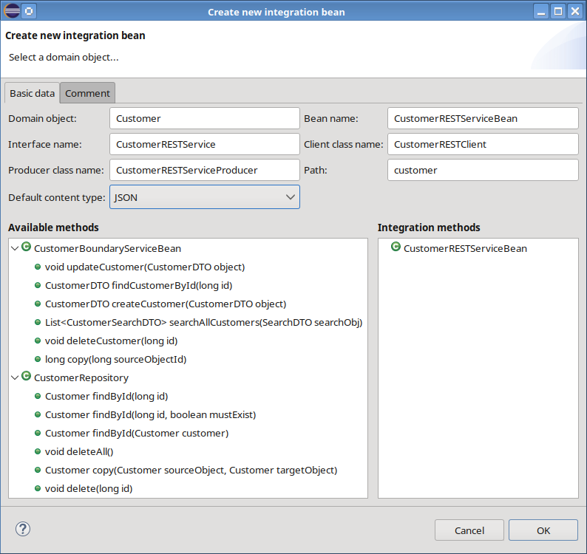Dialog for creating a REST integration bean
After dragging a boundary method (e.g. updateCustomer) to the tree view on the right side, CodeCadenza automatically creates a new integration method which in turn is instantly displayed in the integration method tree view. When performing a double-click on the respective tree view item, a dialog is opened that allows us to change the proposed default settings.

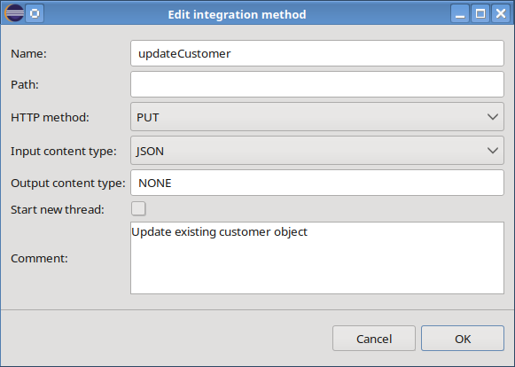Dialog for maintaining details of a REST integration method
Beside of the standard fields “Name”, “Start new thread” and “Comment” that are available for every integration method the rest of the fields depend on the selected integration technology. In case of REST, following fields are also available:

Path | URI path template to which the respective method is mapped to. The field can be blank.
HTTP method | The HTTP method the integration method is mapped to. Possible values are PUT, POST, GET, DELETE and HEAD
Input content type | Is used to specify which MIME media type or representation a resource can accept, or consume, from the client. The possible values are JSON, XML, TEXT and NONE if the method doesn't expect a content.
Output content type | Is used to specify the MIME media type or representation a resource can produce and send back to the client. The list of possible values is equal to the input content type!

If the checkbox “Start new thread” is selected, the generator will build the integration method in such a way that the respective boundary method will be invoked in a new thread in order to relieve the HTTP thread pool of the container at runtime.

SOAP
If we create a new SOAP service, the dialog will contain the following fields:

RPC style | Defines the encoding style for messages sent to and from the web service. If the checkbox is selected, the style is RPC, otherwise, it is DOCUMENT.
Bare parameter style | Determines whether the method parameters represent the entire message body or whether parameters are elements wrapped inside a top-level element named after the operation. If the checkbox is not selected, the parameter style WRAPPED will be applied for the given service.
Service name | Specifies the service name of the web service: wsdl:service.
Port name | Defines the wsdl:portName.
Port type name | The name of the wsdl:portType.

Please note that the JAX-WS standard doesn't support all possible combinations of the SOAP-specific bean settings. For example, the BARE parameter style must not be used in conjunction with encoding style RPC!

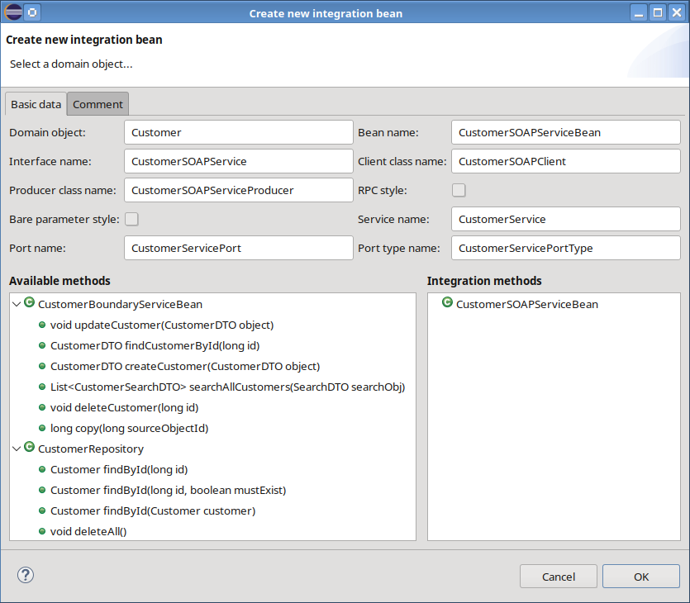Dialog for creating a new SOAP integration bean
The dialog for maintaining a SOAP integration method comes with four additional fields:

Operation name | Specifies the name of the wsdl:operation matching this method.
Return value name | Defines the name of the return value as it is listed in the WSDL file and found in messages on the wire. For RPC bindings, this is the name of the wsdl:part attribute representing the return value. For document bindings, the -name parameter is the local name of the XML element representing the return value. The default value is return for RPC and DOCUMENT bindings. The default value is the method name + Response for DOCUMENT bindings.
Return value part name | Specifies the part name for the result of RPC or DOCUMENT operations. The default value is @WebResult.name.
Add parameter annotations | Controls if the generator adds JAX-WS annotations to method parameters.

Note that all SOAP-related entry fields are not mandatory!

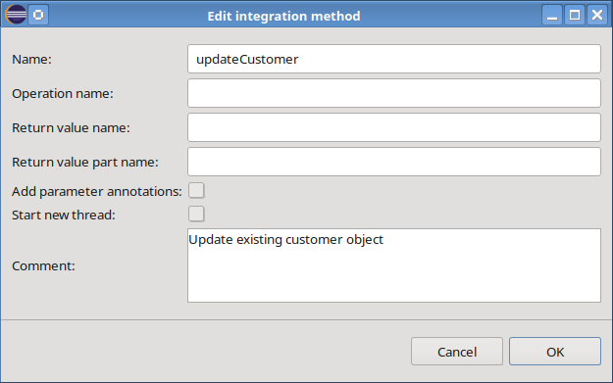Dialog for maintaining details of a SOAP integration method

RMI
As we can see in the following picture an RMI service doesn't contain technology-specific fields:

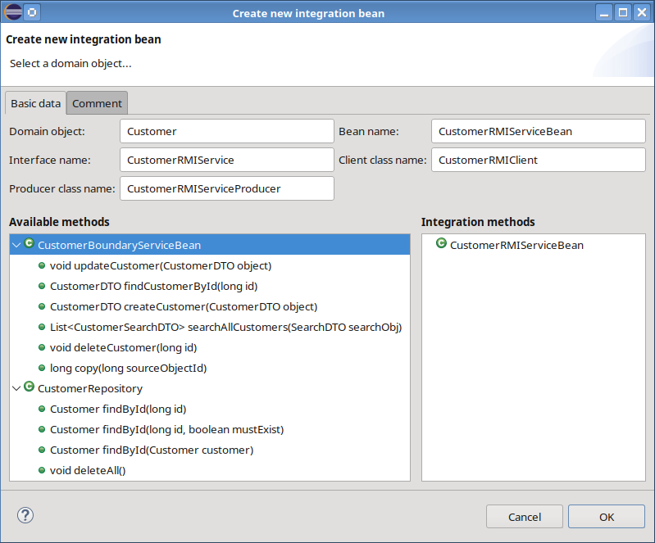Dialog for creating a new RMI integration bean
As with the bean dialog, an RMI integration method also doesn't provide additional fields.

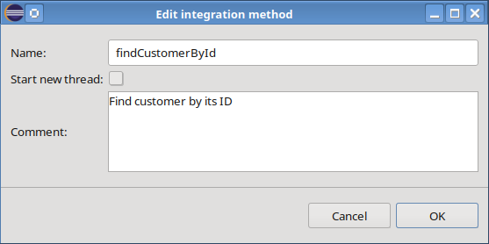Dialog for maintaining details of an RMI integration method

KAFKA
In contrast to the aforementioned technologies (e.g. REST) that follow a basic request-response pattern, there are some notable differences if the application uses Kafka. At the latest, when the respective beans should be tested, it is necessary to have a Kafka broker that is responsible for saving incoming messages in respective topics.
The following picture depicts all major building blocks as well as the basic data flow:

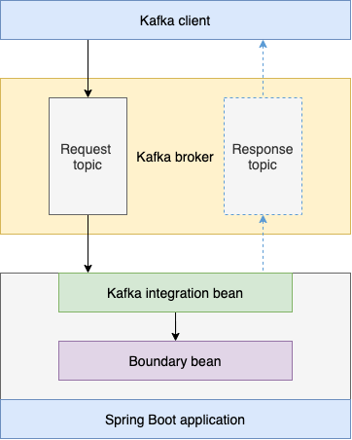Major building blocks
A Kafka client sends messages to a dedicated topic. As soon as the application has been started, the integration bean listens for messages in the same topic. If all requirements regarding the message payload and the message headers are met, the bean is able to process the message by delegating the actual work to the respective listener method. In CodeCadenza this method is responsible for converting the message payload into one or more parameters that are used to invoke the actual boundary method. Due to Kafka's asynchronous nature, the actual return value or a status cannot be sent back directly. Thus, it is necessary to send an appropriate message to a response topic. This message, in turn, can be consumed by the same client that has sent the original request message. Of course, it is possible that other clients are listening on the same topic which are also able to consume the message.

At the moment, CodeCadenza uses Avro for the serialization of the messages. Therefore, a new Avro IDL file is added to the resource folder in the service endpoint interface artifact for every integration bean. This file contains all data structures, enumerations, response and request schemas for all methods of a specific bean. The following examples provide an overview about all relevant parts in the Avro IDL file for creating a new object (e.g. a customer). The record CustomerDTO contains all fields that are necessary for this operation:

/**
* Data transfer object for customer objects
*/
record CustomerDTO {
long id;
string name;
int version;
timestamp_ms creationDate;
}

Due to CodeCadenza's strong coupling between the integration technology and the application, the request schema contains at least one field for every boundary method parameter.

/**
* Request schema for "createCustomer" operations
*/
record CreateCustomerRequest {
CustomerDTO object;
}

If a response including the return value of the boundary method invocation should be sent a corresponding response schema is added which always contains a general response object with a status code and an optional error message.

/**
* Response schema for "createCustomer" operations
*/
record CustomerCreateResponse {
ResponseStatus responseStatus;
union {null, CustomerDTO} responseData = null;
}

A response message with a ResponseStatus object is sent to the respective Kafka topic if no dedicated schema has been selected!

Internally, CodeCadenza generates Avro-related Java classes that are used for the serialization of the schemas by using the Apache Avro Maven plug-in. The integration bean expects that the message header contains the name of the Avro schema for routing the message to the correct listener method. If a response message should be sent the original request message contains a correlation ID that in turn is added to the response message header which allows the message sender to identify the correct response message.

Following additional fields are necessary for creating a new Kafka integration bean:

Request topic | Defines the name of the topic that is used by all service listener methods.
Response topic | Defines the name of the topic where the response status and/or the invocation result (e.g. the method return value) should be sent to after processing a message from the request topic.
Consumer group | Controls the name of the consumer group the service listener belongs to.

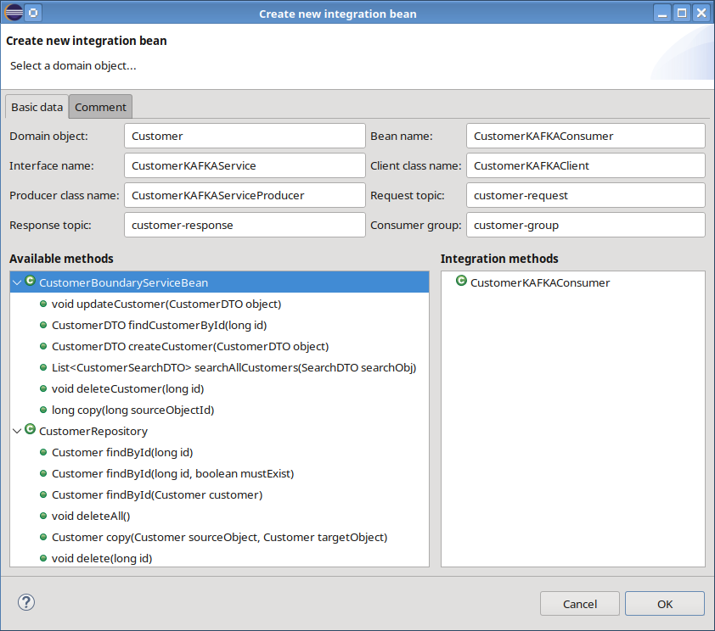Dialog for creating a new KAFKA integration bean
The dialog for maintaining a Kafka integration method contains following additional fields:

Request schema name | Defines the name of the Avro request schema.
Send response | Controls if the listener method should send a response message to the respective response topic. If no response message should be sent the following fields will be disabled!
Response schema name | Defines the name of the Avro response schema. If this field is empty no dedicated response schema will be added!
Use dedicated partition | Controls if the client provides the partition where the listener method should send the response message to. This feature reduces the overall network traffic in a system where many clients are listening on the same topic as the client just fetches the response messages of the desired partition!

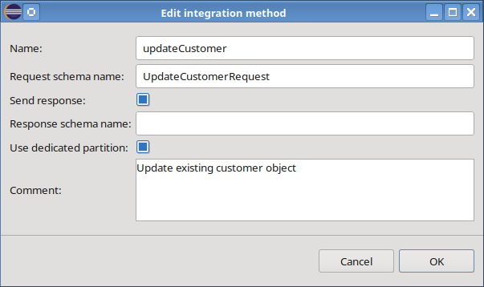Dialog for maintaining details of a KAFKA integration method
After creating a new Kafka integration method, a corresponding listener method is added to the integration bean.

JMS
Another supported integration technology based on asynchronous message processing is JMS. Depending on whether Jakarta EE or Spring Boot is used, there are two variants of the currently supported setup. While Spring Boot applications expect a dedicated broker (Active MQ Artemis), Jakarta EE applications work with embedded brokers.

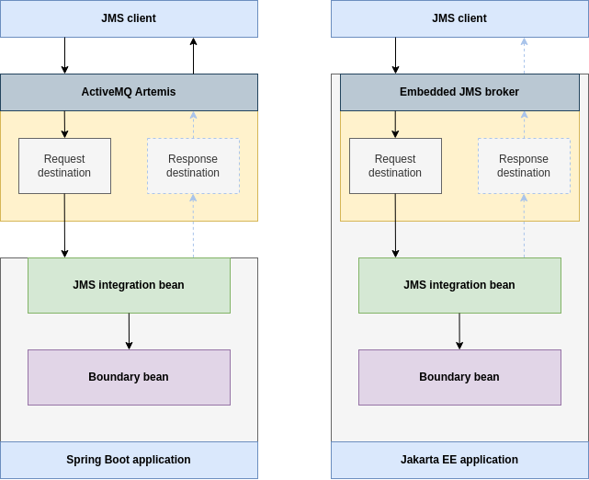Major building blocks
A JMS integration bean contains a listener method that processes the request messages of a topic or queue. This listener method expects a JMS ObjectMessage of type RequestMessage along with a correlation ID. The RequestMessage class contains a field with the operation ID that is used to determine what boundary method should be called. The second field represents an ordered list with serializable objects that must match the expected list of boundary method parameters. If the incoming message was successfully converted, the listener method calls the boundary method and, if necessary, sends a JMS ObjectMessage of type ResponseMessage back to the corresponding JMS destination. A ResponseMessage consists of the optional return value of the boundary method, a response status, an optional text that represents a human-readable error message and the operation ID of the corresponding request message. The aforementioned correlation ID is also added to the JMS response message so that a client can easily find the corresponding response to the request it has sent. When creating a new JMS integration bean following additional fields are necessary:

Request destination | Defines the JNDI name of the destination that is used by all service listener methods.
Response destination | Defines the JNDI name of the destination where the response object should be sent to after processing a message from the request destination.
is JMS topic | Controls if the respective destination represents either a topic or a queue.

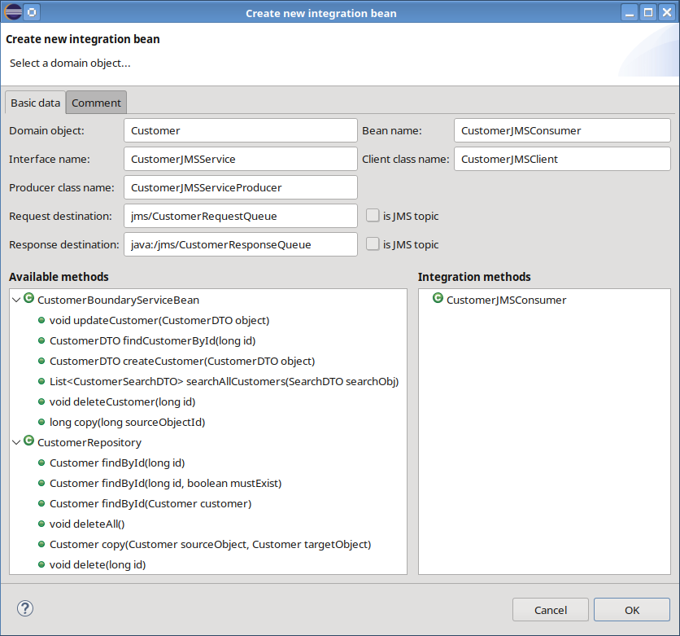Dialog for creating a new JMS integration bean
It is important to note that the JMS destinations of a Jakarta EE application must be configured before deploying it. Otherwise, the deployment will fail!

The dialog for maintaining a JMS integration method just contains one additional field that controls if the listener method should send a response message to the respective response destination.

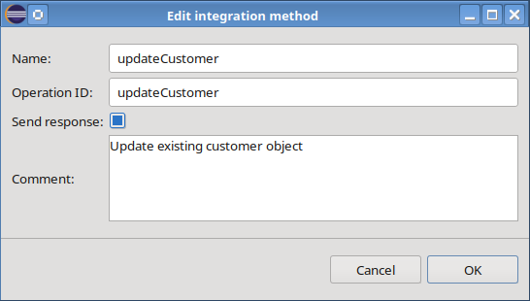Dialog for maintaining details of a JMS integration method

Integration tests
In modern applications the business logic rarely lives in isolation. It talks to external services, consumes APIs, pushes messages onto queues, reads from databases, and coordinates with legacy systems. While unit tests give you confidence that individual components behave correctly, integration tests are the safety net that verifies those components actually work together in real-world conditions.
The following sections will walk you through the core principles of integration test modelling with CodeCadenza.

Core concepts
In this context the term “integration” has a double-meaning as we will model and generate integration tests based on existing integration beans (see previous section). Before we walk through the "how-to”, let's explore the powerful features that form the foundation of this testing approach.

1.) Data-driven testing
This is the foundational principle. A test is split into two distinct parts for maximizing reusability and minimizing maintenance:

- The test logic is contained in a JUnit Java file: This is the generated, executable test class. It contains the logic - it knows how to call a method, how to check a database, and how to report a failure.

- The test data is stored in an XML file and contains all the values for a test. It's a structured list of parameters, expected return values, and data for database checks.

Why is this important? You can easily create dozens of test cases (e.g., testing with valid data, invalid data, nulls, edge cases) simply by adding new entries to the XML or new files.

2.) Flexible test composition
A single generated test is not bound to a single service or bean. This feature is crucial for moving beyond simple unit testing and into true integration testing. It allows you to model realistic, end-to-end business processes that span multiple services.

Think of a real user story: "As a user, I want to register, find an item, and add an item to my cart”. A test for this story would involve multiple, separate integration beans. With this tool, you can create one test that defines a sequence of invocations:

- Call RegistrationService.createUser()
- Call ProductService.findItem()
- Call CartService.addItemToCart()

This allows you to test the complete flow and interaction between your services, not just isolated methods. Although it is possible to add integration beans of different technologies (e.g. REST or SOAP) to an application, it is currently not possible to mix integration beans of different technologies in one integration test!

3.) Using client artifacts
The generated test doesn't know how to "speak" REST or SOAP by itself. It relies on the integration client artifacts that “know”, for example, how to serialize a message and send it to Kafka. The test will use these existing clients to invoke the services. By delegating external calls to a reusable integration client, the test code does not need to import HTTP or Kafka libraries - the client abstracts those details away. As a result, tests read like business scenarios, making the purpose of each test instantly clear.

Creating a first integration test
To create a new integration test, go to the CodeCadenza project navigator. Open the folder “Test modules” and select one of the available integration test modules (e.g. REST). Open the context-menu and click “New test case”. This will open the dialog for creating a new integration test.

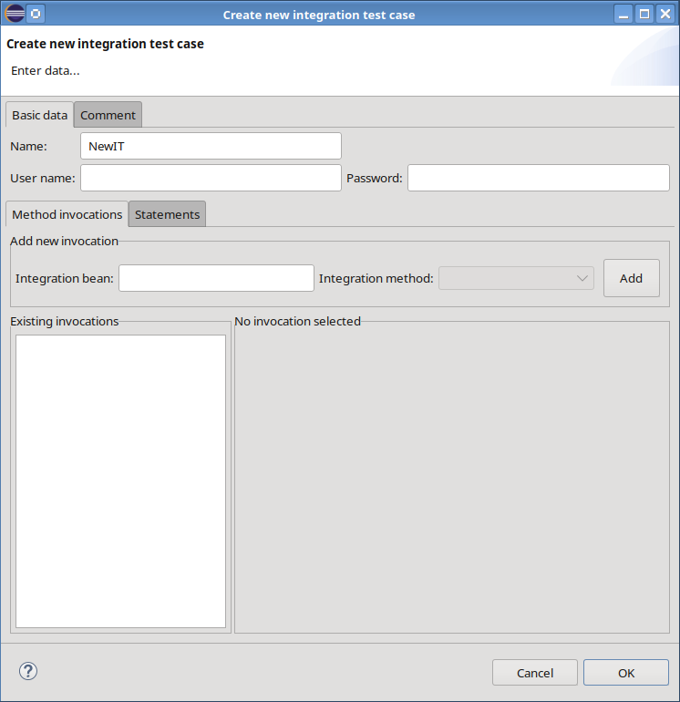Dialog for creating a new integration test
In the section “Basic data” the name of the test case can be entered. If the respective integration client needs to authenticate it against the running application it will be necessary to enter a user name and the correct password.
The tab-page “Comment” contains a single text field where a comment can be entered.

In the previous chapter a REST integration bean for customer domain objects has been added. Now, the functionality of this service should be tested. When entering the name (or a part of the name) of the customer integration bean in the field “Integration bean” a respective proposal item should be displayed that can be selected and the combobox “Integration method” will be filled with all available integration methods. In a first test a new customer should be created. Thus, the “createCustomer” method must be selected. Click on the “Add” button to create and initialize a new invocation for this method. The new integration method invocation will be displayed in the previously blank area on the right side.

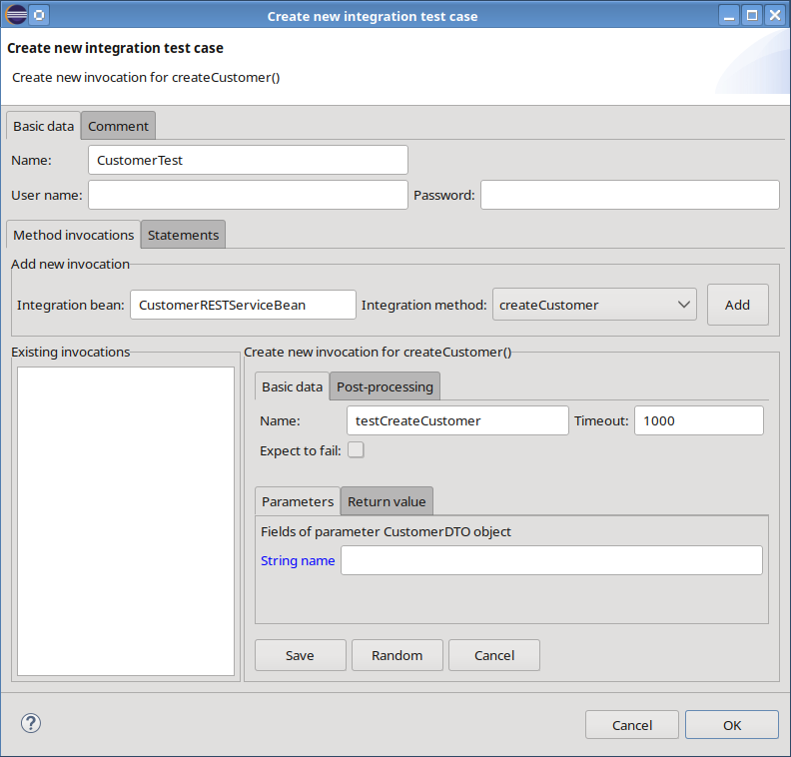Enter data for a new integration method invocation
The generated JUnit test will later contain a separate method that invokes the integration method with respective data. Initially, the text field “Name” is filled with the name of the integration method and the prefix “test”. The name can be changed, but it must follow the Java method naming conventions!
The text field “Timeout” is initially filled with the value that has been entered when creating the test module. This value has a real impact on the test as it defines the maximum time to wait for an invocation to return until the test will end with a failure. A timeout of 1000 milliseconds feels very long, but it must be considered that applications sometimes need a warm-up that leads to long-running initial requests! It is also allowed to define no timeout which will result in blocking the test until the invocation has been completed. A timeout can also be set for pure asynchronous operations - such as Kafka or JMS requests that dispatch a message without waiting for a response message. Then, the timeout defines the maximum period of time the test will wait for the outbound message to be transmitted. It does not consider when the downstream consumer has finished processing the request, because the client receives no response from the backend.
Usually, tests are defined to follow the “happy path”. That means that all method invocations are expected to succeed. But sometimes, it is also interesting to force errors (e.g. creating a customer with a duplicate name). If the checkbox “Expect to fail” is selected the test will expect an exception when the method is invoked and it will fail if the invocation returns successfully.
It is now up to the developer to enter data. The tab-page “Parameters” contains input fields for all parameters. Parameters can be simple fields of type boolean, String, double and so forth. If a parameter represents a complex object it will be broken down into its fields. We will come back to the different field types in subsequent chapters.
In the particular example for creating a new customer the parameter “object” contains only one field “name” of type String. The field label has a blue colour, indicating that the field must not be null. But wait, what about the other fields of the CustomerDTO? All fields that are filled or generated by the application won’t be displayed when creating a new object as this would give the impression that the method will consider these fields. But this is not the case here!
In the tab-page “Return value” all fields of the returned object can be found and values can be entered that are expected to be returned. In addition to the “Parameters” tab-page there is also a combobox with type-dependent assertion operators for each field. Neither selecting an operator nor entering a value is mandatory here. As being said, the values are used to validate the method invocation’s return value and this usually makes sense but is sometimes not necessary. When a value is entered it is not necessary to select an operator. In this case the “EQUAL” operator is used. When selecting either the operator “IS_NULL” or “IS_NOT_NULL” the corresponding input field will be cleared and disabled as these operators don’t expect a value.
Note, that an operator without entering a value won’t be ignored. The generator will add an assertion expression and will use the default value (e.g. 0 for int or null for Integer) initialized by the test data runtime library.

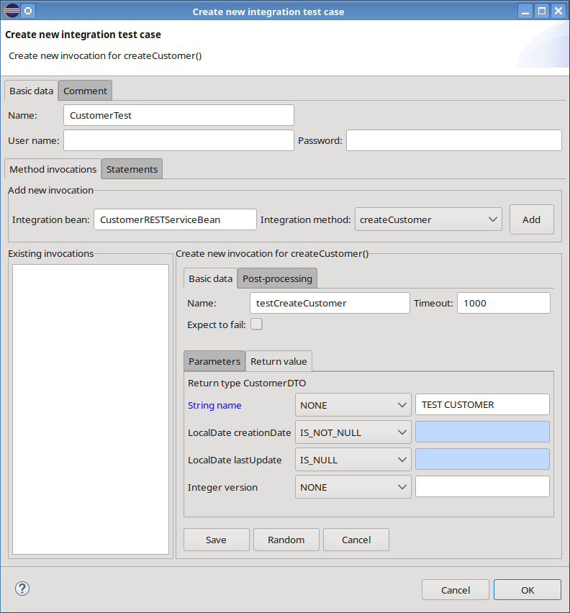Entering validation data
After entering the name of the new customer and selecting some operators the test can be saved using the respective button on the bottom of the invocation area. The new invocation will then be displayed in the tree view on the right side showing all parameters and return values including all fields and their assertion operators. By pressing the “OK” button the test case will be saved and the dialog will be closed. The new test case will also be added to the respective test module in the project navigator view. As stated above, CodeCadenza creates the respective JUnit test as well as a corresponding test data XML file with all invocations including their timeouts and their parameters and return values in a generic fashion. Fields that were left blank won’t be added here.

<?xml version="1.0" encoding="UTF-8"?>
<test_data>
<method_invocation class_name="CustomerRESTClient" method_name="createCustomer" timeout_millis="1000">
<parameters>
<parameter name="object">
<object id="f77b6498-5b34-4711-a564-293218e3b014">
<field name="name" value="TEST CUSTOMER"/>
</object>
</parameter>
</parameters>
<return_value>
<object id="fa6133d1-36c8-4686-b3ac-382098a4b540">
<field id="fb7ff8b8-c3dc-436e-a5b6-a9f1ec548f09" name="id"/>
<field name="name" value="TEST CUSTOMER"/>
</object>
</return_value>
</method_invocation>
</test_data>

The generated test class contains an init() method that initializes every integration client class used by the test. For each operation, a dedicated test method (e.g., testCreateCustomer()) is added; it invokes the corresponding integration client method and verifies its return value. The runtime library annotation @FileBasedTestDataSource is responsible for loading the test data and the initialization of the method parameters. CodeCadenza will create the corresponding JUnit test class as follows:

@TestInstance(Lifecycle.PER_CLASS)
@TestMethodOrder(MethodOrderer.OrderAnnotation.class)
class CustomerTest {
private static final String XML_FILE_PATH = "src/test/resources/testdata/CustomerTest.xml";
private static CustomerRESTClient customerService;

/**
* Initialize the services that should be tested
*/
@BeforeAll
static void init() {
customerService = new CustomerRESTClient();
}

/**
* Test method CustomerRESTClient::createCustomer
* @param object
* @param expectedResultObject
* @param testDataProvider
*/
@Order(1)
@ParameterizedTest
@FileBasedTestDataSource(XML_FILE_PATH)
void testCreateCustomer(CustomerDTO object, CustomerDTO expectedResultObject, ITestDataProvider testDataProvider) {
final var actualResultObject = assertTimeoutPreemptively(
testDataProvider.getTimeout(),
() -> customerService.createCustomer(object));
// ...
assertThat(actualResultObject.getName())
.isEqualTo(expectedResultObject.getName());
assertThat(actualResultObject.getCreationDate()).isNotNull();
assertThat(actualResultObject.getLastUpdate()).isNull();
}

}

Tracked attributes
Often a test case begins by creating an object that later invocations must reuse, for example, to update or delete that same object. Frequently the object's identifier (primary key) is generated automatically by the persistence provider or the database, yet that ID is essential for subsequent operations such as deletion. CodeCadenza solves this problem with tracked attributes.

When the plug-in creates a new object, the generated primary key value is treated specially so that it can be referenced automatically in later method calls. If the create-method returns the newly created object, CodeCadenza extracts the ID and writes it back into the test data after the create-method completes. If the method does not return the object, CodeCadenza builds an appropriate SQL statement to retrieve the generated ID, adds this statement to the “Post-processing” field for the current integration test invocation, and executes it after the create call. The retrieved ID is then written back into the in-memory test data. Because the test data is loaded from an XML file and kept only in memory until the test ends, the fields that reference the tracked attribute are populated automatically - but the value is not persisted back to the XML file, since the next test will most likely generate a different ID.

To see tracked attributes in action, extend the existing test case by deleting the customer after it has been created. In the project tree navigator select the CustomerTest item, choose “Edit”, and pick the deleteCustomer() integration method. The input field for the customer ID parameter will contain a placeholder text indicating that the field will be initialized by a tracked attribute. With this configuration the customer created in the previous step will automatically be deleted in the next step.

If you need to delete a different customer, simply overwrite the placeholder with a concrete ID (e.g., 111). When multiple customers are created within the same test and the automatically chosen ID is not the one you want, you can correct it manually: open the invocation tree view, locate the desired primary key attribute from a previous invocation, and drag it to the input field. Tracked attributes are always marked distinctively (e.g., long id (tracked – using ID…)), making them easy to identify.

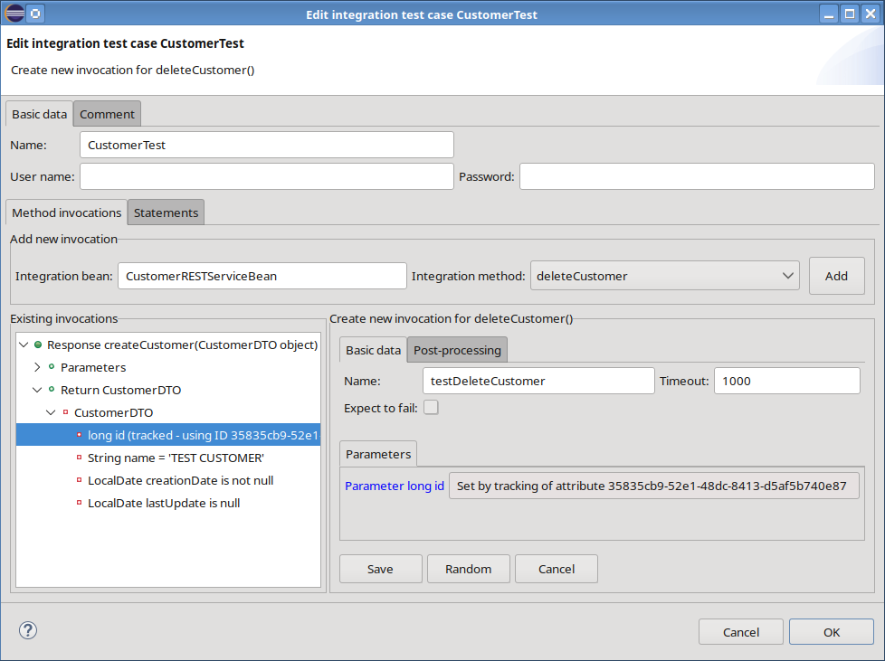Field that references a tracked attribute
The updated test data XML file looks like this:

<?xml version="1.0" encoding="UTF-8"?>
<test_data>
<method_invocation class_name="CustomerRESTClient" method_name="createCustomer" timeout_millis="1000">
<parameters>
<parameter name="object">
<object id="f77b6498-5b34-4711-a564-293218e3b014">
<field name="name" value="TEST CUSTOMER"/>
</object>
</parameter>
</parameters>
<return_value>
<object id="fa6133d1-36c8-4686-b3ac-382098a4b540">
<field id="35835cb9-52e1-48dc-8413-d5af5b740e87" name="id"/>
<field name="name" value="TEST CUSTOMER"/>
</object>
</return_value>
</method_invocation>
<method_invocation class_name="CustomerRESTClient" method_name="deleteCustomer" timeout_millis="1000">
<parameters>
<parameter name="id">
<object id="ed50b479-3c4b-4627-a01d-4e05ff3853" ref_field_id="35835cb9-52e1-48dc-8413-d5af5b740e87"/>
</parameter>
</parameters>
</method_invocation>
</test_data>

At runtime, the test data library sets the value returned by the create-method by searching all fields that reference it by comparing the XML attributes “id” and “ref_field_id”.

@TestInstance(Lifecycle.PER_CLASS)
@TestMethodOrder(MethodOrderer.OrderAnnotation.class)
class CustomerTest {
private static final String XML_FILE_PATH = "src/test/resources/testdata/CustomerTest.xml";
// The test case must know the IDs of the tracked attributes!
private static final LinkedList<String> IDS_OF_FIELD_ID = new LinkedList<>(List.of("35835cb9-52e1-48dc-8413-d5af5b740e87"));
private static CustomerRESTClient customerService;

/**
* Initialize the services that should be tested
*/
@BeforeAll
static void init() {
customerService = new CustomerRESTClient();
}

/**
* Test method CustomerRESTClient::createCustomer
* @param object
* @param expectedResultObject
* @param testDataProvider
*/
@Order(1)
@ParameterizedTest
@FileBasedTestDataSource(XML_FILE_PATH)
void testCreateCustomer(CustomerDTO object,
CustomerDTO expectedResultObject, ITestDataProvider testDataProvider) {
final var actualResultObject = assertTimeoutPreemptively(
testDataProvider.getTimeout(), () customerService
.createCustomer(object));

// Fill the referenced fields using the returned primary key value
testDataProvider.setGeneratedFieldValue(
UUID.fromString(IDS_OF_FIELD_ID.poll()),
actualResultObject.getId(), long.class);

assertThat(actualResultObject.getName())
.isEqualTo(expectedResultObject.getName());
assertThat(actualResultObject.getCreationDate()).isNotNull();
assertThat(actualResultObject.getLastUpdate()).isNull();
}

}

Fields for entering and validating test data
This chapter provides an overview of how fields are mapped for entering and validating test data.

Fields with a simple type
Date, numeric and UUID values are stored in the test data XML file. At runtime the test data library converts them to their target types according to the format settings defined in the CodeCadenza project, allowing the test case dialog to validate input and prevent saving values that do not match the expected format. Boolean values are represented by a checkbox and require no validation, enum values are selected via a combobox, and string values are unchecked as well. Pressing F5 toggles the input field between single-line and multi-line modes. Blank fields are translated at runtime to the default value of their type: object types (e.g., String, Long, Double, Date) become null, while primitive types receive 0, 0.0 false accordingly. When an empty String is required, the context-menu of string fields provides a “Set empty” command.

Fields that are mapped to a many-to-one association
A complex object (e.g., a DTO) usually does not contain only fields with simple data types. For example, a customer may have a many-to-one relationship to a country. In that case the CustomerDTO contains a field “country” of type CountryDTO, which itself has its own fields. When a new customer is created, the relation is established solely by using the field that holds the primary key value, so entering such a relationship requires only a single input field. No check is performed to verify whether an object with the entered primary key actually exists in the target database! But the dialog will check if the input can be converted to the respective primary key type (e.g. long, int or UUID).

Fields that are mapped to a many-to-many and one-to-many associations
If the customer domain object must reference several countries, replace the many-to-one association with a many-to-many association. In this case, test data management changes: an arbitrary number of country objects can be added when creating a customer or when validating a returned customer. For each many-to-many or one-to-many association a dedicated tab-folder is added to the method invocation panel. Objects are created by entering the primary key value in the “ID of new object” field. The primary key alone is sufficient to resolve the references of a many-to-many association. When objects belonging to a one-to-many association must be persisted, all mandatory fields typically need to be filled. This is done by double-clicking the corresponding row, which opens a dialog where the required fields can be entered.

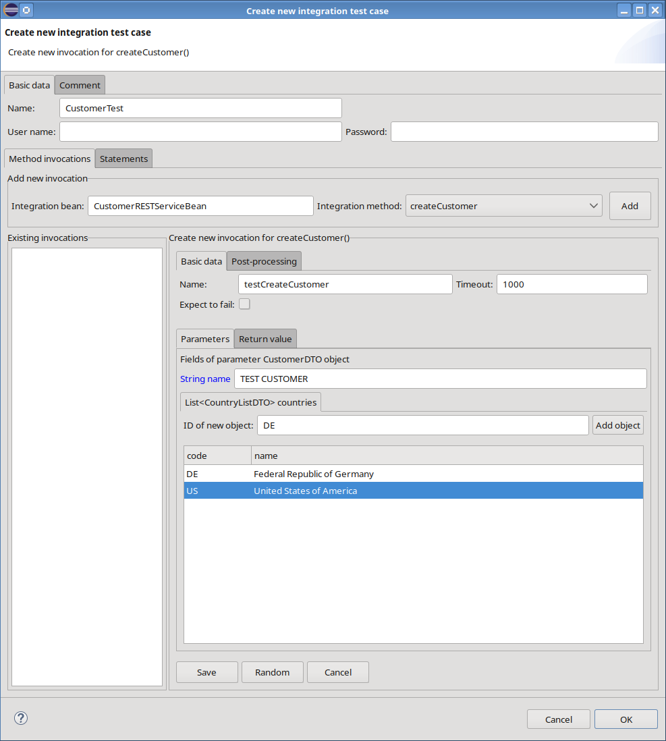Adding test data to a many-to-many association

Fields that are mapped to an element collection
Entering test data for element collection fields also requires a list. For example, a person can have any number of nicknames. The dialog will validate the input if the field is either mapped to a date or a number.

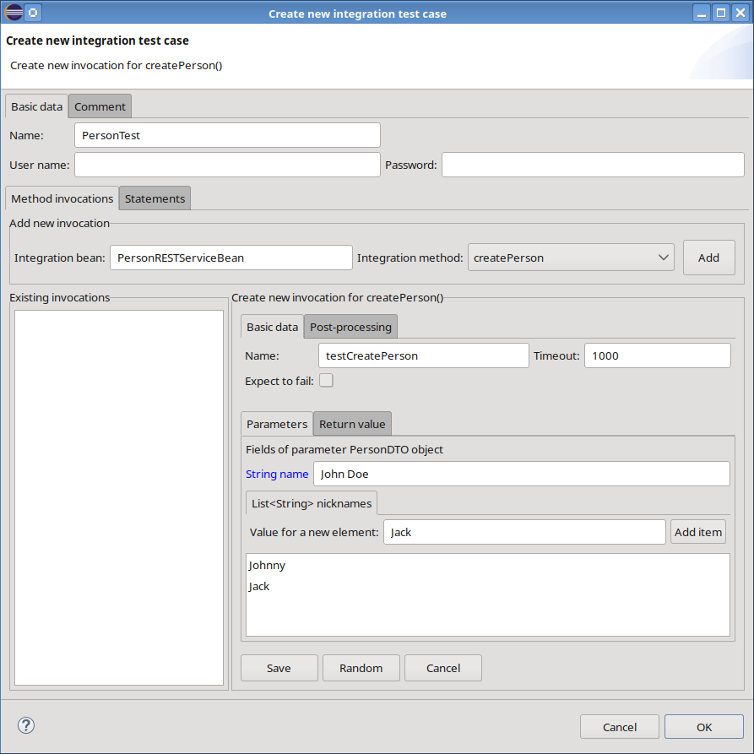Entering test data for an element collection

Nested invocations
When you need to generate or validate multiple objects of the same type, CodeCadenza lets you reuse a single test method (e.g. testCreateCustomer()) through “nested invocations”. To add a new nested invocation, open the invocation tree navigator in the test case dialog, select the existing invocation, and choose the context-menu item “Add”. The new node is created as a child and the same method is executed for it, eliminating the need for separate uniquely-named test methods.

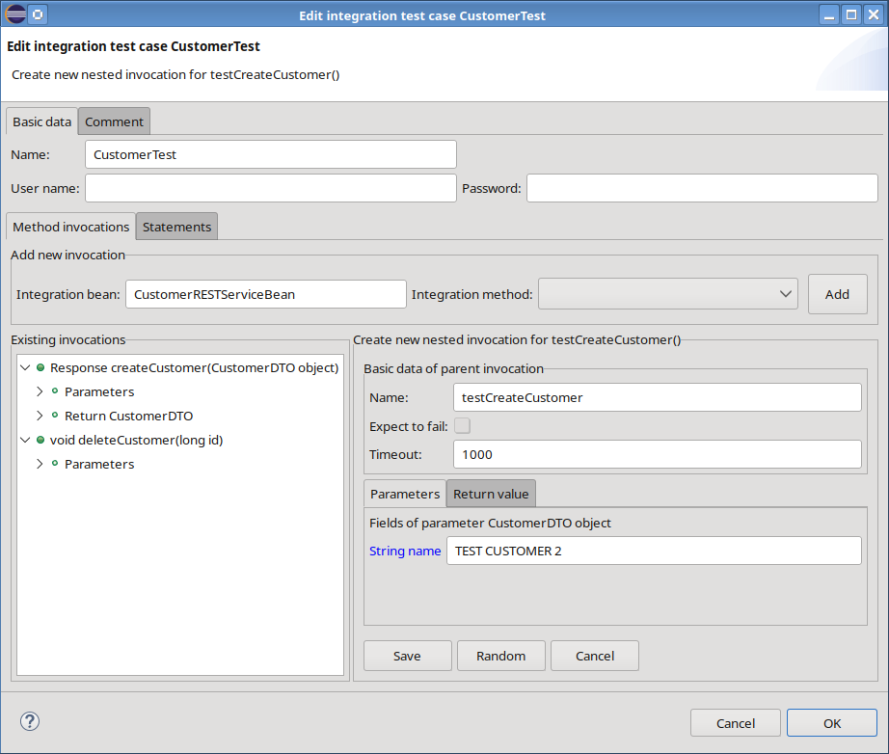Adding a new nested invocation
The panel looks very similar to the parent method invocation but there are some differences. The timeout cannot be overwritten as this setting is used for all invocations. The same is true of the “Expect to fail” flag. When the parent method invocation is expected to fail all subsequent nested invocations are also expected to fail! It is also not possible to overwrite the assertion operators defined in the parent method invocation. As a result, make sure to fill all respective fields in all nested invocations that are supposed to be validated in the parent method invocation. For example, if the name of the customer is validated using the “EQUAL” operator in the parent method and the respective field in one of the nested invocations is empty it is very likely that the test will fail as every returned object will contain the customer name. But if the field in the nested invocation is empty the equality check must fail as the returned name is not equal to null.
The test case generator is aware of the nested invocations and will add the nested invocation to the test data. The testCreateCustomer() won’t be changed as it is parameterised and will be invoked for the parent and all its nested invocations when running the test.

Pre-processing and post-processing statements
Integration tests must be repeatable and the database must be prepared so that a test can find all objects it needs. To help the developer to fulfill these requirements respective database statements can be added to a test case.

Add all SQL statements to the “Pre-processing statements” field that should be executed before running the actual tests. Every statement must be delimited by a ‘;’ character.

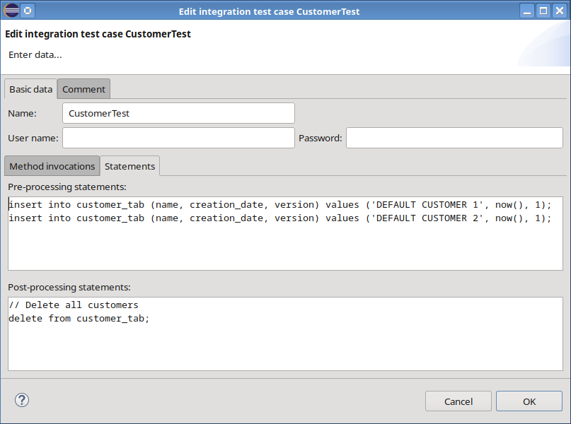Pre-processing and post-processing statements

It is always a good strategy to delete all objects that have been created during a test to provide a clean setup when running the test again. Deleting objects at the end of the test by adding respective invocations (e.g. deleteCustomer()) seems to be a good alternative for clearing the database instead of using SQL statements. But keep in mind, that a test can always fail and the delete-methods will never be invoked!

@BeforeAll
static void init() {
//...

// Load the properties for the statement processor
final var statementProcessorProperties = new StatementProcessorProperties();
statementProcessorProperties.load();

// Initialize the statement processor
statementProcessor = StatementProcessorFactory
.getStatementProcessor(statementProcessorProperties);

// Execute the pre-processing statements
statementProcessor.executeStatements(testData.getPreProcessingStatements());

// ...
}

/**
* Run all post-processing statements before the test will be finished
*/
@AfterAll
static void cleanUp() {
if (statementProcessor != null)
statementProcessor
.executeStatements(testData.getPostProcessingStatements());
}

Testing search- and count-operations
In earlier sections we showed that each parameter or field of a complex object is mapped to a dedicated input field for entering or validating data. When the task shifts from invoking a method to searching for objects, the interface must accommodate more information: for every searchable field the user must be able to specify a filter value, choose a search operator, and set a sort order. Moreover, the system has to validate the objects returned by a search-operation - or the result of a count-operation - just as it validates ordinary input. Consequently, the input form required for search- and count-operations looks fundamentally different compared to “standard” method invocations:

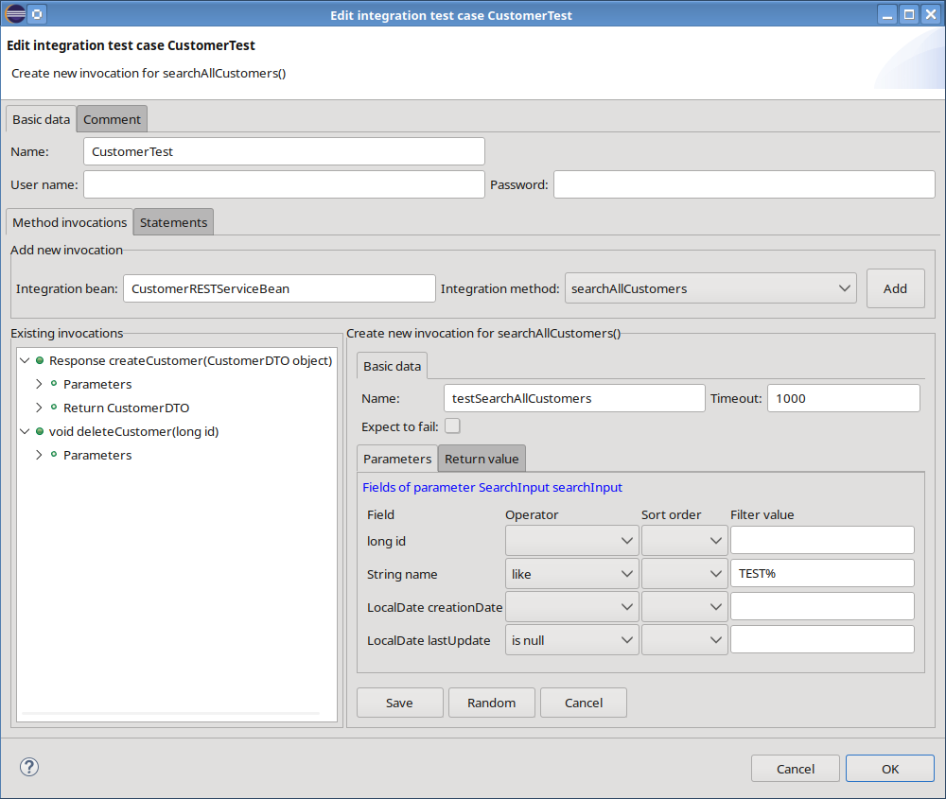Testing a search operation
When a search operation returns a list of objects, the “Return value” section includes a field for specifying the expected number of results.
The objects that must appear in the result list can be defined explicitly. An expected object is added by selecting the context-menu item “Add object” of the result list view, which opens a dialog for entering the corresponding field values. Alternatively, a tracked attribute can be dragged from the invocation tree view and dropped on the result list view. This action pre-initialises all input fields with the values generated by the preceding method invocation.

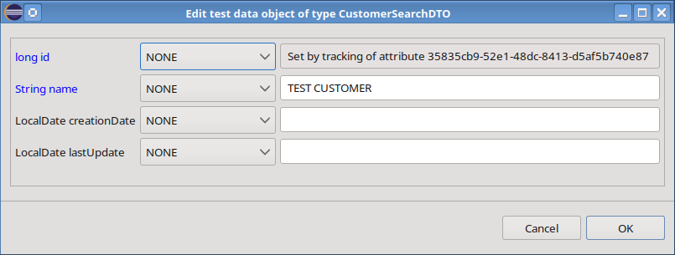Initial test data object after dragging a tracked attribute
After pressing the “OK” button, the new object is added to the result list view:

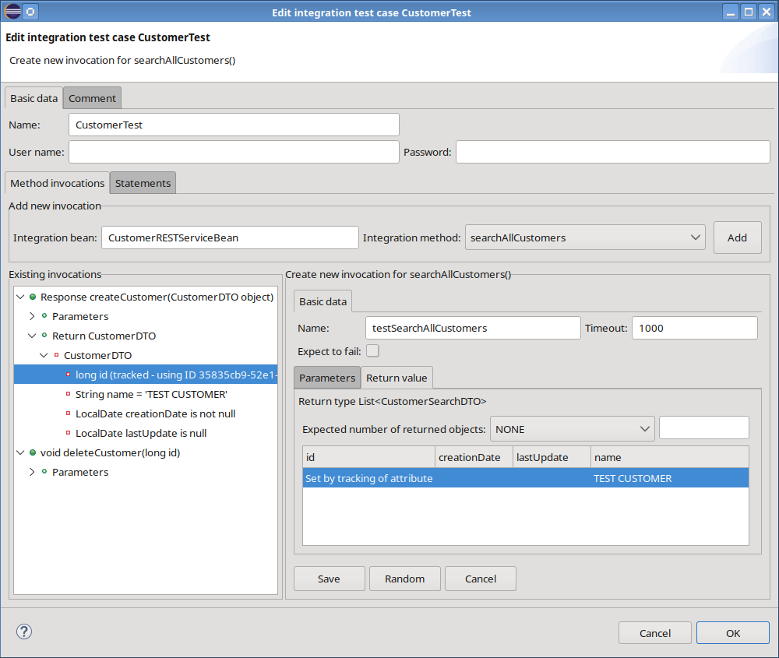Entering the expected result
Depending on the filter criteria and the data stored in the database, a query can return a very large number of objects. Entering every returned object into the list field would be impractical, so the test can be limited to the objects that must be present in the result; any additional objects that appear during execution are ignored. The generated test case compares the actual objects returned by the search-operation with the expected ones by using either the primary key or the display attribute. The assertion operators defined for the first expected object are automatically applied to all subsequent expected objects. Consequently, if equality of a customer’s name is specified for the first object, the same equality check is performed for every other expected object. The test will fail if any of the expected objects does not contain the required name!

Testing file operations
When a domain object includes binary data or represents a document, and the corresponding integration bean provides the appropriate methods, file-related operations such as uploading and downloading can be tested. In the example, a Person entity contains a binary picture field.
For an upload, the absolute path to the source file has to be entered. For a download, the invocation typically requires only the identifier of the target object; the expected file size and an assertion operator may also be supplied to verify the result.

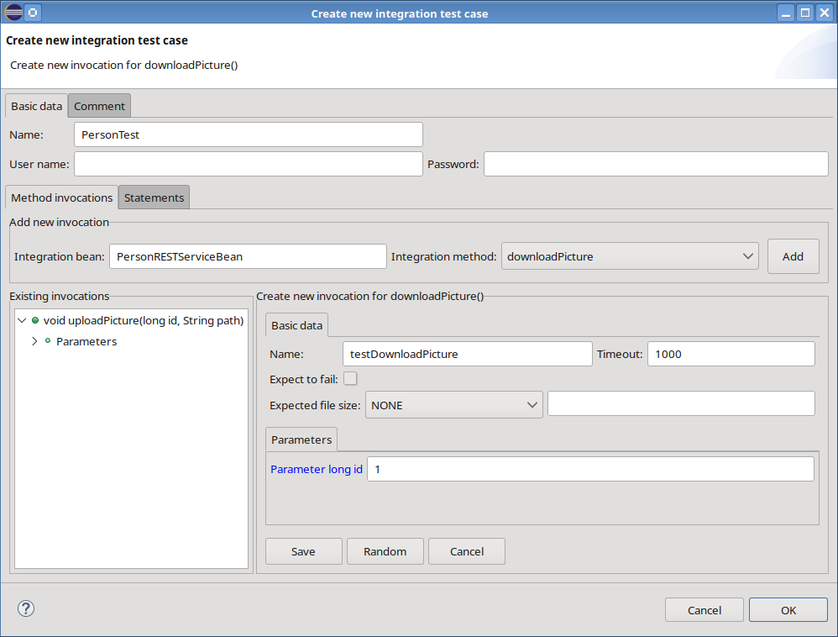Definition of a file download invocation
The generated code adapts to the chosen integration technology and incorporates additional file-handling operations. These operations are delegated to a dedicated FileService, whose implementation is provided for each supported technology:

/**
* Test method PersonRESTClient::uploadPicture
* @param id the ID of the person to which the picture should be added
* @param path the local path of the picture to upload
* @param testDataProvider
*/
@Order(1)
@ParameterizedTest
@FileBasedTestDataSource(XML_FILE_PATH)
void testUploadPicture(long id, String path, ITestDataProvider testDataProvider) {
final File fileToUpload = new File(path);
final String pathInBackend;

try {
pathInBackend = fileService.uploadFile(fileToUpload);
}
catch (Exception e) {
throw new IllegalStateException(e);
}

assertTimeoutPreemptively(testDataProvider.getTimeout(),
() -> personService.uploadPicture(id, pathInBackend));
}

/**
* Test method PersonRESTClient::downloadPicture
* @param id the ID of the person from which the picture should be downloaded
* @param testDataProvider
*/
@Order(2)
@ParameterizedTest
@FileBasedTestDataSource(XML_FILE_PATH)
void testDownloadPicture(long id, ITestDataProvider testDataProvider) {
// Get the path of the file where it is stored in the backend
final var actualResultObject = assertTimeoutPreemptively(
testDataProvider.getTimeout(),
() -> personService.downloadPicture(id));

final Path tempFilePath = testDir.resolve(DOWNLOAD_FILE_NAME);

try {
fileService.downloadFile(actualResultObject, tempFilePath.toFile());

assertThat(tempFilePath).exists();
assertThat(Files.size(tempFilePath)).isNotZero();
}
catch (IOException e) {
throw new UncheckedIOException(e);
}
}

Configuration properties
Every generated test artifact contains a test.properties file in the test resource folder.

Name | Description
TEST_DATA_PROVIDER_CLASS_NAME | The fully-qualified name of the class that is responsible for loading the test data from the persistence store. The default implementation XMLTestDataProvider uses XML files.
INVOCATION_HANDLER_CLASS_NAME | The fully-qualified name of the class that is either waiting for a statement to finish or fetching a generated field value. The default implementation DatabaseInvocationCompletionHandler is using a database. Do not change this class for CodeCadenza projects as they always use a relation database! It will only make sense to use a different implementation if the test data library is used for other persistence stores (e.g. Cassandra or OpenSearch).
STATEMENT_PROCESSOR_CLASS_NAME | The fully-qualified name of the class that processes pre- and post-processing statements. The default implementation DatabaseStatementProcessor is using a database.
DEFAULT_TIMEOUT_MS | The maximum time in milliseconds to wait for the completion handler to finish a statement.
DATE_FORMAT | The format (e.g. dd.MM.yyyy) for saving date values in the persistent test data store. The format pattern must follow the rules defined by the DateTimeFormatter.
DATE_TIME_FORMAT | The format (e.g. dd.MM.yyyy HH:mm:ss) for saving date-time values in the persistent test data store. The format pattern must follow the rules defined by the DateTimeFormatter.
DECIMAL_FORMAT | The format (e.g. 0.00) for saving decimal values in the persistent test data store. The format pattern must follow the rules defined by the DecimalFormat.
DECIMAL_SEPARATOR | The decimal separator (e.g. ‘.’) for decimal values.
GROUPING_SEPARATOR | The grouping separator (e.g. ‘,’) of decimal values.
RESOURCE_URL | The resource URL for the invocation handler and the statement processor to connect to.
USER_NAME | The user name used by the invocation handler and the statement processor.
PASSWORD | The password used by the invocation handler and the statement processor.

Starting the test
Before a test can be executed it is necessary to consider that the target environment must be ready:

- Existing Database: The application's database must be running and accessible. The generated tests will connect to it to perform database validation and cleanup steps.

- Running Application: The application that contains the respective integration beans must be started and running. The generated test acts as a client and needs a live endpoint to connect to.

- Test Data Maintenance: The developer is responsible for ensuring the database is in a known state before a test runs. If your test tries to read product data it is important, it must exist in the database. This is often called "test data seeding".

- Test Data Cleanup: The developer is responsible for database cleanup after a test finishes. Tests must be repeatable. If a test creates new data, you should have a plan to remove that data so it doesn't interfere with the next test run.

Either start or deploy the application in Eclipse (see chapter 18), go to the test case in the project tree navigator and select the menu-item “Run”. If everything works fine the JUnit view will open and the test will start. You can also run all integration tests from the command line with Apache Maven by executing “mvn test”.

GUI testing
Testing is a fundamental, yet sometimes expensive, part of the software development process. CodeCadenza provides powerful features for generating tests for Angular, JSF and Vaadin web applications based on Selenium. It is important to note, that generated tests always follow two basic design patterns. First, a generated GUI test is data driven. That means, that anything that has a potential to change is separated out from the test logic. By default, CodeCadenza will create a separate XML file for every test case that contains test data. The other basic design pattern represents the so-called page object. A page object simply provides all available functions of a single web page or a fragment that can be used in a test. This reduces the amount of duplicated code and means that if the GUI changes, the fix need only be applied in one place.
The forms that are used in the following examples are based on the domain model of chapter 13.4.

Creating a first GUI test
The entry point for creating a GUI test can be found in the project navigator. If the project has a Selenium configuration (see chapter 6) the project navigator will contain an item “Selenium” under the top-level element “Testing”. By selecting the context-menu item “New test case” a dialog for creating a new GUI test case is opened.

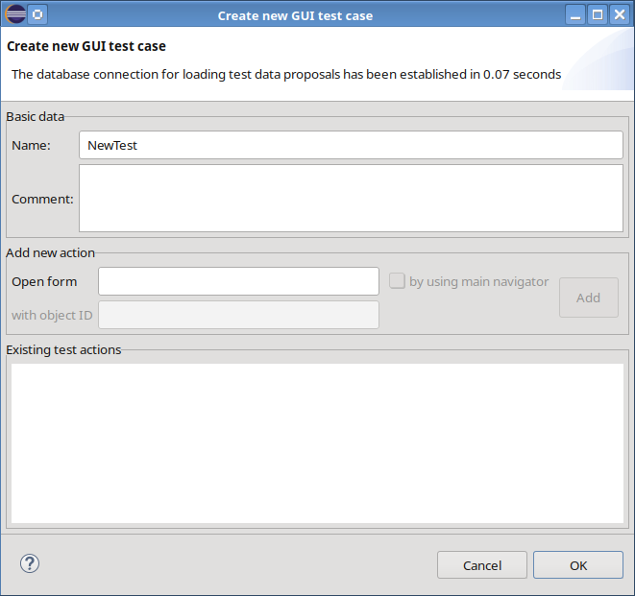Dialog for creating a new GUI test case
The text field “Name” is automatically filled with a default value. Note, that all test cases belong to the same package within the GUI test artifact. Thus, every test case needs a unique name! The field “Comment” is optional. A GUI test case contains an arbitrary number of so-called test actions. In the following chapters, we will cover all details regarding test actions. At the beginning, the first test case should only contain one test action that can be added to the test case in the “Add new action” area. Usually, an existing web page must be opened in order to test its functionality. The selection of an existing form can be done in the text field “Open form”. As soon as characters are entered, all available forms that match the entered text are displayed. Note that tree views (see chapter 11.4) are currently not supported and won't be displayed in this list!
After selecting a form further fields of this section will be enabled. In the case of view forms, the checkbox “by using main navigator” can be selected. If this field is selected the respective form is opened by using the main navigator component of our application. Otherwise, the form is opened directly! Forms that display data for an existing object (e.g. UPDATE, READONLY) cannot be opened if the ID of the respective object is missing. Thus, it is necessary to enter that value into the field “with object ID”. For our first test, we select the form CountryView. A value for the object ID is not necessary. By pressing the “Add” button a graphical editor that represents the selected view is opened.

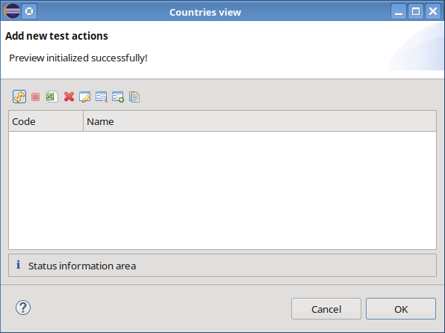Graphical editor for form CountryView
The graphical editor provides two fundamental features. First, it automatically creates further test actions by recording user interaction. For example, when clicking on a tool-bar item (e.g. 'Refresh') the corresponding test action will be added and the user gets notified by a respective text in the title area of the preview dialog. The second key feature of the graphical editor represents entering of test data. For our first test, we neither add further test actions, nor we must enter test data as we just want to test if the view can be opened. Hence, we save that test action by clicking the "OK" button and the graphical editor will be closed.
The initially empty section 'Existing test actions' displays our first test action as depicted in the following picture.

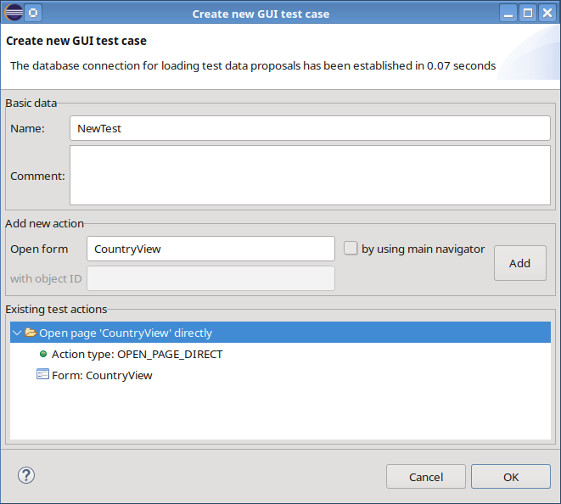GUI test case dialog after closing the graphical editor
Let's save the first test case by clicking on the dialog's "OK" button. Thereby, the dialog will be closed and CodeCadenza creates the test case file in the GUI testing artifact of our workspace. This artifact also contains a resource folder where all test data files are saved to. Although our simple test doesn't require test data a respective file should have been created also! If everything worked fine the new test case should be visible in the “Selenium” folder of the project navigator.

The anatomy of a generated GUI test
Before going through all features in detail it is very important to understand the basic structure of a generated test by taking a look at the example from the previous chapter.

public class NewTest extends AbstractSeleniumTestCase
{
@Generated
public void test(SeleniumTestContext testContext) {
// Open page 'CountryView' directly
var countryView = new CustomerView(testContext);
countryView.open(CountryView.RESOURCE_PATH);
}
}

Many features regarding GUI testing are provided by a special CodeCadenza runtime library. For example, our class NewTest is derived from AbstractSeleniumTest. The tasks of this class are

- loading of configuration properties,
- creating a Selenium WebDriver instance,
- preparation of test data and
- the initialization of a SeleniumTestContext.

The class SeleniumTestContext also belongs to the CodeCadenza runtime library and it is used for the initialization of page objects (e.g. CountryView) regarding configuration properties and the Selenium WebDriver. Furthermore, it is responsible for loading test data.

Every generated test case contains only one test method that is invoked as soon as the initialization of a SeleniumTestContext instance has been finished and the test environment is ready. The method now executes every single GUI test action in the predefined order.

The aforementioned Selenium runtime library is tightly bound to the functionality of an application that has been created by CodeCadenza. Thus, it doesn't raise the claim to represent the leading Selenium library for all other Angular, JSF or Vaadin applications out there!

Page objects
We have already learned that a page object provides all functionality for testing an existing form. In CodeCadenza a page object class is generated in the GUI testing artifact for all client forms and grid panels. Per definition, the page object and its corresponding client counterpart always have the same name. The following code snippet demonstrates the basic structure of page objects in CodeCadenza.

public class CreateNewCountryDialog extends AbstractPageObject
{
@Generated
public static final String RESOURCE_PATH = "/dialog/CreateNewCountryDialog.jsf";
@Generated
public static final String FIELD_ID_TXTCODE = "form:txtCode";
@Generated
public static final String FIELD_ID_TXTNAME = "form:txtName";

/**
* Constructor
* @param testContext
*/
@Generated
public CreateNewCountryDialog(SeleniumTestContext testContext) {
super(testContext);
}
}

The most important characteristic of a page object is the fact that it extends the runtime library class AbstractPageObject that provides all necessary functionality for interacting with the web page at runtime. Furthermore, it contains constants for all visible form fields. Normally, these objects don't have state. Only if a form contains either grid panels or list fields a corresponding property is added to the page object's class.
As a page object class is tightly bound to a corresponding form CodeCadenza will automatically synchronize the page object as soon as the respective form has been changed! When deleting a form the page object is also deleted!

Test data
In the previous chapters it was already mentioned that CodeCadenza stores test data in a separate XML file for every single test case. The following table describes the structure of that files as well as their content.

Element | Description
test_case | The element test_case represents the root element of the XML file.
test_action | CodeCadenza will create one test_action element for every test action that needs test data.
  Attribute | Description
  pageClassName | Contains the fully qualified name of the page object class this test action refers to. At runtime a test data provider collects all test_action elements of the same page object and will return these elements in the order as they have been defined in the XML file.
  objectId | This attribute is filled with an appropriate value if a page for an existing object must be opened.
  navigationTarget | If a page is opened using the application's main navigator this attribute contains a value for finding the proper item in the navigator tree view structure.
element | For every HTML element that should be either changed or tested a separate element tag is added to the test_action. It could be the case that this tag doesn't refer to a HTML element as this tag is also used to store test data for specific test actions (e.g. page title tests, row count validation and row search operations).
  Attribute | Description
  id | The attribute usually contains the ID of a HTML element that should be either modified or tested. It is also possible that it contains internally used IDs for page title tests, row count validation and row search operations (see chapter 16.6 and following).
  filterValue | If a HTML form element is used to search data the filter value is entered in this attribute.
  newValue | The newValue attribute contains the text that should be used to change a corresponding HTML element.
  expectedValue | This attribute contains the expected value of a HTML element that is defined by the id attribute.
result | In chapter 16.7.3 we will see that it is also possible to test status messages that are shown to the user after performing a web page action. The result element is responsible for providing respective data.
  Attribute | Description
  status | Represents the expected status of a message component (e.g. INFO, WARNING, ERROR).
  message | Contains the expected message text.

Of course, it is possible to change the content of the file manually. But these changes get lost as soon as CodeCadenza rebuilds the test case this file belongs to.

Global configuration properties
The resource folder in the Selenium test artifact contains the file test.properties. As the name implies it contains global configuration data for all GUI tests. The file is created automatically when creating a new project. Some of the properties can be configured in the respective project creation wizard page (see chapter 6). As it is very likely that these properties must be adapted sooner or later they should be explained in more detail.

Property name | Description
BASE_URL | Represents the base URL for all tests. When opening a page object this value is used in order to build the full resource URL.
PAGE_LOAD_TIMEOUT | The value limits the time that the script allots for a web page to be displayed. If the page loads within the time then the test continues. If the page does not load within the timeout the test will be stopped.
IMPLICIT_WAIT_TIME | An implicit wait is to tell the Selenium WebDriver to poll the DOM for a certain amount of time when trying to find elements if they are not immediately available.
DRIVER_PATH | The fully qualified path to the driver. If it is empty or points to a driver that does not match the supported browser version, the test will fail.
DRIVER_CLASS | The fully qualified name of the driver class.
DRIVER_NAME | The name of the driver.
DRIVER_MAXIMIZE_WINDOW | Controls if the browser window should be maximized immediately after starting the driver.
TEST_DATA_PATH | The relative path of the folder that contains test data.
LOGGING_PROPERTIES | The relative path of the logging.properties file.
DATA_PROVIDER_CLASS | The fully qualified name of the data provider class. By default, test data is saved in XML files. If necessary, alternative test data sources can be implemented. In this case, a respective data provider must be implemented and registered using this property.
DRIVER_PRODUCER_CLASS | The fully qualified name of the driver producer class. The CodeCadenza Selenium runtime library provides a standard implementation for a driver producer. If necessary, a new driver producer can be implemented and made available using this property.
HTTP_WAIT_TIMEOUT | Every invocation of a CodeCadenza page object method performs a check if the application processes HTTP requests. Only when there are no more pending HTTP requests, the method executes its internal logic. The value of this property defines the maximum time in seconds to wait for pending HTTP requests.
PAGE_LOAD_DELAY | In the case of a Vaadin application, it could be necessary to delay further test operations after a new page has been opened as internal JavaScripts must finally render the page. If the value (in milliseconds) for this property is too small it is likely that the page rendering has not been finished and the Selenium WebDriver may use an incorrect location for a specific element which finally causes the test to fail.
HTTP_CHECK_DELAY | This property controls the time in milliseconds to wait before checking for pending HTTP requests. Note, that the value should be set carefully as it increases the total test time.

GUI test actions
In the introductive example, we have created a test case with a single test action, that simply opens an existing page of our web application. A GUI test action (or simply test action) represents a single operation (e.g. open) that is always processed on a page object (e.g. CountryView). We will see in this chapter that a test action always has a predefined type that describes its general purpose. Depending on this type one or more commands are sent to the browser.

Enter form data
In many test scenarios, it is important to either create new or to update existing objects by using the respective form. Assuming that our project contains a form for creating a new customer (e.g. CreateNewCustomerDialog) we can create a new test case and select the respective form using the aforementioned search field in the test case dialog. After pressing the “Add” button CodeCadenza opens the graphical editor for the selected form.

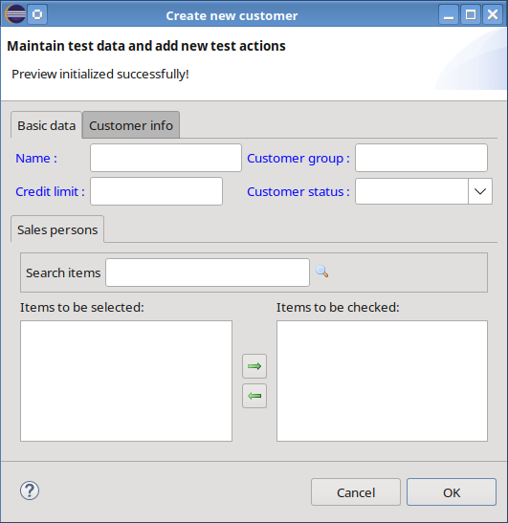Graphical editor for form CreateNewCustomer
As a new customer should be created in this test case it is necessary to enter data into respective fields of the graphical editor. It is important to note that the entered field values are used exactly as they have been entered. This means that the format of date and numeric values (e.g. Credit limit) must match the corresponding settings in the web application. Furthermore, it is very likely that a test will fail if the value of a lookup field (e.g. Customer group) doesn't exist in the application's database. The developer is also responsible for entering all mandatory fields. If a mandatory field is left blank it is possible that the test will also fail! The graphical editor changes the background colour for every non read-only input field into yellow as soon as the user enters a text.
When pressing the "OK" button the new test action will be added to the test case and the graphical editor is closed. Beside of the test action for entering form data an additional test action for pressing the form's "OK" button will be created automatically.
The new test actions including all details (e.g. test data) should now be visible in the test case dialog as depicted in the following picture.

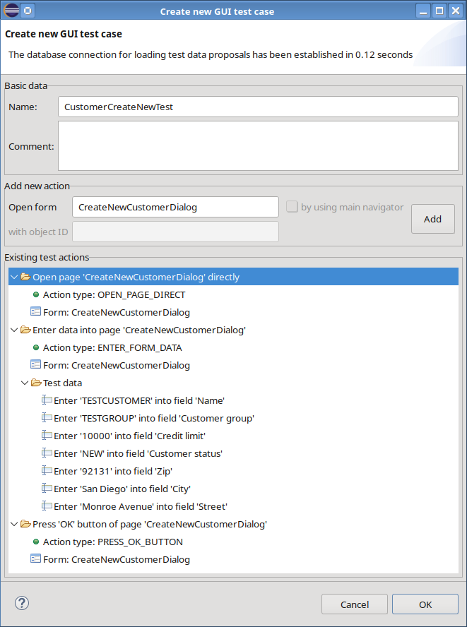Test case for creating a new customer
After successfully executing the test for the first time everything seems to be fine! Running the test again will definitely fail as the test tries to create a customer with a name (here TESTCUSTOMER) that already exists. The root cause of the problem is that the corresponding column possesses a unique key constraint. It is always a good strategy that a test discards all changes being made in the database before the test is about to be finished. In this case, the problem can be avoided by creating an additional test action that deletes the customer at the end of the test (see chapter 16.6.3).

Validate form data
After creating a new customer we might want to validate if the corresponding read-only form (e.g. ViewCustomerDialog) can be opened. Beside of that, it should be tested if the fields contain the expected values. This can be done by either creating a new test case or adding new test actions to the existing test case from the previous example. The graphical editor will display all form fields with a gray background colour indicating that they are read-only. But in contrast to the 'real' page of our web application, data can be entered here. Every time when entering a text into a read-only field the input will be used for validating the field's value when running the test. After entering a validation value the background colour of the form field will be changed to green.
CodeCadenza also supports the validation of fields that are not read-only. But when entering data in such a field the provided text is used to change the field (see previous chapter). In this case, it is necessary to open the context-menu of the selected field. The menu item “Set expected value” opens a dialog with an input field for defining the text that should be used for validation.
If values of form fields should be changed and tested within one test action the validation will be always performed prior to setting a new field value!

Execute form actions
Especially view forms and grid panels provide further actions (e.g. open a form to update data of the selected object). The graphical form editor displays all these actions in a tool-bar. When pressing a tool-bar button in the graphical editor CodeCadenza automatically creates a new test action. Depending on the form action that is being triggered different things may happen.
If the corresponding form action depends on an object that is selected in a row the user must define how to find the respective row while performing the test. In this case, following dialog is opened automatically.

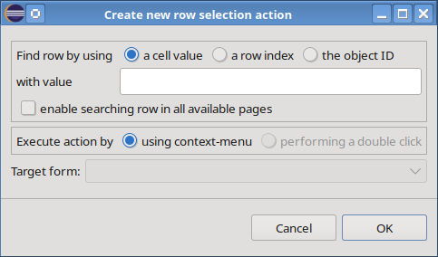Row selection dialog
If we come back to chapter 16.1 where we have defined a simple test action for opening a view that displays all countries we might want to open the form to update an existing country for changing some field values. In order to define the row that represents the country that should be changed there are three options available. A row can be searched by using

- a cell value
In this case, the test will search for a row that contains a visible cell with the given value. The developer is responsible for providing a value that sufficiently identifies the row in order to avoid selecting a wrong one.

- a row index
When selecting this option the test will search for a visible row at the given index. Per definition, the first row has index 1!

- the object ID
We have already learned that every persistent domain object has a primary key attribute. If this option is selected the test will search for a row with the respective value. It is allowed that the respective column is invisible! Note that this mode is not supported for Vaadin applications!
By default, the search operation does only include the initially loaded rows. If the test should use the table's pagination feature it is also possible to select “enable searching row in all available pages”. It is seductive to enable this option always! But keep in mind that it can dramatically increase the test time! If the test is not able to find a row the test will fail!
Normally, a form action is triggered using the table's context-menu. It is also possible to execute a form action by performing a double-click on the given row. The respective option is only enabled if a double-click for the respective form action is basically supported!
Due to the fact that a double-click might open different forms depending on the user that is logged in, it is possible to overwrite the default value in combobox “Target form”.

If we want to create a new country object we can simply click on the respective tool-bar button of the view form. In this case, the row selection dialog is not opened as no selection is necessary. Rather, the graphical editor for creating a new country object is opened directly! As this example illustrates, it's possible to create very complex test flows as one test action can be the starting point for many others. In other words, a graphical editor dialog may open an arbitrary number of other graphical editor dialogs. CodeCadenza is responsible for recording the user interaction and adding new test actions to the test case in the correct order.

Some test actions (e.g. executing a data exchange operation see chapter 13 and following) neither require the selection of a row nor open a target form. In this case, only a notification in the title area of the graphical editor is shown indicating that a new test action has been added.

Search input
In the previous chapter, we have learned that finding the proper row in either a view form or a grid panel can be a sophisticated task. Forms of type SEARCHABLE_VIEW always provide a search input dialog (see chapter 11.3.3). This functionality is also available in the graphical test editor for respective forms. When performing a click on the tool-bar button “Search” following dialog (based on form CustomerView) is opened:

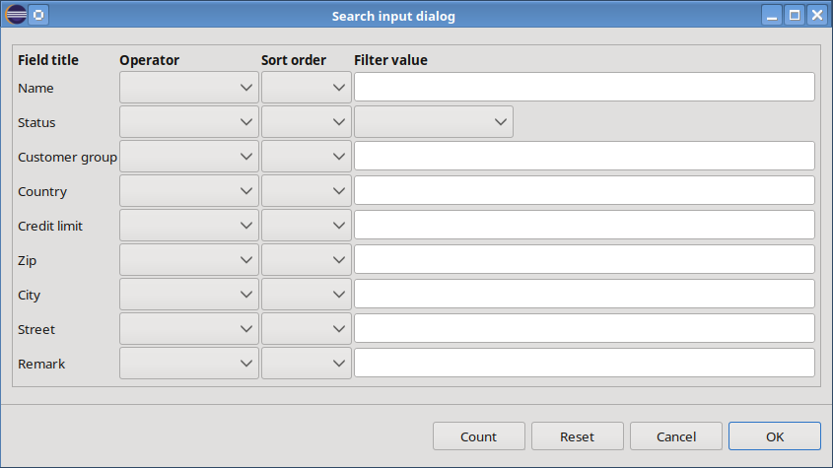Search input dialog
Beside of entering filter criteria it is also possible to select a filter operator and the sort order for a specific column. By pressing the dialog's "OK" button a search input operation will be added to the test case. After opening the form at runtime the provided test data will be used accordingly and the view should be filled with the expected results. By using this dialog it should be relatively easy to force the application returning only the row we are interested in!

Alternatively, the dialog can also be used to perform either a count or an input reset operation by pressing the corresponding button!

Row count validation
After loading the rows of either a view form or a grid panel it is possible to validate the number of visible rows.

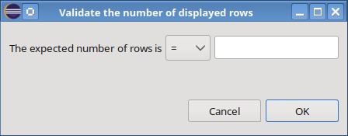Row count validation dialog
The selection of the operator combobox controls if the number of expected rows is either greater, smaller or equal compared to the value entered in the dialog's text field. By pressing the "OK" button the new test action is added to the test case.

Uploading and downloading files
Sometimes a domain object contains either a binary column or a column with a reference to a physical file (see chapter 8.8.1). Corresponding forms usually will be supplied with actions that allow the user to either upload or download this attachment. It also makes sense to test these actions.
In the graphical editor, an upload test action can be created by pressing either a tool-bar item or a form button. In a file dialog the path to the upload file must be selected. A file download action doesn't require additional information. But it is necessary to change browser settings accordingly in order to save a file directly without opening an internal pop-up dialog that requests the download target folder. Otherwise, it is very likely that the test will fail!

Login and logout
As soon as the application is secured, it is necessary that all GUI test cases must be adapted properly as they now operate on protected resources. While the tests have run without failures before, they will fail after enabling security. To circumvent this problem it is possible that a login test action is executed before the actual test will start.
A login test action can be created by selecting an existing test action in the GUI test case dialog. By selecting the test action's context-menu item “Add login action” a simple dialog is opened that requires a user name and a password to be entered.

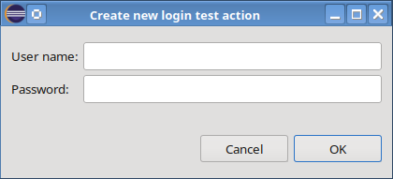Dialog for creating a new login action
After clicking the "OK" button a new login test action is created.
The aforementioned context-menu also contains an item “Add logout action”. If this item is selected a new logout test action will be added to the list of existing test actions.

Additional features
The last chapters have covered the details about how to model GUI tests. Now it is time to discuss further functionality.

Page title test
Sometimes it should be tested if the page that has been opened is really the expected page. The easiest way to prove that is to verify the page title. By selecting the context-menu item “Edit expected page title” of an existing GUI test action an input dialog is opened that requests the expected title to be entered. By default, the proposed text should match the title of the page. The text must be adapted accordingly if the title has been changed manually! Testing the page title is only supported for GUI test actions that either open a page directly or open it by the application's main navigator.

Moving test actions
Sometimes it is necessary to change the execution order of existing test actions. If we select a test action in the GUI test case dialog it is possible to move the selected test action by simply pressing the '+' or '-' key. Note that CodeCadenza will neither reject this operation nor it warns the user if the changed order either doesn't make sense or is likely to let the test fail!

Test action results
Until now, we have modelled different GUI tests that were expected to succeed. But it is also interesting to verify the behaviour of the application if an error (e.g. due to inappropriate user input) occurs.
If a given GUI test action is expected to fail it is possible to define the expected result in a separate dialog that can be opened by the context-menu item “Edit test action result”.

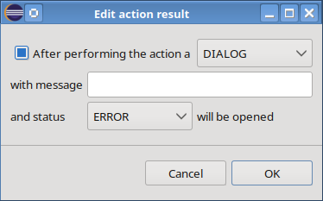Dialog for maintaining the result of a GUI test action
After selecting the checkbox on the left side of the dialog the rest of the dialog components will be enabled. The combobox on the right side controls if the test action will either open a dialog or a notification message. For Vaadin applications only the option DIALOG is available! The text field in the next line can be used o enter an expected message that the selected component will present to the user. Depending on the severity of the failure the message component has a different status. The supported states are INFO, WARNING and ERROR!
As this functionality assumes that an error can be handled by the page using a notification component it cannot cover situations regarding unexpected errors that might open the standard error page!
It is possible to remove an existing result check from a test action by opening the dialog again. After unselecting the checkbox and pressing the "OK" button the result check will be removed.

Delaying test actions
In chapter 16.5 different global configuration parameters regarding the test timing has been discussed. It sometimes could be the case that a specific test always fails when executing the same test action. If it turns out that the reason for that is a timing issue it could be helpful to specify a delay either before or after the respective test action is executed. A test action delay can be defined by the context-menu item “Delay” in the test case dialog. When selecting either the sub-item “After” or “Before” an input dialog is opened where the delay in milliseconds can be entered. If an existing delay should be removed the input dialog can be opened again. If the input field is left blank the delay will be removed as soon as the "OK" button is pressed.
Note that this feature should be rarely used in order to avoid increasing the test duration!

Test action comments
You may have already noticed that CodeCadenza also creates a reasonable test action comment which is used in the Java source file of the test case as well as in the test data file. It is possible to change the text by selecting the test action's context-menu item “Edit comment”. An input dialog is opened that contains a text field with the current comment.

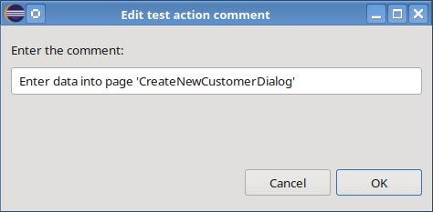Dialog for editing the test action comment
By pressing the “OK” button the changed text will be saved and the respective files are being rebuilt.

Delete a test action
For the sake of completeness, it should be mentioned that the deletion of test actions is also possible by using the respective item of the well-known test action context-menu. CodeCadenza neither warns nor prevents the user from deleting the test action even if the test becomes inconsistent. A good example for causing an inconsistent state is to delete an action for opening a page. If the next page action is responsible for entering form data the test becomes inconsistent and won't even compile.

Test data proposals
The previous chapters should have shown that modelling of GUI test cases with CodeCadenza represents a considerable ease compared to programming tests manually. Nevertheless, the effort for entering test data must not be underestimated as it is usually necessary to provide valid data especially in the case of lookup fields. This requires permanently searching for values in the project database or in the application.
To improve that situation the graphical test editor provides a proposal feature for test data that has already been entered in previous tests for a specific field. Furthermore, test data proposals are loaded from the database if the project data source has been initialized correctly (see chapter 7.2). After typing the first character in a field the graphical editor searches for proposals that match the entered text. Note that this feature is not available for numeric and date fields!

Running a test
After the test has been created, it is added to the CodeCadenza project navigator. The test can then be started or debugged using the menu item “Run” or “Debug”. It is important to ensure that the relevant applications have been started beforehand (see chapter 18).

GUI test suites
CodeCadenza also allows to aggregate existing test cases using a test suite. By selecting the context-menu item “New test suite” in the project view a dialog for creating a new GUI test suite is opened.

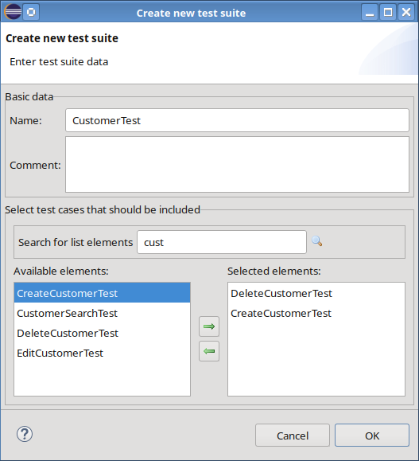Dialog for creating a new GUI test suite
A valid name must be entered into field “Name”. The comment field is optional. It must be considered that all test case and test suite classes belong to the same package. Thus, the name must not match the name of an existing test case or test suite!
Test cases that should be added to the test suite have to be moved from the list of available test cases on the left side of the dialog to the list on the right side. The order of the selected test cases in the list also controls the execution order when running the test suite. The rule is that the topmost test case in the list is executed first.

Communication between client and server
In many real-world rich-client applications, the client communicates with the back-end application server by using RMI-IIOP. Although this protocol is fast, reliable and part of the Jakarta EE specification, it has some drawbacks:

- It is hard to use when it comes to load-balancing.
- By default, an enterprise firewall blocks the ports necessary for working with RMI.
- It could be hard to setup RMI data stream encryption.

These drawbacks were the motivation to implement a simple protocol that should avoid aforementioned problems. By default, every CodeCadenza rich-client uses this HTTP-based protocol in order to communicate with the application server. Therefore, we won't run into problems with firewalls. Furthermore, load-balancing is possible by either using appropriate software (e.g. mod_proxy of the Apache HTTP server) or hardware.

Although the internals are quite sophisticated, the protocol is easy to use for an application developer. In a first step, the (remote) client application must initialize a ServiceLocator object including all necessary information to connect to a remote system (e.g. target URL and application name).

final var hostLocal = new ServiceLocatorDTO
(
ALIAS_HOST_LOCAL,
"http://host/my-invoker",
false,
TransportType.HTTP
);

// Initialize service locator in order to communicate with the application server
ServiceLocator.initialize(serviceLocatorDTO);

As soon as the ServiceLocator has been initialized, the application is able to use remote boundary service interfaces. In the beginning, it might seem strange that the client application works with interfaces only. But there are two reasons for that: On the one hand, the implementation resides on a remote server and the method should be processed remotely. Hence, we don't necessarily need the implementation of the boundary service. On the other hand, every call to a boundary method must be intercepted by an InvocationHandler that is physically responsible for remote communication. In order to facilitate proper invocations, it is necessary that the boundary interface will be initialized via the ServiceLocator.

UserBoundaryService service = ServiceLocator .getService(UserBoundaryService.class);

In other words, the ServiceLocator binds an InvocationHandler to the respective interface and makes the interface methods callable!

UserDTO user = service.findUserById(id);

When invoking the boundary method findUserById(), the InvocationHandler knows how to convert the invocation into a generic transport object. In most cases, it sends a HTTP request to the InvocationServlet which is responsible for acting as a controller that in turn searches for a respective boundary service (e.g. via a JNDI lookup) and performs the method invocation. Finally, the servlet converts the invocation result or an exception into a generic transport object and sends it back to the InvocationHandler. Afterwards, the InvocationHandler converts the result and returns it to the client. The protocol web application also provides two further services: the FileUploadServlet and the FileDownloadServlet. As the names imply, these servlets are optimized for exchanging files between client and server.

The following picture illustrates the protocol's architecture:

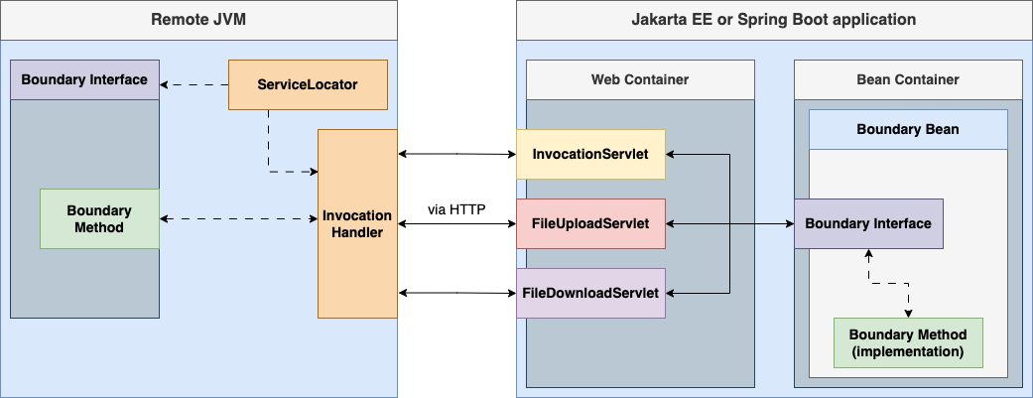CodeCadenza's rich-client communication protocol
When generating the rich-client application, all necessary configurations and source code is being created by CodeCadenza. Most of the time an application developer just has to adapt the given target URL in order to connect to the desired back-end system.

Launching the application
Now, that all objects are in place, we are able to test our application for the first time!

If the application accesses the target database directly (without using an application server), we will only have to take care of synchronizing the target database with our domain model!

In order to successfully run a client application that communicates with an application server, there are some prerequisites that must be met:

  - The target database needs to be in sync with the application's JPA entities.
  - The application server must have been started.
  - The web application archive (crm.war) must be successfully deployed on the application server.

A Jakarta EE application can be easily deployed by performing the Apache Maven build command “clean install”. This command automatically deploys the application to the selected application server.

In case of RCP applications, we have to open the product definition file (application.product) to start the client application. By default, these kinds of files are displayed in the product configuration editor of Eclipse:

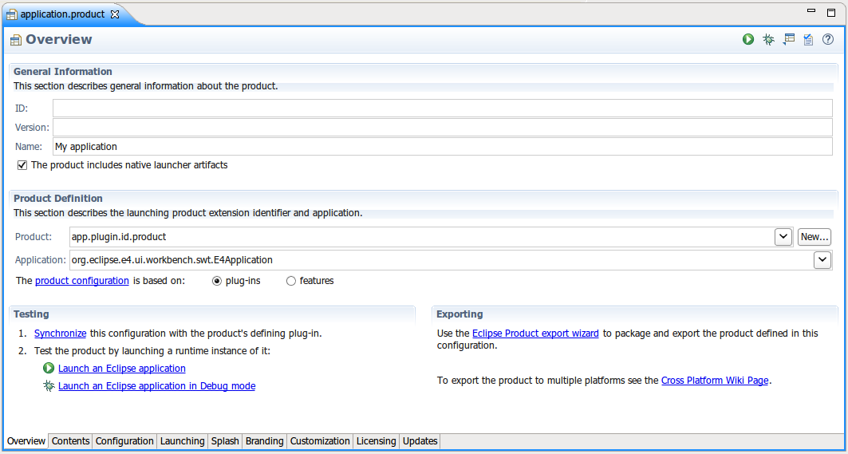application.product file in the product configuration editor
The application starts as soon as we click on the hyperlink “Launch an Eclipse application”. No matter if we have already defined security, a log-on dialog will appear by default:

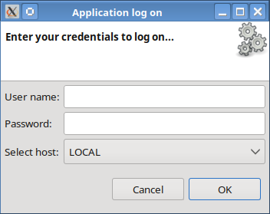Log-on dialog
If security isn't in place, we will just have to select a proper host in combobox “Select host” in order to connect to the application server. When pressing the "OK" button, the dialog disappears and the application's main window is opened.
A Swing application can simply be launched by using file Application.java in the Package Explorer and selecting “Run As → Java Application”.
Use the file AppLauncher.java in order to start a JavaFX application.

For starting a RAP client we just select the project's root item in the Package Explorer of Eclipse and select “Run As → RAP Application”.

If we haven't integrated the application server into Eclipse (e.g. by using Eclipse WTP), we will have to deploy a JSF application to the target application server. After starting the application server, we can open a browser and enter the application's start URL. Note that CodeCadenza uses the entry in field project code (see chapter 6) as the application's context root. In the following example, the project code is “dw” and thus we can insert http://localhost:8080/dw/ in the browser's address field. Note that the default HTTP port (in this case 8080) depends on your personal application server settings! If everything works fine, the browser will open the application's start page:

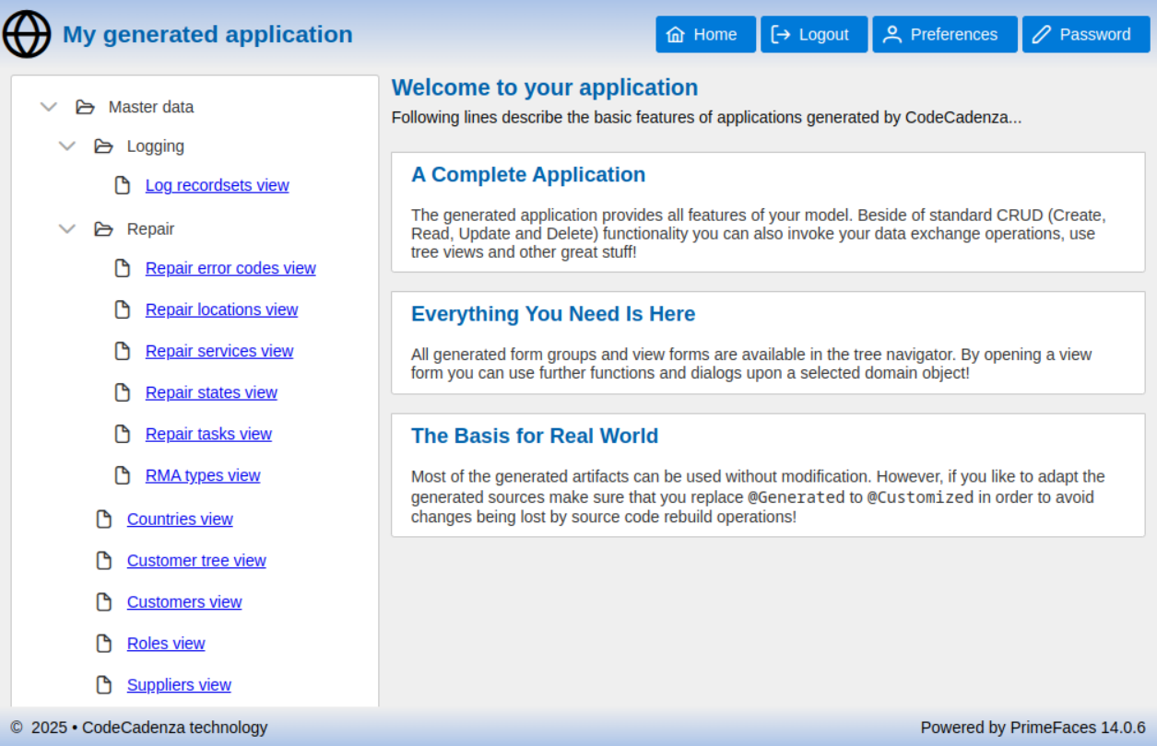Start page of a generated JSF application
A Vaadin application must either be deployed on an application server or via its respective Spring Boot main class (see chapter 6)!
If this has been finished successfully, we can open a browser and enter the application's root URL in order to test our generated application.

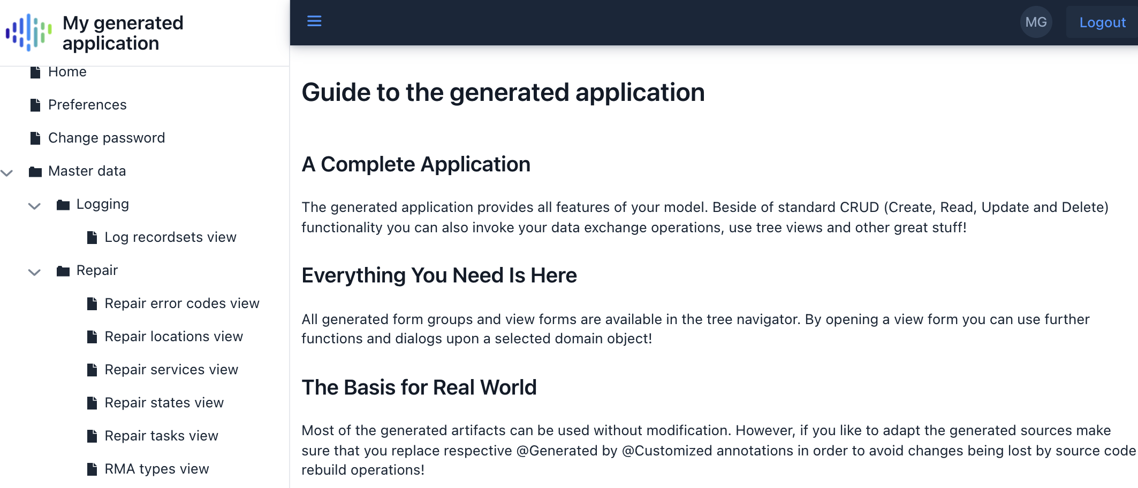Start page of a generated Vaadin application
Alternatively, the applications can also be started, debugged and built using the CodeCadenza project navigator (menu item “Run”). This starts both the server and the client application (if available). For a Jakarta EE application, the corresponding build process is launched. It is important to ensure that the application server is started first. If the application has an Angular client, the corresponding command for starting or building is executed in a local console using “ng serve” or “ng build”. After a web application (e.g. Angular, JSF or Vaadin) has been successfully started, the default browser is automatically opened with the initial URL of the application.
CodeCadenza creates an Eclipse launch configuration for each application that is started in this way. This configuration is used when restarting and can therefore be changed accordingly. For example, for a web application, the initial URL can be adjusted using the “WEB_APPLICATION_URL” environment variable if the application uses a different port or the application is deployed on a remote machine.

Maintenance of generated source code
You may have already noticed that all generated attributes and methods are annotated with @Generated which is an annotation that neither belongs to JPA nor to any other official Java standard. This annotation belongs to the internal source code generation and management framework and does not provide any runtime features. In fact, @Generated provides an easy and powerful feature to change generated source code manually. It sometimes may happen that a generated method body should be changed because of functional or performance reasons. Without such a facility the manual changes get lost as soon as the source will be rebuilt. If a developer wants to change the generated method body, @Generated should be replaced by @Customized. The internal source code generation framework will check every existing class and will protect manual changes within such methods. But it is even possible to add new attributes and methods to generated sources without a need for any special annotation. Additional import statements that might be necessary if a developer modifies generated source will be recovered also.
Every class that may be recreated by the plug-in is supplied with @Generated annotations. Those annotations are not integrated into classes that are generated by CodeCadenza only once where later rebuilds are not expected or even not possible.
Some model driven architecture experts claim that generated source should not be modified at all. Rather, they advise using Java language utilities like inheritance or proxies to “change” behaviour of generated source code.
It is always a good strategy to modify generated source code as little as possible. But before you might think of creating a sub-class or even a proxy just to change some lines of code it might be helpful to rely on the plug-in's source code generation and recovering capabilities.
Note that this feature is only available for generated Java classes. For all other file types (e.g. TypeScript, HTML or XHTML files) the manual changes get lost when rebuilding them!

Trademarks
- Oracle, GlassFish, MySQL, J2EE, Java EE and Java are registered trademarks of Oracle and/or its affiliates. Other names may be trademarks of their respective owners.

- JBoss and Hibernate are trademarks of Red Hat, Inc.

- Jakarta EE, Eclipse and EclipseLink are trademarks of Eclipse Foundation, Inc.

- Microsoft, Microsoft SQL Server, Microsoft Excel, and Windows are either registered trademarks or trademarks of Microsoft Corporation in the United States and/or other countries.

- PostgreSQL is a trademark of the PostgreSQL Global Development Group.

- ActiveMQ is a trademark of the Apache Software Foundation.

