Syllabus Core Java

Syllabus Core Java

(Duration 45 - 50 Days)

**Day1**

Introduction

Java Architecture

Basic program

Identifiers & Rules

Variables

**Day2**

Data types

Types of variables

**Day3**

Operators

**Day4**

Revision And Asking Questions on Above Topics.

**Day5**

Conditional statements

Loops

**Day6**

1.Sum of n natural number

2.Factorial number

3.Multiplication table

Task : 3 programs

**Day7**

4.Fibonacci series

5.LCM & HCF

6.Print single digit by adding given number

Task : 3 programs

**Day8**

7.WAP sum of even & odd number in a given number

8.WAP count no of digits in a given number

9.WAP to display the sum of square of each digit.

Armstrong number

Task : 3 programs

**Day10**

10.Perfect number

11.Strong number

12.Prime number

13.Automorphic number

14.Magic number

Task : 4 programs

**Day11**

15.Reverse number

16.Palindrome

17.Niven number

18.Neon number

Task : 4 programs

**Day12**

19.Decimal to Binary

20.Binary to Decimal

**Day13**

Interview on Above Concepts and All Above programs.

**Day14**

Discuss About patterns

Some Basic pattern

1.

**\* * * * \***

**\* * * * \***

**\* * * * \***

**\* * * * \***

**\* * * * \***

2.

**\***

**\* \***

**\* * \***

**\* * * \***

**\* * * * \***

**Day 15**

3**.**

**\* * * * \***

**\* * * \***

**\* * \***

**\* \***

**\***

4.

**\* * * * \***

**\* \***

**\* \***

**\* \***

**\* * * * \***

5.

**\* \***

**\* \***

**\***

**\* \***

**\* \***

Task 5 programs

**Day 16**

6.

1 2 3 4 5

10 9 8 7 6

11 12 13 14 15

20 19 18 17 16

21 22 23 24 25

7.

**\***

**\* \***

**\* * \***

**\* * * \***

**\* * * * \***

Task 3 programs

**Day 17**

8.

**\***

**\* * \***

**\* * * * \***

**\* * * * * * \***

9.

**\***

**\* \***

**\* \***

**\* * * * * \***

10.

**\***

**\* * \***

**\* * * * \***

**\* * * * * * \***

**\* * * * \***

**\* * \***

**\***

**Day 18 & Day19 & Day20**

Here Below Patterns Patterns We will discuss

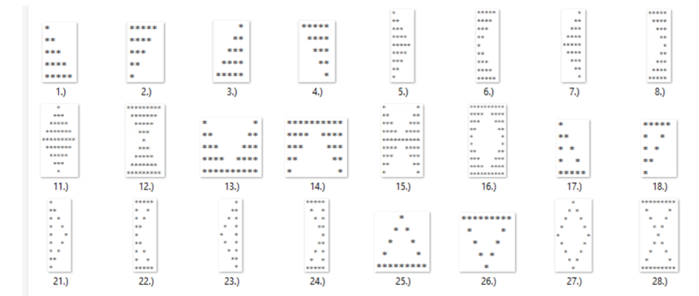

**Day21**

Interview on Above All Patterns And Programs.

**OOPS Concepts**

**Day22**

Methods

Modifiers

**Day23**

Method Overloading

Real time examples

**Day24**

Type Casting With examples

Ambiguity

**Day25**

What is JDK

What is JRE  
Class loading

Static and non static members

**Day 26**

Object

Amandon object

This keyword

Why main method is static

Why main method is public

**Day27**

Interview on Above OOPS Concepts

**Day28**

Constructor with real time examples

Constructor overloading with real time examples

**Day29**

Copy constructor with real time examples

Blocks

Static block & non static block

**Day 30**

Inheritance

Types of inheritance

**Day 31**

Use of super keyword

What is constructor chain

What is the use of super

Final

**Day32**

Overriding with real time examples

@override annotation

Method hiding with real time examples

**Day33**

Non primitive Type casting (Derived type casting)

Two types of Non primitive Type casting

Upcasting

Downcasting

**Day34**

Interview on Above OOPS Concepts

**Day35**

Bindings

Two types of Binding

Early binding

Late binding

**Day36**

Abstract & Advantages

Why multiple inheritance is not possible in java

**Day37**

Interface

**Day38**

Downcasting

Encapsulation

Instance of

**Day 39**

Marker interface or tag interface

Polymorphism

Aggregation

Composition

Singleton class

**Day 40**

Final Interview on Above All OOPS Concepts

**Day 41**

Final Test on Patterns And Programs

**Day 42**

Strings Concepts

toString

== and equal()

**Day 43**

1.Anagram

2.Given String is Palindrome or not

3.Count vowels and consonants in a string

4.Find the length of a string

5.Convert uppercase to lowercase and vice versa

Task 5 programs

**Day 44**

6.Remove Space in a given string

7.Remove duplicates from a string

8.Find the first non-repeating character

9. aaabbcdd i/p

3a2b1c2d o/p

10. java is very easy i/p

Easy very is java o/p

11. java is very easy i/p

ysae yrev si avaj o/p

12. java is very easy i/p

avaj si yrev ysae o/p

Task 5 programs

**Day 45**

String constant pool

What is immutable & why string is immutable

String Builder

Diff b/w string buffer and string builder

**Day 46 & Day 47**

Arrays

Find Smallest in Array

Find 2nd Smallest in Arrays

**Bellow Concepts We will provide Recorded videos**

Bubble Sort

Selection Sort

Insertion Sort

Quick Sort

Merge Sort

Linear Search

Binary Search

Collections

Regex

MockTest

**Day4**

Revision And Asking Questions on Above Topics.

**Day13**

Interview on Above Concepts and All Above programs.

**Day21**

Interview on Above All Patterns And Programs.

OOPS  
**Day27**

Interview on Above OOPS Concepts

**Day34**

Interview on Above OOPS Concepts

**Day 40**

Final Interview on Above All OOPS Concepts

**Day41**

Final Test on Patterns And Programs

**Last Day50**

**Final Mock Test on All Core Java Course**