

Delhi Public School

(Joka) South Kolkata

Physics Investigatory Project File

Submitted For:

|  |  |
| --- | --- |
| Submitted To:  **Mr. Kaustav Das**  Physics Teacher  Delhi Public School, Joka  (South Kolkata) | Submitted By:  **Name:** Sagnik Ray  **Class:** XII-SCI  **Session:** 2024-25  **Subject:** Physics Investigatory  **School Admission No:** XI/0139/23-24  **Board Roll No:** |

**AISSCE 2024-25**

Certificate of Completion

This is to certify that Sagnik Ray of Class-XII SCI-C has successfully completed the Physics Investigatory project as part of the Class XII Physics curriculum under the CBSE guidelines. The project has been completed with diligence and has met the standard of the CBSE curriculum.

External Examiner Signature Internal Teacher’s Signature

Acknowledgement

I would like to formally acknowledge our Physics Teacher Mr. Kaustav Das for his invaluable guidance and support during my Investigatory Project on "**Relation between Ratio of Input & Output Voltage and No of turns in Primary and Secondary Coil of Self-designed Transformer**". His expert advice, thoughtful feedback, and encouragement were essential in helping me successfully complete this project. I am very grateful for his dedication and the time he invested in guiding me through the process.

Index

|  |  |  |
| --- | --- | --- |
| **Sl No.** | **Topic** | **Page No.** |
| 1. | Introduction | 5 |
| 2. | Materials Required | 7 |
| 3. | Theory | 8-9 |
| 4. | Circuit Diagram | 9 |
| 5. | Procedure | 9-10 |
| 6. | Observations & Conclusions | 11-12 |
| 7. | Precautions & Sources of Error | 12 |
| 8. | Application of Transformers | 13 |
| 9. | Conclusion | 14 |
| 10. | Bibliography | 15 |

# **Introduction**

**Transformers: A Physics Marvel**

A transformer is a device that transfers electrical energy from one circuit to another through the principle of electromagnetic induction. It does this without changing the frequency of the alternating current (AC) supply. Transformers are essential components in the transmission and distribution of electrical power, as well as in various electronic devices.

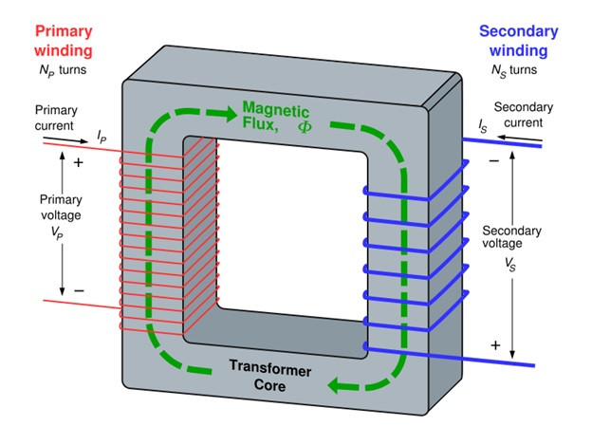

**How does a transformer work?**

A transformer typically consists of two coils of wire, called the primary and secondary coils, wound around a common iron core. When an alternating current flows through the primary coil, it creates a changing magnetic field in the core. This changing magnetic field, in turn, induces an alternating current in the secondary coil.

The voltage in the secondary coil is related to the voltage in the primary coil by the ratio of the number of turns in the two coils:

$$\frac{Vs}{Vp}=\frac{Ns}{Np}$$

Where:

* **Vs** = Secondary voltage
* **Vp** = Primary voltage
* **Ns** = Number of turns in the secondary coil
* **Np** = Number of turns in the primary coil

**Types of Transformers**

There are two main types of transformers:

**1. Step-up Transformer:**

* + Increases voltage
  + Ns > Np
  + Used to transmit electricity over long distances at high voltages to reduce power loss.

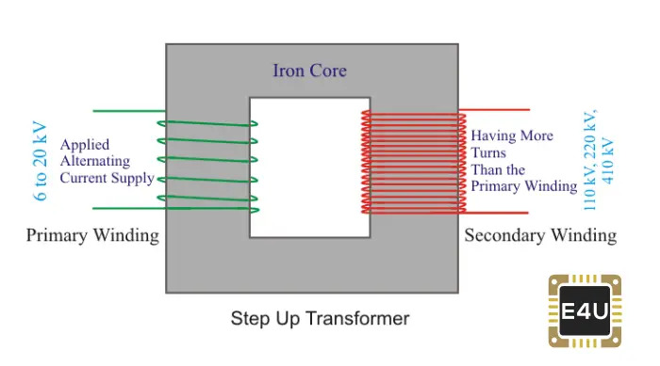

Step-up Transformer

**2. Step-down Transformer:**

* + Decreases voltage
  + Ns < Np
  + Used to reduce voltage for household and industrial applications.

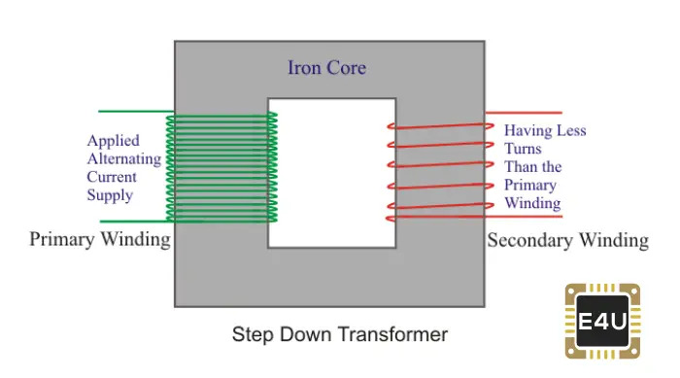

Step-down Transformer

**Materials Required**

# An iron rod

# Copper wires of different guage (diameter)

# 2 A.C voltmeters

# 2 A.C. Ammeters

**Theory:**

The working of a transformer is based on **mutual induction** phenomenon.

Let an ideal transformer in which the primary and secondary coil have negligible resistance and all the flux in the core links both primary and secondary windings.

The induced emf in the primary coil,

$$ξ_{p}=-N_{p}\frac{dϕ}{dt}$$

The induced emf in the secondary coil,

$$ξ_{s}=-N_{s}\frac{dϕ}{dt}$$

where the $ϕ$ is the magnetic flux linked with each turn of primary and secondary coil at a time t. Then,

$$\frac{ξ_{s}}{ξ_{p}}=\frac{N_{s}}{N_{p}}=K=Transformation ratio$$

For an ideal transformation, there is no loss of energy, then

**Input power=Output Power**

$$I_{p}ξ_{p}=I_{s}ξ_{s}$$

$$\frac{I_{p}}{I_{s}}=\frac{ξ_{s}}{ξ_{p}}=K$$

**Circuit Diagram**

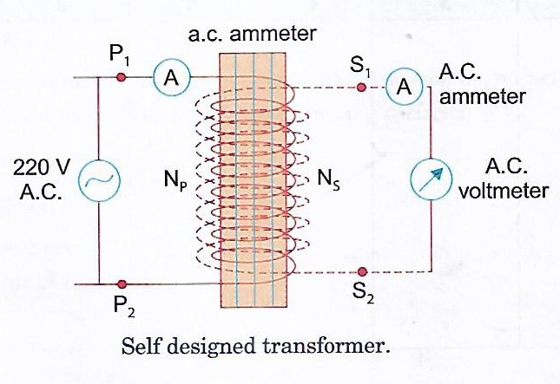

**Procedure:**

**1.** Take thick iron rod and cover it with a thick paper and wind a large number of turns of thin Cu wire on thick paper (say 60). This constitutes primary coil of the transformer.

**2.** Cover the primary coil with a sheet of paper and wound relatively smaller number of turns (say 20) of thick copper wire on it. This constitutes the secondary coil. It is a step down transformer.

**3.** Connect $P_{1}P_{2}$ to a.c. mains (say 220V) and measure the input voltage and current using a.c. voltmeter and ammeter respectively.

**4.** Similarly, measure the output voltage and current through $S_{1}S_{2}$.

**5.** Now connect the $S_{1}S_{2}$ to a.c. mains and again measure voltage and current through primary and secondary coil of step-up transformer.

**6.** Repeat all steps for other self-made transformer by changing number of primary turns in secondary coils.

**Observations**

|  |  |  |  |  |  |  |  |
| --- | --- | --- | --- | --- | --- | --- | --- |
| SlNo | No. of turns in primary coil($N_{p}$) | No. of turns in secondary coil($N_{s}$) | Voltage in primary coil($ξ_{p}$) | Current in P. coil($I_{p}$) | Voltage in secondary coil($ξ_{s}$) | Current in secondary coil($I_{s}$) | Loss of power |
| 1. |  |  |  |  |  |  |  |
| 2. |  |  |  |  |  |  |  |
| 3. |  |  |  |  |  |  |  |
| 4. |  |  |  |  |  |  |  |
| 5. |  |  |  |  |  |  |  |
| 6. |  |  |  |  |  |  |  |
| 7. |  |  |  |  |  |  |  |

**Conclusions:**

1. The output voltage of the transformer across the secondary coil depends upon the turn ratio **($\frac{N_{s}}{N_{p}}$)** w.r.t input voltage.

2. The output current of the transformer across the secondary coil depends upon the turn ratio **($\frac{N_{s}}{N_{p}}$)** w.r.t input current.

3. There is loss of power between input and output coil of a transformer.

**Precautions:**

1. Keep yourself safe from the high voltage

2. While taking the readings of current and voltage, the a.c. main supply should remain constant.

**Sources of Error:**

1. Values of currents can be changed due to heating effect of current.

2. The eddy current can change the readings.

Application of Transformers

Transformers are ubiquitous in our modern world, playing a crucial role in various applications. Here are some of the key areas where transformers are used:

**1. Power Transmission and Distribution:**

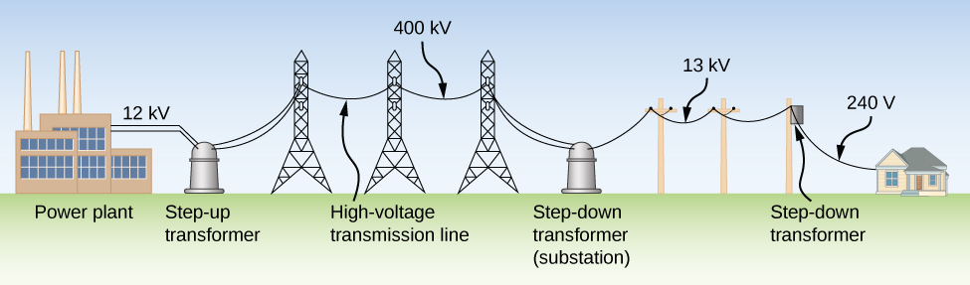

Power Transmission Lines with Transformers

* **Step-up Transformers:** These transformers increase the voltage of electricity generated at power plants to extremely high levels. This reduces power loss during transmission over long distances.
* **Step-down Transformers:** These transformers decrease the high voltage to safer levels for distribution to homes and industries.

**2. Electronic Devices:**

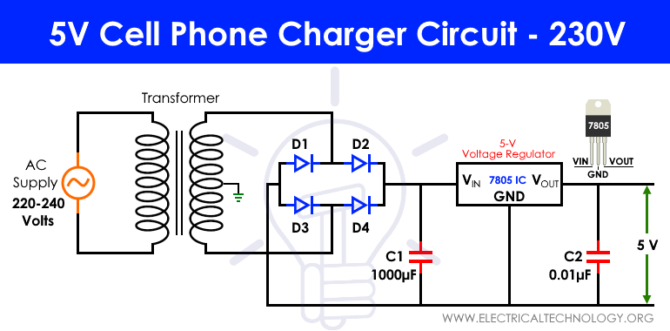

Smartphone Charger with a Transformer

* **Power Supplies:** Transformers are used in power supplies to convert AC voltage to DC voltage, which is required to power electronic devices.
* **Audio Equipment:** Transformers are used in audio equipment, such as amplifiers and speakers, to match impedances and improve sound quality.

**3. Medical Equipment:**

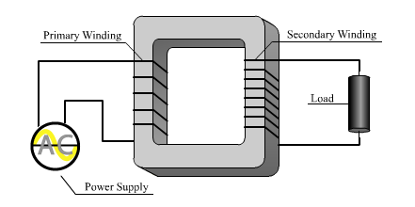

X-ray Machine with a Transformer

* **X-ray Machines:** Transformers are used to generate high voltage for X-ray tubes, which are essential for medical imaging.
* **MRI Machines:** Transformers are used in MRI machines to generate strong magnetic fields.

**4. Industrial Applications:**

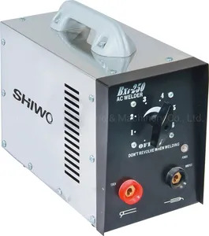

Industrial Welding Machine with a Transformer

* **Welding Machines:** Transformers are used in welding machines to supply high current at low voltage, which is necessary for welding metals.
* **Induction Heating:** Transformers are used in induction heating systems to heat metals without direct contact, which is used in various industrial processes.

**Conclusion**

Through this investigation, we have delved into the fascinating world of transformers, a crucial component in modern electrical systems. Our experiments have demonstrated the fundamental principle of electromagnetic induction, which governs the operation of transformers.

We have observed that by varying the number of turns in the primary and secondary coils, we can effectively step up or step down the voltage. This ability to manipulate voltage levels has far-reaching implications, from efficient long-distance power transmission to powering our everyday electronic devices.

However, we have also encountered certain limitations and sources of energy loss in transformers, such as eddy current losses and hysteresis losses. These factors can impact the overall efficiency of transformers.

In conclusion, this project has provided valuable insights into the working principles of transformers and their practical applications. By understanding these concepts, we can appreciate the role that transformers play in our modern society and explore potential avenues for improving their efficiency and performance.

**Bibliography**

* Comprehensive Practical Physics (XII) by Laxmi Publications
* <https://vietnamtransformer.com/our-news/purpose-of-a-transformer>
* <https://stardelta.com.au/step-up-vs-step-down-transformers/>
* <https://theorycircuit.com/power-circuits/step-down-transformer-guide/>
* <https://pressbooks.online.ucf.edu/osuniversityphysics2/chapter/transformers/>
* <https://electronics.stackexchange.com/questions/608430/how-does-this-charger-work>
* <https://www.nde-ed.org/NDETechniques/Radiography/xraygenerators.xhtml>
* <https://shiwochina.en.made-in-china.com/product/MZqakWfcHJhT/China-AC-Arc-Stainless-Steel-Transformer-Portable-Welding-Machine-Promotional-Industrial-Welding-Equipment-Bx6-200-Inverter-AC-220V-Arc-Welder-200-AMP-Welder.html>