CODECHECK certificate 2025-XYZ



# Summary

This code was straightforward to codecheck. As per the ENCORE[1] structure, there was a renv lockfile located in the 0_SoftwareEnvironment folder. I created an .RProj file in the root directory and copied over the lock file so that upon executing renv::restore() it would be easily recognised. I updated my R version to match the lockfile too. The AbSolution package itself was installed from the pre-existing 0_SoftwareEnvironment folder using install.packages("0_SoftwareEnvironment/R/AbSolution_0.0.5.9550.tar", repos = NULL, type="source").

I could then knit the RMarkdown file and it executed with no errors first time. The tables and figures are printed directly in the HTML output. The figures are interactive. For the purposes of this codecheck, I made a screenshot of each one. The resulting HTML output file matches the given file as expected. I did not test the docker file as the outputs were reproduced on a Windows machine using renv, so there was no need to delve into this for a codecheck.

## Recommendations

The project was straightforward to reproduce so there are no specific recommendations for improvement. I’d be interested to know how the authors predict users will make use of the renv lock file in the absence of any instructions. The lock file in the pre-existing software environment folder is a .prod file extension (i.e., not .lock, which is the default for renv). For me, renv did not recognise the lock file until I changed the file extension to .lock and placed it in the root folder.

# Manifest files

## table1.png

**Comment:** Screenshot Table 1

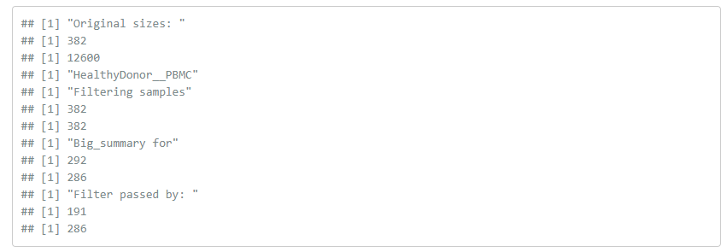

## figure1.png

**Comment:** Screenshot Figure 1

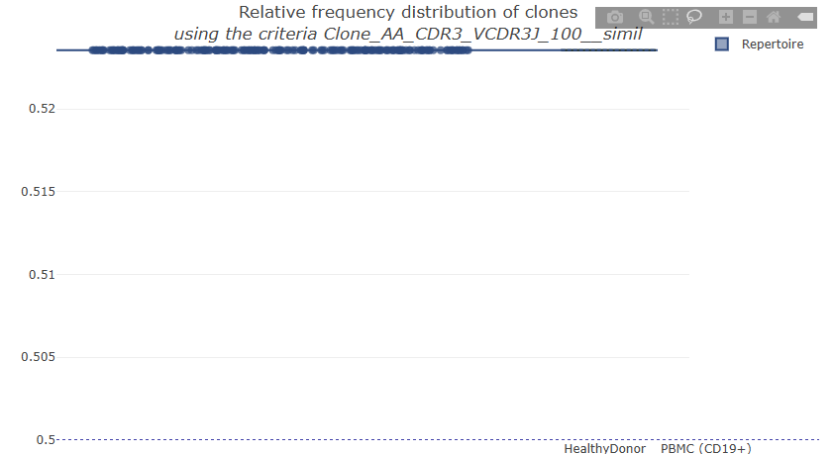

## figure2.png

**Comment:** Screenshot Figure 2

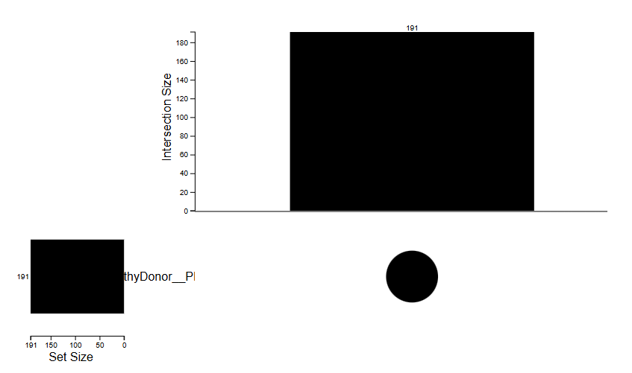

## figure3.png

**Comment:** Screenshot Figure 3

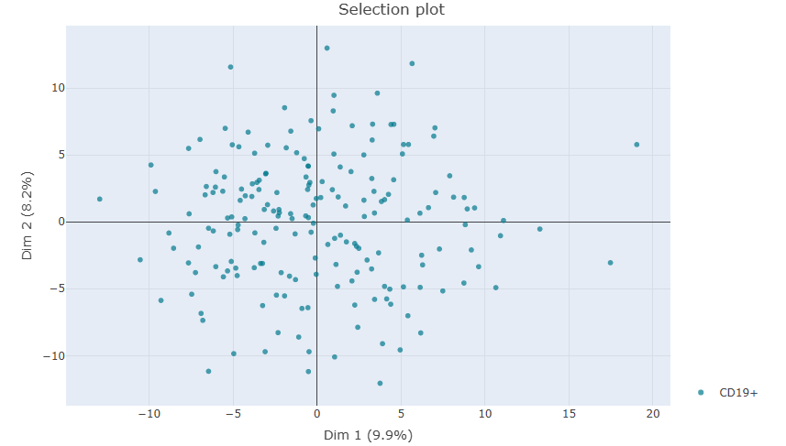

## figure4.png

**Comment:** Screenshot Figure 4

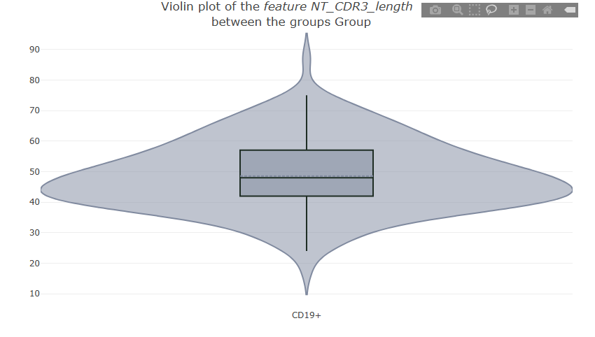

# Citing this document

Sam Langton (2025). CODECHECK Certificate 2025-XYZ. Zenodo. <https://doi.org/10.5281/zenodo.FIXME>

# About CODECHECK

This certificate confirms that the codechecker could independently reproduce the results of a computational analysis given the data and code from a third party. A CODECHECK does not check whether the original computation analysis is correct. However, as all materials required for the reproduction are freely available by following the links in this document, the reader can then study for themselves the code and data.

# Session info

The following session info was saved after successful completion of the codecheck.

read.delim("sessionInfo.txt")

## R.version.4.3.1..2023.06.16.ucrt.  
## 1 Platform: x86_64-w64-mingw32/x64 (64-bit)  
## 2 Running under: Windows 11 x64 (build 22621)  
## 3 Matrix products: default  
## 4 locale:  
## 5 [1] LC_COLLATE=English_United States.utf8   
## 6 [2] LC_CTYPE=English_United States.utf8   
## 7 [3] LC_MONETARY=English_United States.utf8  
## 8 [4] LC_NUMERIC=C   
## 9 [5] LC_TIME=English_United States.utf8   
## 10 time zone: Europe/Amsterdam  
## 11 tzcode source: internal  
## 12 attached base packages:  
## 13 [1] stats graphics grDevices utils datasets methods base   
## 14 other attached packages:  
## 15 [1] plotly_4.10.1 ggplot2_3.5.1 dplyr_1.1.2   
## 16 [4] shiny_1.7.4 AbSolution_0.0.5.9550  
## 17 loaded via a namespace (and not attached):  
## 18 [1] shinythemes_1.2.0 later_1.3.1   
## 19 [3] bitops_1.0-7 tibble_3.2.1   
## 20 [5] Peptides_2.4.5 R.oo_1.25.0   
## 21 [7] shinymanager_1.0.410 lifecycle_1.0.3   
## 22 [9] shinyjqui_0.4.1 doParallel_1.0.17   
## 23 [11] rprojroot_2.0.3 lattice_0.20-45   
## 24 [13] MASS_7.3-58.2 crosstalk_1.2.0   
## 25 [15] magrittr_2.0.3 sass_0.4.6   
## 26 [17] rmarkdown_2.21 jquerylib_0.1.4   
## 27 [19] yaml_2.3.7 bigparallelr_0.3.2   
## 28 [21] httpuv_1.6.11 askpass_1.1   
## 29 [23] reticulate_1.34.0 cowplot_1.1.1   
## 30 [25] DBI_1.2.3 RColorBrewer_1.1-3   
## 31 [27] ade4_1.7-22 golem_0.4.1   
## 32 [29] zlibbioc_1.46.0 R.cache_0.16.0   
## 33 [31] GenomicRanges_1.52.0 purrr_1.0.1   
## 34 [33] R.utils_2.12.2 BiocGenerics_0.46.0   
## 35 [35] RCurl_1.98-1.12 styler_1.10.0   
## 36 [37] bigassertr_0.1.6 reactable_0.4.4   
## 37 [39] GenomeInfoDbData_1.2.10 IRanges_2.34.0   
## 38 [41] S4Vectors_0.38.1 umap_0.2.10.0   
## 39 [43] RSpectra_0.16-1 parallelly_1.35.0   
## 40 [45] codetools_0.2-19 DelayedArray_0.26.7   
## 41 [47] DT_0.28 bs4Dash_2.3.4   
## 42 [49] tidyselect_1.2.0 bigstatsr_1.5.12   
## 43 [51] viridis_0.6.3 shinyWidgets_0.7.6   
## 44 [53] matrixStats_1.2.0 stats4_4.3.1   
## 45 [55] flock_0.7 GenomicAlignments_1.36.0   
## 46 [57] jsonlite_1.8.4 ellipsis_0.3.2   
## 47 [59] dashboardthemes_1.1.6 iterators_1.0.14   
## 48 [61] foreach_1.5.2 tools_4.3.1   
## 49 [63] progress_1.2.2 stringdist_0.9.10   
## 50 [65] Rcpp_1.0.10 glue_1.6.2   
## 51 [67] gridExtra_2.3 xfun_0.46   
## 52 [69] MatrixGenerics_1.12.3 GenomeInfoDb_1.36.0   
## 53 [71] withr_2.5.0 formatR_1.14   
## 54 [73] fastmap_1.1.1 sourcetools_0.1.7-1   
## 55 [75] fansi_1.0.4 shinyjs_2.1.0   
## 56 [77] openssl_2.0.6 digest_0.6.31   
## 57 [79] R6_2.5.1 mime_0.12   
## 58 [81] colorspace_2.1-0 RSQLite_2.3.1   
## 59 [83] diptest_0.76-0 R.methodsS3_1.8.2   
## 60 [85] config_0.3.2 utf8_1.2.3   
## 61 [87] tidyr_1.3.0 generics_0.1.3   
## 62 [89] data.table_1.16.2 iterors_1.0   
## 63 [91] prettyunits_1.1.1 httr_1.4.6   
## 64 [93] htmlwidgets_1.6.2 S4Arrays_1.0.4   
## 65 [95] pkgconfig_2.0.3 gtable_0.3.3   
## 66 [97] blob_1.2.4 shinymeta_0.2.0.3   
## 67 [99] XVector_0.40.0 htmltools_0.5.5   
## 68 [101] scales_1.3.0 fresh_0.2.0   
## 69 [103] Biobase_2.60.0 sunburstR_2.1.8   
## 70 [105] png_0.1-8 attempt_0.3.1   
## 71 [107] knitr_1.42 rstudioapi_0.14   
## 72 [109] tzdb_0.4.0 nlme_3.1-162   
## 73 [111] cachem_1.0.8 stringr_1.5.0   
## 74 [113] KernSmooth_2.23-20 parallel_4.3.1   
## 75 [115] shinycssloaders_1.0.0 pillar_1.9.0   
## 76 [117] grid_4.3.1 vctrs_0.6.5   
## 77 [119] shazam_1.2.0 promises_1.2.0.1   
## 78 [121] shinyFiles_0.9.3 airr_1.4.1   
## 79 [123] xtable_1.8-4 billboarder_0.4.0   
## 80 [125] evaluate_0.21 readr_2.1.4   
## 81 [127] cli_3.6.1 compiler_4.3.1   
## 82 [129] Rsamtools_2.16.0 rlang_1.1.1   
## 83 [131] crayon_1.5.2 sortable_0.5.0   
## 84 [133] fs_1.6.2 stringi_1.7.12   
## 85 [135] viridisLite_0.4.2 BiocParallel_1.34.1   
## 86 [137] assertthat_0.2.1 munsell_0.5.0   
## 87 [139] Biostrings_2.68.1 lazyeval_0.2.2   
## 88 [141] upsetjs_1.11.1 Matrix_1.6-5   
## 89 [143] benchmarkme_1.0.8 scrypt_0.1.6   
## 90 [145] hms_1.1.3 alakazam_1.3.0   
## 91 [147] bit64_4.0.5 learnr_0.11.5   
## 92 [149] seqinr_4.2-30 SummarizedExperiment_1.30.1  
## 93 [151] igraph_1.6.0 memoise_2.0.1   
## 94 [153] bslib_0.4.2 benchmarkmeData_1.0.4   
## 95 [155] bit_4.0.5 ape_5.7-1

1. <https://github.com/EDS-Bioinformatics-Laboratory/ENCORE>