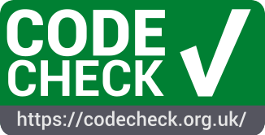

CODECHECK Workshops
-
A recipe for organizers

A report from the project “CODECHECKing goes NL - strengthening open science through reproducible publications in the Netherlands” (CHECK-NL) funded by the Dutch Research Council (NWO) in the Open Science Fund programmer (OSF23.2.063).

The current version of the recipe is published at
https://codecheck.org.uk/guide/event-recipe.

