Homework-14

Jayalakshmi Kari

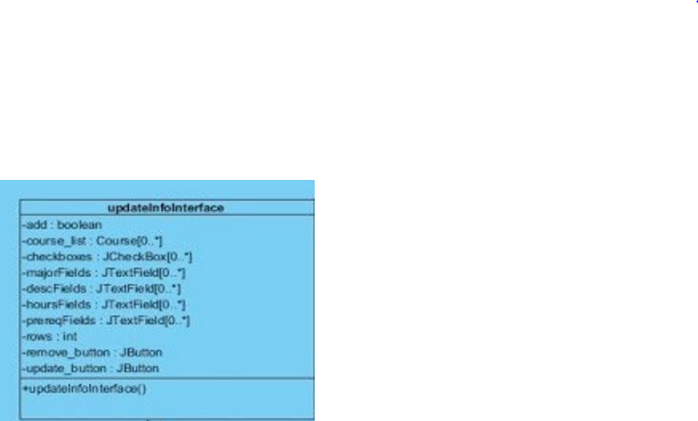



Query builder is accessing information from uodateInfoInterface. Which tells that one module is accessing content of other module to perform its own activity. Query builder is using the data variables in updateInfoInterface to invoke its methods. Therefore these two modules have *content coupling*.