NSTL DATA

The data for training and testing the network model was extracted from the given mat files as follows.  
  
  
1. 41_min_loiter   
  
The DVL beams velocity data has a few missing beams as shown in the plot below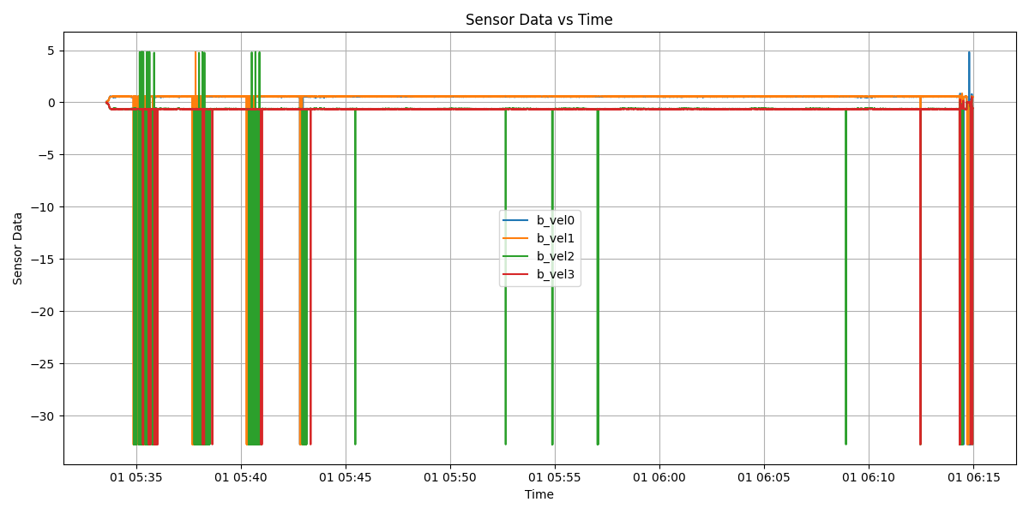

From the above plot we can clearly see that some of the beams are having very high variations. If the beam is having the value of -32 or +5 then, it is assumed to be missing beams.   
  
We can also see that during some intervals of the trajectory all the four beams velocities are available, the beam velocities during these intervals can be considered as complete and can be used as training dataset for the network. From the above plot we can clearly see that we can extract two small parts from the whole trajectory for training that is:  
Dataset1 —> 05:46 to 05:51

Dataset2 —> 05:58 to 06:08

Along with DVL beam velocity data, IMU data was used between the same corresponding time intervals.   
  
GPS data was not available in this particular trajectory, so no ground truth data was available.  
  
2. 300m_lawn_mower  
  
  
The beam velocity plot of the trajectory is shown below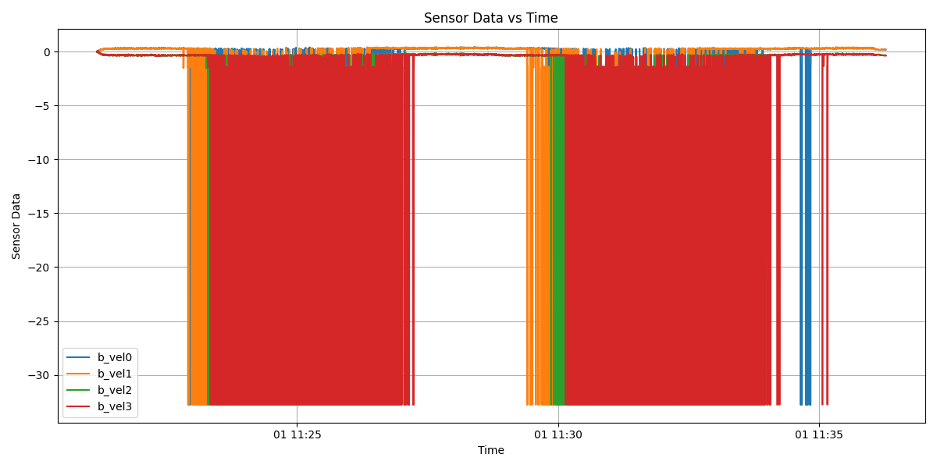

Data for DVL beams velocity and IMU was extracted in the same way as described above

Dataset 1 —> 11:21 to 11:22

Dataset 2 —> 11:27 to 11:29

Dataset 3 —> 11:35 to 11:36

IMU data was extracted between the same time intervals as the DVL beam velocity.

GPS data was available along the whole course of the trajectory with good HDOP (<1) except for the ending part of the trajectory. Even though proper latitude and longitude have been recorded, the GPS velocity INS_Data_pack doesn’t seem to be right as it ranges between -10 to 16 m/s.

| DATASET | Duration | DVL Points | IMU points | Trajectory |
| --- | --- | --- | --- | --- |
| Dataset 1 | 05:46 to 05:51 | 4287 | 30000 | 41_min_loiter |
| Dataset 2 | 05:58 to 06:08 | 8573 | 60000 | 41_min_loiter |
| Dataset 3 | 11:21 to 11:22 | 1359 | 9500 | 300m_lawn_mower |
| Dataset 4 | 11:27 to 11:29 | 1759 | 12300 | 300m_lawn_mower |
| Dataset 5 | 11:35 to 11:36 | 930 | 6500 | 300m_lawn_mower |