Notes

1. Chaining method
2. db.collection.find().limit()

- limit the amount of data to display

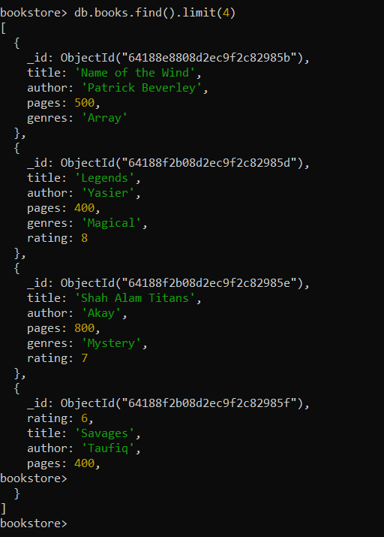

1. db.collection.find().sort(title: 1)

- if the value in sort method is 1 , data display will be in ascending order

- if the value in sort medthod is -1, data display will be in descending order

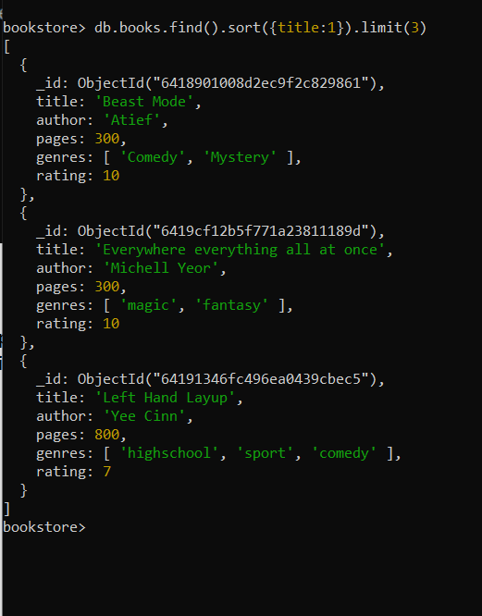

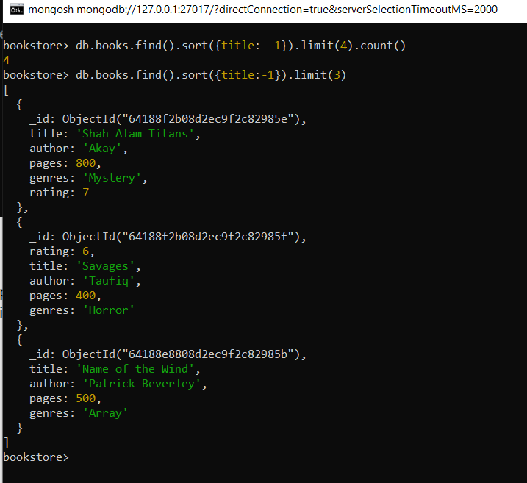

1. db.collections.find().count()

Capture

1. nested documents

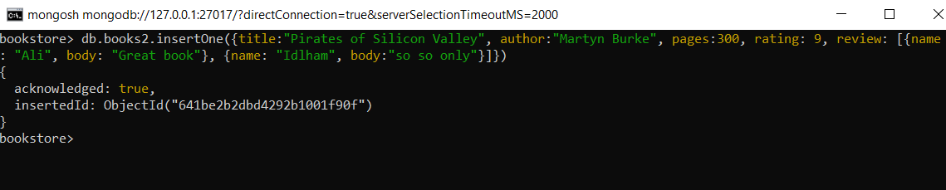

- use array if the field contain more than one types

