Notes:

1. db.books.find({rating: {$lt:8}})

db.books.find({rating: {$gt:7})

- dollar sign to filter out, lt = less than, gt = greater than

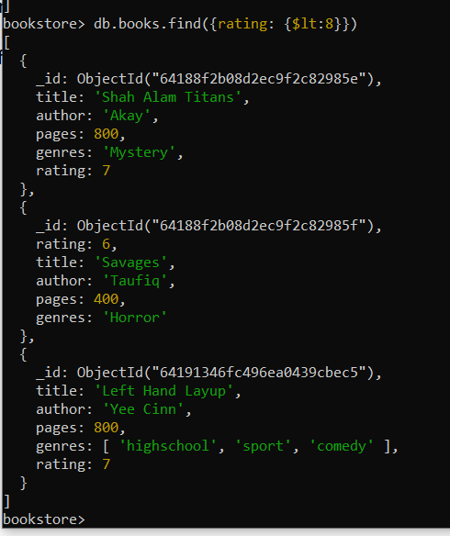

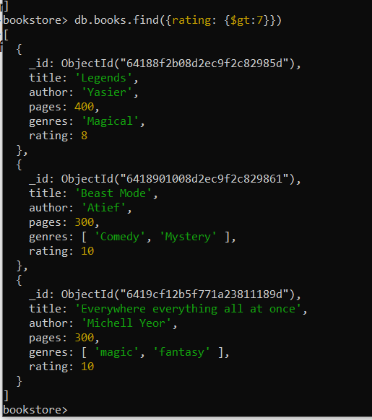

1. Or filter method

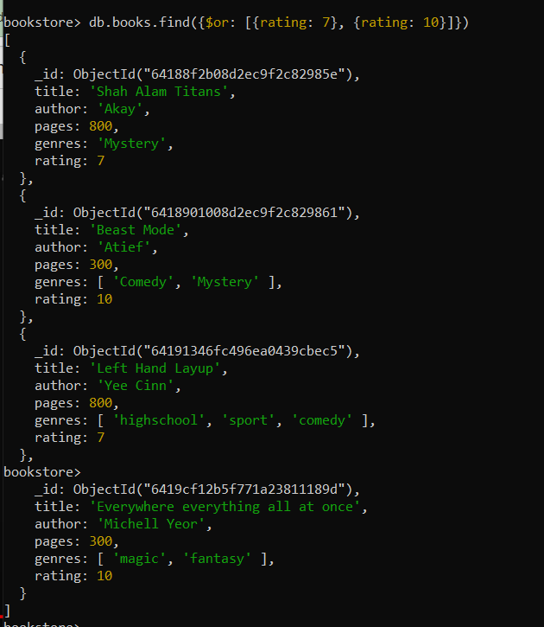

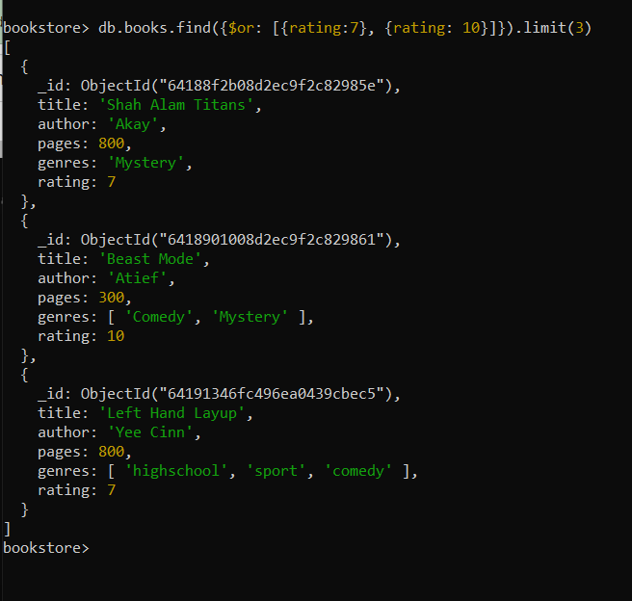

1. Mixing $gt, $or chain method



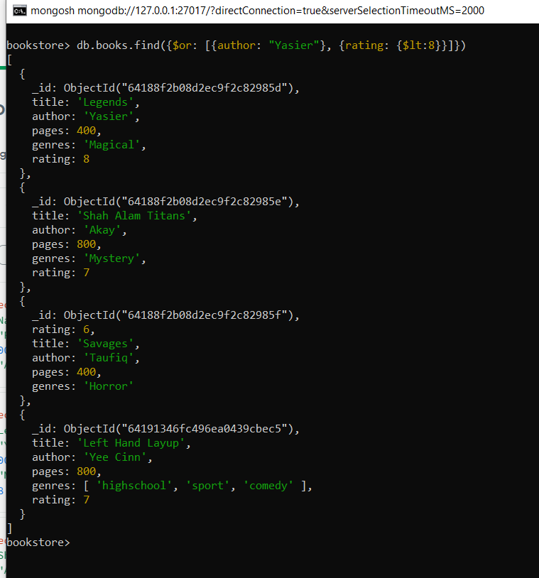

1. $in & $nin to replace $or

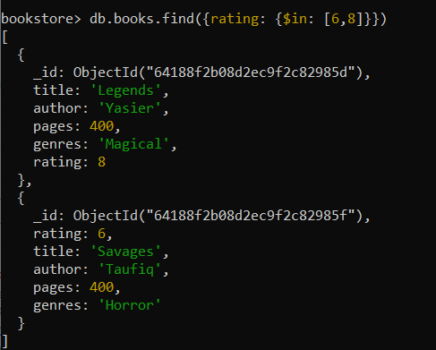

#data with rating 6 and 8 will appear in the screen

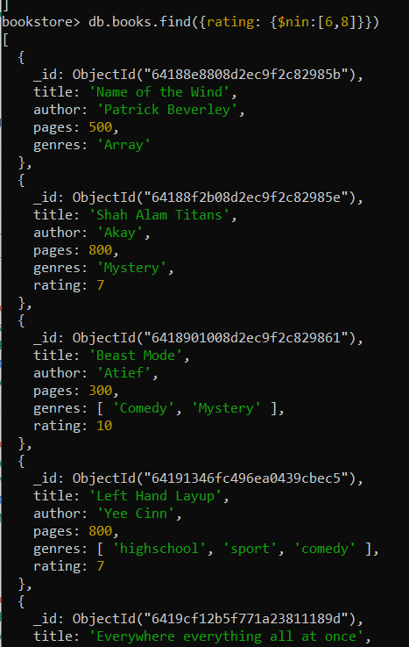

#data which is not in rating 6 and 8 will appear on the screen