Notes: 25/3/2023

How to query an array

1. To only display the data which only all the specific value input

- db.collections.find({genres:[“”, “”]})

1. To display the data which only the specific value (more than one) input

- db.collections.find({genres: {$all: [“” , “”]}})

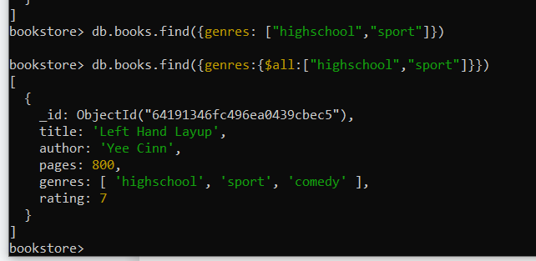

1. db.collection.find({“review.name”: “Yee Cinn”})

- querying a data where the variable in an objects

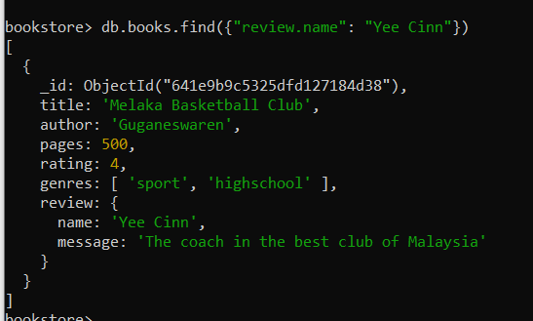

1. Best way to delete one item in the database

db.collections.deleteOne({_id: ObjectId(‘’)})

1

1. Way to delete data with the variable declare in it

db.collections.deleteMany({rating:7})

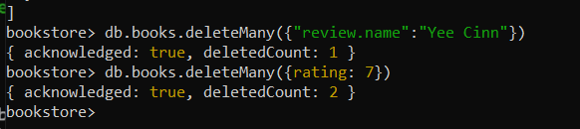

- if the use db.collections.deleteOne({}) , it will delete the first one it came out in the database, therefore the best way to delete a specific one data is to use the id