

# Adventures on the Web

*Add images to your rooms using pixilart.*

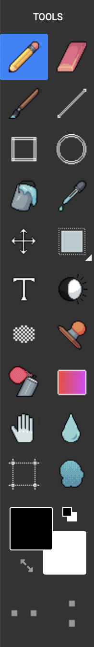

* Open pixilart.com (we can use the same login **CodeClub67**)

1. Click START DRAWING > NEW DRAWING
2. SELECT **Canvas Preset** 500 x 500

*Draw a scene from your room.*

*When your drawing is finished:*

* **SAVE** your drawing to your **downloads** folder

1. Click *SAVE DRAWING (at the top-right)
2. give it a title– **the room name**
3. set visibility to **PRIVATE**
4. click **SAVE** (or UPDATE if you’re saving an update)

* You can also **save** it by doing:

1. File > Export
2. DOWNLOAD .PNG

* You can also **load** a previous drawing:

1. Click on the (smiley) avatar (top-right).
2. Select My Gallery
3. Click on the drawing
4. Select “Edit Drawing”

## Login to **replit.com** with the login provided.



1. Select Apps “Colossal Cave Adventure”
2. Click on the three dots next to files (top-left)
3. Select **Upload files**
4. Choose your image from the **downloads** folder.

* *Select your room from the list at the left**(an* ***html*** *file)*

1. At the bottom of the page add a line break
2. After the line break add an image tag.   
   Replace **MY IMAGE** with the filename you just uploaded.

**<img src= “MY IMAGE.PNG” >**

*“src” is short for source.*

1. You can adjust the size by adding a **width**.   
   This is a percentage of the width up to 100%:

**<img src="MY IMAGE.PNG " width="50%">**