*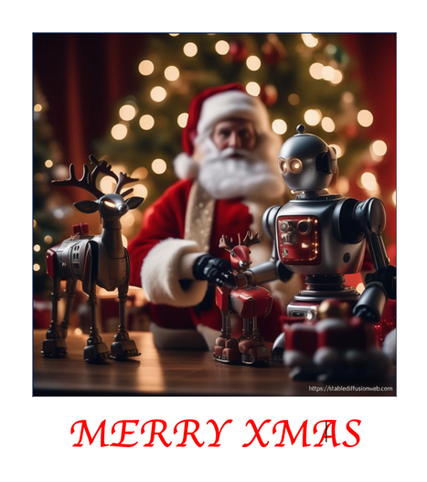*****

# Christmas Card Creator

***AI generates images based on your description.***

## Open [**https://stablediffusionweb.com**](https://stablediffusionweb.com/) **[1]**



1. Click **Free AI Image Generator**

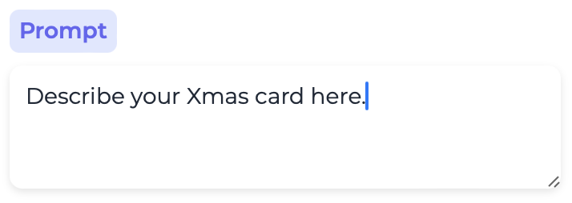

1. **Prompt** the AI with a detailed description of your card.  
   *Be as detailed as possible.*
2. 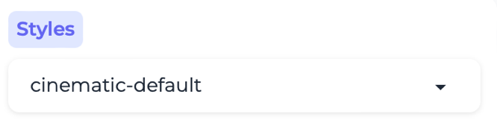Select the **Style** (click on the little triangle). *“cinematic-default” is photo-quality – there are many other styles.*
3. Click **Generate**  
   This may take a little while…  
   You can see your place in the queue, and a time estimate.

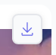

When it’s ready, click the download button at the top-right of the image.

**Open** [**https://codeclub67.github.io**](https://codeclub67.github.io/)****

1. Select the images icon
2. Click on **card-template.docx** to download it.

*Find the card-template in your Downloads folder.*

1. Double click on the card (icon) to open it.
2. Select the **Insert** tab
3. Click **Pictures** or **Image**, then **Picture**/**Image from File**
4. Select the image you created and downloaded, then **insert**.
5. 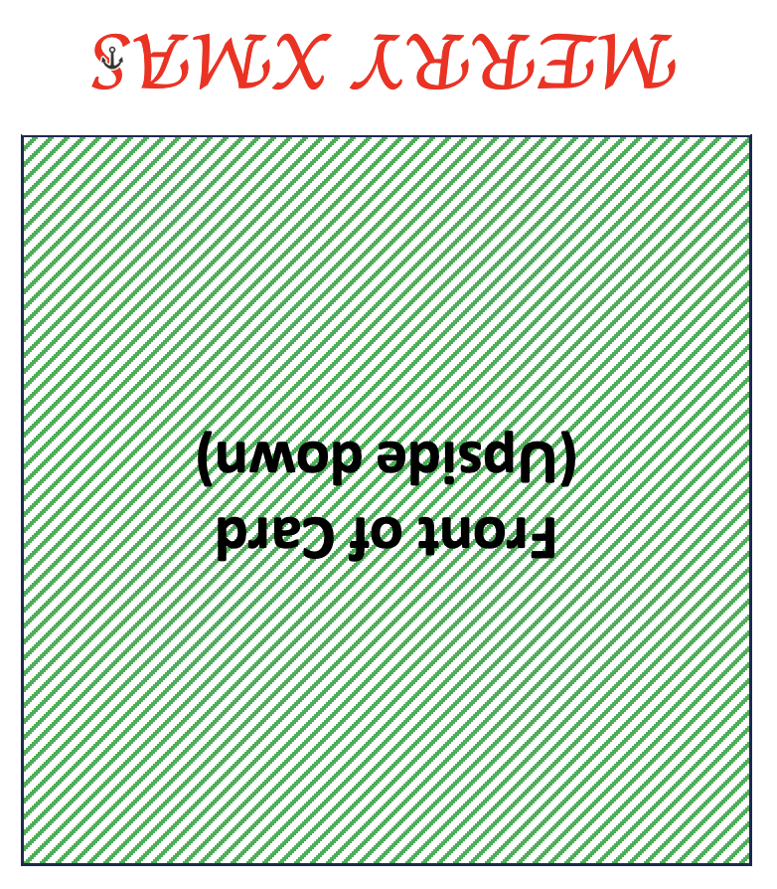Right-click on the image, select **Wrap-Text** or **Wrapping style**, then select **Tight**.
6. Drag the photo so the top-left corner aligns with the same corner of the green square.
7. Resize the image by dragging the small white box at the lower-right corner. Make it the same size as the green square.

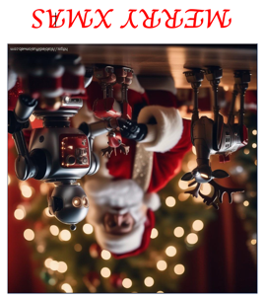*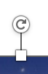“****Merry Xmas****” is upside down because the card will be folded. The image has to be upside-down as well.*

1. At the top of the image there’s a rotation handle. Press and hold the handle, then drag to rotate the image until it’s upside-down.

*Finish the card by completing the text:*

1. 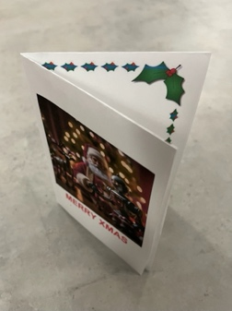“**Happy Christmas** …” (who is the card to)
2. “**Love from** …” (from you)

*Now print your card*

1. Click on the printer icon to print your card
2. Fold the paper in half **horizontally,** then **vertically**.

***Save it on your USB drive as “card”***

1. Stable Diffusion was chosen because it has safety filters.