

**Face Detection**

*Detect your face in the computer’s camera.*

* Open **https://scratch.machinelearningforkids.co.uk**
* 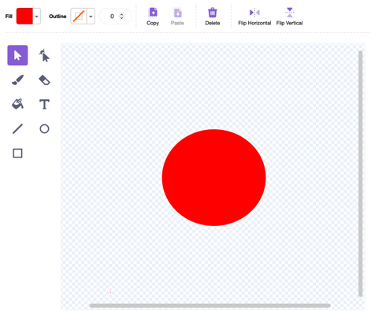Press the Add Extension button and add the   
  Face Detection extension.
* Create a new sprite with the paint tool. Create a red clown nose in the centre of the sprite.

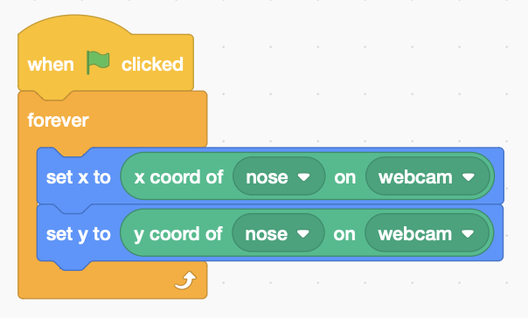

* Add code to detect the position of your nose and move the red nose to that x,y position. The loop is needed so it works when you move around.
* Press the green flag to run it. You might have to give the computer permission to use the camera.

*Move your face closer to the camera. The red nose might be too small to cover your real nose. Move backwards – now it looks too big.*

* Add code to the loop to adjust the size according to the size of your nose on camera.

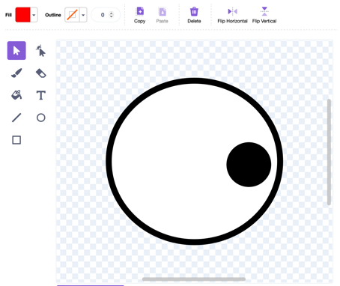

*It can also detect the position of your eyes*

* Create a new sprite using the paint tool. Make an eye looking to the right.

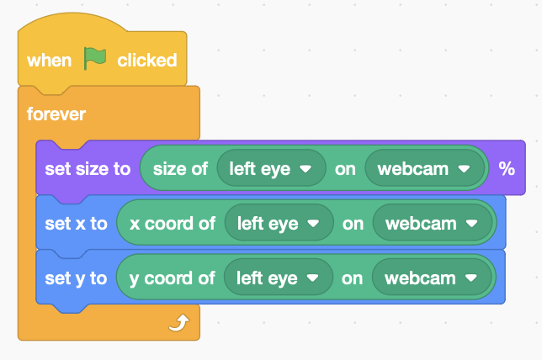

* Copy code from the nose sprite and change it to detect your **left eye**.



* Add code inside the loop to turn the eyes to look towards the mouse.
* Copy the whole sprite and adjust it to detect your right eye.

*What graphic can you add to use the mouth detection?*

*The mouth will appear at the centre of the sprite, so use this as a reference point.*