

**Pose Detection**

*Detect your pose in the computer’s camera and control a robot puppet.*

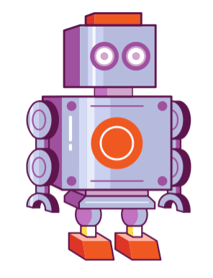

Open [**https://scratch.machinelearningforkids.co.uk**](https://scratch.machinelearningforkids.co.uk)

(you can’t login like normal Scratch)

* Press the Add Extension button and add the   
  **Pose Detection** extension.
* Create a new sprite and choose the ‘**retro robot’**.
* Open the costume editor. All we need is the robot’s arm.
* Use the **select** arrow and click on the arm to its left, and drag it away from the body.
* 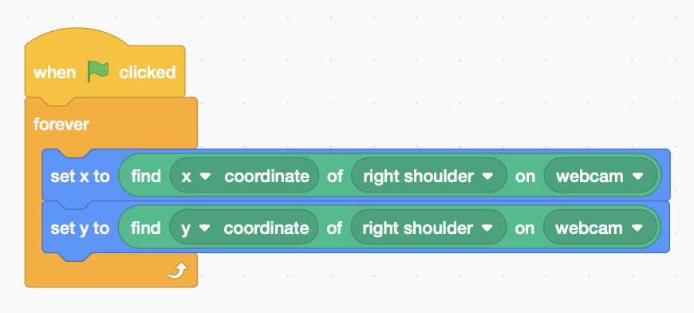Use the select arrow to draw a **selection box** around the rest of the body and delete it.
* Drag the arm to centre the sprite on the shoulder.
* Add code to align the arm with your **right shoulder**.
* Adjust the size to match your own – about 350%
* Rename it ‘**right arm**’.

*Control the robot like a puppet so that when you move your arm, the robot arm follows.*

* 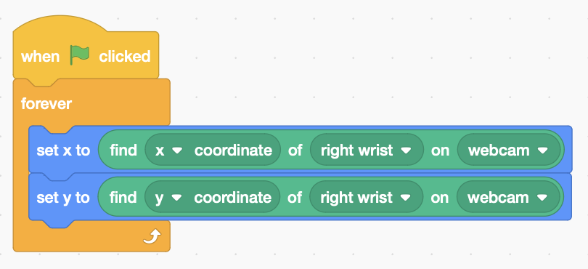Create a new sprite with the Paint tool, and leave it blank so it’s invisible.
* Copy the code from the arm and change it to follow your **right wrist**.
* Rename it ‘**right wrist**’
* 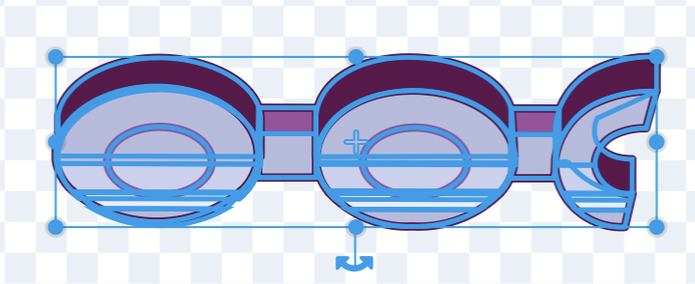Edit the costume for the **right arm**. Using the selection arrow, draw a selection box around the whole arm.
* The little curved arrow at the bottom lets you rotate the arm. Rotate it to make it horizontal.

**The arm at an angle of zero degrees**

* 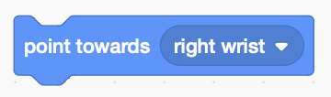Drag the whole arm so that the shoulder is at the centre again.
* Now make the arm **point towards** the **right wrist** by adding this code inside the loop of the **right arm**.

*Duplicate both sprites to make a* ***left arm*** *and* ***left wrist****.   
Change the code of both sprites to make it work on the left.*

***Get a head***

* Create a new sprite and choose the ‘**retro robot’** again.
* Open the costume editor. All we need is the robot’s head.  
  Use the select arrow to draw a selection box around the head and eyes.
* Drag the head and eyes away from the body.
* 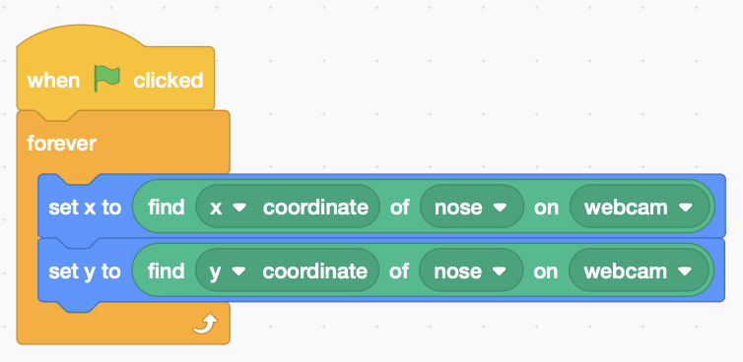Use the selection arrow to select the rest of the body and delete it.
* Move the head and eyes to the centre of the sprite.
* Add code to centre the head on your nose.
* Rename the sprite as ‘**head’** and adjust **size** so that it covers your own head.

*Do the same for the body, and align one corner with your left or right shoulder.*

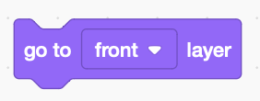

* To make it look right, add code to bring the right arm to the front layer, and send the left arm to the back.

*Your code isn’t saved to Scratch.* ***Save it on a USB drive.***