

# The Sentimental Jellyfish

*Cheer up the sentimental jellyfish with kind words.*

## Open [**https://codelab.cognimates.me**](https://codelab.cognimates.me/)(you can’t login like normal Scratch)

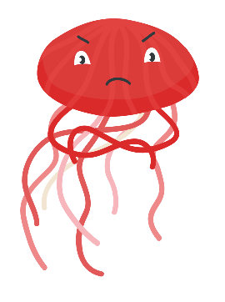

*The jellyfish has a range of expressions from sad to happy.*

* Create a new jellyfish sprite (or create your own set of three sad to smiley faces).

*Use ‘speech to text’ to capture what you say.*

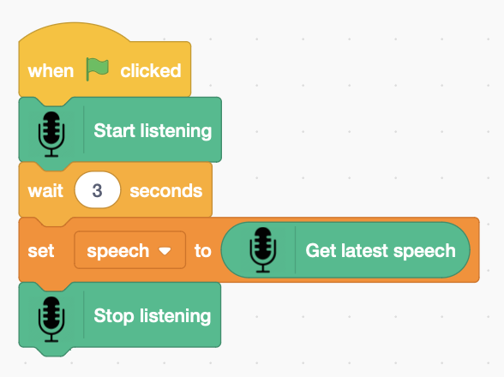

* Create a variable **speech** to store what you say.
* Add code to that **starts listening** to you when you click the **green flag**. What you say is stored in the **speech** variable.

*Press the* ***green flag*** *and speak (you have 3 seconds). Does it hear you?*

*The sentiment of your words can be* ***positive*** *(kind),* ***neutral****, or* ***negative*** *(unkind).*

* Add a variable to store the **sentiment**.
* Add code that works out if the **feeling** is positive or negative.

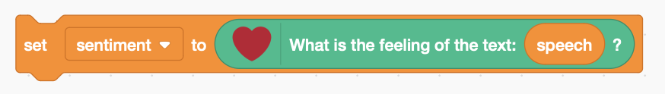

*Press the* ***green flag*** *and say something kind to the jellyfish.   
What is the sentiment?*

*Change the costume according to the sentiment, positive words make it happy, negative words make it sad. Which is the happiest costume?*

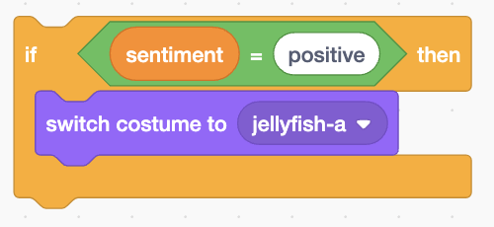

* Add code that looks for **positive** sentiment.
* **switch costume** to the happiest costume**.**
* Duplicate the above code, and add it to the end.
* Change it to look for ‘**negative’** sentiment.
* **Switch costume** to the saddest costume.
* Make another duplicate, and add it to the end.
* Change it to look for ‘**neutral’** sentiment.
* **Switch costume** to a something neutral, not happy or sad.

*Your code isn’t saved to Scratch.* ***Save it on a USB drive.***