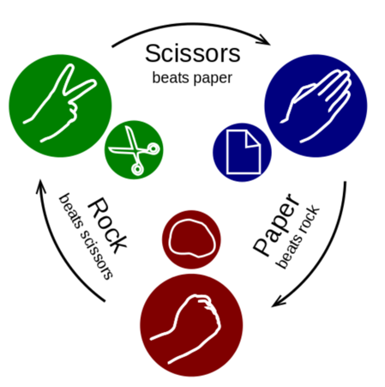****

Stone

# Teach a machine to play Scissors, Paper, Stone

## Open [**https://teachablemachine.withgoogle.com**](https://teachablemachine.withgoogle.com/)

* Click **Get Started**, **Image Project**, **Standard image model**

*Gather samples (You can close the how-to videos -* ***click on the X****)*

* Rename ‘Class 1’. Click on the name and call it **scissors**.
* Rename ‘Class 2’ to **paper**.
* Click **Add Class**, and name it **stone**.
* 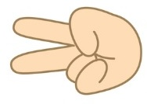On **scissors** click on **Webcam**   
  Give the computer permission to use the camera - Allow / OK.
* 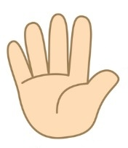Make a scissors sign with your hand in front of the camera, filling the image. Press **Hold to record** about 1000 images, moving your hand around a bit.
* Now hold your hand up flat, “speak to the hand” style. Press **Hold to record** on **paper**, and record a similar number of images. Remember to move around.
* Make a fist to the camera, and press **Hold to record** on **stone**. Record a similar number of images, moving around.
* Click **Train Model** - a progress bar shows you how long it takes.
* 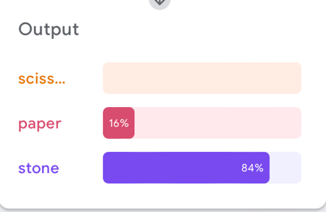In the preview panel, test that it recognises scissors, paper, and stone.
* When you’re happy it works, Click on **Export Model** then **Upload my model**
* When it’s finished, copy the sharable link using the copy button next to it.

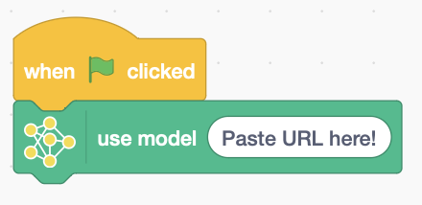*In another browser tab, open*: <https://playground.raise.mit.edu/main/>

* Delete the sprite.
* Add extension: **Teachable Machine** and allow it to use the camera.
* 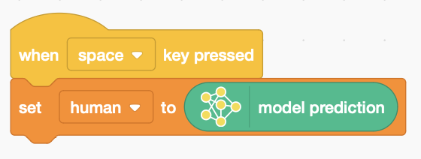Add code to **use the model**, and paste in the link copied from the Teachable Machine.
* Click the **green flag** to run it.
* Create variables for **human** and **computer**.
* 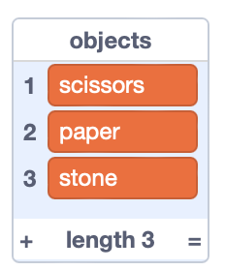Add code to recognise **human** input when you press the space key.
* **Make a list** of **objects**, and add **scissors**, **paper**, **stone**.
* 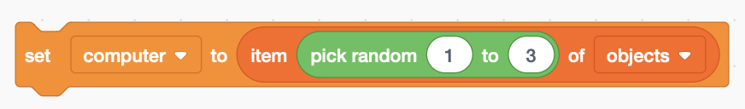Add the **computer** choice, picking one at random.
* Create a variable for the **winner**.
* 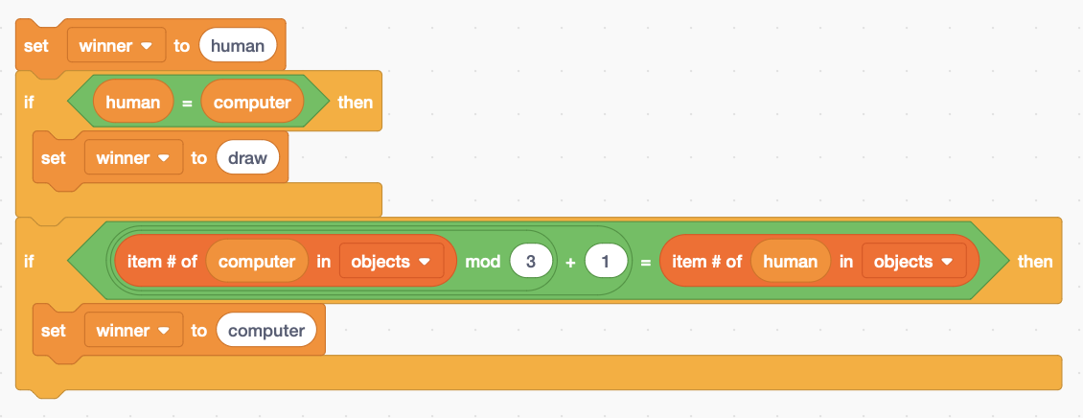Add code to decide who wins, or if it’s a draw.

It can beat the next object up, so 1 beats 2, 2 beats 3, and it wraps around so 3 beats 1.

*Your code isn’t saved to Scratch.* ***Save it on a USB drive.***