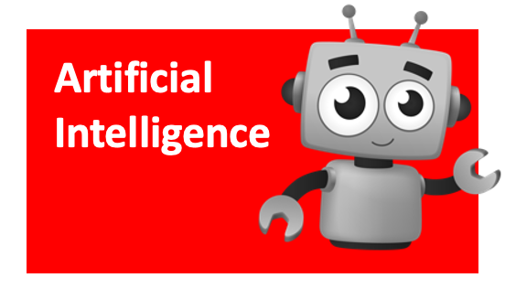

# Universal Translator

*Translate your words   
into any language.*

## Open [**https://scratch.machinelearningforkids.co.uk**](https://scratch.machinelearningforkids.co.uk)

(you can’t login like normal Scratch)

**Speech to Text**

*Convert what you say into text.*

**

* 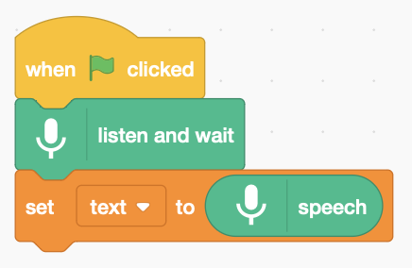Press the Add Extension button and add the   
  **Speech to Text** extension.



* Create a variable called **text**,   
  to save what you say.
* Add this code to **listen and wait** for you to say something. Then use **speech to text**.

**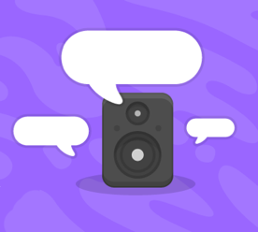***Press the green flag and say something into the mic…*

**Text to Speech**

*Make the computer speak*

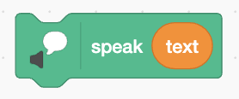

* Press the Add Extension button and add the   
  **Text to Speech** extension.

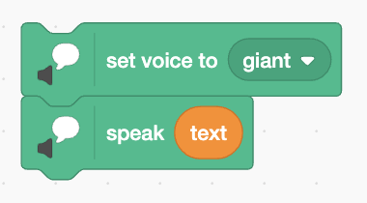

* Add code to the end to speak what you said.
* Try changing the voice before it speaks.

### **Translate**

*Translate what you say into another language*



* Press the Add Extension button and add the   
  **Translate** extension.
* Create a new variable called **translation.**
* Insert this code to **translate** before it speaks.
* Choose whatever language you like.
* 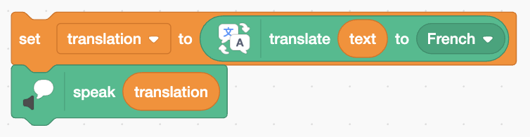Change it to speak the translation.

*Does it speak with a proper accent?*

* *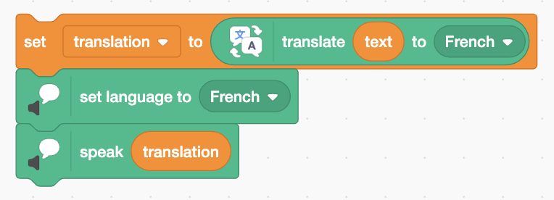Try changing the language to the same as the translation.*

*You can even translate into kittenish by setting the voice to kitten.*

*Your code isn’t saved to Scratch.* ***Save it on a USB drive.***