

# Voice Control

*Pop an on-screen balloon, using your voice to control the aim.*

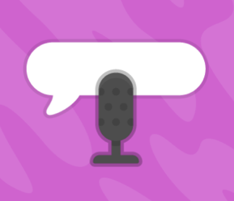

## Open [**https://scratch.machinelearningforkids.co.uk**](https://scratch.machinelearningforkids.co.uk)

(you can’t login like normal Scratch)

**

* Press the Add Extension button and add the   
  **Speech to Text** extension.
* Add a balloon sprite and a cross sprite **X** to show your aim.

*Begin by coding the cross sprite* ***X.***

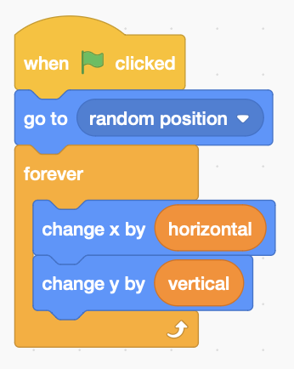

* Add two variables **horizontal** and **vertical** to control the movement of the cross.
* Add the code to the left that positions the cross using these variables.

*Try inputting -1,0,1 into these variables to see how it moves.*

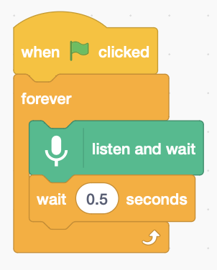

* Add a loop that **listens and waits** for us to give voice commands. It needs a short delay.

*Use the words* ***up****,* ***down****,* ***left****,* ***right*** *to control the aim,  
and* ***fire****! to pop the balloon.*

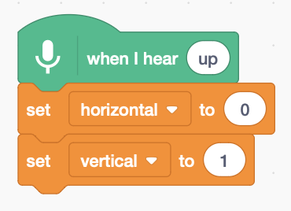

* **When it hears** **up**, **down**, **left**, **right** set **horizontal** and **vertical** as needed.
* Make four copies of this code using settings from the table below.

|  |  |  |
| --- | --- | --- |
| **When I hear** | **horizontal** | **vertical** |
| **up** | 0 | 1 |
| **down** | 0 | -1 |
| **left** | -1 | 0 |
| **right** | 1 | 0 |

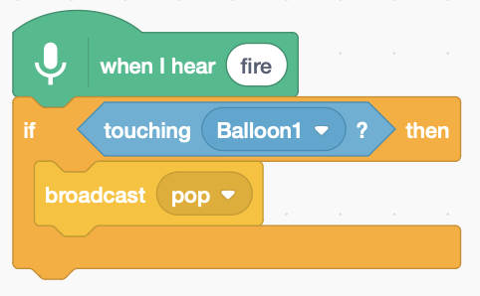

* **When it hears fire**, add code that **broadcasts** a ‘pop’ message to the balloon if the cross sprite ‘**X’** **touches** it.

*Now, add code to the* ***balloon*** *sprite to make it pop!*

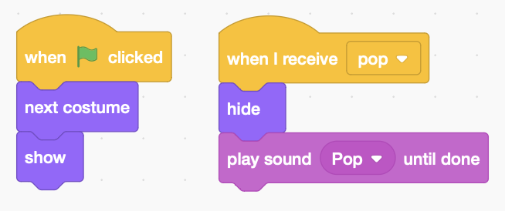

* Add code to the balloon that **receives** the ‘pop’ message, **hides** the balloon, and **plays** a pop sound.



* When the **green flag** is clicked switch to the **next costume** which is a different colour balloon,   
  and **show** it again as we hid it when it popped.

*Your code isn’t saved to Scratch.* ***Save it on a USB drive.***