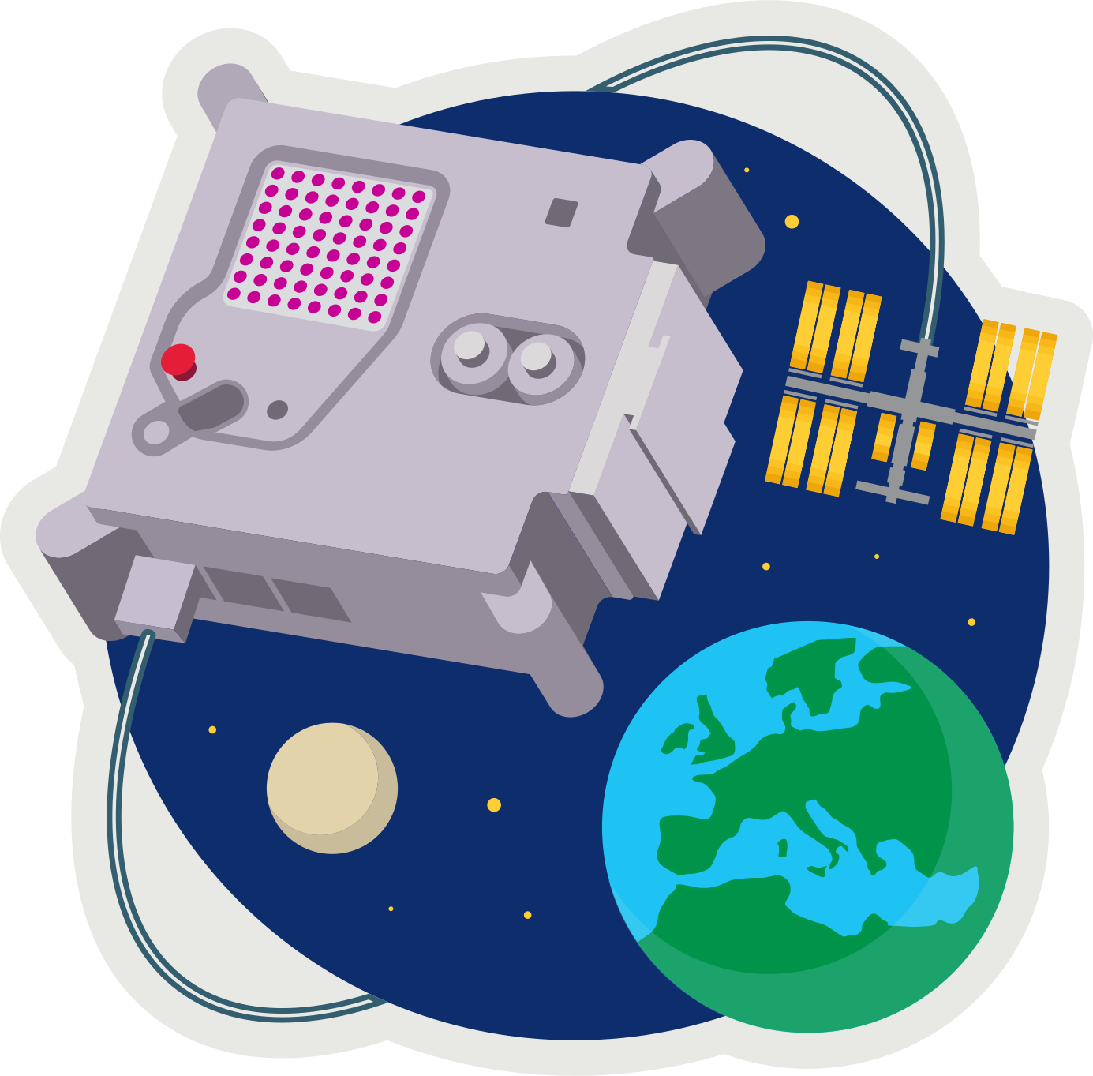 **ASTRO PI[1]  
MISSION ZERO**

*Send a personalised image to the astronauts on the International Space Station!*

*Your image should be inspired by nature, on Earth or beyond: trees, flowers, animals, insects, rainbows, or alien life forms.*

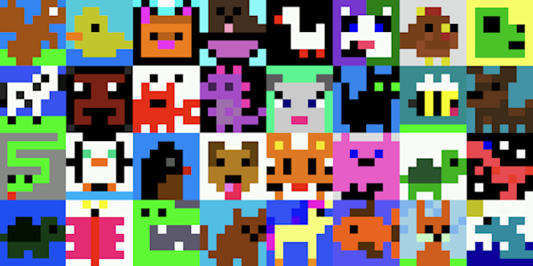Example images from Mission Zero 2023/24.

These are all 8x8 pixel-art (8 pixels high by 8 pixels wide)

Pixels are picture elements.

* Open pixilart.com (we can use the same login **CodeClub67**)

1. Click START DRAWING
2. input width 8, and height 8.
3. SELECT COLOR PALETTE[2]
4. Where it says “Search Palette” enter **astro-pi**
5. **Click NEW DRAWING**

* 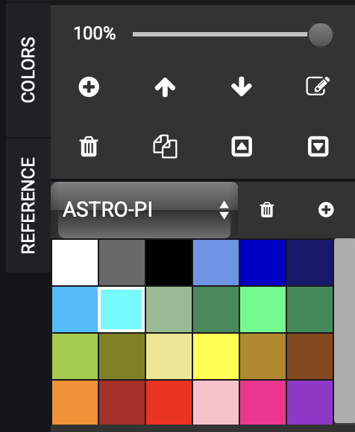**CREATE** your pixel art

1. Select the pencil icon (top-left in TOOLS)
2. Select the colour on the COLORS tab
3. Click anywhere in the 8x8 grid.

* **SAVE** your drawing

1. Click *SAVE DRAWING
2. give it a **title**
3. set visibility to **PRIVATE**
4. click **SAVE** (or UPDATE if you’re saving an update)

* 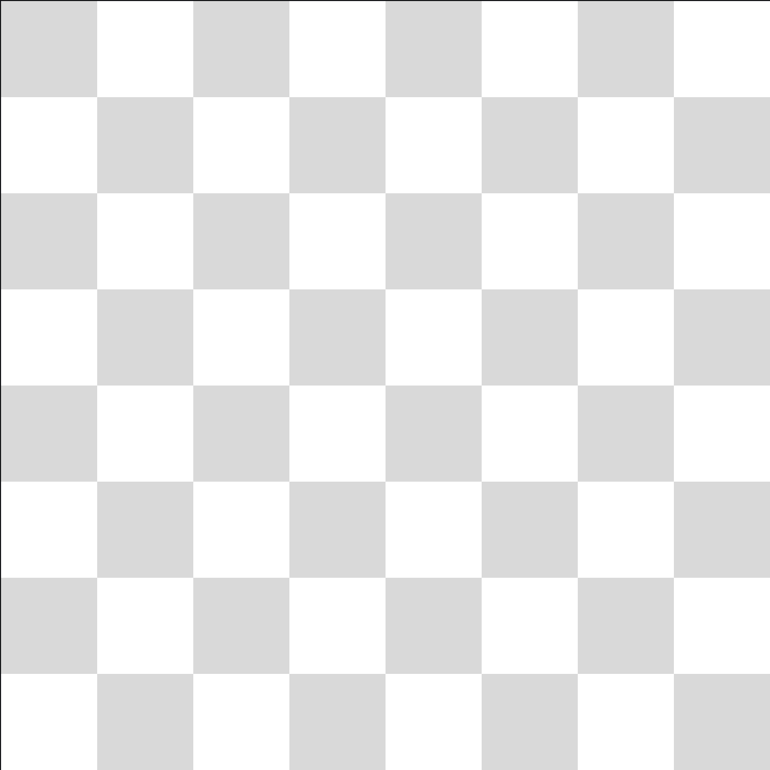**LOAD** a drawing

1. Click on the (smiley) avatar (top-right).
2. Select My Gallery
3. Click on the drawing
4. Select “Edit Drawing”



1. astro-pi.org
2. ffffff,696969,000000,6495ed,0000cd,191970,00bfff,00ffff,8fbc8f,2e8b57,00ff7f,228b57,9acd32,808000,f0e68c,ffff00,b8860b,8b4513,ff8c00,b22222,ff0000,ffc0cb,ff1493,9932cc