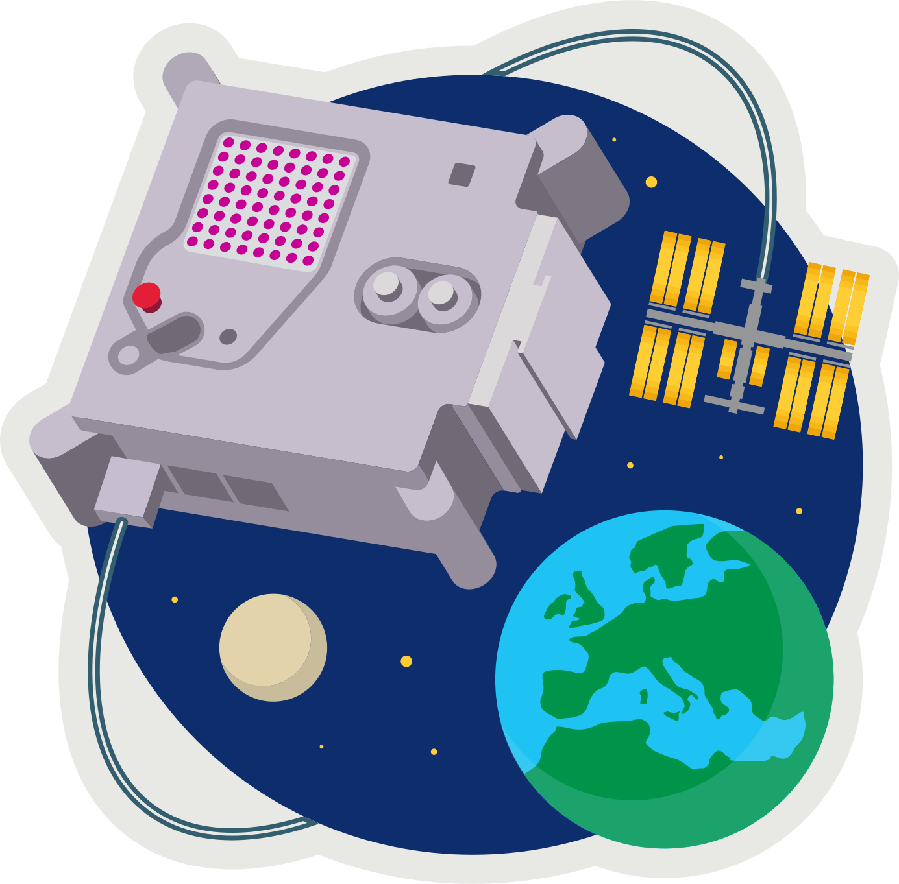 **ASTRO PI[1]  
MISSION ZERO**

*Send a personalised image to the astronauts on the International Space Station!*

Last week you created 8x8 pixel-art (8 pixels high by 8 pixels wide)

Pixels are picture elements.

* Open **pixilart.com** (we can all use the same login **CodeClub67**)

1. Click on the profile *avatar* at the top-right of the window
2. Select **My Gallery**
3. Click on your first image (if you want to change it click **edit**)
4. In the panel on the right scroll down to **Details**
5. Click **Download Original** to download a .png (ping) image.
6. Save this in your downloads folder.

* **MISSION ZERO grid**

1. Open **https://codeclub67.github.io/astro-pi**
2. Choose the **.png** file in downloads
3. Complete the first mission grid on the sheet.
4. Write your name on the back.

*Your first mission is to change your image using a sensor reading. We can simulate this in Scratch.*

*Use a sensor to change image colours.*

*Colours can be placed on a colour wheel. Any colour can be shifted clockwise around the wheel using the Scratch* ***colour effect*** *with the shift value.*

*The wheel is 200 units around, so a value of 100 will shift any colour to the opposite side.*

**MISSION ZERO – Scratch Simulation**

1. Login to **scratch.mit.edu**
2. Create a new Scratch project
3. **Upload** a new sprite using the .png image in downloads.
4. It’s very small – only 8x8. Adjust the size to 2000%
5. Simulate a sensor by **making** a new variable, called **temperature**.
6. Make sure the variable is **ticked** so it’s shown on-screen.
7. Right-click on the on-screen variable to make it a **slider**.
8. Right-click on the on-screen variable to **change slider range**Set the **maximum value** to 200 (the *circumference* of the colour wheel), **OK**
9. Add this code to set the colour effect according to the temperature.
10. A screenshot of a computer

    AI-generated content may be incorrect.Run the code and change the temperature.

*Try a temperature of 100, does it shift the colour to the opposite side of the colour wheel?*

*A sensor value of 200 should take the colour all the way round the colour wheel back to where it started. What happens?*

**Astro-pi**

Your tutor will show you how to do the same thing on the Astro-pi.

* Open Astro-pi Mission Zero:   
  **https://missions.astro-pi.org/mz/code_submissions/new**
* Paste in and demo the example sensor code from:  
  **https://codeclub67.github.io/astro-pi/sensor.py**
* Select a Pixilart gallery image and use the mission grid tool to generate the image and past this into the Python code, and indent as necessary:  
  [**https://codeclub67.github.io/astro-pi**](https://codeclub67.github.io/astro-pi)
* Run the code and vary the temperature
* The code also uses the colour sensor to clear the screen at the end.
* Enter **classroom code** and **team name** and save the work   
  (no need to submit yet)

1. astro-pi.org