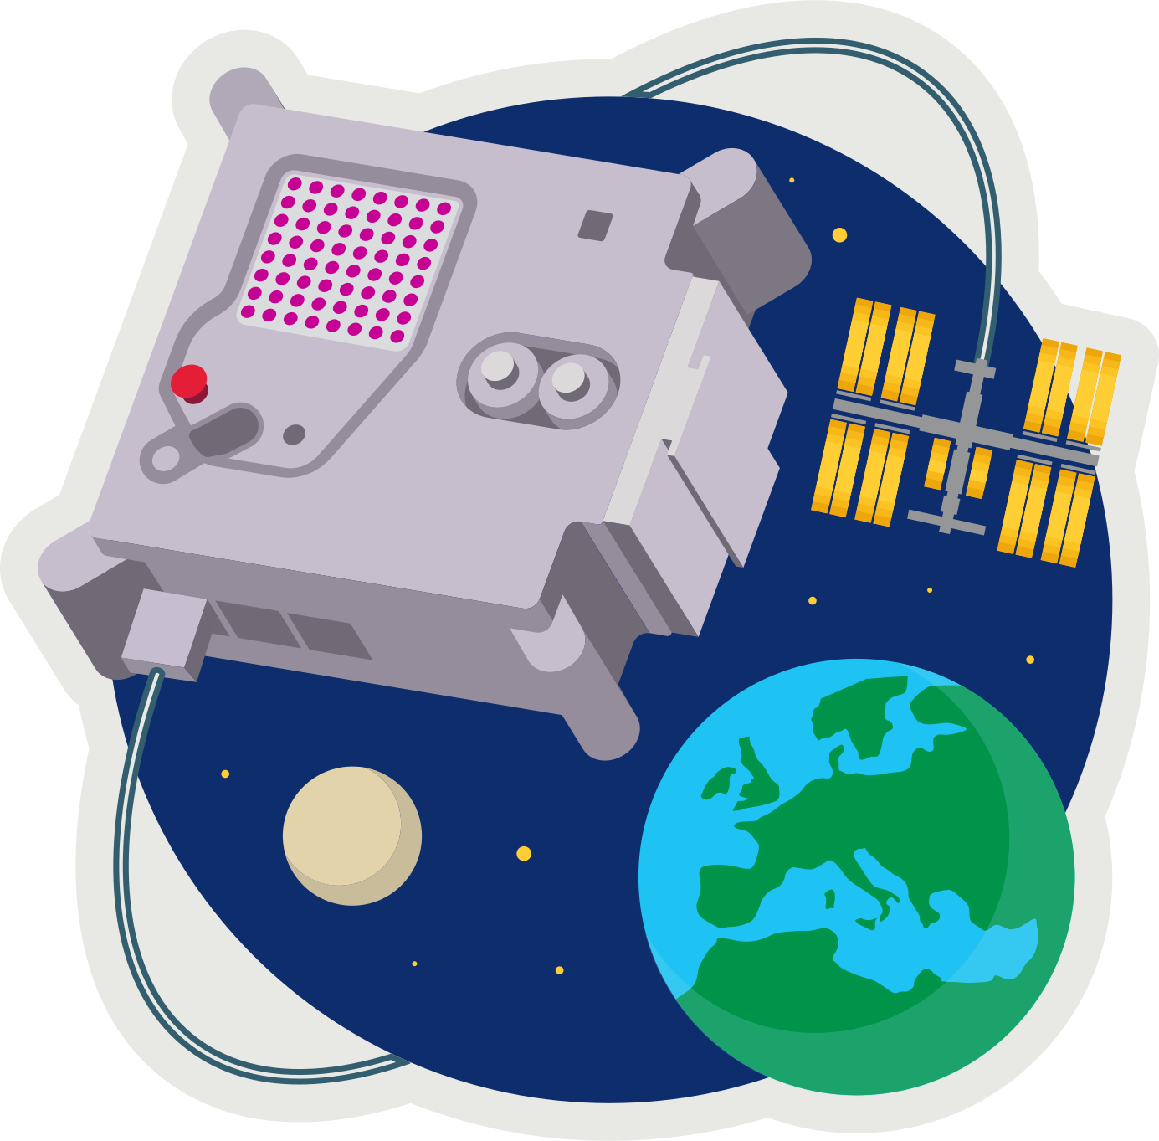 **ASTRO PI[1]  
MISSION ZERO**

*Send a personalised image to the astronauts on the International Space Station!*

Last week you created 8x8 pixel-art (8 pixels high by 8 pixels wide)

Pixels are picture elements.

* Open **pixilart.com** (we can all use the same login **CodeClub67**)

This week download both your **first** and **second** images.

1. 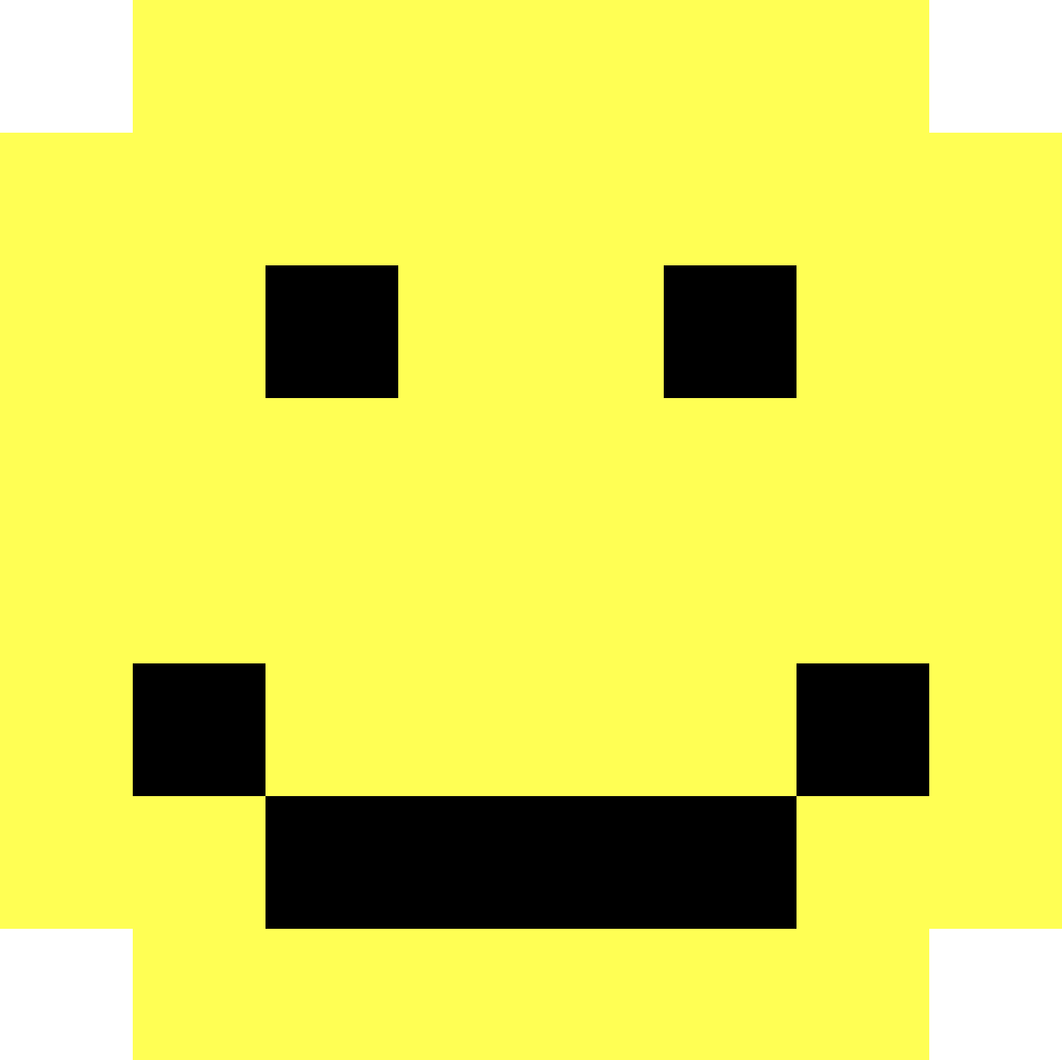Click on the profile *avatar* at the top-right of the window
2. Select **My Gallery**
3. Click on your first image (if you want to change it click **edit**)
4. In the panel on the right scroll down to **Details**
5. Click **Download Original** to download a .png (ping) image.
6. Save this in your downloads folder.
7. Repeat for your second image.

* A yellow face with black dots

  AI-generated content may be incorrect.**MISSION ZERO grid**

1. Open **https://codeclub67.github.io/astro-pi**
2. Choose the **second** **.png** file in downloads.
3. Fill in the second mission grid on the sheet.

*Your next Scratch mission is to create a simple animation,   
switching between the two images once every second.*

**MISSION ZERO – Scratch Simulation**

1. A screenshot of a computer

   AI-generated content may be incorrect.Login to **scratch.mit.edu**
2. Open your Scratch project from last week.   
   It already has a sprite with the first image.
3. Select the sprite and choose the **Costumes** tab.
4. **Upload Costume** from the second .png image in downloads.
5. Modify the code adding a costume change with **next costume**. It should do this once very second, so make it **wait** 1 second.
6. Run your code.

**Astro-pi**

Your tutor will show you how to do the same thing on the Astro-pi.

* Open Astro-pi Mission Zero:   
  [**https://missions.astro-pi.org/mz/code_submissions**](https://missions.astro-pi.org/mz/code_submissions)
* Open an existing program with the class code and team name.
* Select a Pixilart gallery image and use the mission grid tool to generate the images and past them into the Python code, indenting as necessary:  
  [**https://codeclub67.github.io/astro-pi**](https://codeclub67.github.io/astro-pi)
* Name the two images image1 and image2 and indent as necessary.
* See demo code at: [**https://codeclub67.github.io/astro-pi/sensor2.py**](https://codeclub67.github.io/astro-pi/sensor2.py)
* Rename the first image as **image1**
* Add the second image as **image 2**
* Edit the image display line: sense.set_pixels(image1 if i%2==0 else image2)
* Run the code and vary the temperature
* The code also uses the colour sensor to clear the screen at the end.
* Enter **classroom code** and **team name** and save the work.
* **Write down the team name** and submit the work when it’s been checked.
* **Mission completed** - Hand out the stickers

1. astro-pi.org