
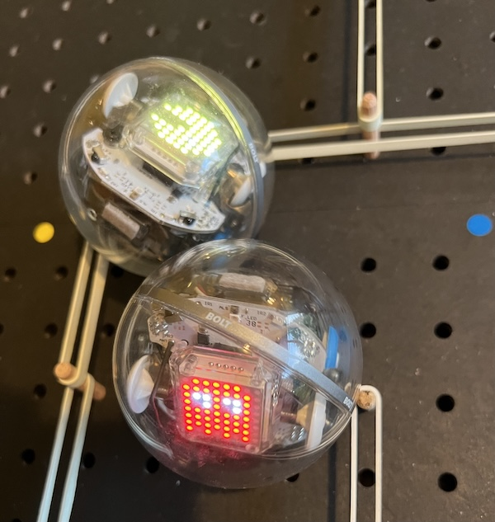
Robot Pac-Man

Keynsham Music Festival is excited to announce a Discovery Zone* to this year’s festival. The new space will give festivalgoers the chance to explore science, technology and research in a fun and interactive way alongside the music and community atmosphere the festival is known for.
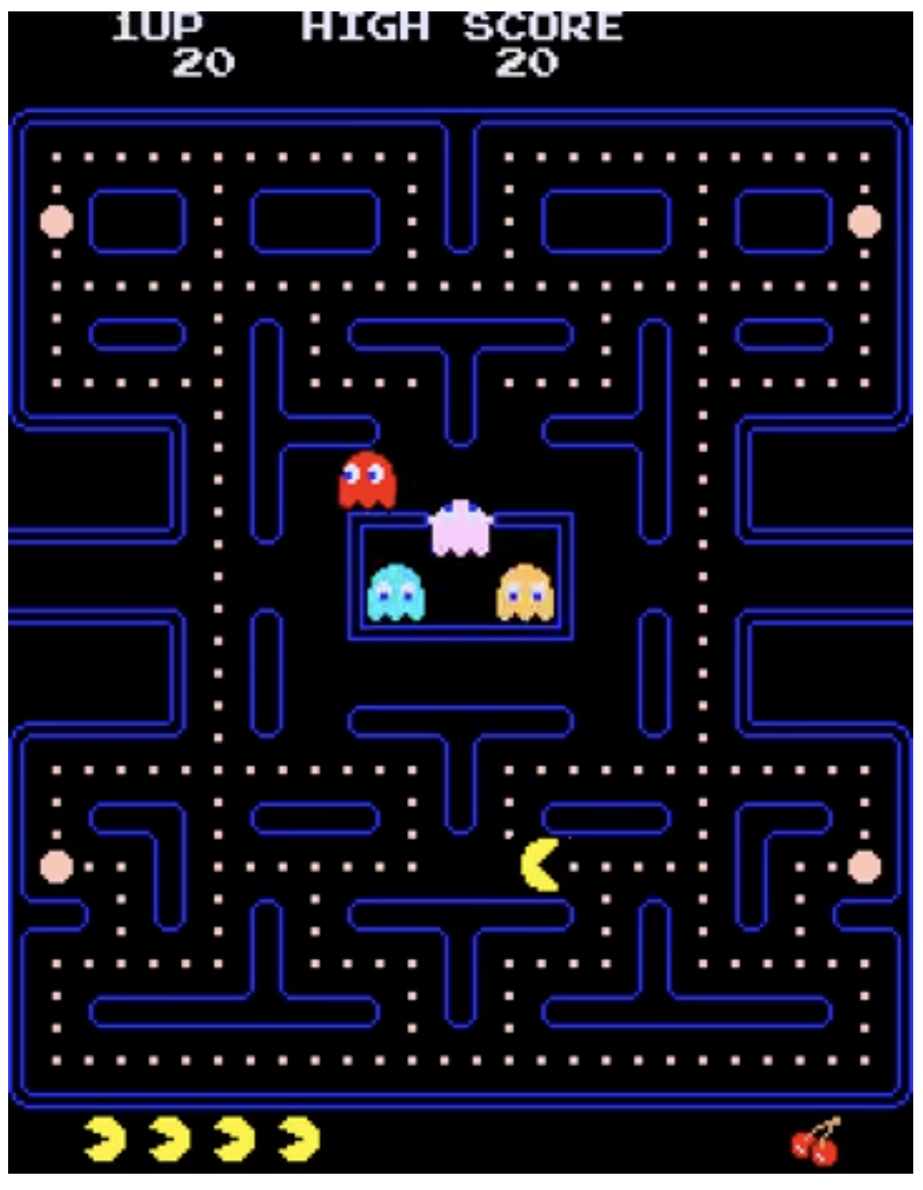
Code-Club present Robot Pac-Man. You’ve (probably) played Pac-Man the video game, but have you played it with robots? In this interactive exhibit, help Pac-Man escape the ghostly clutches of Blinky, Pinky, Inky, and Clyde.
This is the original Namco Pac-Man videogame from 1980. Can we recreate it with robots?
https://youtu.be/i_OjztdQ8iw

* You will need your parents’ consent to help on Saturday July, 4.

