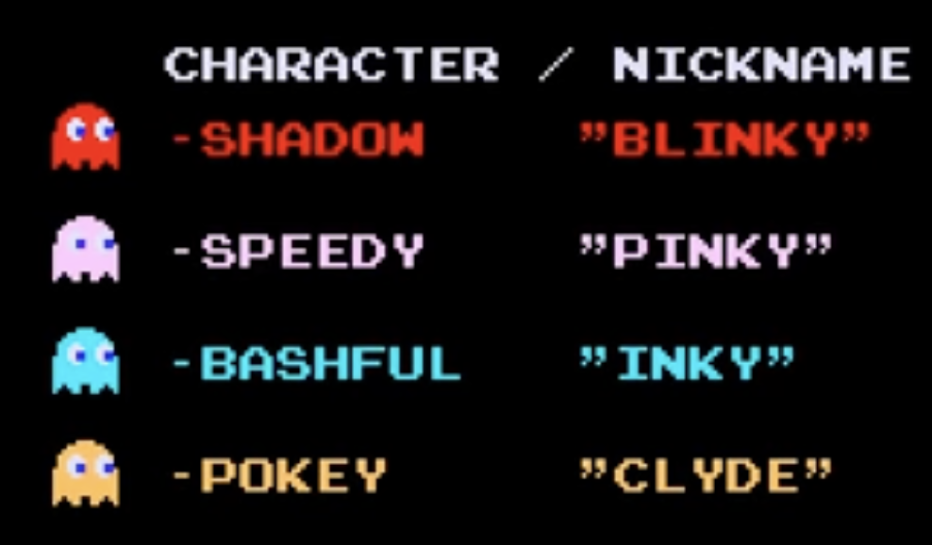
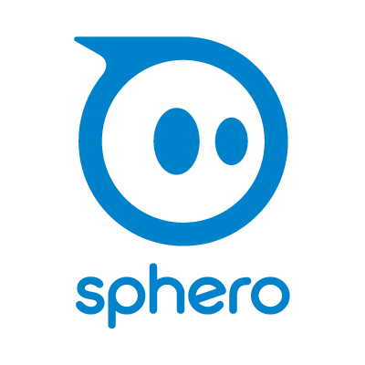
Ghosts

The Pac-Man videogame has four ghostly characters named “Blinky”, “Pinky”, “Inky” and “Clyde.” We need at least one of each character, so see what others are doing, and do something different.

- In Chrome, open https://edu.sphero.com/code

- Connect your Sphero BOLT robot: click


- Select then


- Your BOLT has a sticker with a code on it. Choose the matching BOLT from the list then

- Check your robot is showing the right image then
- Click + CREATE PROGRAM.
- Name your program after the character you’re creating. Leave BLOCKS selected. Select SPHERO BOLT, deselect SPHERO BOLT+ then CREATE.
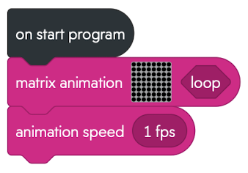
- Add code for a matrix animation with your ghost design.
Click on the matrix grid to edit then  to add a new 8x8 matrix. Click to finish.
- Animate it to make its eyes look left 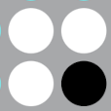 then right .
Select your graphic then click to edit it.
Click + to add a new frame.
To remove a frame, click , select a frame then .
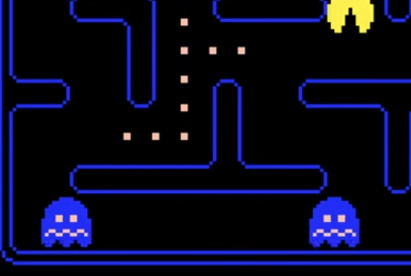
-  your code. Does it work?
When ghosts run away from Pac-Man, they turn blue and take fright. Add another matrix design for this.
- In Variables, create a new variable called chase. This is boolean because it will only be true or false.
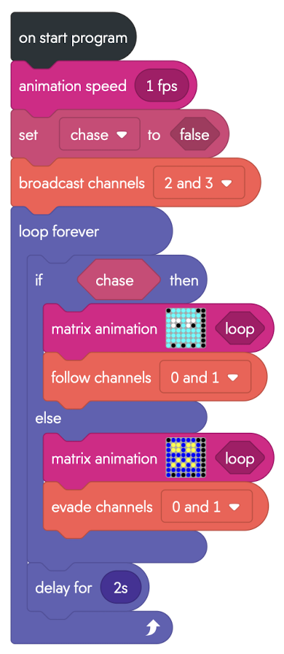
Sphero robots communicate using infra-red light invisible to us. Ghosts broadcast their position on channels 2, 3 (short & long range), and follow Pac-Man on channels 0, 1.
- Replace the existing code with the following:
Sometimes the robot gets stuck on the maze walls.
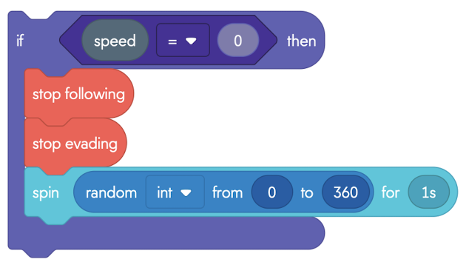
- Add the code (right) at the end of the loop (but still inside the loop) to detect when it has stopped moving and give it a random spin.
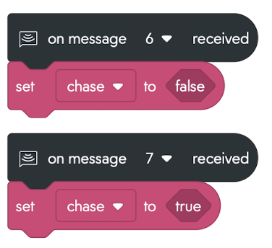
- When Pac-Man receives an energizer it sends a message to reverse the chase. Add code (left) to receive this message and set chase to true or false.

To Save your code go back to the main page. Don’t forget to add “Blinky”, “Pinky”, “Inky” or “Clyde” to the name of your program. Click on the 3 dots (ellipsis) next to your program and download to a USB drive.

