
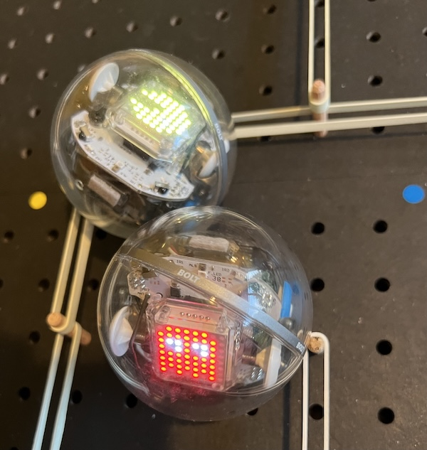
Pac-Man Badge

Keynsham Music Festival welcomes the Discovery Zone to this year’s festival. Code-Club presents Robot Pac-Man. This week we will create a special Pac-Man badge you can wear to the Festival.
Over the page are your 8x8 graphics (8 pixels high by 8 pixels wide). Pixels are picture elements.
- Create an 8x8 image using fuse beads. You can leave empty background spaces.
You will need:
- A plastic pegboard
- Fuse beads
- craft tweezers
- An adult will use an electric iron to heat and fuse the beads for 30 seconds, using the special ironing paper, keeping the iron on the move.
- After ironing the first side, we’ll remove the fused beads from the pegboard and iron the other side.
- Let the fused beads cool down. Place something heavy on them to prevent warping.
- Stick a magnetic fastener on the back.

