
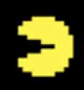

Pac-Man

Pac-Man explores a maze, avoiding ghosts. An energizer temporarily reverses the chase where ghosts enter a frightened state and become vulnerable.

- In Chrome, open https://edu.sphero.com/code

- Connect your Sphero BOLT robot: click


- Select then


- Your BOLT has a sticker with a code on it. Choose the matching BOLT from the list then

- Check your robot is showing the right image then
- Click + CREATE PROGRAM.
- Name your program after the character you’re creating. Leave BLOCKS selected. Select SPHERO BOLT, deselect SPHERO BOLT+ then CREATE.
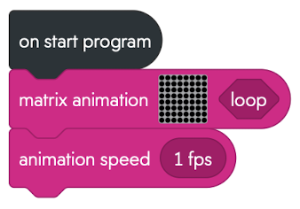
- Add code for a matrix animation with your Pac-Man design. Animate it to make its mouth open and close.
Click on the matrix grid to edit then  to add a new 8x8 matrix. Click to finish.
Select your graphic then click to edit it.
Click + to add a new frame.
To remove a frame, click , select a frame then .
-  your code. Does it work?
- In Variables, create a new variable called time. This is a number because it records time elapsed. We’ll use time for the energizer later.
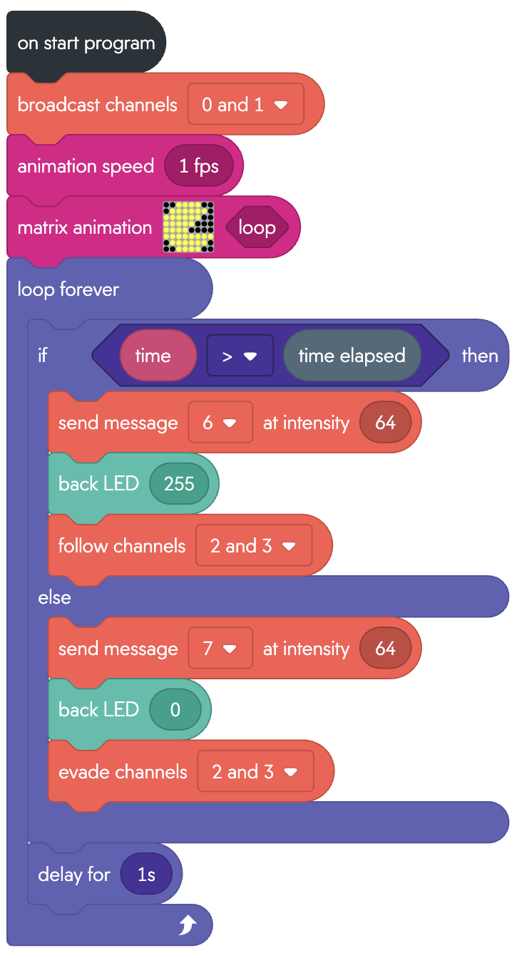
Sphero robots communicate using infra-red light invisible to us. Ghosts broadcast their position on channels 2, 3 (short & long range), and follow Pac-Man on channels 0, 1.
- Replace the existing code with the following:
Sometimes Pac-Man gets stuck on the maze walls.
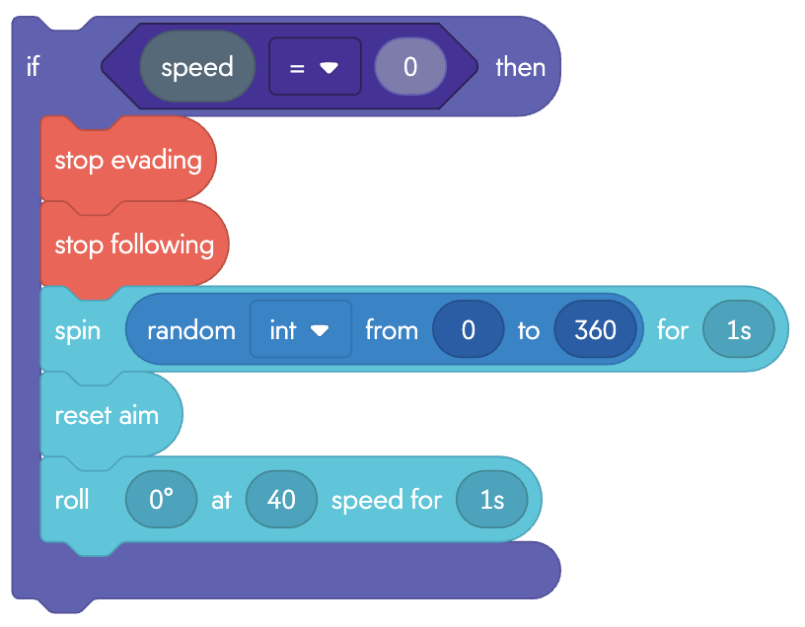
- Add the code (right) at the end of the loop (but still inside the loop) to detect when it has stopped moving, give it a random spin and roll forwards.

Energizer
In the videogame, the energizer is a large “Power Pill” that Pac-Man can eat to power-up. In the robot game we will use a torch to energize Pac-Man.
When we walk from bright sunshine into a house, we can’t see anything until our eyes adjust to the dark. The robot is the same. It has a light sensor, and we measure the average light level.
If the brightness suddenly increases, then assume that’s a flash of light from the torch. The light sensor is next to the front LED, so set this to a really dim red (red=1) to show people where to point the torch.
- In Variables, create a new variable called average. This is a number as it records the average light level.
- Add the code (below) at the end of the loop (still inside the loop) to take the average:
(0.5 * average) + (0.5 * ambient light).
If the brightness increases by 100 then set time to 20 seconds in the future, during which Pac-Man is energized.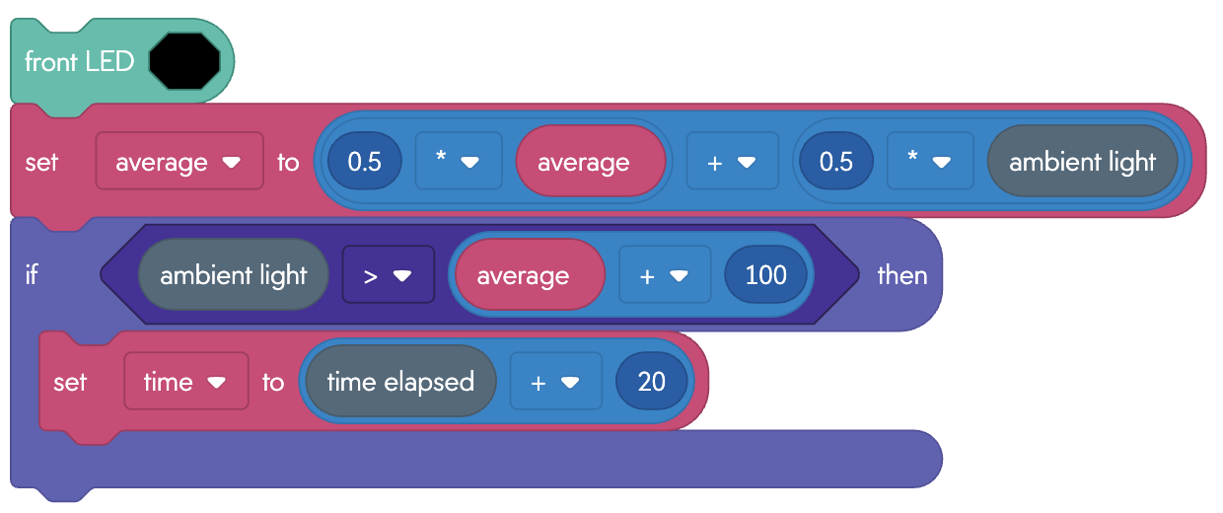
To Save your code go back to the main page. Don’t forget to add “Pac-Man” to the name of your program. Click on the 3 dots (ellipsis) next to your program and download to a USB drive.

