
Control Car

Register/login at https://scratch.mit.edu
Build a remote controlled car.
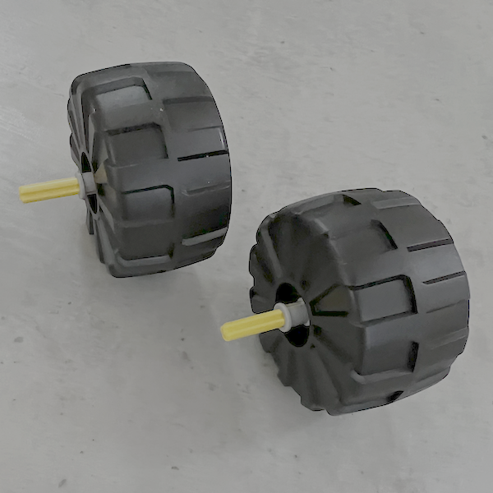
- Create a new Scratch project, add the LEGO BOOST extension, and connect the BOOST.
- Find and build two wheels with a cross-shaped axle to fit into motors A and B on front of the BOOST.
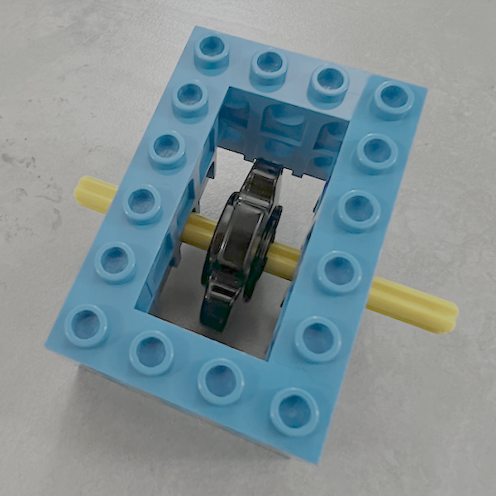
- You need one or two wheels at the back. The image (left) shows one design idea.
- Add the wheels to the BOOST.
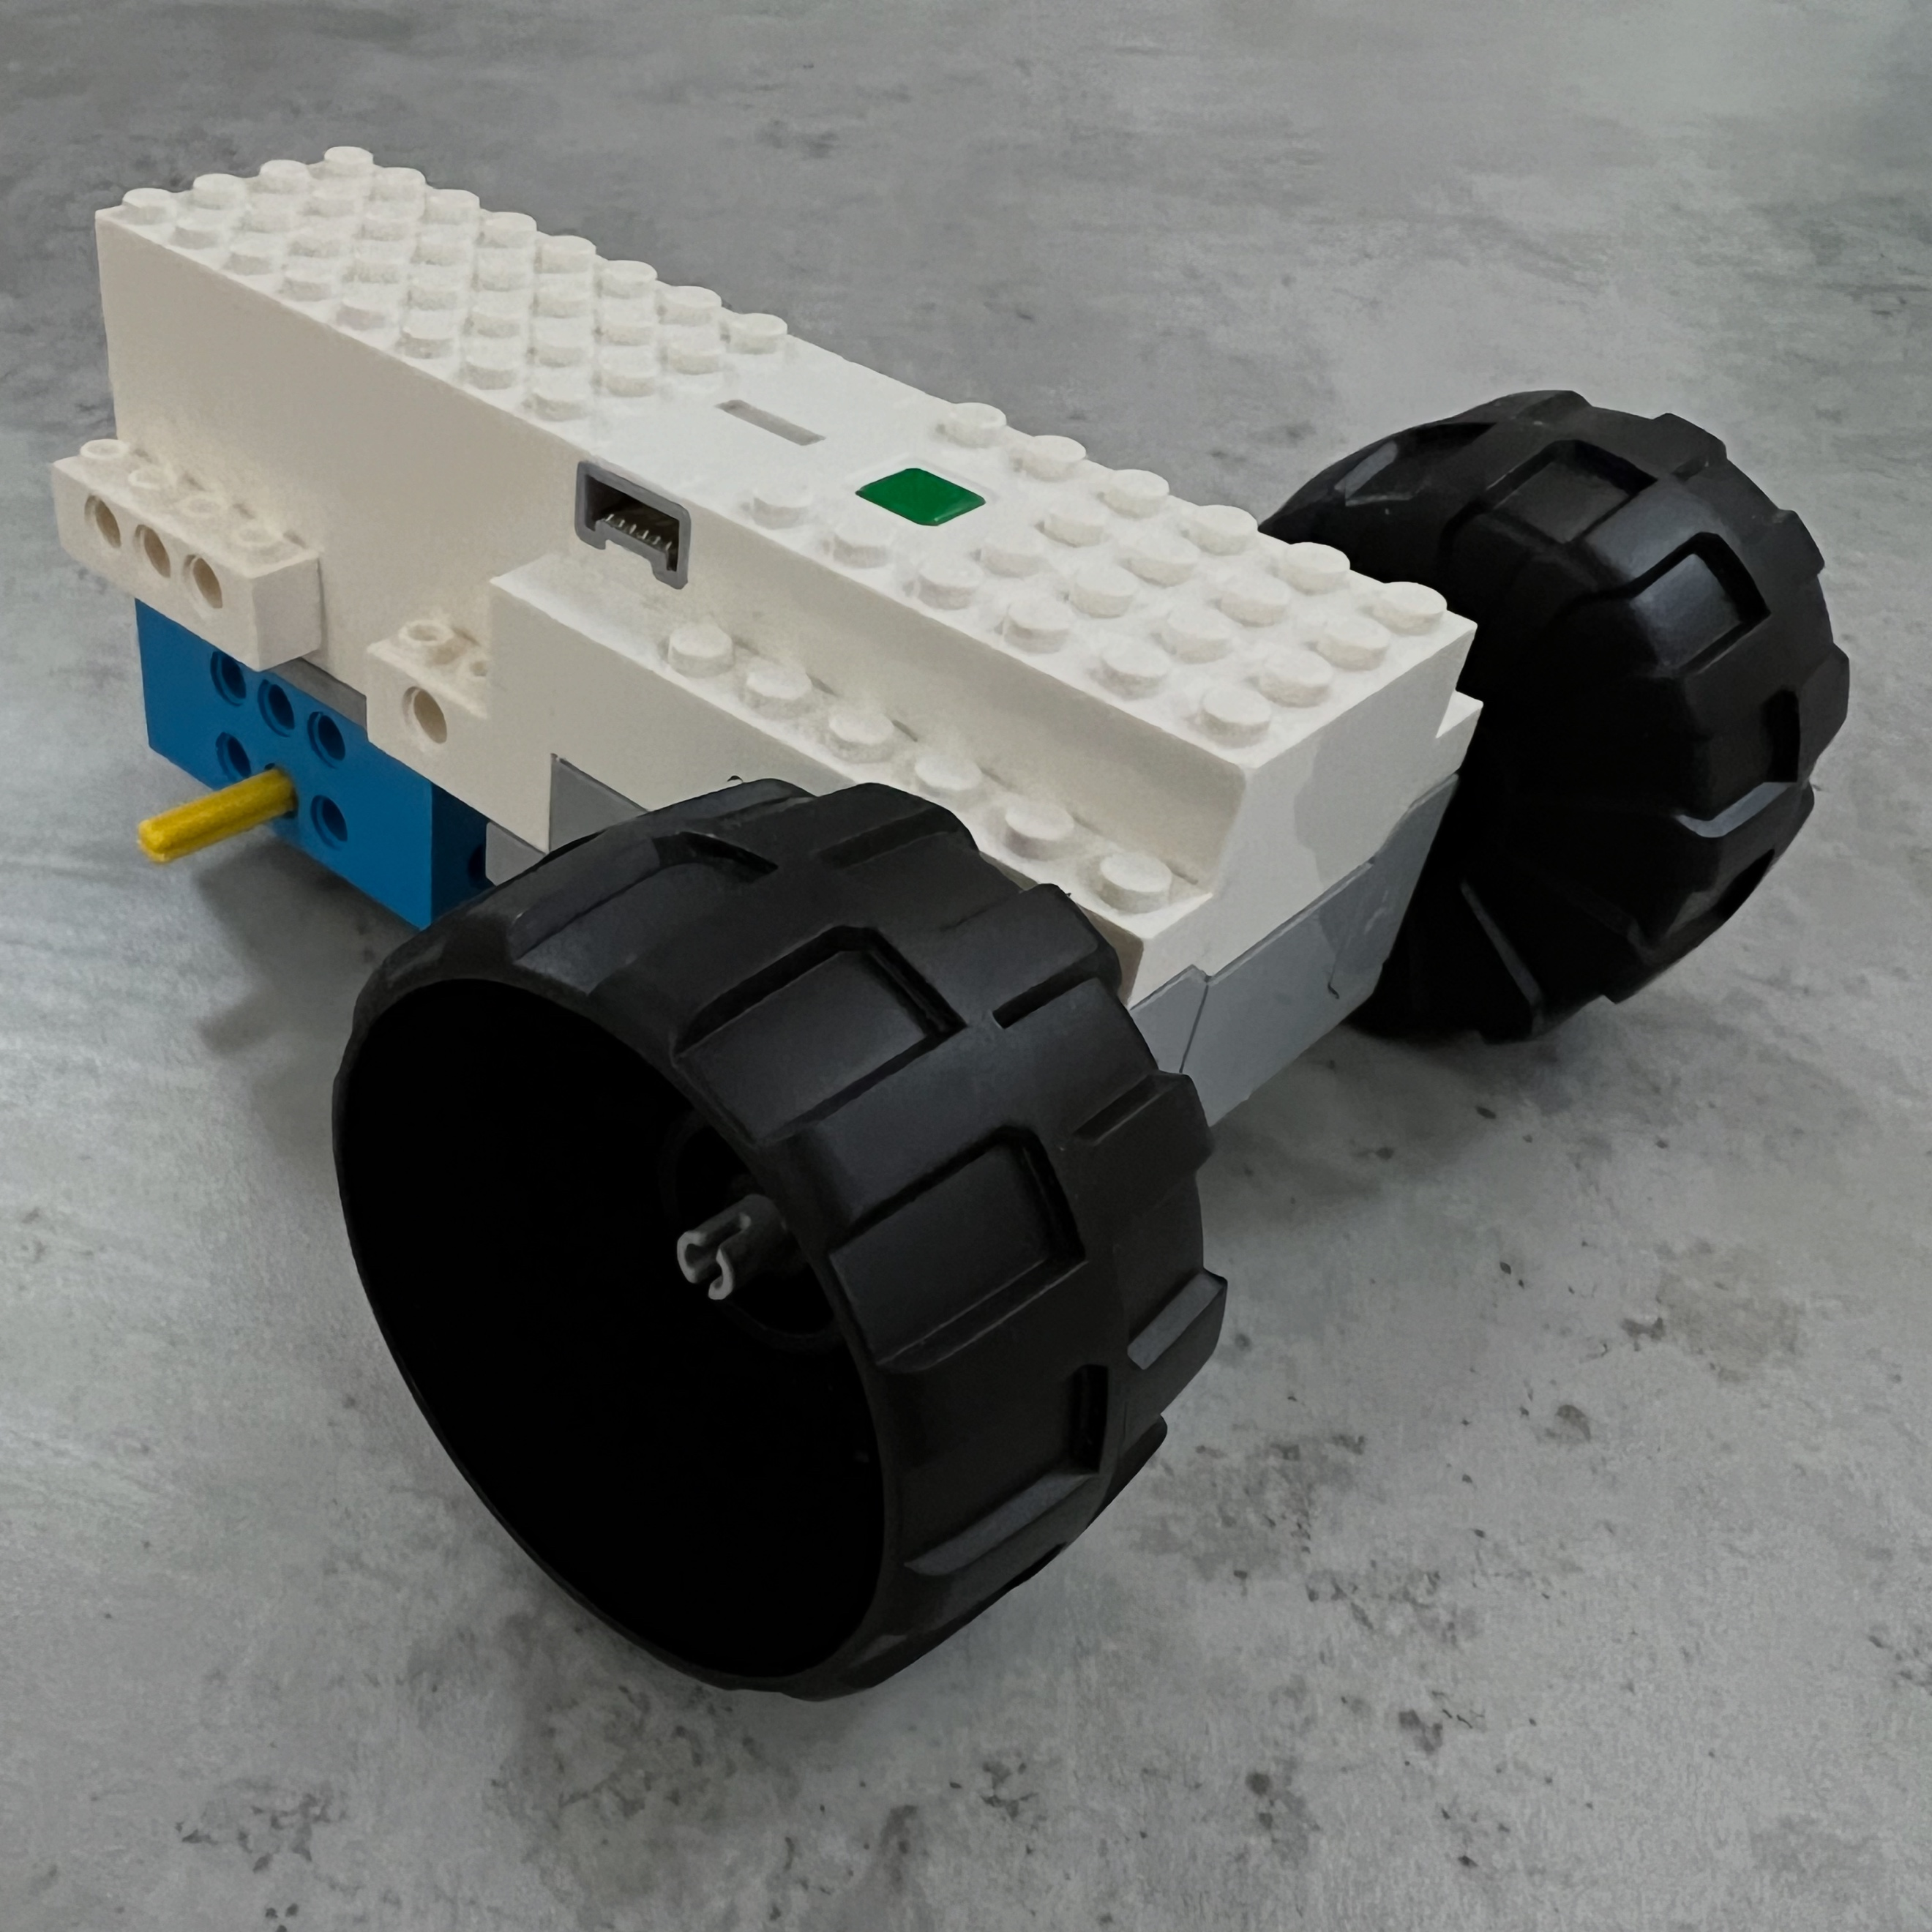
- Decorate your car with your own Lego designs so it doesn’t get mixed up with somebody else’s car.

Now write code to control the car from Scratch. Use the up key to go forward, and the left, right keys to steer.
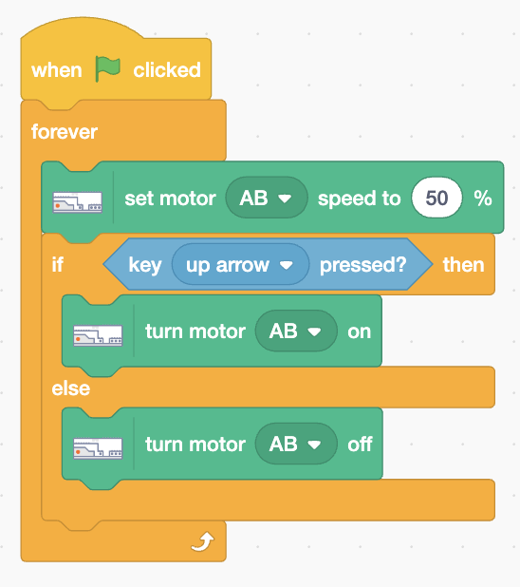
- Add code (right) in a forever loop that turns on motors A and B if the up arrow is pressed. Or else it turns both motors off.
Add steering.
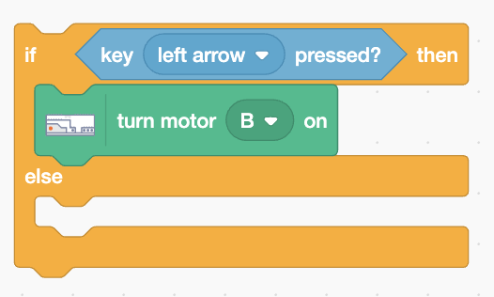
- Take out the turn off motor A and B and replace it with another if ... else (below) that turns on only (the right-hand) motor B if the left arrow is pressed. Motor A should already be off, so it will turn right.
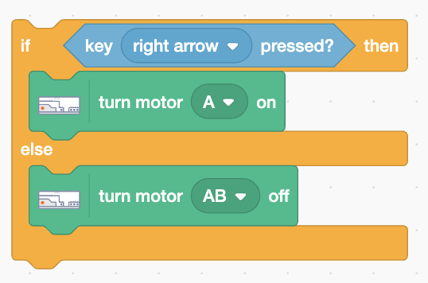
- Add code to the empty else part to turn on motor A if the right arrow is pressed, or else it turns off both motors.
The if ... else must be nested so it turns off the motors if no keys are pressed.
If the wheels skid then wrap elastic bands around them for better grip.
Save your code with a good name. File > Save now

