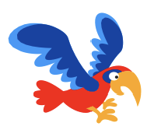

Flappy Bird

Login at https://scratch.mit.edu
Remember to keep your password safe.

A game with an animated bird and a moving background. Avoid flying into the clouds.

- Create a new project and make a new “Parrot” sprite.
- On the stage choose the “Blue Sky 2” backdrop.
- Create a new “Cloud” sprite.
The clouds blow from right to left creating an impression of movement.
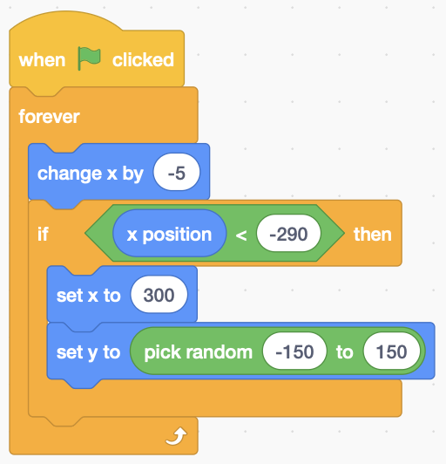
- Add the code (right) to the cloud. As the horizontal (x) position changes, it moves left until it goes off-screen (<-290). At this point x is set to a starting position just off the right-hand edge (300) with a random height (y).
- You can duplicate the cloud, but two might be enough!
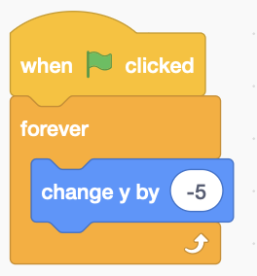
- Add code (right) to the parrot. Gravity makes the Parrot fall. Change the vertical position (y) value negatively in a forever loop to make it go down.
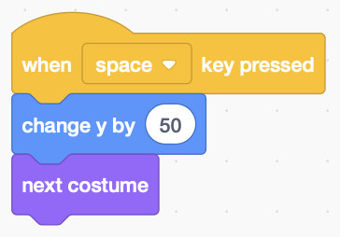
- The parrot flaps its wings to fly upwards. Add code (left) to the parrot so that when you press the space key it changes the vertical position (y) by 50.
Changing to the next costume animates its wings.
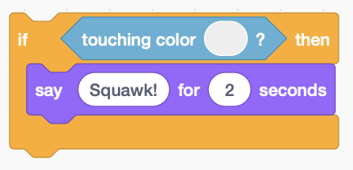
- Detect when the parrot flies into a cloud. Add code (below) into the parrot’s forever loop that detects when it touches clouds and make the parrot say Squawk!

- To get the right colour, click on the touching colour swatch and select the colour dropper icon. Use this to pick a colour from the cloud.

Remember to Save your code with a good name.
File > Save now

