
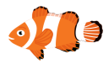
Aquarium

Register/login at https://scratch.mit.edu
Remember to write down your password.

Create an aquarium and watch the fish school together.

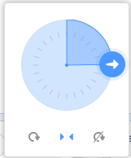
- Choose a fishy sprite and a suitable aquarium background.
- Click on Direction and play with changing the angle. To make the fish flip between looking left and right, click on the mirroring button (middle).

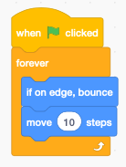
Make the fish swim left and right

- The code starts when you click the green flag. Add a forever loop.
- Inside the loop check if the fish has hit an edge, “if on edge, bounce.” This turns the fish around at the edge of the tank.
- Finally, add “move 10 steps” to move the fish forward.

To make the fish swim together they must talk to each other.

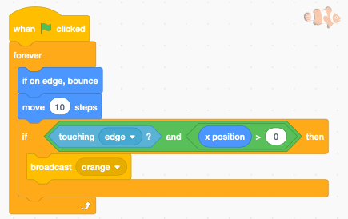
When the fish bump into the side of the tank,
move them closer together.
- Insert an if block and add the and operator.
- Check that the fish is touching one of the edges of the tank with touching edge.
- Check this is on the right-hand side with
x position > 0 (the left side would be x position < 0).
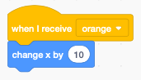
- Broadcast a new message with the fish colour e.g. orange.
- Add an event to receive the message. Add change x by 10 (moves it right).
- Right-click on the fish sprite and duplicate it to make another.

Watch the fish eventually school together.
Add different fish and change the message colour.
Save your code with a good name. File > Save now

