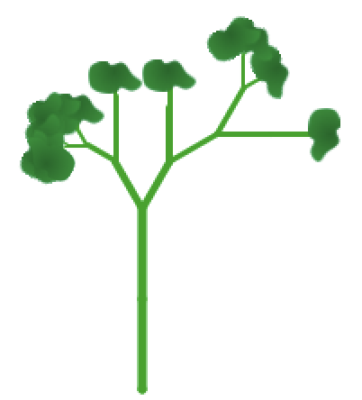

Scratchling

Register/login at https://scratch.mit.edu

Grow your own Scratch sapling – a scratchling.
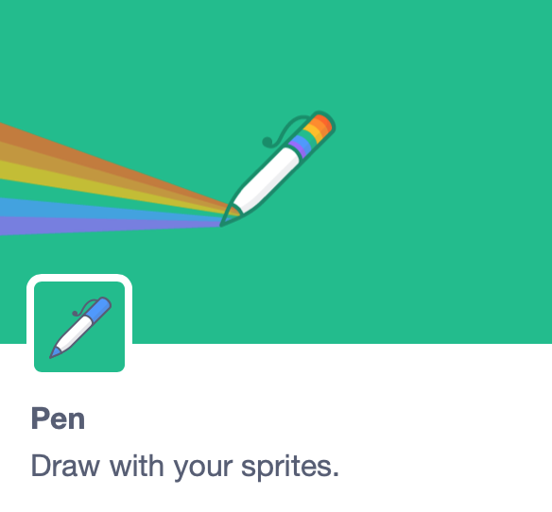

- Click on the Add Extension button, and add the Pen extension.
- Create a sprite using the Tree1 graphic.
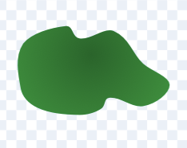
- In costumes, select one leaf and drag it to one side.
- Delete the rest of the tree, then drag the leaf to the centre cross.
Make a sapling (a young tree).
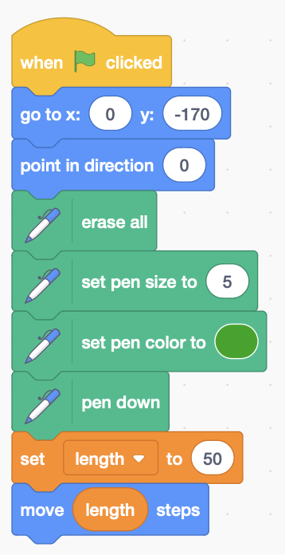
- Make a variable, for the length of the stalk, for this sprite only.
- Add the code to the right. First, place the sprite somewhere near the bottom of the screen, pointing upwards.
- Use pen commands to erase the screen, set the pen size and colour, and put the pen down to start drawing.
- Initialise the stalk length to 50, and then move it to draw the stalk.

Run this to see your new sapling.

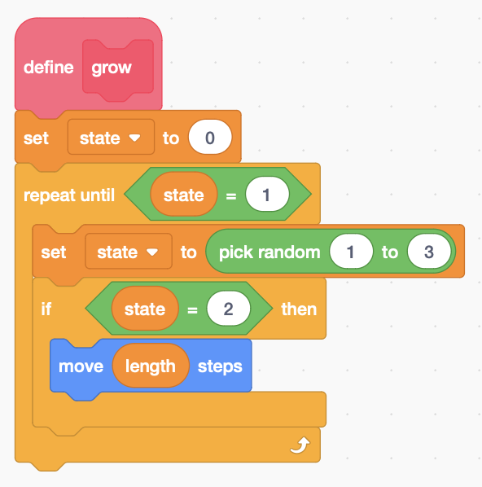
Grow your plant with a repeat loop
- Make a block to grow your plant.
- Make a variable for the state of the plant, for this sprite only, and initialise it to zero.
- Randomise the state each time round the loop, between 1 and 3.
- When state = 1 it exits the loop and stops growing.

- If state = 2 move the sprite to grow a little bit.
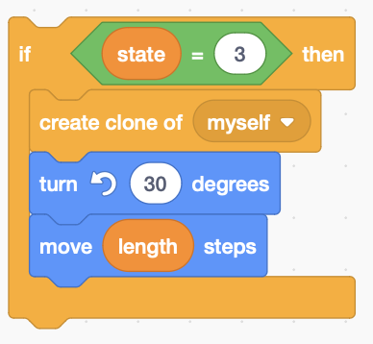
- Add to the end of your green flag code.

Now the clever bit – the plant branches.
- Add code after the last if, inside the loop, so the main plant turns 30° left and a clone of the sprite branches right.
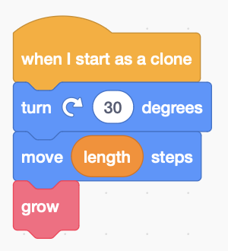
- Add code when it starts as a clone to turn 30° right, and continues to

Is your plant a bit bushy? Prune it by cutting back the length each time round the loop.
- Add code at the end of the loop – but inside it – to scale back the length and reduce the pen size.
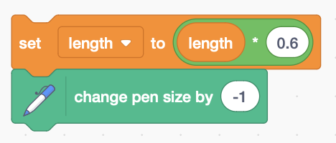
Remember to Save your code with a good name.

