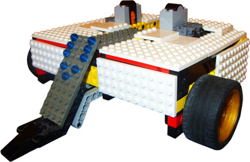

SumoBot

Register/login at https://scratch.mit.edu
Lego Robot Wars is a real thing.
https://legorobotwars.weebly.com
Adapt your Boost Kart to compete in Lego SumoBot.
The goal is to push each other off a table.
The last bot standing wins.
Add a weapon like a flipper to lift your opponent’s wheels making them easier to push.
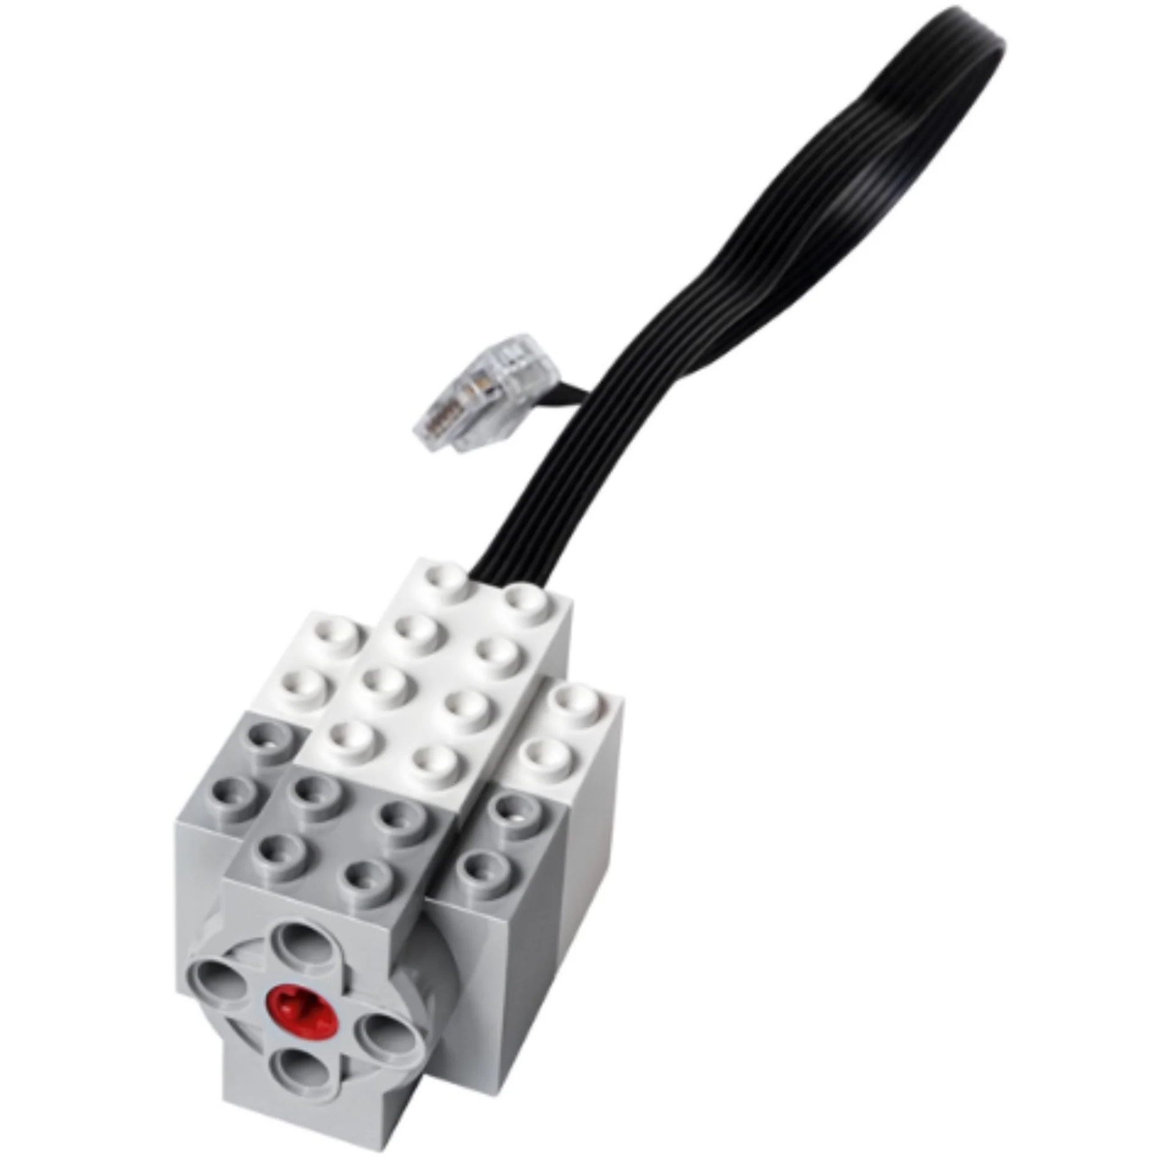
- Attach a motor to the front of your SumoBot with the axle pointing sideways.
- Plug it into Boost socket C (or D).
- Design your Lego flipper and attach it to the motor axle.

Write code to control the flipper in Scratch.
The motor can be rotated through 1 whole turn, or half a turn ½ = 0.5, or a quarter of a turn ¼ = 0.25
In turn motor, you can enter a decimal number like 0.25
or use a division operator like 
How much of a turn do you need?
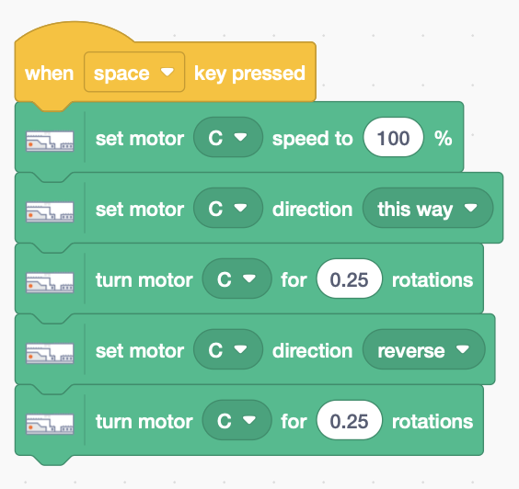
- Add code (right) that flips it up and then back down again when you press the space bar. Set motor speed to maximum (100%) and set motor direction to this way or that way. Rotate motor C upwards then reverse it to turn it downwards.

Organise a knockout tournament where bots compete in pairs to decide the ultimate SumoBot.

Save your code with a good name. File > Save now

