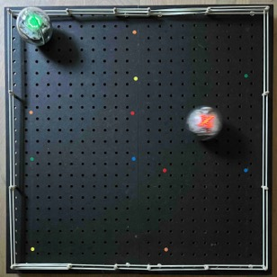

Run Robot Run

Robots give chase but may have to escape.

- In Chrome, open https://edu.sphero.com/code

- Connect your Sphero BOLT robot: click


- Select then

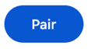
- Your BOLT has a sticker with a code on it. Choose the matching BOLT from the list then
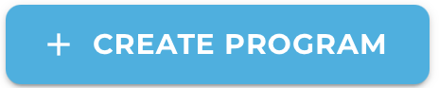
- Check your robot is showing the right image then
- Click + CREATE PROGRAM.
- Input a name for your program. Leave BLOCKS selected. Select SPHERO BOLT, deselect SPHERO BOLT+ then CREATE.
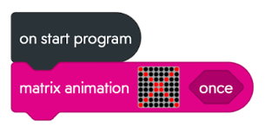
- Add code for a matrix animation with your own design for a robot chaser in red. My example is a red X.



Click on the matrix grid to edit then to add a new 8x8 matrix, or to edit an existing one. Click to finish.


the code. Does it work?
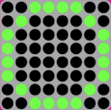
- Click on the matrix grid and press to add another 8x8 matrix in green for when your robot has to escape. My example is a green O.
- In Variables, create a new variable called chase. This is boolean because it will only be true or false.
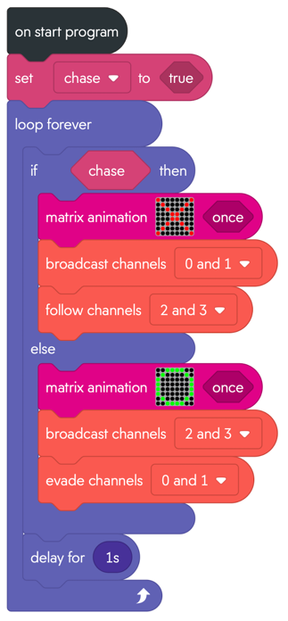
Sphero robots communicate using infra-red light invisible to us. Chasers broadcast their position on channels 0 & 1, and those trying to escape on channels 2 & 3.
- Add code (right) that follows or evades these channels depending on if it has to chase or escape. Click on true (chase) or false (escape) to toggle it.
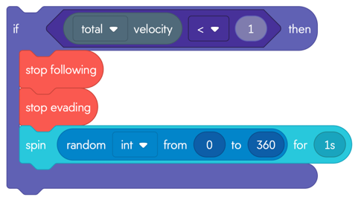
- Sometimes the Sphero gets stuck on the sidelines. You can add code (left) after the delay, inside the loop, to randomly spin Sphero if it stops.
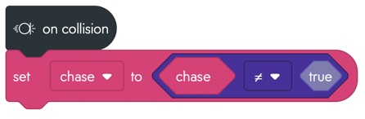
- We can toggle between chase and escape modes on collision (but it won’t detect glancing blows). The code (right) toggles between true and false.
To Save your code go back to the main page. Click on the 3 dots (ellipsis) next to your program and download to a USB drive.

