
Scores

Register/login at https://scratch.mit.edu
Keep score in your games.
- Use one of your existing Projects (e.g. QuizBot)
Use a variable to keep score. Every sprite needs to be able to see the score so make sure that you make it for all sprites.
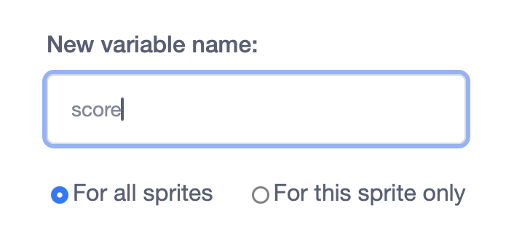
2) Create a new variable, called score, to keep score. In variables click Make a Variable, input the name and select “for all sprites.” Then click OK.

You want to see the score on the screen while you play the game.
3) In Variables, check the box next to score.
When a game starts you need to clear the score to zero.
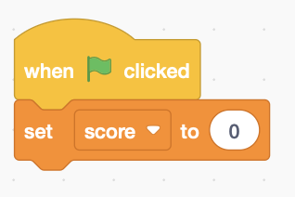
4) Find a block that starts with the green flag and insert a block to set score to 0. Make sure the existing code is still attached.
How do you gain points in the game? It could be getting a question right. How many points do you gain for each?
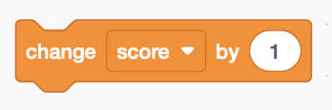
5) Find points in your game where you gain points (there could be more than one) and insert a block to change the score. Make sure the existing code is still attached.
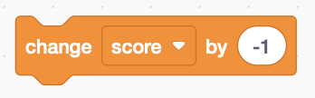
Can you lose points?
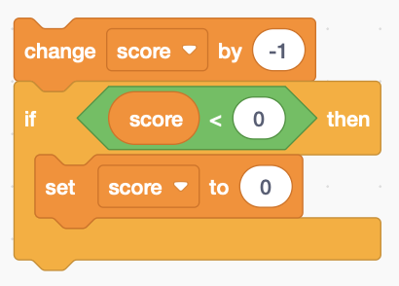
6) Find points in your game where you lose points and insert a block to change the score negatively.
7) If you don’t want to have negative scores then check the score right after you change it. If it goes negative (score less than 0) just set it to 0.
If your Scratch account has been promoted to Scratcher, you can keep a high score that’s saved between games.
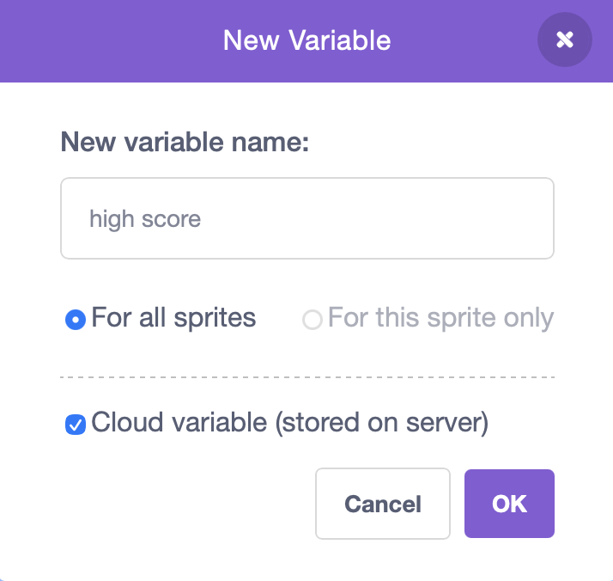
8) Check your profile page (by your name) and check your profile. Is there an invitation to become a Scratcher?
9) Create a new variable for the high score.
If you can see cloud variable, tick the box.
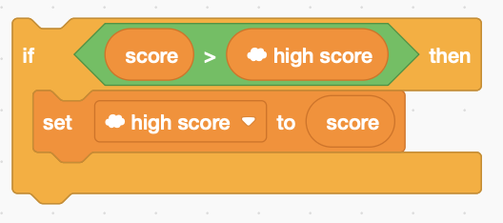
10) At the end of the game check to see if you beat the high score.
Save your code with a good name.
File > Save now

