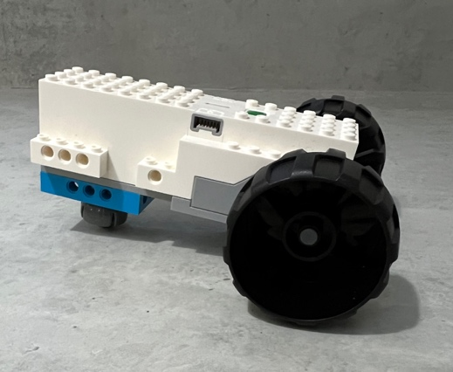

Kart

Register/login at https://scratch.mit.edu
A remote-controlled car that can go forward and in reverse.
- Create a new Scratch project, add the LEGO BOOST extension, and connect the BOOST.
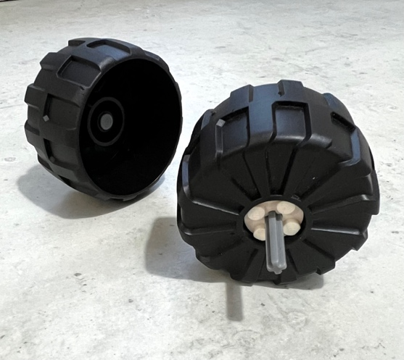
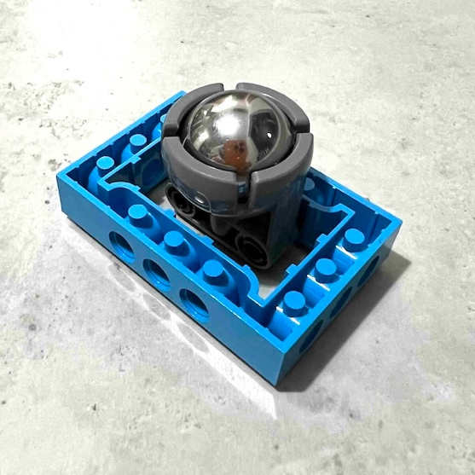
- Find and build two wheels with a cross-shaped axle to fit into motors A and B on front of the BOOST.
- You need a wheel at the back. The image (left) shows one design idea, using a caster wheel.
- Add all the wheels to the BOOST.
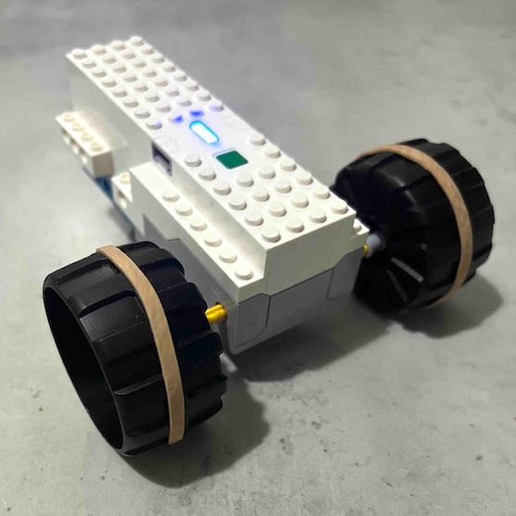
- Decorate your car with your own Lego designs so it doesn’t get mixed up with somebody else’s car.
If the wheels skid then wrap elastic bands around them for better grip.
Now write code to control the car from Scratch.
Use the arrow keys to drive it.
- Create a variable called speed to control the speed. Make it visible (check the box) and change it to a slider.
The drive motors are A and B (embossed on the Boost).
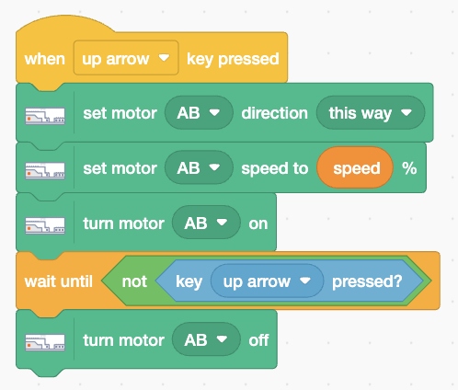
- Add code (right) that moves the kart forward when you press the up arrow. Set motor direction and speed then turn motors A and B on. When you release the key it turns them off.
- Duplicate this code and change it to drive backward, or “that way”, when you press the down arrow.
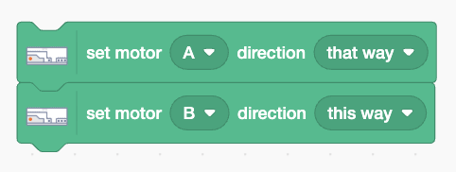
- To turn the kart using left and right arrows, you can drive the motors in opposite directions like this:
Save your code with a good name. File > Save now

