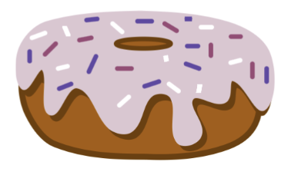

Fill Yer Face

Register/login at https://scratch.mit.edu
Eat as many doughnuts as you can – using your face.

- Click on the Add Extension button at the bottom left of the screen.
- Select the Face Sensing extension.
First the eyes.
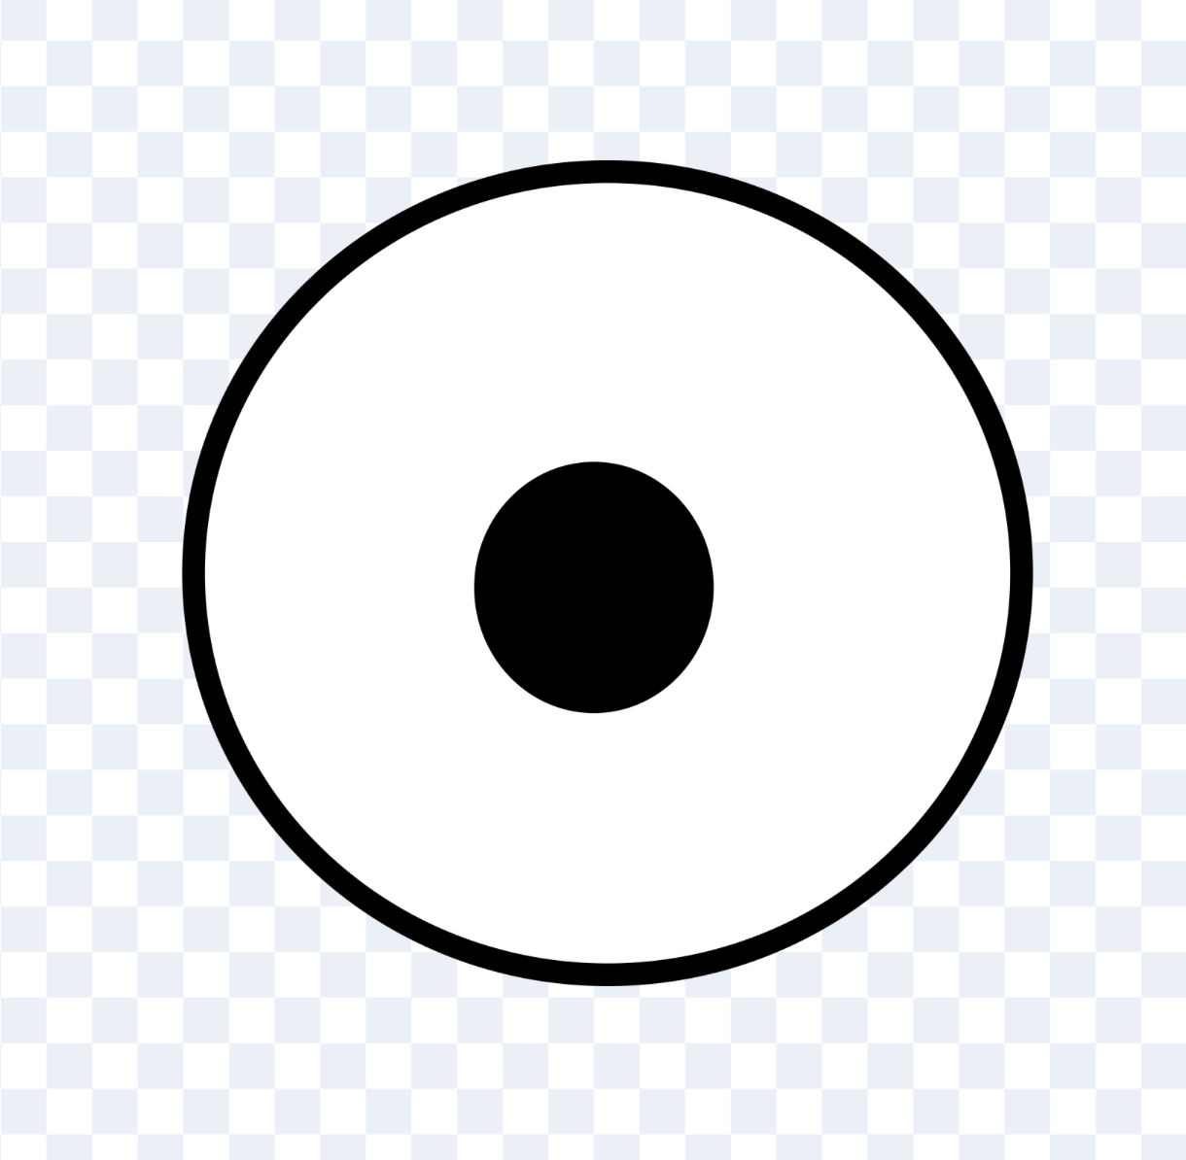
- Create a new sprite for the left eye.
- On the costumes tab, paint a new costume. Draw a white circle with a black outline.
- Position this white circle so that it’s at the centre of the sprite (use the select tool).
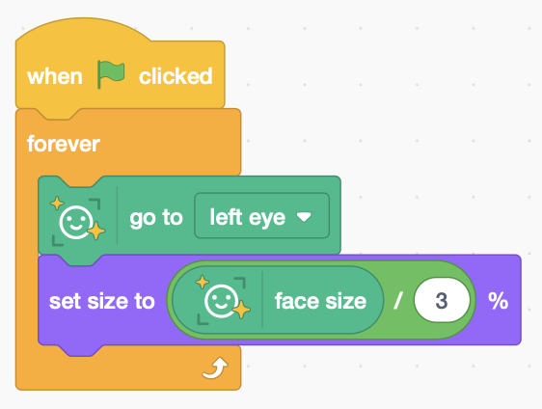
- Draw a smaller circle inside for the pupil.
Change the fill colour to black.
- Add the following code (right) to follow your left eye (you might need to adjust the size).
- Duplicate the sprite for the right eye and change the code to follow the right eye.
Run it to see what happens.

Now add a hat…
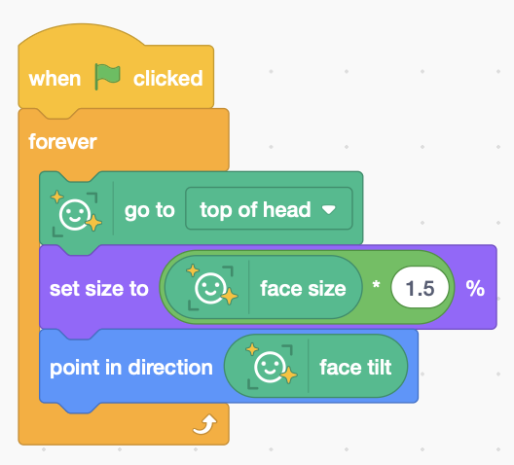
- Choose a sprite for your hat.
- Add code (right) to make it follow the top of your head.
- Adjust the hat size based on your face size. Change the number as needed.
- Tilt your hat so that it points in the same direction as your face.
Try it to see what happens. Tilt your head sideways.
The game is to eat doughnuts.
- Choose the doughnut sprite
(search for “donut” – the American spelling).
- Add code (below) that senses when the doughnut touches your mouth, makes a “chomp” sound, then moves it to a new random position.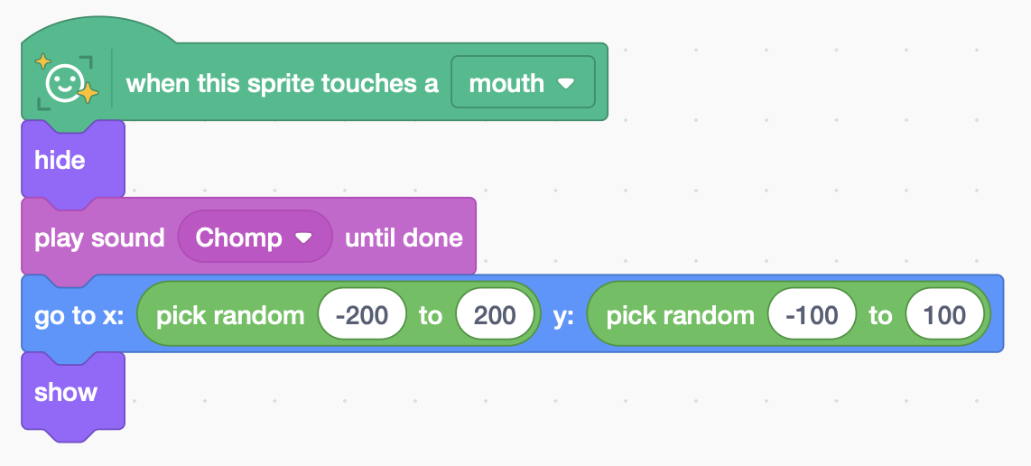
Try adding a score that counts the doughnuts you eat.
Save your code with a good name. File > Save now

