
Colour Sensor

Register/login at https://scratch.mit.edu
Detect the colour of Lego bricks and change the colour of the light on the BOOST to match it.

- Create a new Scratch project and add the
LEGO BOOST extension.
Connect the BOOST

- Click on the BOOST blocks section. If you see  then click it, press the green button on the BOOST and click start searching.
- The light on the BOOST should turn blue.
If it connected OK then press Go to Editor.
- If it goes wrong reset the BOOST by holding the green button for 10 seconds and try again.
Colour Sensor
- Plug the colour sensor into the BOOST.
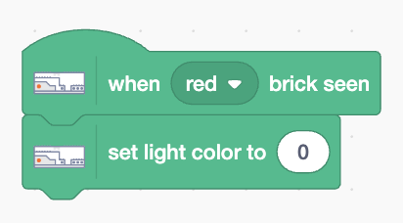
- Add code (any sprite) that detects when a brick colour is seen and sets the light colour to match the colour of the brick.

Try it by holding a red Lego brick in front of the sensor.
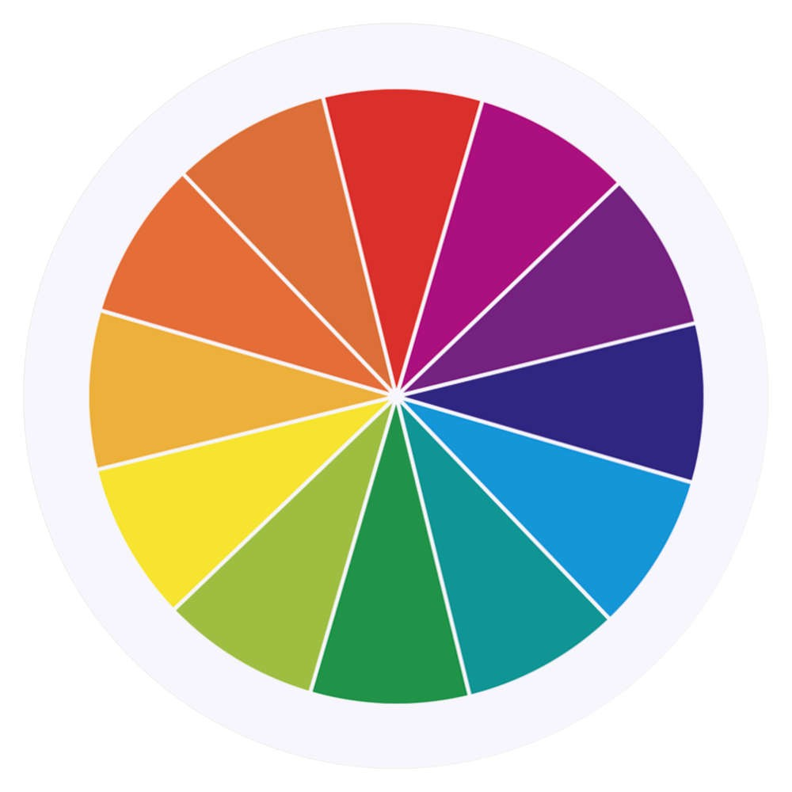
The sensor can detect different colour bricks.
What colour number do we use for the light? The colour hues are arranged on a wheel, numbered from 0 (red) to 99. There’s no hue for black or white.

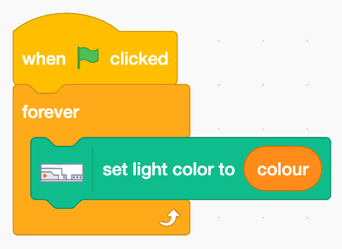
- Duplicate your code to detect different colour bricks.
Add blue, green, and yellow
(don’t worry about white or black).
- Create a variable called colour and turn it into a slider (right-click on the variable in the output).
- Add code (right) to find matching colours.

Run the code and adjust the slider to match the brick colour.
- When you’ve found the right colour code, you must stop it otherwise it keeps changing the colour.
- use the colour code to set the light colour.

Text to Speech
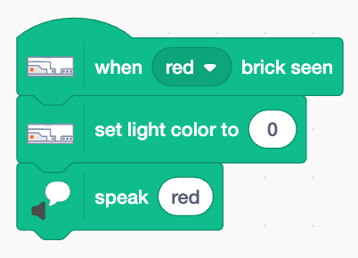
- Add the Text to Speech extension
- Add extra code right to each of your brick detectors to speak the colour.
Just type in the name of the colour.
Save your code with a good name.
File > Save now

