
Colour Selector

Register/login at https://scratch.mit.edu
Select Lego bricks by colour. When it sees a coloured brick it swings out an arm to push it off the conveyor belt, then the arm swings back.
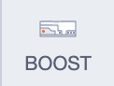
- Create a new Scratch project and add the
LEGO BOOST extension.
- Connect to the BOOST like last time.
- Plug a motor into socket C on the BOOST.
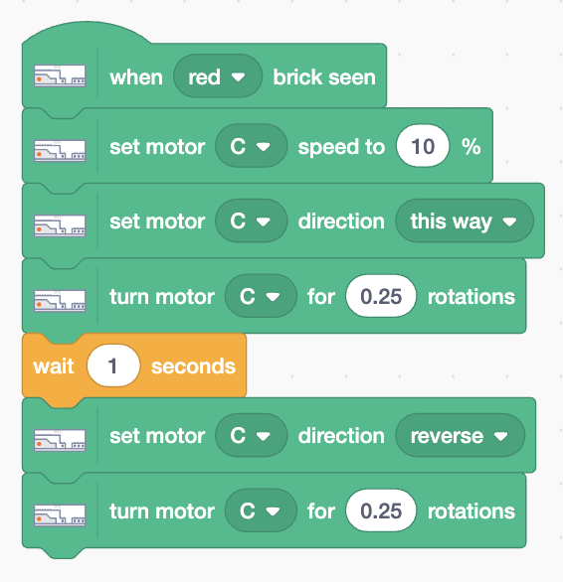
- Plug a colour sensor into socket D on the BOOST.
- Add this code to any sprite to detect when a brick colour is seen (choose your colour). It turns the motor one quarter of a rotation then after a wait, turns it back.

Check that it works before building the Lego.

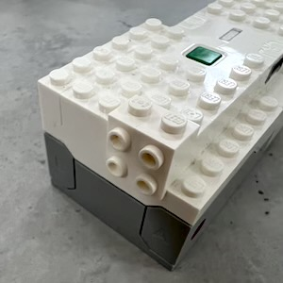
- First add a 90 degree bracket to the end of the BOOST.
- Attach the motor to the bracket with the hole facing upwards.
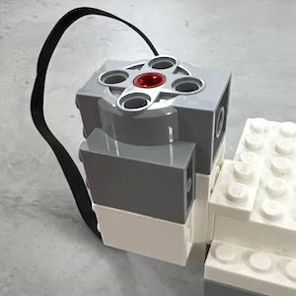
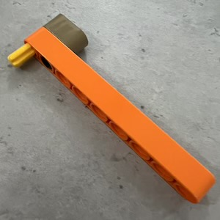
- Create an arm long enough to push a brick off the conveyor. This fits into the motor.
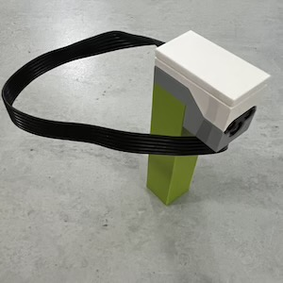
- Create a stack of bricks 7 blocks high and 2 wide and put the colour sensor on top.
- Install the BOOST next to the conveyor belt
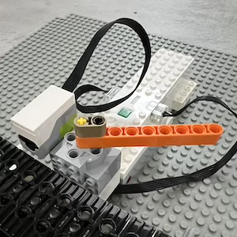
- Adjust the arm so it’s angled back 45 degrees.

We’ll start the conveyor belt to see if it selects bricks properly.

Save your code with a good name.
File > Save now

