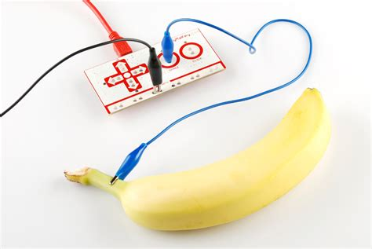



Fruit Machine

Use fruit as computer input.

- Register/login at https://scratch.mit.edu
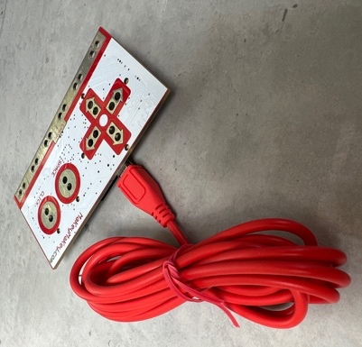
- Add the Makey Makey extension.
- Plug the USB cable into your Makey.
- Plug the other end of the cable into a USB socket on your computer.
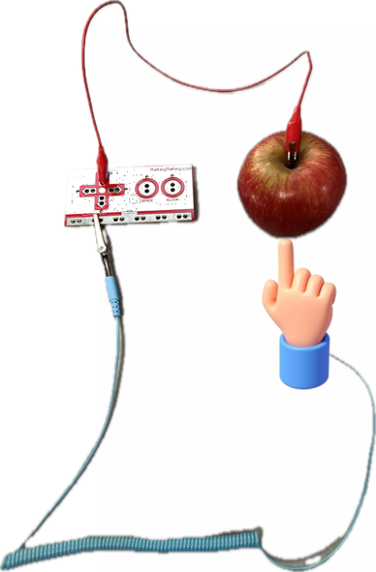
The Makey is all about making electrical circuits. Make a circuit from earth, through conductive objects, back to a Makey input. Conductive objects include wires, fruit, and your body!

- Put on the wrist strap and connect the “crocodile clip” onto earth at the bottom of the Makey.
- Touch any of the Makey inputs. A green light next to the inputs will light up when you have made a circuit.
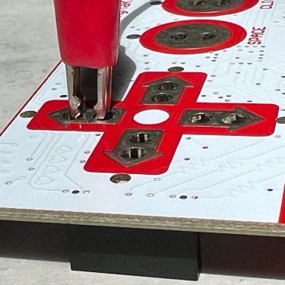
- Connect a crocodile clip to a pair of holes on one of the Makey inputs.
- Choose a fruit and poke a paper clip into it – this makes a better electrical connection.
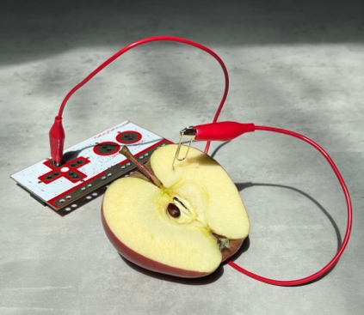
- Clip the other end of the “crocodile clip” cable onto the paper clip.
- Choose a sprite graphic that matches your fruit.
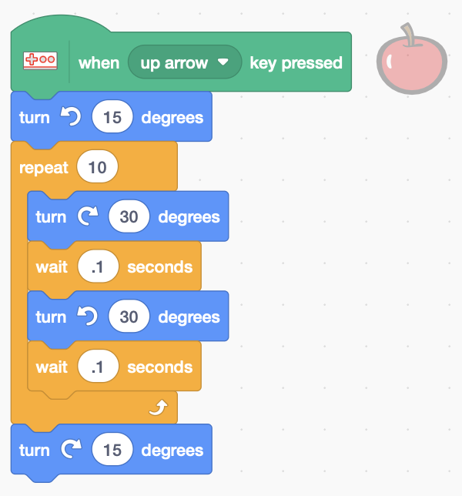
- Add code to your sprite (below) that jiggles the icon when you touch the matching fruit. Make sure you select the correct Makey input key.

Touch the fruit – does it jiggle?

Repeat steps 7 to 11 above for different fruit.
Try adding appropriate sound-effects!

Remember to Save your code.

Materials:

- Makey Makey
- Anti-static wrist straps help make the circuit
- Paper clips make a good electrical connection with the fruit
- Bananas, apples, oranges (halved or quartered for a better connection)

