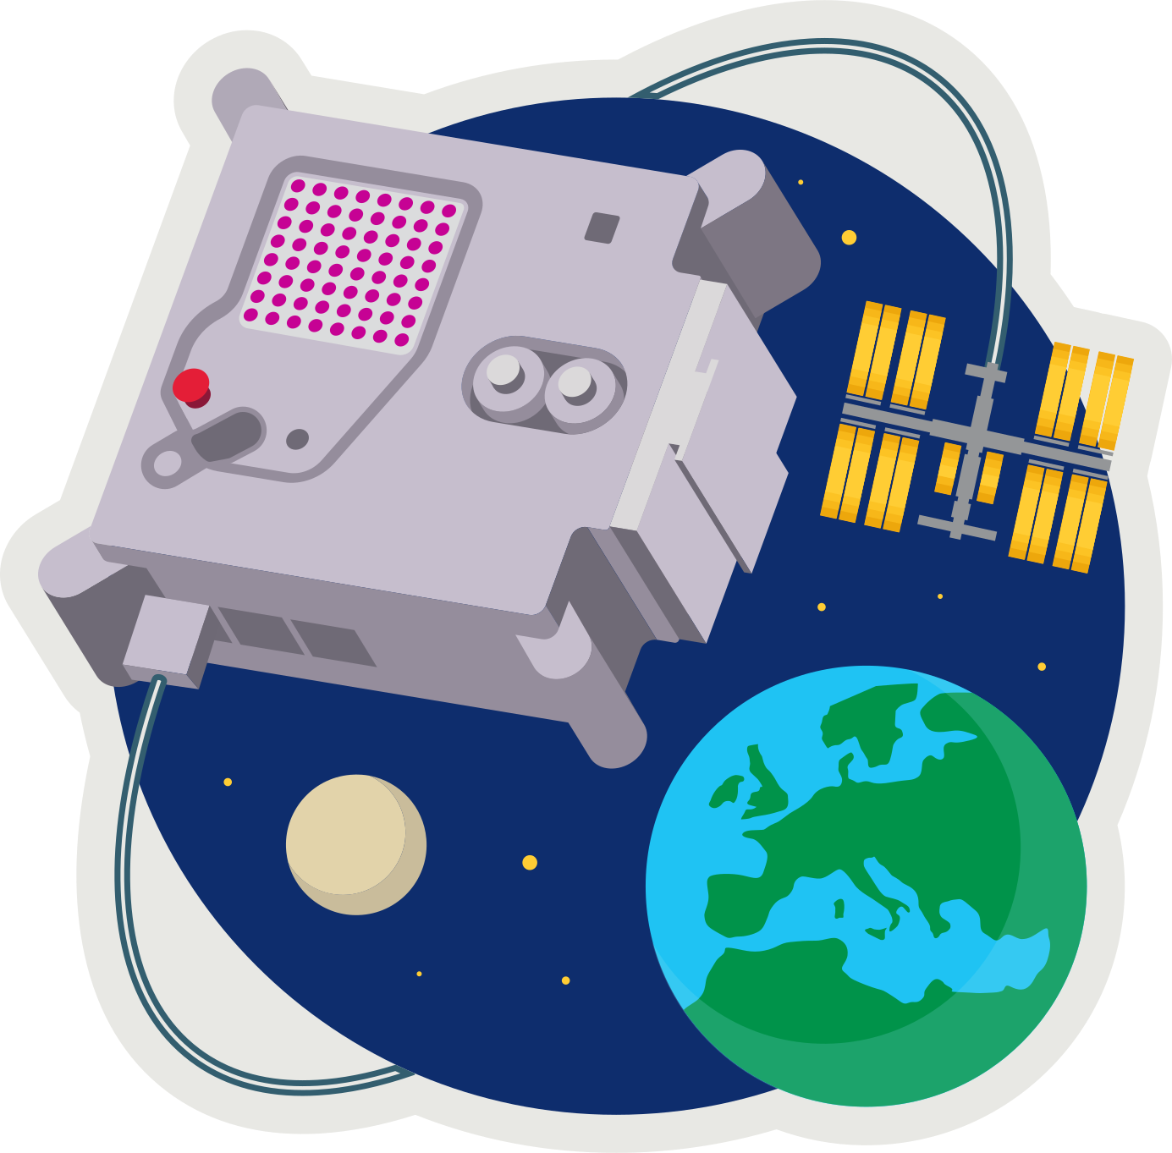
ASTRO PI MISSION ZERO
Part 2: Pixel Art

Send a personalised image to the astronauts on the International Space Station!

Your image should be inspired by nature, on Earth or beyond: trees, flowers, animals, insects, rainbows, or alien life forms.

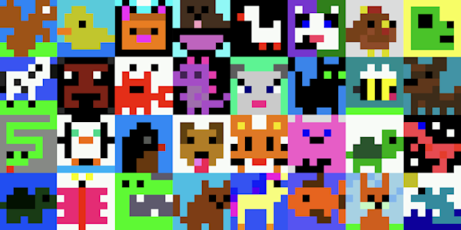
Example images from Mission Zero 2023/24.

These are all 8x8 pixel-art (8 pixels high by 8 pixels wide)
Pixels are picture elements.

- Open pixilart.com (we can use the same login CodeClub67)

- Click START DRAWING
- input width 8, and height 8.
- SELECT COLOR PALETTE
- Where it says “Search Palette” enter astro-pi
- Click NEW DRAWING

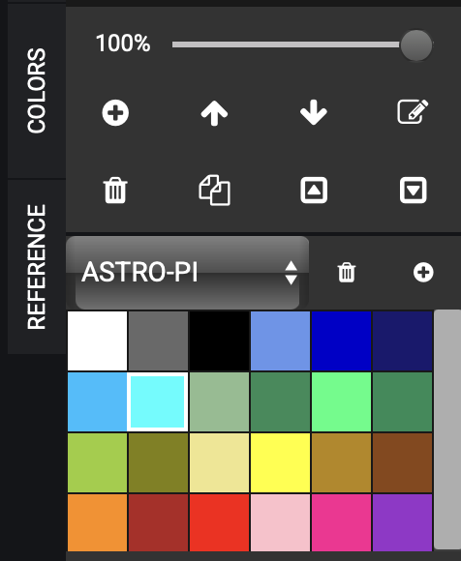
- CREATE your pixel art
- Select the pencil icon (top-left in TOOLS)
- Select the colour on the COLORS tab
- Click anywhere in the 8x8 grid.

- SAVE your drawing
- Click *SAVE DRAWING
- give it a title
- set visibility to PRIVATE
- click SAVE (or UPDATE if you’re saving an update)

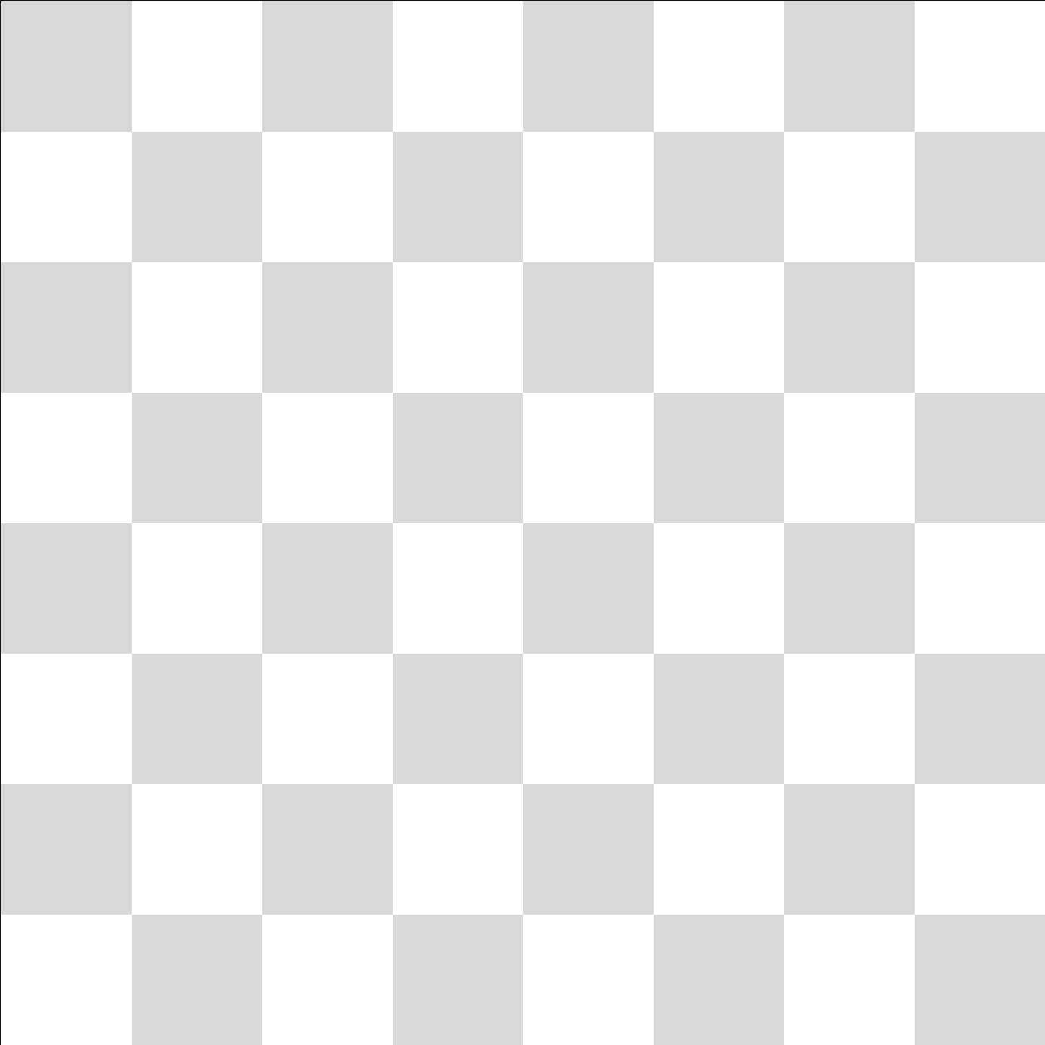
- LOAD a drawing
- Click on the (smiley) avatar (top-right).
- Select My Gallery
- Click on the drawing
- Select “Edit Drawing”



astro-pi.org
ffffff,696969,000000,6495ed,0000cd,191970,00bfff,00ffff,8fbc8f,2e8b57,00ff7f,228b57,9acd32,808000,f0e68c,ffff00,b8860b,8b4513,ff8c00,b22222,ff0000,ffc0cb,ff1493,9932cc

