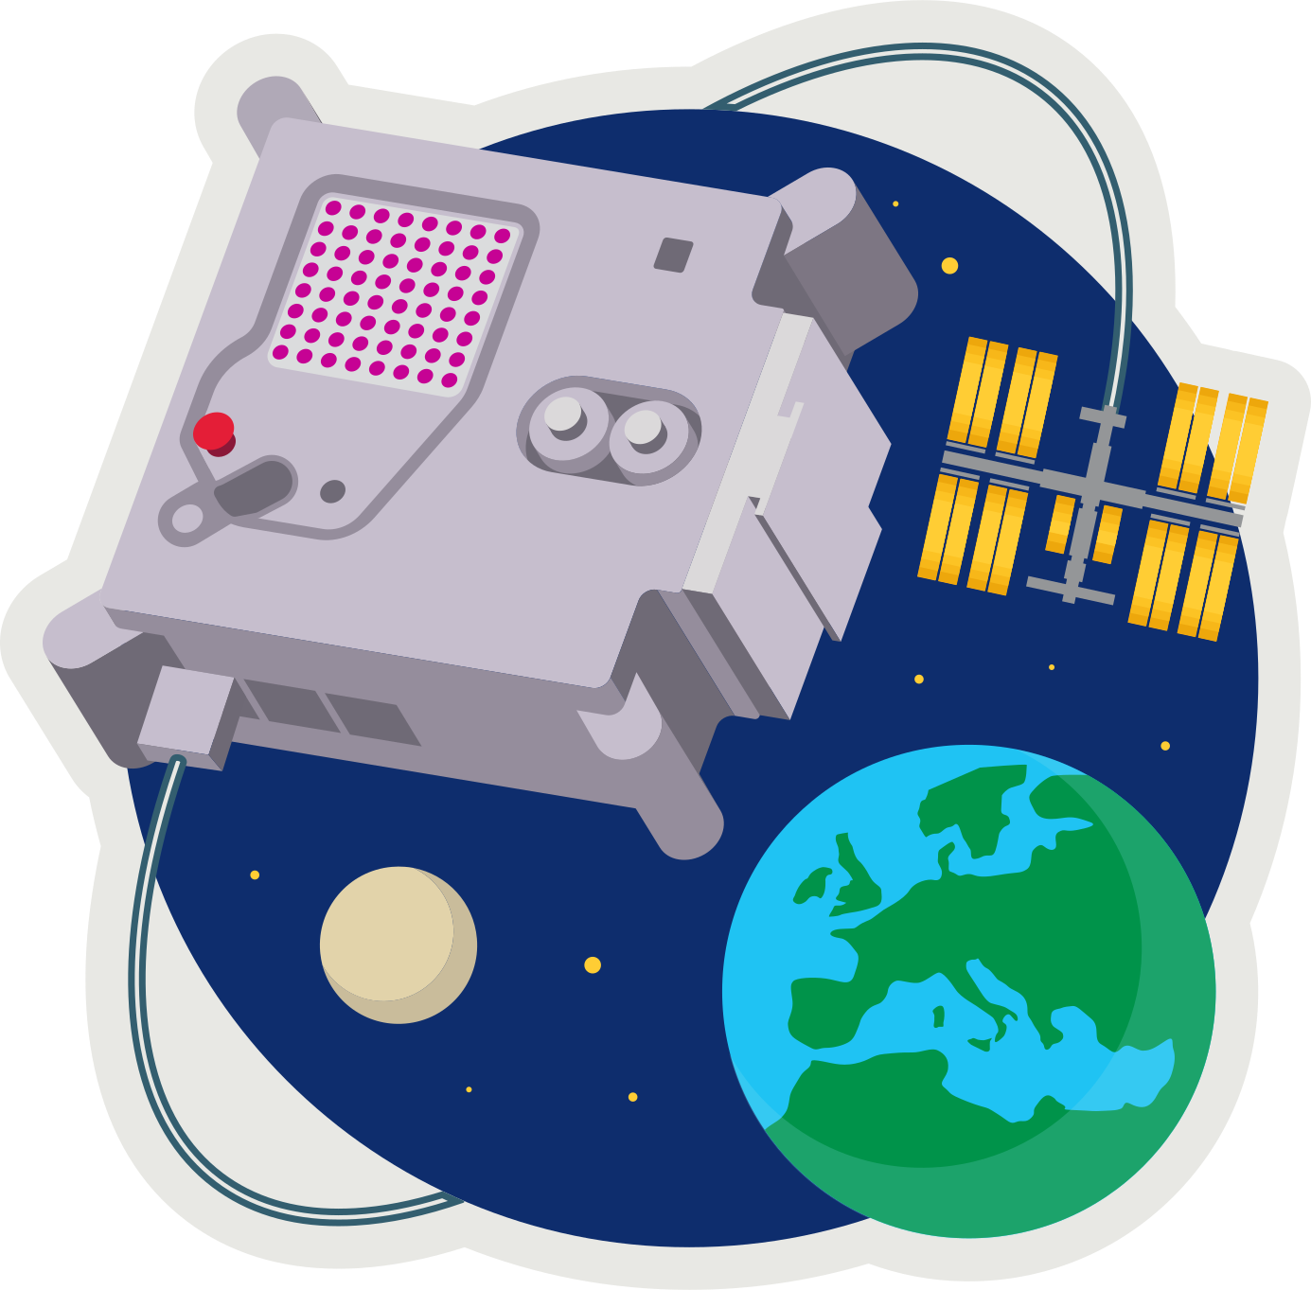
ASTRO PI MISSION ZERO
Fuse Beads

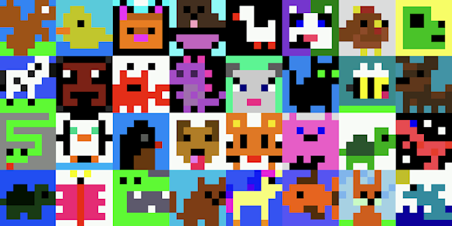
Send a personalised image to the astronauts on the International Space Station! Your image should be inspired by nature, on Earth or beyond: trees, flowers, animals, insects, rainbows, or alien life forms.

These are all 8x8 pixel-art (8 pixels high by 8 pixels wide). Pixels are picture elements.
- Design an 8x8 image using fuse beads.

You will need:
- A plastic pegboard
- Lots of fuse beads
- craft tweezers

- Make sure your design is no more than 8x8 beads.
You can leave empty background spaces.
- An adult will use an electric iron to heat and fuse the beads for 30 seconds, using the special ironing paper, keeping the iron on the move.
- After ironing the first side, we’ll remove the fused beads from the pegboard and iron the other side.
- Let the fused beads cool down. Place something heavy on them to prevent warping.

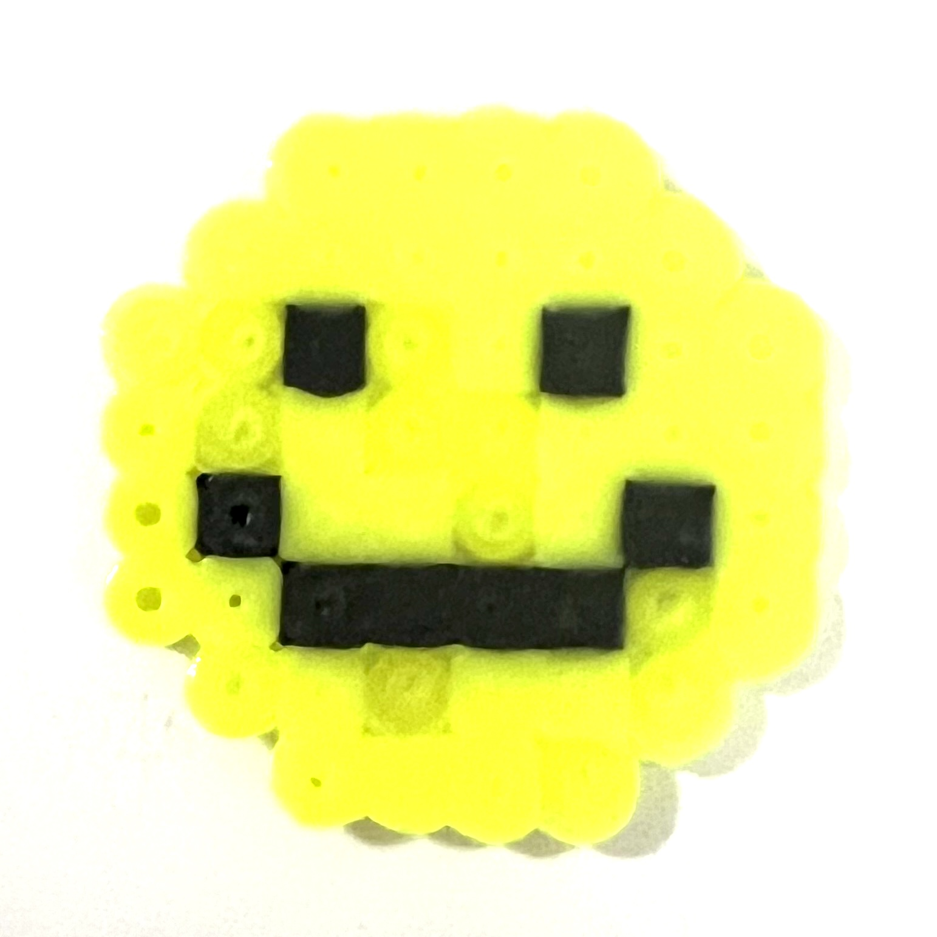
Here’s one I created earlier…
Next week we’ll turn your designs into 8x8 sprites.

astro-pi.org

