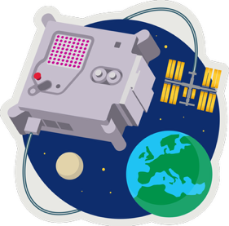
ASTRO PI MISSION ZERO
Mission Launch

- Download Pixilart gallery image(s).
- Download python code for one or two images.
- Open Astro-pi Mission Zero simulator
https://missions.astro-pi.org/mz/code_submissions
- Select START A NEW PROGRAM.
- Select and delete the example code.
- Open, copy & paste in the python code.
- Use the Mission Zero encoder to generate the image data and paste this into the Python code, overwriting the example image(s).
- Run the code and vary the temperature.
- The code also uses the colour sensor to clear the screen at the end.
- Enter classroom code fog-even and team name which can be the child’s name.
- Save or submit the work if this is the final version.

astro-pi.org

