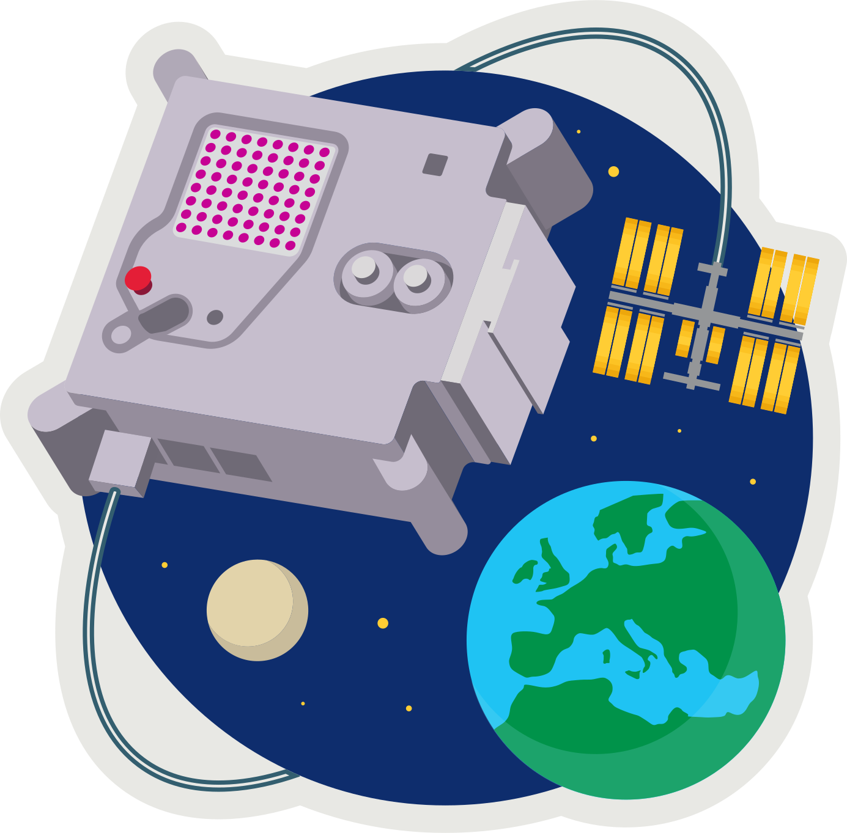
ASTRO PI MISSION ZERO
Pixel Art

Send a personalised image to the astronauts on the International Space Station!

Your image should be inspired by nature, on Earth or beyond: trees, flowers, animals, insects, rainbows, or alien life forms.

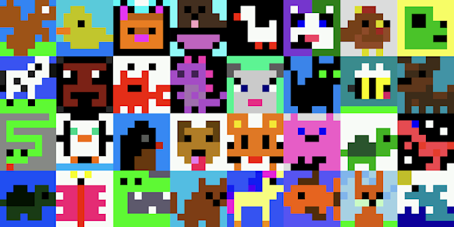
Example images from Mission Zero 2023/24.

These are all 8x8 pixel-art (8 pixels high by 8 pixels wide). Pixels are picture elements.

- Open pixilart.com and login as CodeClub67.

- NEW DRAWING
- Click START DRAWING
- input width 8, and height 8.
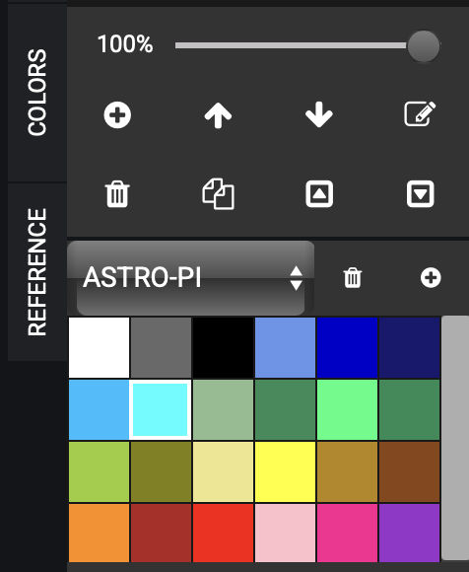
- SELECT COLOR PALETTE
- Where it says “Search Palette”
enter astro-pi
- Click on the astro-pi palette
- Click NEW DRAWING

- CREATE your pixel art
- Select the pencil icon (top-left in TOOLS)
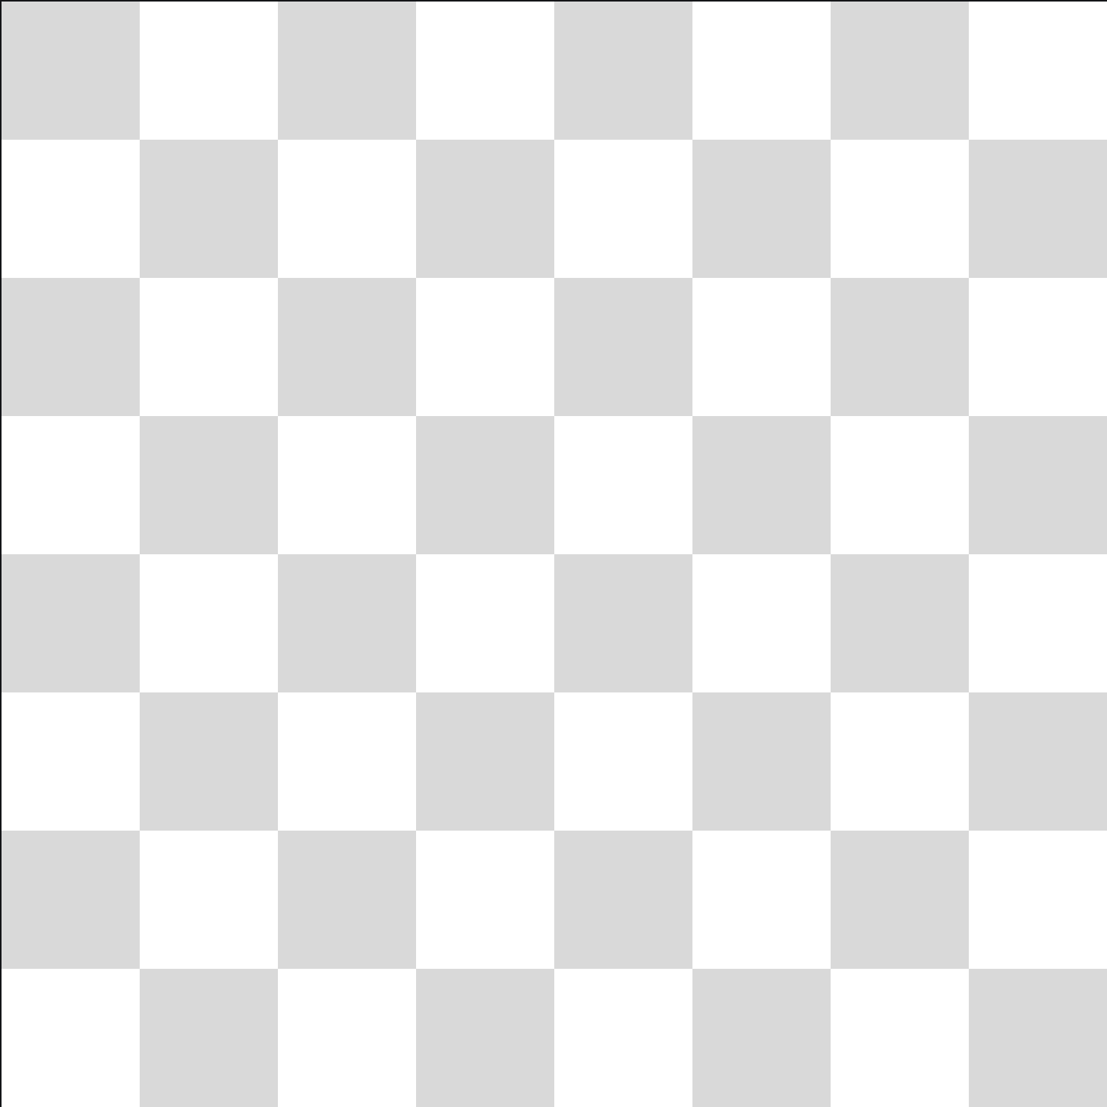
- Select the colour on the COLORS tab
- Click anywhere in the 8x8 grid.

- SAVE your drawing
- Click *SAVE DRAWING
- give it a title
- set visibility to PRIVATE
- click SAVE
(or UPDATE if you’re saving an update)


- LOAD a drawing
- Click on the (smiley) avatar (top-right).
- Select My Gallery
- Click on the drawing
- Select “Edit Drawing”

astro-pi.org
ffffff, 696969, 000000, 6495ed, 0000cd, 191970, 00bfff, 00ffff, 8fbc8f, 2e8b57, 00ff7f, 228b57, 9acd32, 808000, f0e68c, ffff00, b8860b, 8b4513, ff8c00, b22222, ff0000, ffc0cb, ff1493, 9932cc

