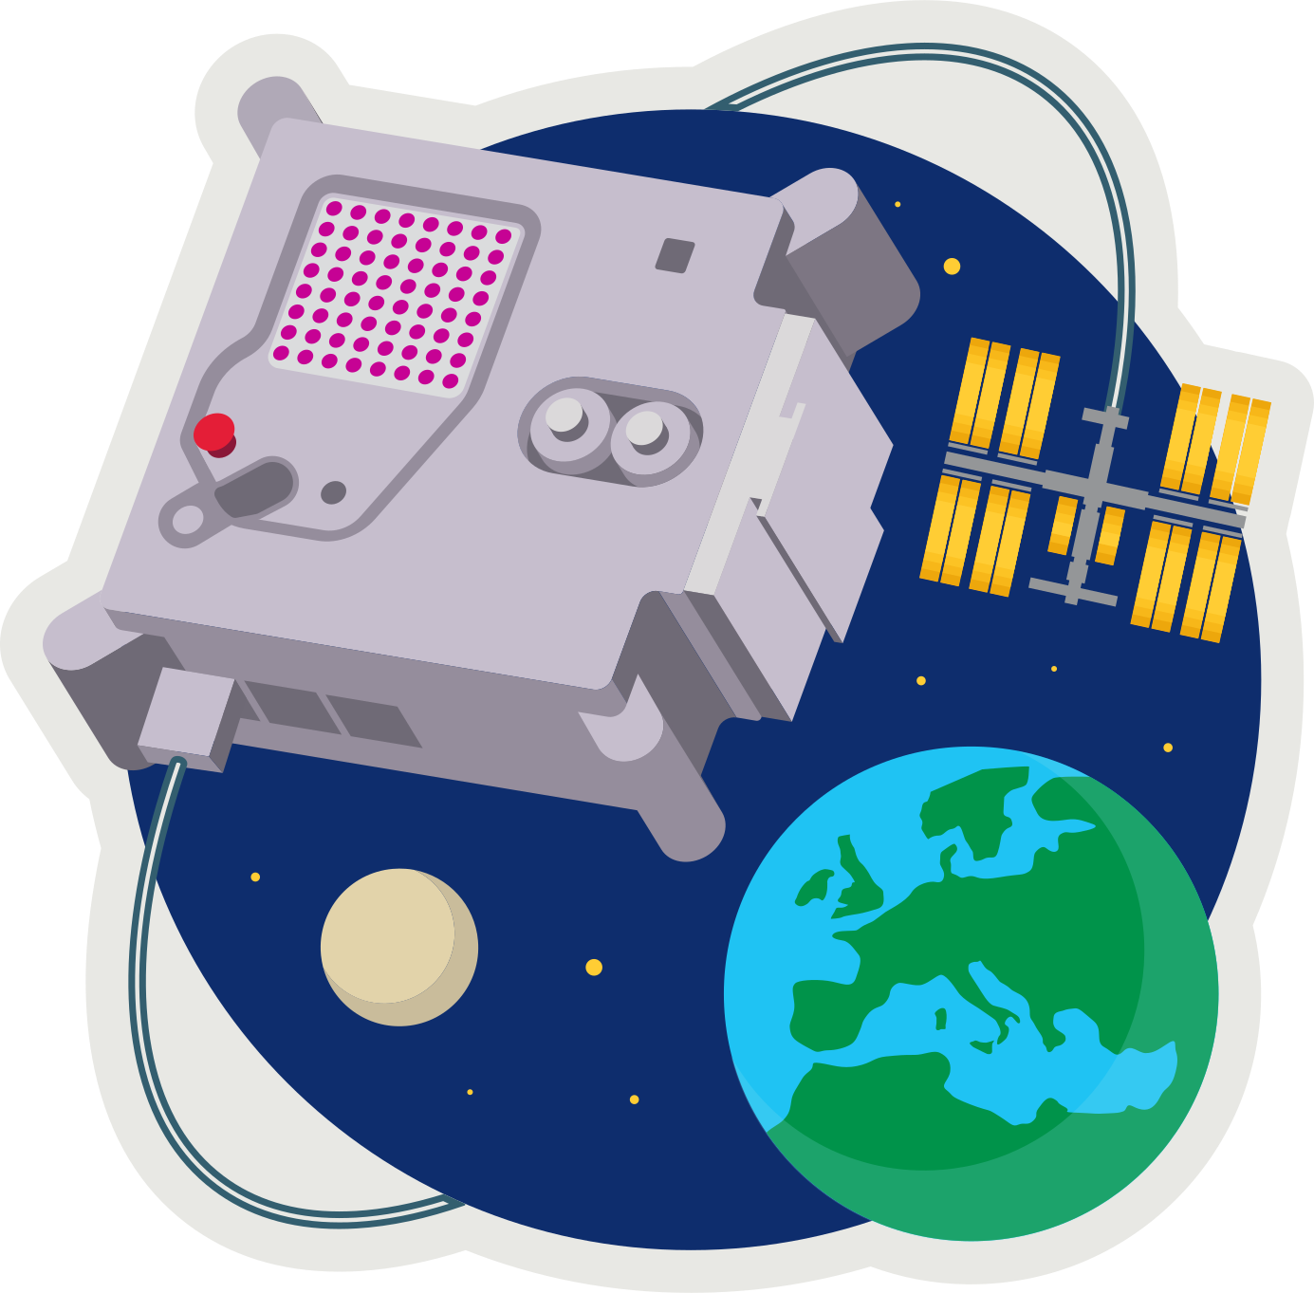
ASTRO PI MISSION ZERO
Scratch Sensor Simulator


Send a personalised image to the astronauts on the Space Station!
Last week you created two 8x8 pixel-art works. Pixels are picture elements.

- Open pixilart.com – login as CodeClub67
- For each of your Pixilart images:
- Click on the smiley face at top-right
- Open My Gallery
- Select your image – you can edit it if you like.
- In the panel on the right scroll down to Details
- Click Download Original to download a .png (ping).
- Save it in your downloads folder.
Your mission is to animate your images in Scratch.
- Register/login at https://scratch.mit.edu
- Create a new Scratch project
- Upload a new sprite from the first image in downloads.
- It’s very small – only 8x8. Adjust the size to 1000%.
- On the costumes tab upload the second image.
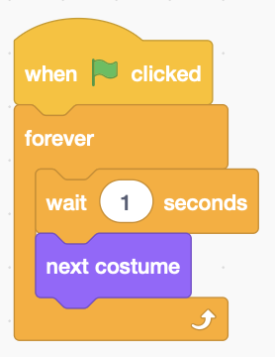
- Add the code (right) to animate the sprite by switching between the two costumes every second.
Simulate a space station sensor.
- Make a Variable called sensor (for all sprites).
- Make sure the variable is ticked so it’s shown on-screen.
- Right-click the on-screen variable and make it a slider.
- Right-click the on-screen variable to change slider range. Set the maximum value to 200 – OK
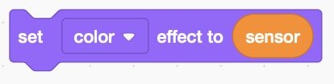
- Add this block into the loop to set the colour effect according to the sensor data.
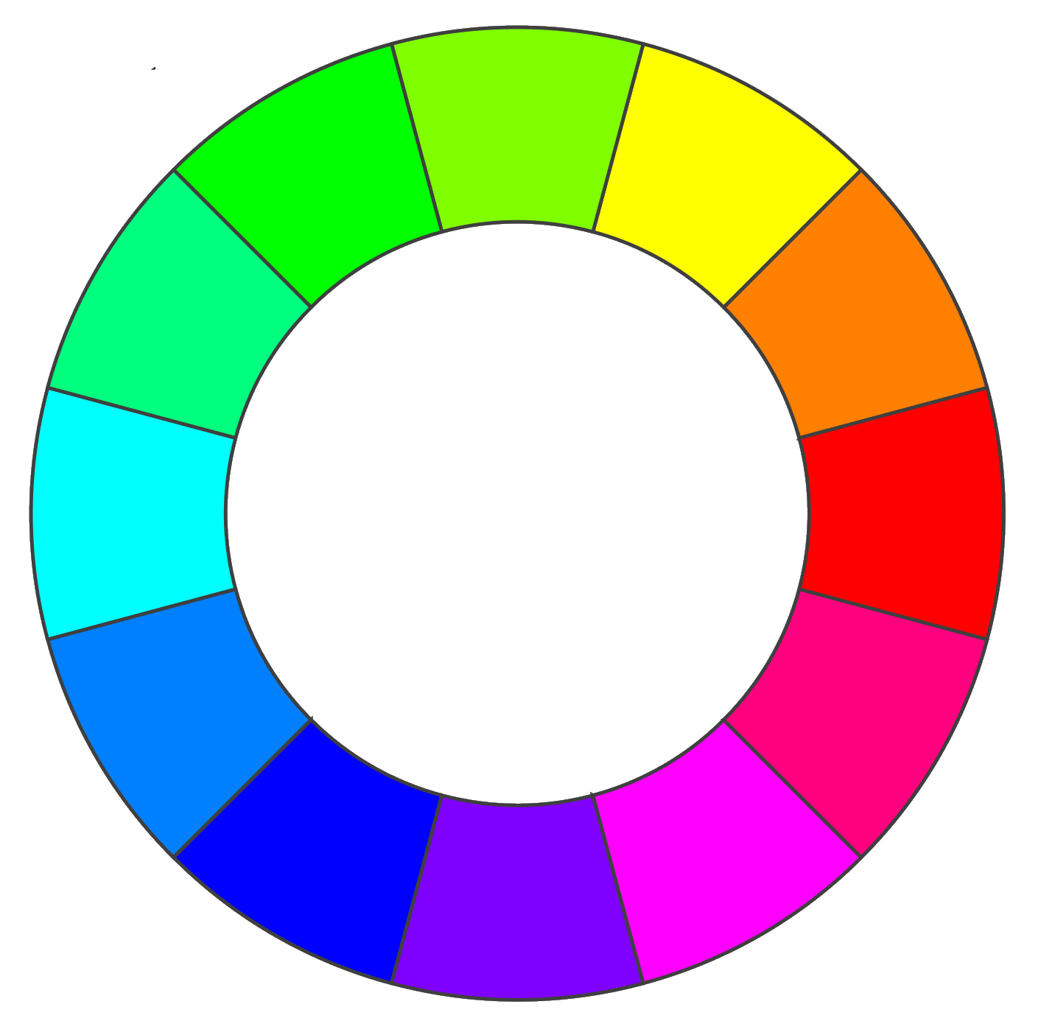
Colours can be placed on a colour wheel. The Scratch colour effect shifts any colour clockwise around the wheel.
The wheel is 200 units around, so a value of 100 will shift any colour to the opposite side.
Try a value of 100, does it shift the colour to the opposite side of the colour wheel?
Try a value of 200 – what happens? A sensor value of 200 takes the colour all the way round back to where it started.
Remember to Save your code with a good name.

astro-pi.org

