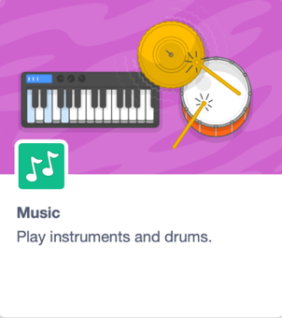

Looper

Register/login at https://scratch.mit.edu
Make rhythms by looping.
- Create a new Project and add the Music extension.
A Beat is a steady, recurring pulse in music that you can tap your foot to.
Tempo is the speed at which sounds play, measured in BPM (beats per minute). The starting tempo in Scratch is 60 BPM, which means 1 beat each second.
- Create code that plays drums for one beat, or 1 second. Start the code with the green flag and use a forever loop to make it repeat.
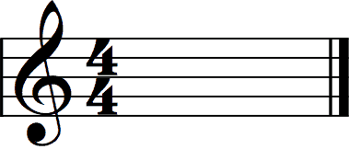
Do you hear one beat per second?
This is your “rhythm section”
A Bar splits music into small, equal groups of beats. A lot of pop music has 4 beats in every bar.
- Add a new code block that also starts on the green flag. Make this code repeat 4 beats to make a bar.
- Set an instrument before you enter the loop and play a note for 1 beat, staying in time with the drums.

Musicians call the first beat of the bar “The One.”
- To play on “The One” you’ll need to count the beats in the bar. Create a loop variable called beats.
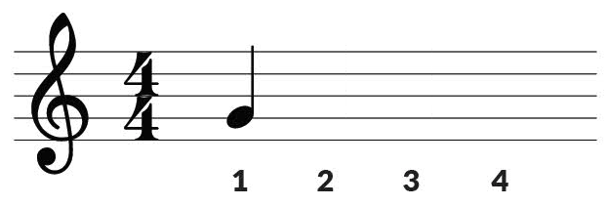
- To count 1, 2, 3, 4, set beats to 1 before you enter the loop and change beat by 1 as the last thing in the loop.
- Add an if .. else around the note so that it only plays on “The One.”
Otherwise (else) add a rest for 1 beat.
A rest is a silent delay.
- We want the bar to repeat so put this loop and the setup of the loop variable inside another forever loop.
This is a nested loop as one loop is nested inside another.
- Now, add some different notes on other beats in the bar. Add another if .. else replacing the rest, and check for a different beat.
- Don’t forget to put the rest back in at the last else in the chain.
Have fun looping! You can always change the tempo by dragging a set tempo block onto your code space and just click on it.
Save your code with a good name.
File > Save now

