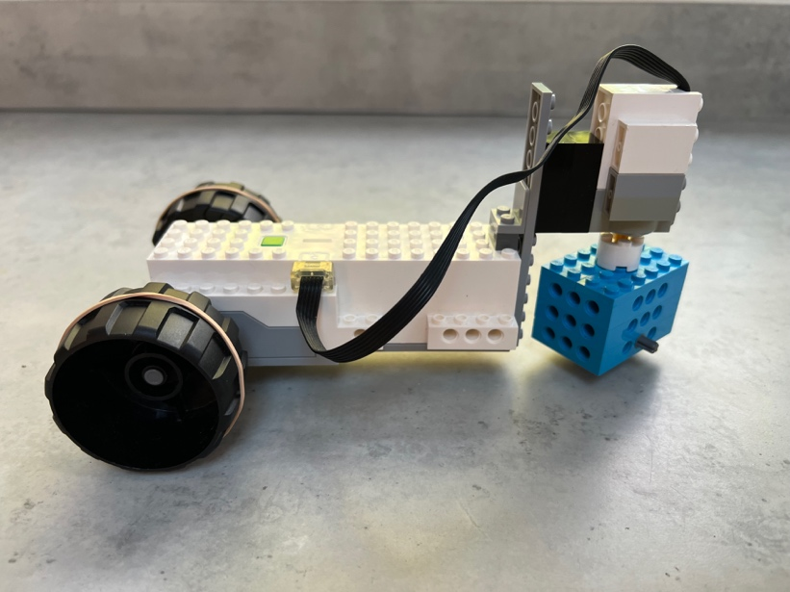

Trike

Register/login at https://scratch.mit.edu
A remote-controlled trike with a steering wheel.
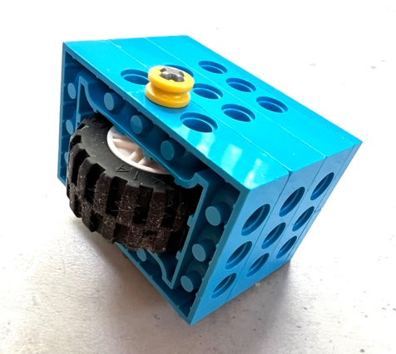
- Create a new project, add the LEGO BOOST extension, and connect the BOOST.
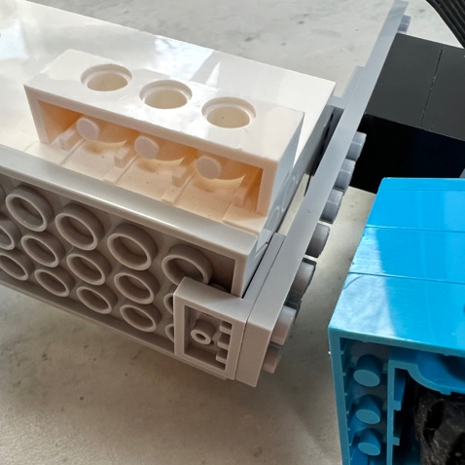
- Find and build two rear wheels with a cross-shaped axle to fit into motors A and B on the BOOST.
- Make a front steering wheel.
- Attach the motor and steering wheel. Use two Lego 90-degree brackets to clamp the front wheel securely.
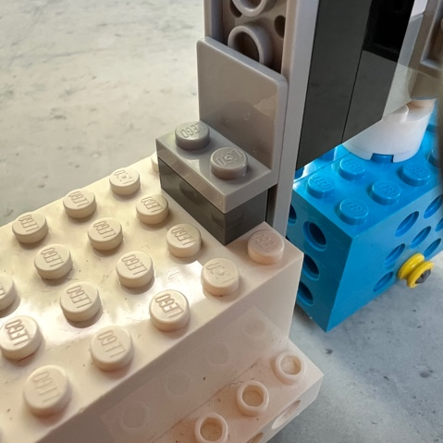
- Decorate your car with your own Lego designs so it doesn’t get mixed up with somebody else’s car.
Now write code to control the trike from Scratch. Use the arrow keys to drive it. If the wheels skid then wrap elastic bands around them for better grip.

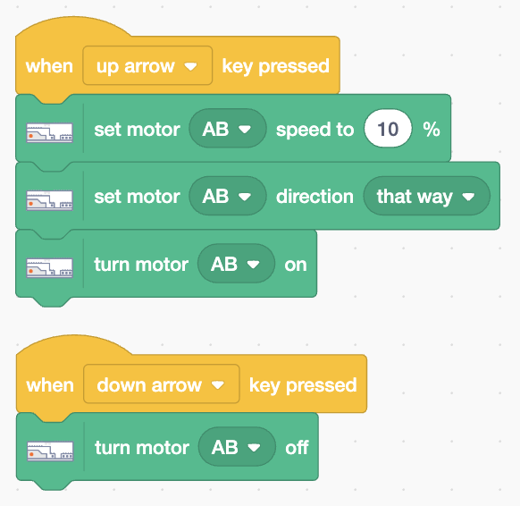
- Add code (right) that sets the A & B motor speed and direction. It turns on the motors when you press the up arrow and turns them off when you press the down arrow.

Add steering.
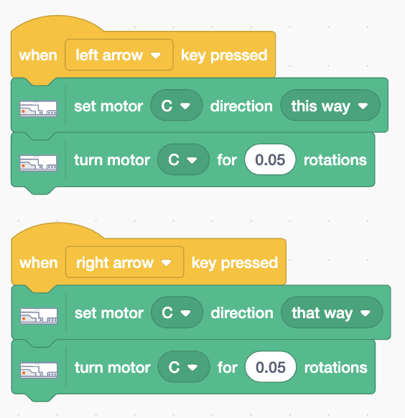
- Add code (left) to steer the trike. The left arrow rotates the wheel slightly left. The right arrow rotates the wheel slightly right.

Save your code with a good name. File > Save now

