
QuizBot

Register/login at https://scratch.mit.edu
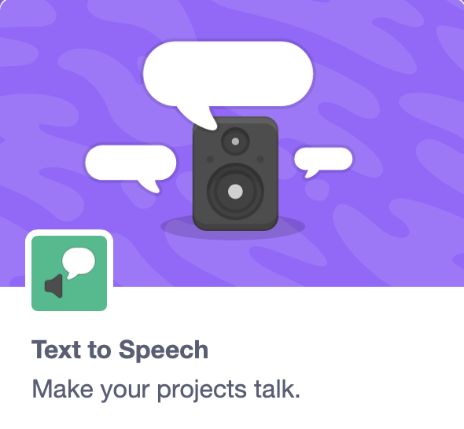
Make a talking scratch quiz.
1) Create a New Project and give it a name
2) In extensions, add Text to Speech to make your project talk.
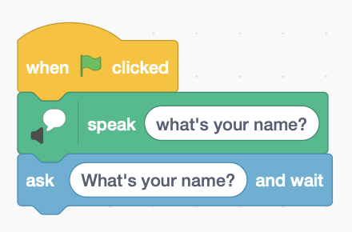
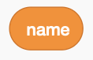
3) The QuizBot is polite and asks your name. Create a variable called name to store it.
4) It speaks “What’s your name?” To get input it will ask and wait. It must repeat the question so it appears on the screen as well as being read aloud.
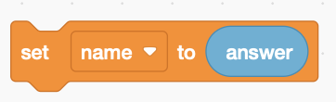
5) Whatever you enter is in answer (in sensing). Set name to your answer.
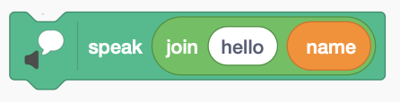

6) Now speak “hello” and then your name. Join hello and your name together.
7) Make a block (in My Blocks) to ask a question. Call the new block ask. Add ask to the code above.

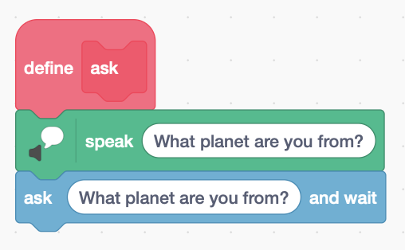
8) It should speak before asking a question.
This time, instead of saving the answer we must check if it’s right or wrong.
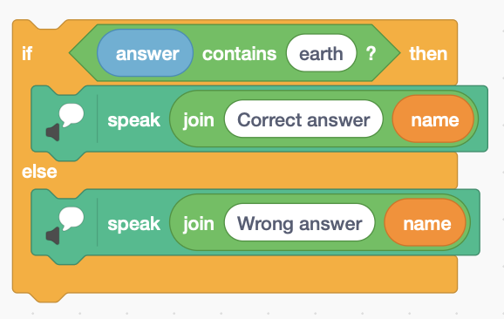
9) Add an if … else to check the answer. In the condition at the top see if the answer contains the correct answer. This works even if I said, “I come from the planet Earth.”
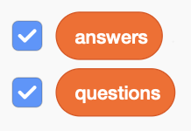
We want to ask more than one question. A good way to do this is to store your questions and answers in a List.
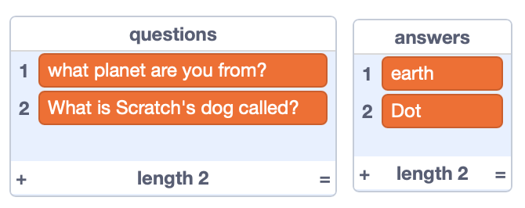
10) Make a List (in Variables) and call it questions. Make another List for the answers. Check the boxes next to them so you can see them.
11) Click + at the bottom of each list to add questions and answers.
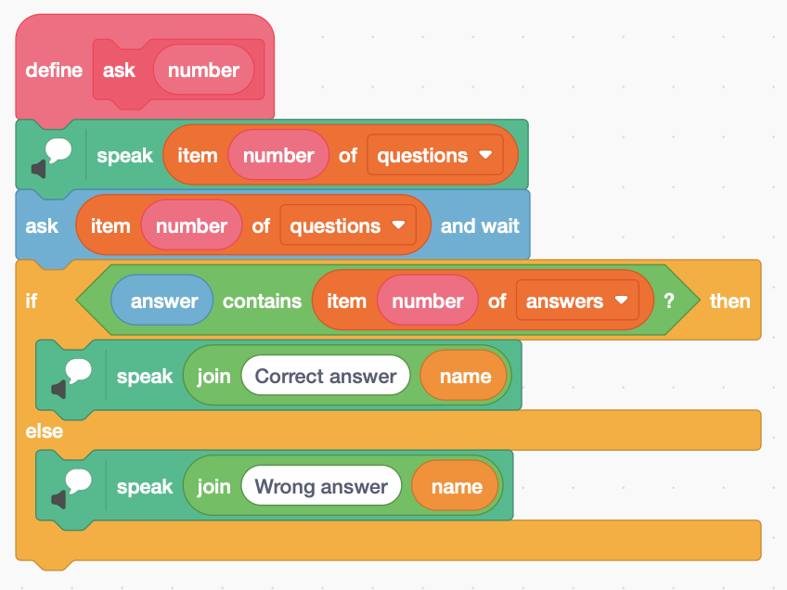
12) Right click on your ask block to edit it. Add an input for the question number.
Drag number from here
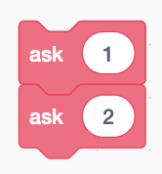
13) Edit your code to use the right item number of questions and answers.
14) Don’t forget to ask all the questions in the main code.
Save your code with a good name. File > Save now

