
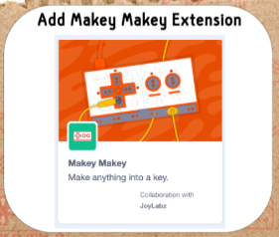

Buzz Wire

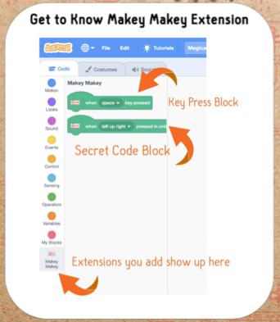

- Bend the long wire around the marker to form a shape.
- Stick each end in the block.
- Attach a crocodile clip.
- Connect to space on Makey

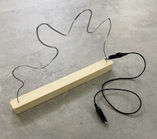

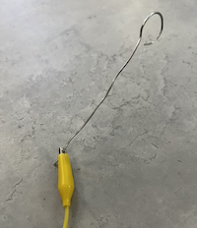
- Bend one end of the probe into a loop with a small opening.
- Attach a crocodile clip.
- Connect to ground on Makey.

Scratch Code
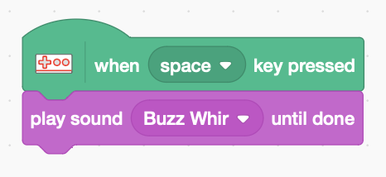
- Add code to detect a buzz wire contact: when space key pressed
- Click on the sound tab
- Choose a sound – search for “Buzz”
- Play sound on contact

- Try some other sounds

Materials:

- Makey Makey
- 15 Gauge 1.5mm Aluminum Craft Wire.
- Cut the wire into lengths about 80cm long and roughen with emery cloth to make better contact.
- Cut 20cm off one end for the probe.
- Wooden blocks about 20cm long with a 1.5mm diameter hole drilled each end on one face.
- Board markers are a good size to bend the wire around.
