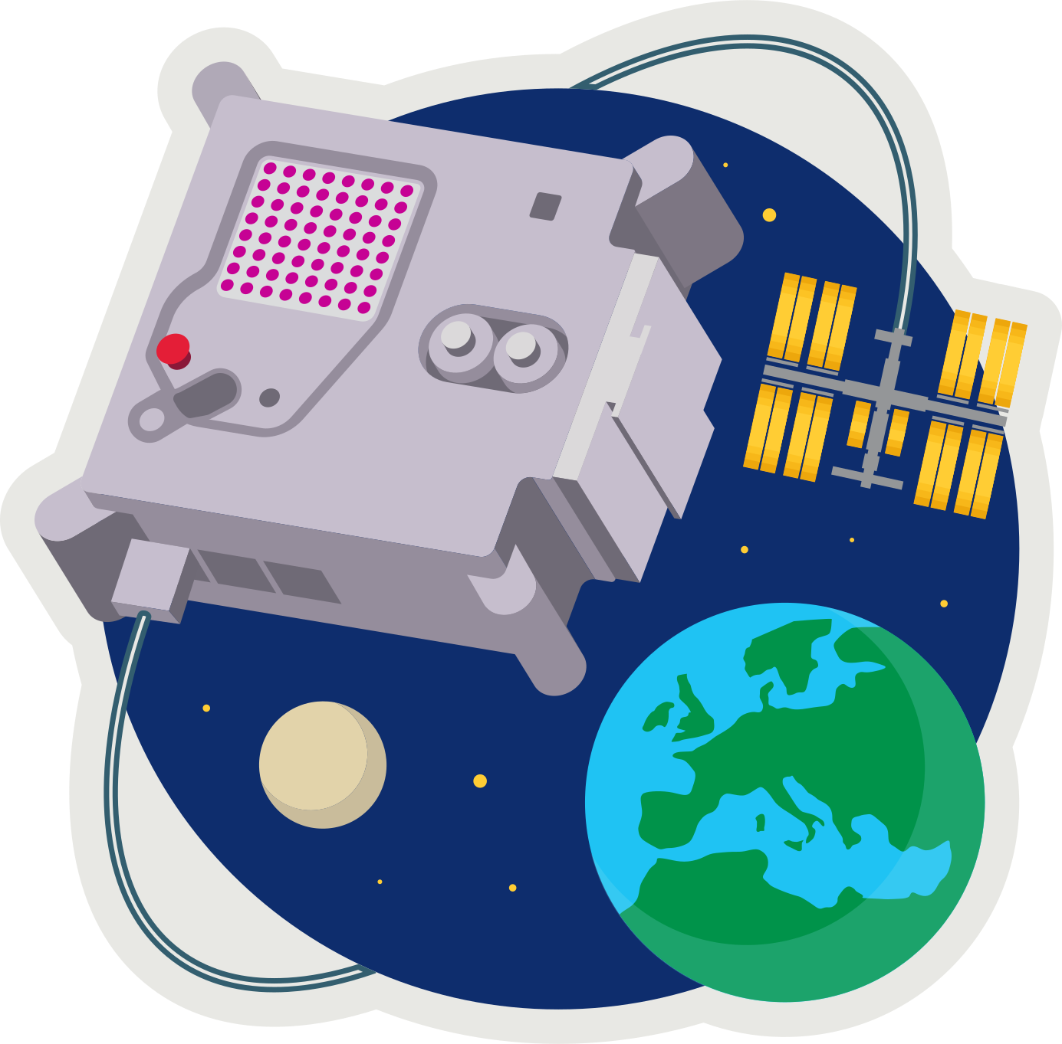
ASTRO PI MISSION ZERO
Part 4: Temperature Sensor

Send a personalised image to the astronauts on the International Space Station!

Last week you created 8x8 pixel-art (8 pixels high by 8 pixels wide)
Pixels are picture elements.

- Open pixilart.com (we can all use the same login CodeClub67)

This week download both your first and second images.


- Click on the profile avatar at the top-right of the window
- Select My Gallery
- Click on your first image (if you want to change it click edit)
- In the Details panel on the right scroll down to Details
- Click Download Original to download a .png (ping) image.
- Save this in your downloads folder.
- Repeat for your second image.


- MISSION ZERO grid
- Open https://codeclub67.github.io/astro-pi
- Choose the second .png file in downloads.
- Fill in the second mission grid on the sheet.

Your next Scratch mission is to create a simple animation,
switching between the two images once every second.

MISSION ZERO – Scratch Simulation
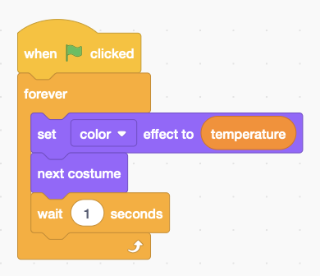
- Login to scratch.mit.edu
- Open your Scratch project from last week.
It already has a sprite with the first image.
- Select the sprite and choose the Costumes tab.
- Upload Costume from the second .png image in downloads.
- Modify the code adding a costume change with next costume. It should do this once very second, so make it wait 1 second.
- Run your code.

Astro-pi
Your tutor will show you how to do the same thing on the Astro-pi.
- Open Astro-pi Mission Zero:
https://missions.astro-pi.org/mz/code_submissions
- Open an existing program with the class code and team name.
- Select a Pixilart gallery image and use the mission grid tool to generate the images and past them into the Python code, indenting as necessary:
https://codeclub67.github.io/astro-pi
- Name the two images image1 and image2 and indent as necessary.
- See demo code at: https://codeclub67.github.io/astro-pi/sensor2.py
- Rename the first image as image1
- Add the second image as image 2
- Edit the image display line: sense.set_pixels(image1 if i%2==0 else image2)
- Run the code and vary the temperature
- The code also uses the colour sensor to clear the screen at the end.
- Enter classroom code and team name and save the work.
- Write down the team name and submit the work when it’s been checked.
- Mission completed - Hand out the stickers

astro-pi.org

