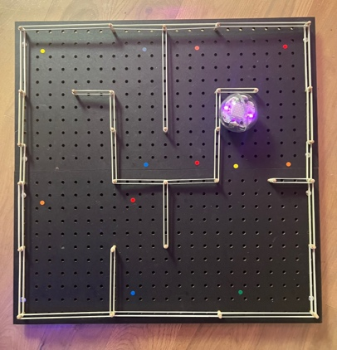

Ice-Slide Maze

Guide a bump’n’turn BOLT robot around a maze, turning only when you bump into a wall. This is called an ice-slide maze. Do a clockwise loop around the maze, starting and finishing at the top-right corner.

- In Chrome, open https://edu.sphero.com/code

- Connect your Sphero BOLT robot: click


- Select then


- Your BOLT has a sticker with a code on it. Choose the matching BOLT from the list then
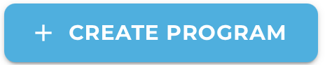
- Check your robot is showing the right image then
- Click + CREATE PROGRAM.
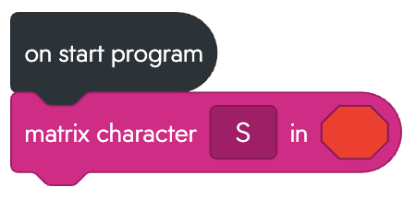
- Input a name for your program. Leave BLOCKS selected. Select SPHERO BOLT and deselect SPHERO BOLT+ then click CREATE.
- Add code to display the initial character of your name so you can find your robot in a crowd.
Choose a colour for it.

the code. Does it work?
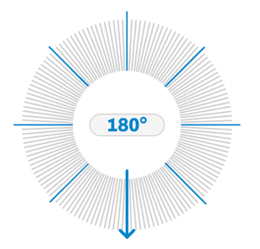
Use the coloured dots as a guide round the maze. Move from one dot to the next by rolling up (0 °), down (180°), left (270°), or right (90°).
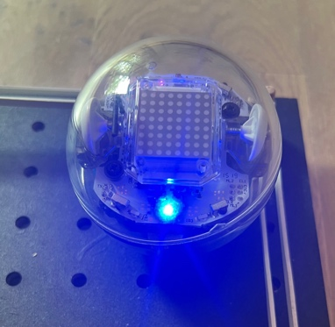
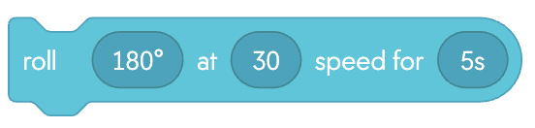
- Add code to roll down from the first (red) dot to the second (orange) dot at speed 30 for 5 seconds. Change the angle by dragging the arrow to point in the right direction. Change speed by clicking on the slider and using the up/down keys.

- Place the BOLT in the red corner and adjust the aim. Click then use the left/right keys to aim BOLT so that the blue light (it’s tail) points down.

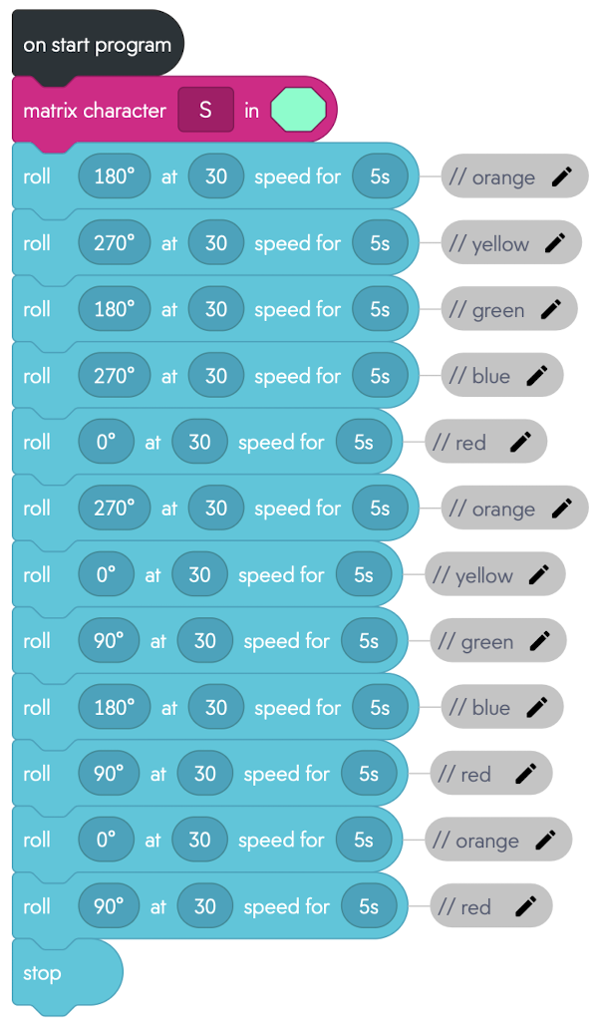
the code. Does it work?
- Add more roll blocks to complete the maze. There are 12 coloured dots so it needs 12 rolls.
Restart the BOLT from the red corner each time you run the code. You may need to correct the aim now and again.
To Save your code go back to the main page. Click on the 3 dots (ellipsis) next to your program and download to a USB drive.

