

Pac-Man 1D

Play one-dimensional Pac-Man in Scratch.
- Download images and create sprites from:
https://codeclub67.github.io/images/pacman.png
https://codeclub67.github.io/images/ghost.png
https://codeclub67.github.io/images/pellet.png
- Double the size of Pac-Man and the Ghost by setting their size to 200%.

- Set the direction of Pac-Man and the ghost to mirror left and right, rather than rotate.
- Add a dark background (e.g. Stars).
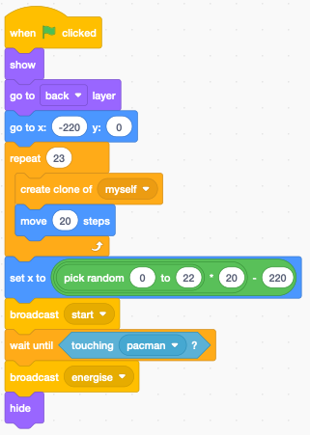
Pac-Man 1D has just a single row of 23 pellets to eat. These small (25% size) pellets are clones.
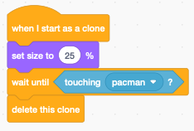
- Add the code (below) to the pellet. The original pellet is the energiser which is placed randomly.
Cycle through Pac-Man’s first four costumes to animate it.
- Add the code below to Pac-Man. The set x block creates a wrap-around (1D) world for Pac-Man. If it goes off one edge it reappears at the other edge. The grouping of the blocks is (((x position + 230) mod 460) – 230).
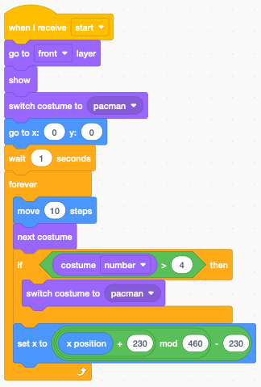
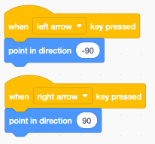
- Guide Pac-Man with left/right keys (see code left) and point it in the corresponding direction.
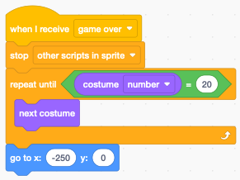
- When Pac-Man loses and it’s “game over”, play out the rest of its costumes, up to costume 20, before moving Pac-Man off-screen (see code right).

When Pac-Man is energised it has two seconds to catch the ghost before it goes back to chasing Pac-Man. The main pellet is the energiser with a time limit of 2 seconds into the future using the timer. When the timer is again bigger (later) than the time limit the normal ghost costume is displayed, and it heads towards Pac-Man. If it touches Pac-Man it’s “game over.” However, if the time limit hasn’t expired and the ghost touches Pac-Man, then the ghost ‘dies’ (costume 6 “eyes”).
- Create a new variable time limit and add the code below to the ghost. The loop at the end animates the ‘death’ of the ghost.
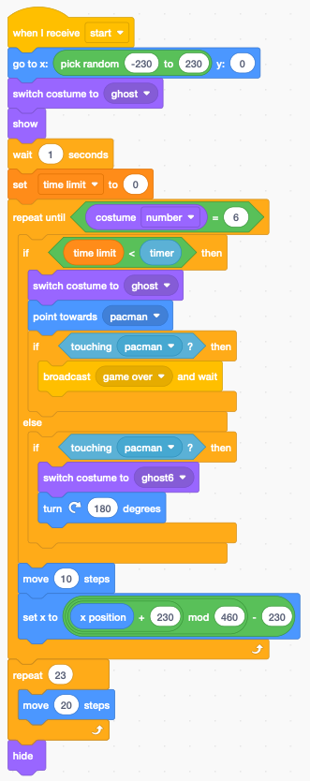
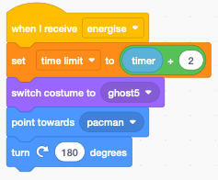
.
The ghost reacts to the energiser by changing to the “frightened” costume and heading away from Pac-Man.
- Add the code (right) to the ghost.
If you duplicate the ghost and select a different colour, how hard is it to play?
Save your code with a good name. File > Save now

